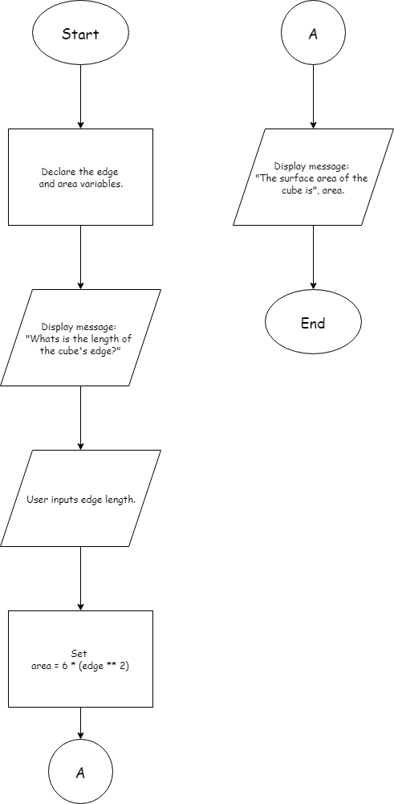

## PSEUDOCODE

* Declare the edge length variable. The variable will be called “***edge***”.
* Declare the surface area variable. The variable will be called “***area***”.
* Ask the user to input the length of the edge of the cube. The input must be an integer.
* Calculate the surface area of the cube using a formula. Use the edge variable in the formula.
* Display the calculated surface area.

## IPO

|  |  |  |
| --- | --- | --- |
| Input | Processing | Output |
| Edge length | Prompt to get edge length | Display: surface area. |
| Surface area | Calculate cube area with the formula $Area= 6a^{2}$ |  |
|  |  |  |

## DESK CHECK

Examples: 2, 10, 25.

Declare the edge length variable.

Declare the surface area variable.

Ask user for length of cube edge.

Display the surface area.

|  |  |
| --- | --- |
| Declare the edge length variable. | Edge = 0 |
| Declare the surface area variable. | Area = 0 |
| Ask user for length of cube edge. | 2 |
| Display the surface area. | 24 |

|  |  |
| --- | --- |
| Declare the edge length variable. | edge = 0 |
| Declare the surface area variable. | area = 0 |
| Ask user for length of cube edge. | 10 |
| Display the surface area. | 600 |

|  |  |
| --- | --- |
| Declare the edge length variable. | Edge = 0 |
| Declare the surface area variable. | Area = 0 |
| Ask user for length of cube edge. | 25 |
| Display the surface area. | 3750 |