**POS ALLURE THEME**

**Key Features**

- More work area for POS users.

- Flexibility for Users to customize dynamic theme colour.

- Flexibility for Users to choose and customize function that they like.

- Flexibility for users to choose multiple views like Kanban, List & Barcode view.

- Flexibility for users managed customized button easily.

- Flexibility to choose between Night Mode/Light mode/Regular mode

- Flexibility to manage multiple payment method & payment screen.

- Change left side bar view of pos screen.

- User can easily view orderline with their updated quantities a products.

- Flexibility to choose from Regular view and Full screen view

- Fully responsive and optimized view to work smoothly laptops, tablets and mobiles devices

- Fully Responsive Modern Material Design.

- Users can customize their own Color Combination.

**POS Home Screen**

- User can dynamically change theme colour and also customize it.

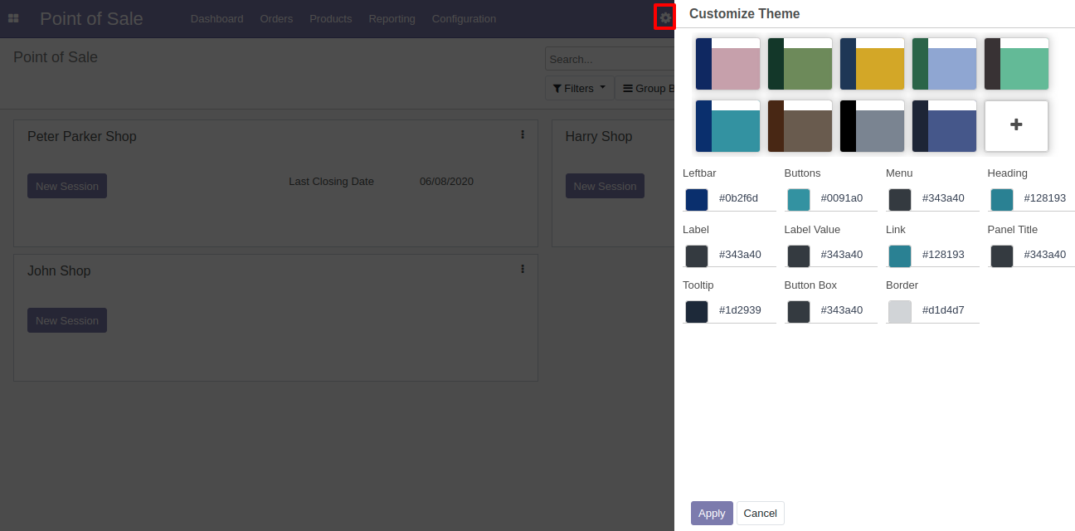

**POS User Configuration**

- Enable an option to Connect Allure Device and set barcode scanner, printer.

- User can easily manage default layout of POS like List view, Kanban view , Barcode view etc.

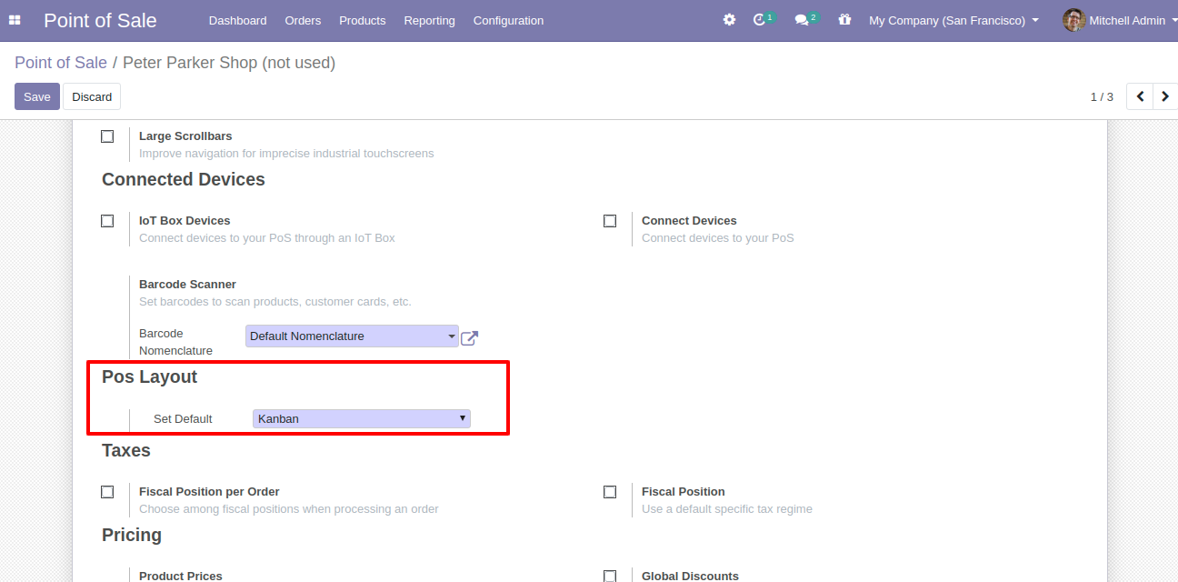

**Cashier Login Screen**

- We have customized the design for cashier selector, Change Cashier, and for pincode window.

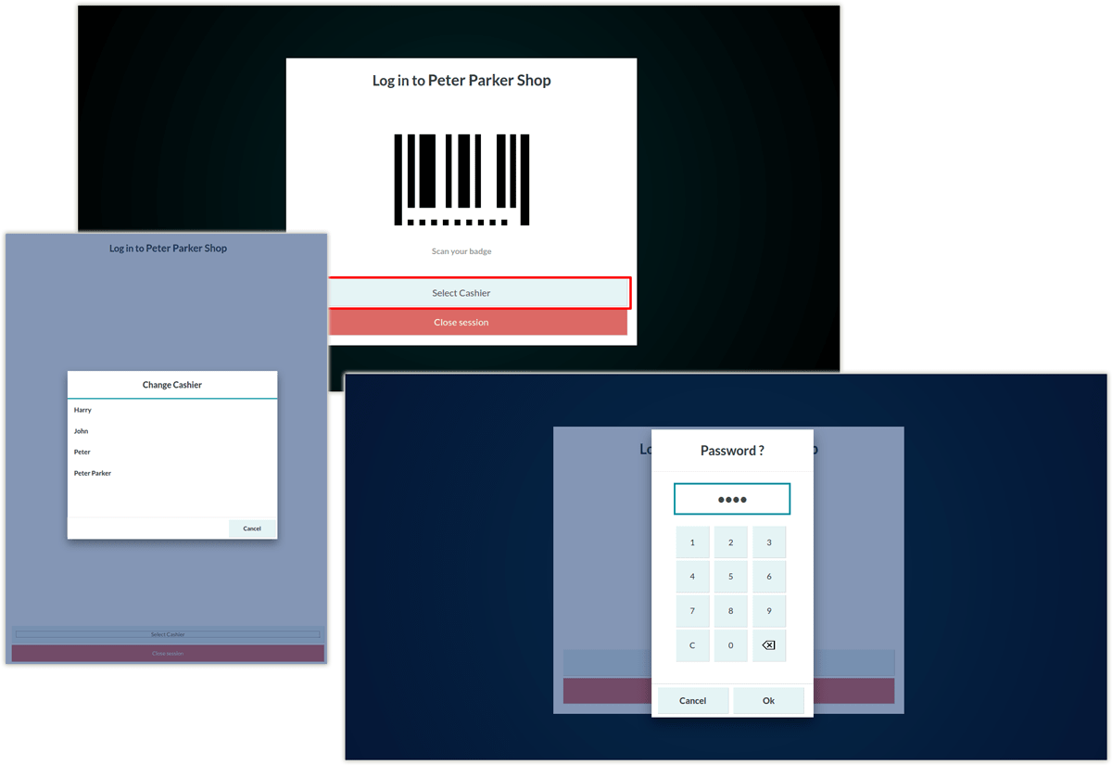

**Ipad View for cashier login screen**

- We have optimize the view and made it Ipad responsive.

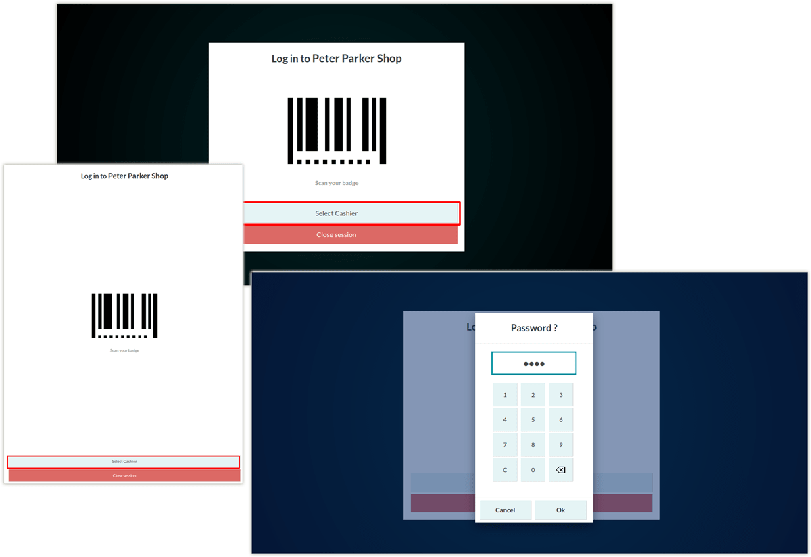

**Mobile View for cashier login screen**

- We have optimize the view and made it Mobile responsive.

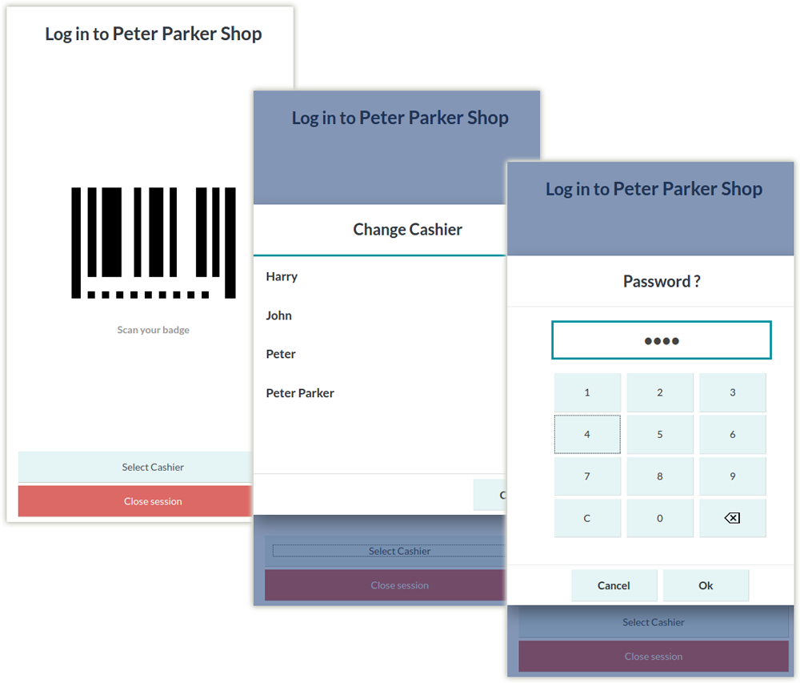

**Views:**

- User can select diffent views as per his choice, there are 3 views are available.

1. Kanban View

2. List View

3. Barcode View

- All views are fully responsive with Tablet and Mobile screens.

- Easily switch with one view to other view.

- On barcode view user can directly scan items and it will added in to card directly

**Kanban View of products**

- Here user can view whole POS screen in a customizable way as following.

1) Full Responsive.

2) Manage different functionality easily.

- POS user can change the view of pos screen any time like List view, Kanban view, Barcode view.

- Here User can change the view of Kanban view to List view and visa versa.

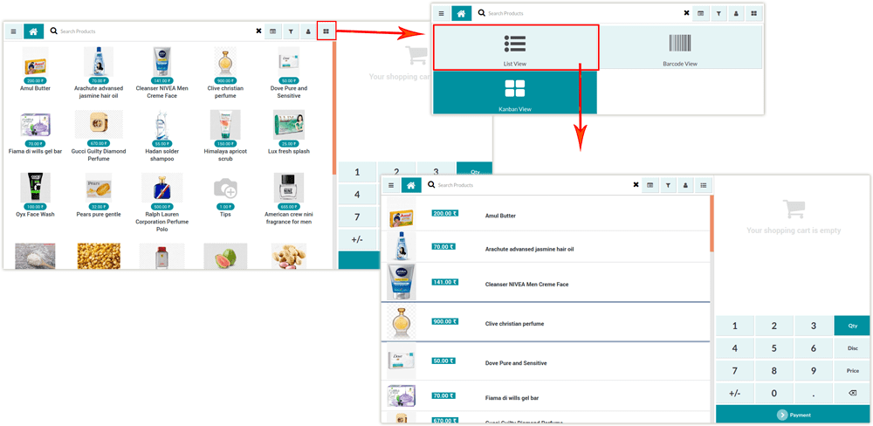

**Ipad View of products**

- We have optimized the view and made it Ipad responsive.

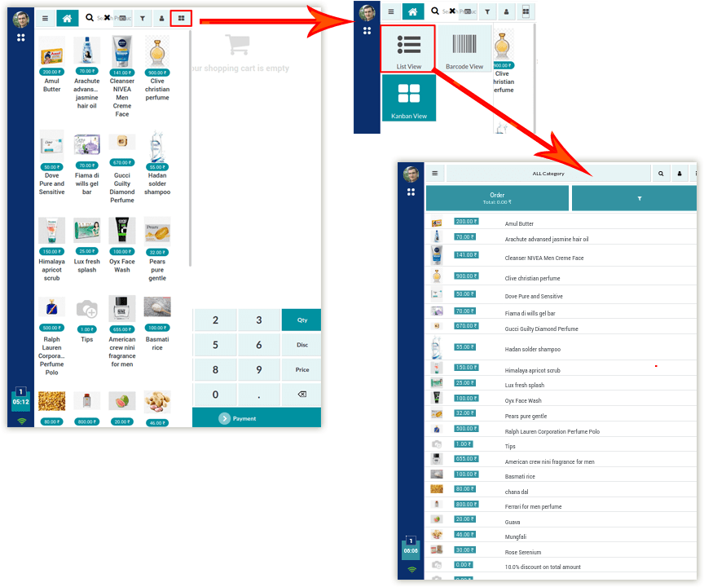

**Mobile View of products**

- We have optimized the view and made it Mobile responsive.

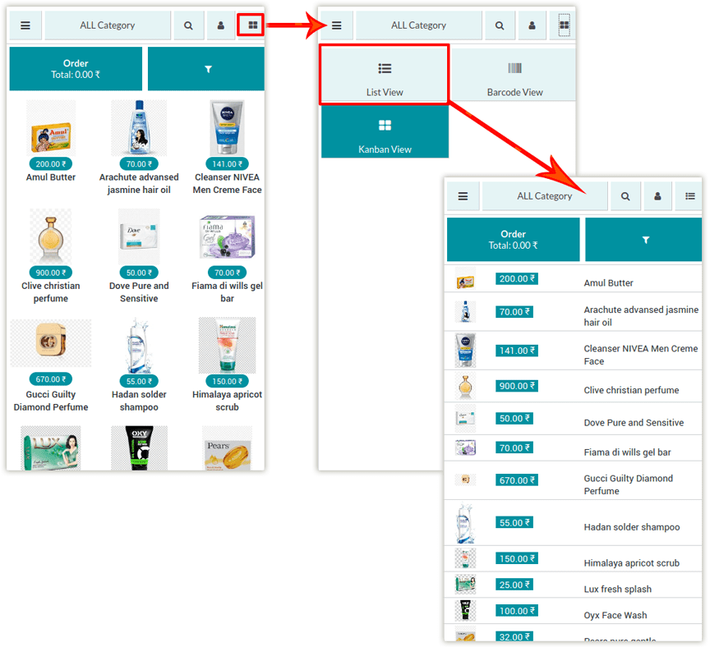

**Barcode scenning view of products**

- Here user can view whole POS screen in a customizable way as following.

1) Full Responsive.

2) Manage different functionality easily.

- Here users can add product using barcode scanner easily & manage them properly.

- Save time for selecting new products.

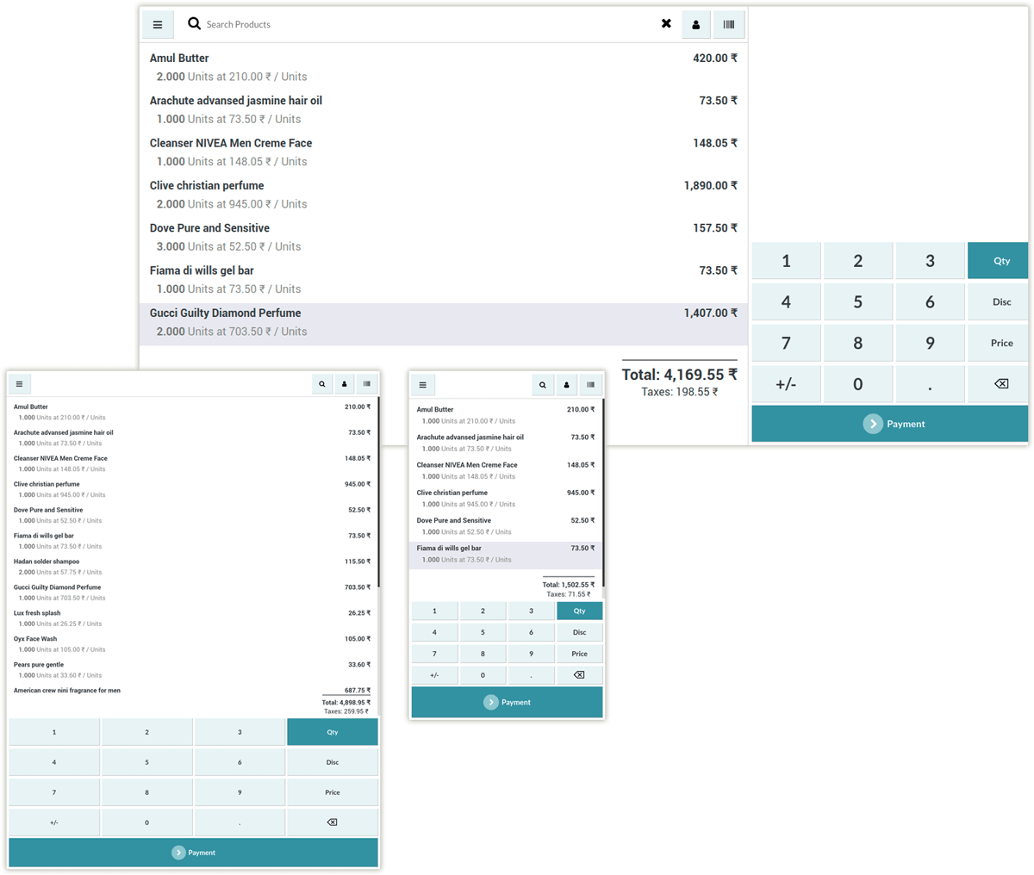

**User SideBar view**

- Here user can lock POS screen, close session, and view POS order reference.

- Fully Responsive Modern Material Design.

- View Photo of user with their name.

- Easy to open & close this sidebar & it helps to reduce extra space of POS screen.

- Easily lock and unlock session.

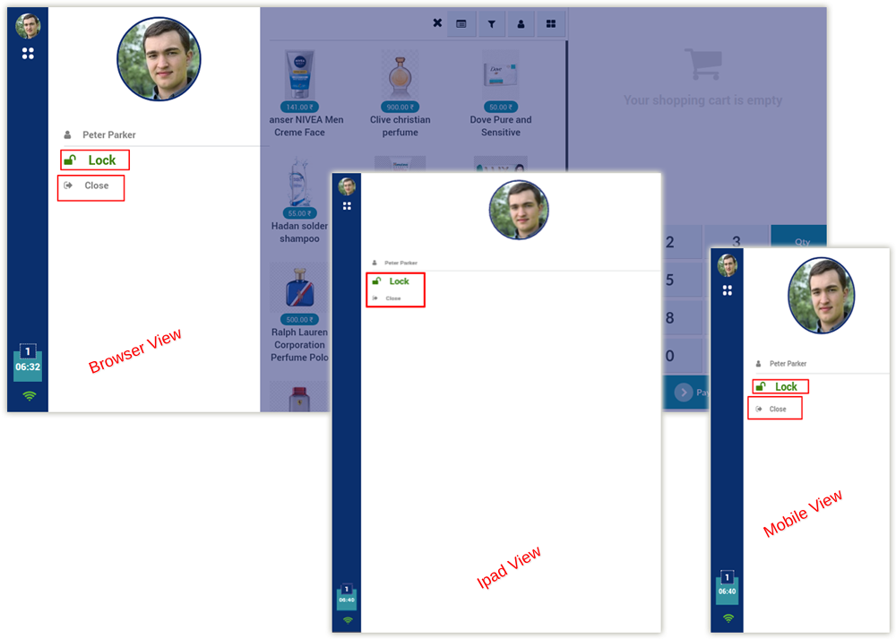

**Change Order Screen**

- Easily switch one order to another order.

- Check number of total orders and easily enter it and update order.

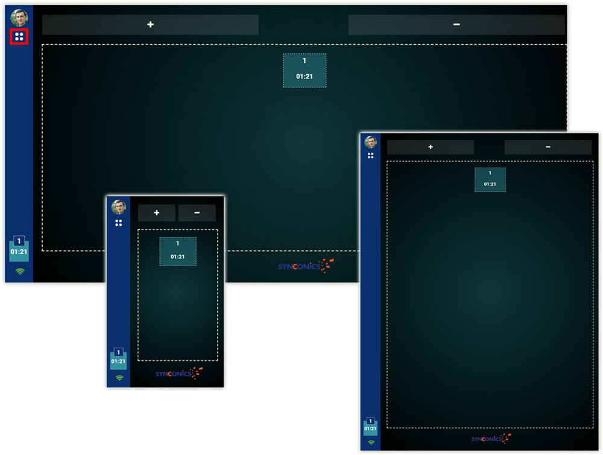

**POS Category Layout**

- User can check POS category on top pannel.

- Easily hide and view category screen.

- Benifit of full screen layout

- Here we have managed a seperate screen for POS category.

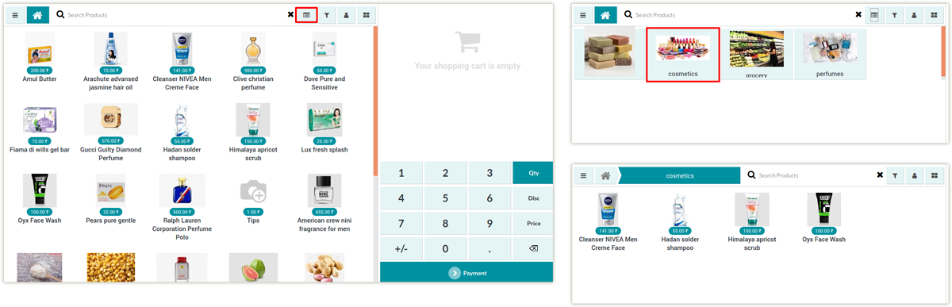

**Tablet View of category**

- We have optimized the view and made it Tablet responsive.

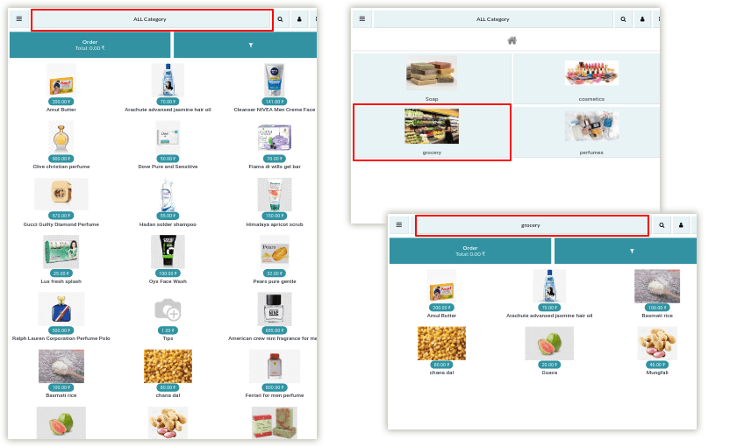

**Mobile View of category**

- We have optimized the view and made it Mobile responsive.

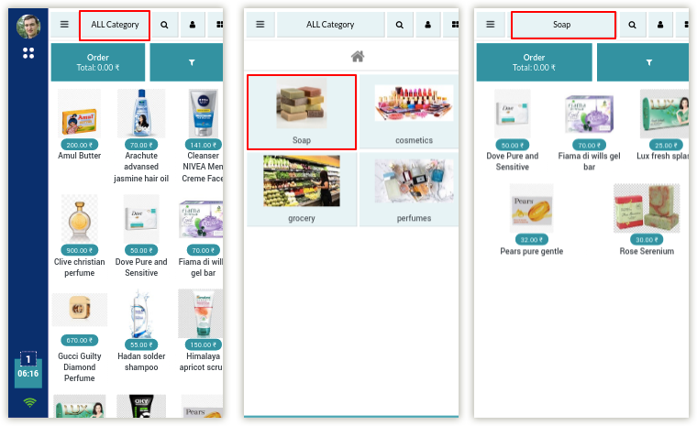

**Search Products**

- User can easily search products on top pannel.

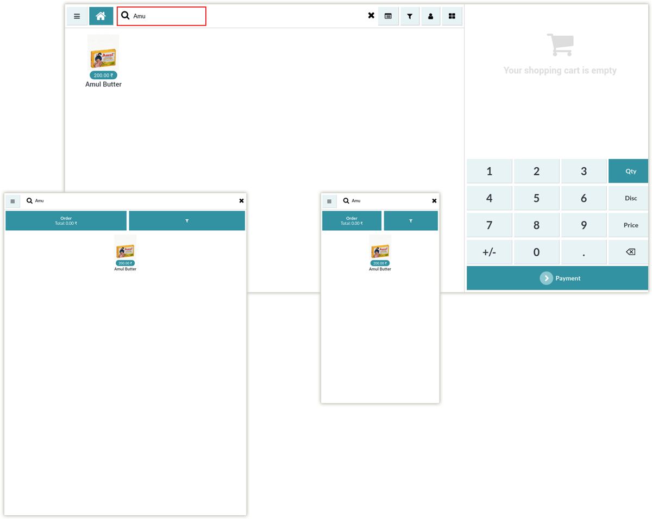

**Add Product in to cart**

- While click on product it will show number of quantities are added on cart.

- Check details on cart.

- On mobile & tablet view, a user has to first, click on the order button then after he can view Point Of Sale order screen.

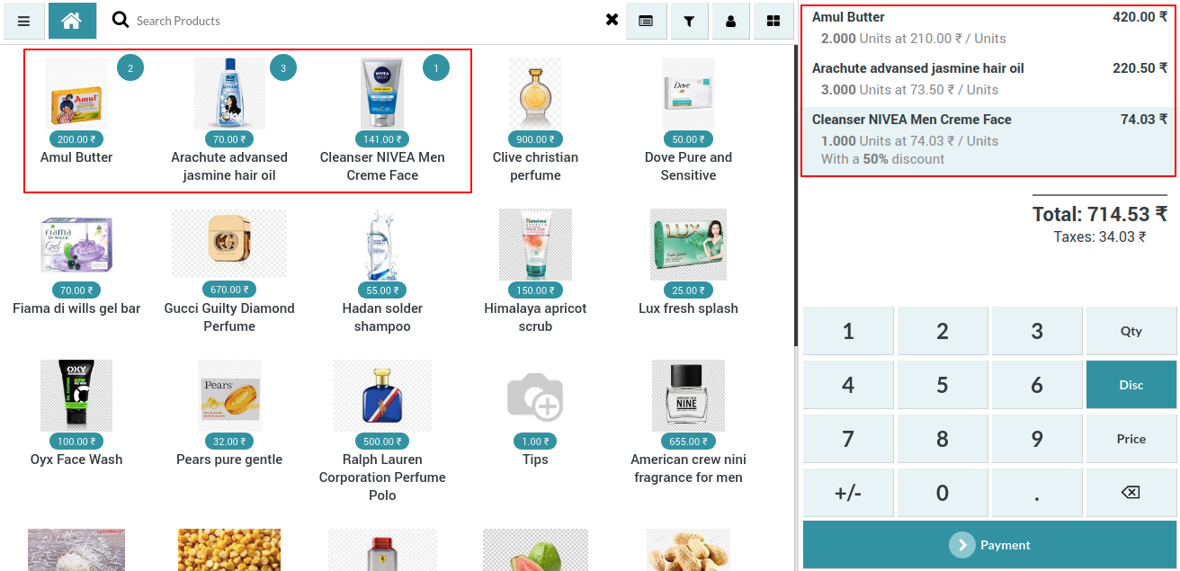

**Tablet view for added items on cart**

- We have optimized the view and made it Tablet responsive.

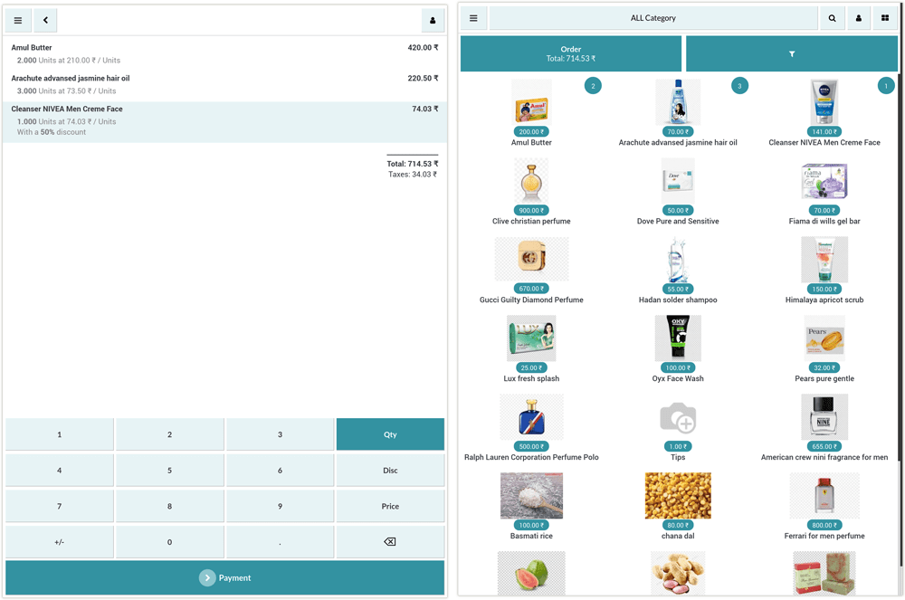

**Mobile View for added item on cart**

- We have optimized the view and made it Mobile responsive.

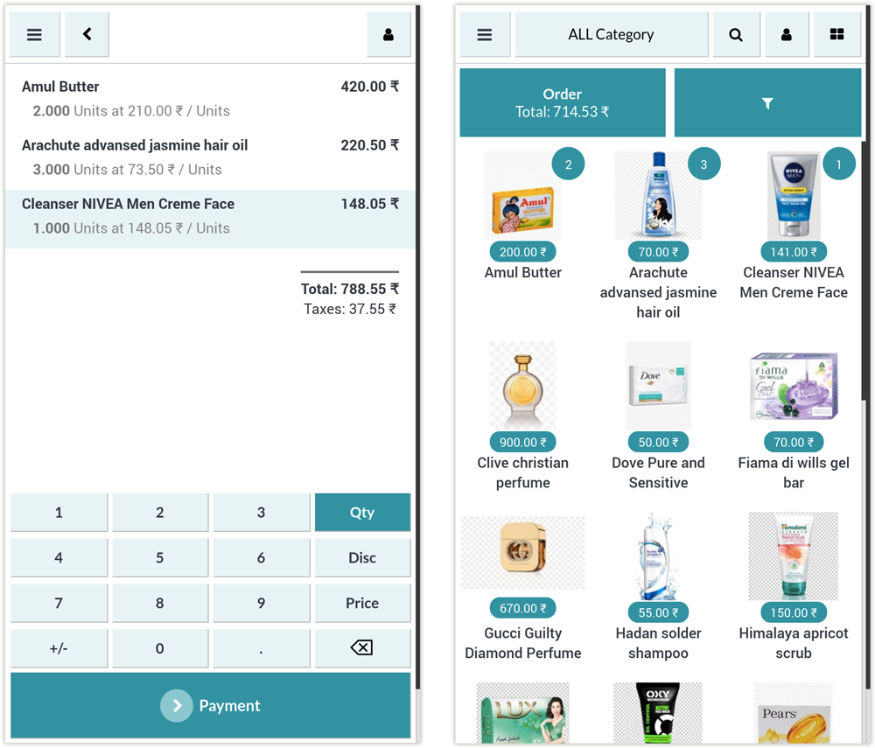

**View Customised POS Button**

- All custom or other features buttons are available at one place.

- Easily hide and show all buttons.

- User can use full space of screen.

- Here user will find buttons for each and every functionality for ex bill, discount, split etc.

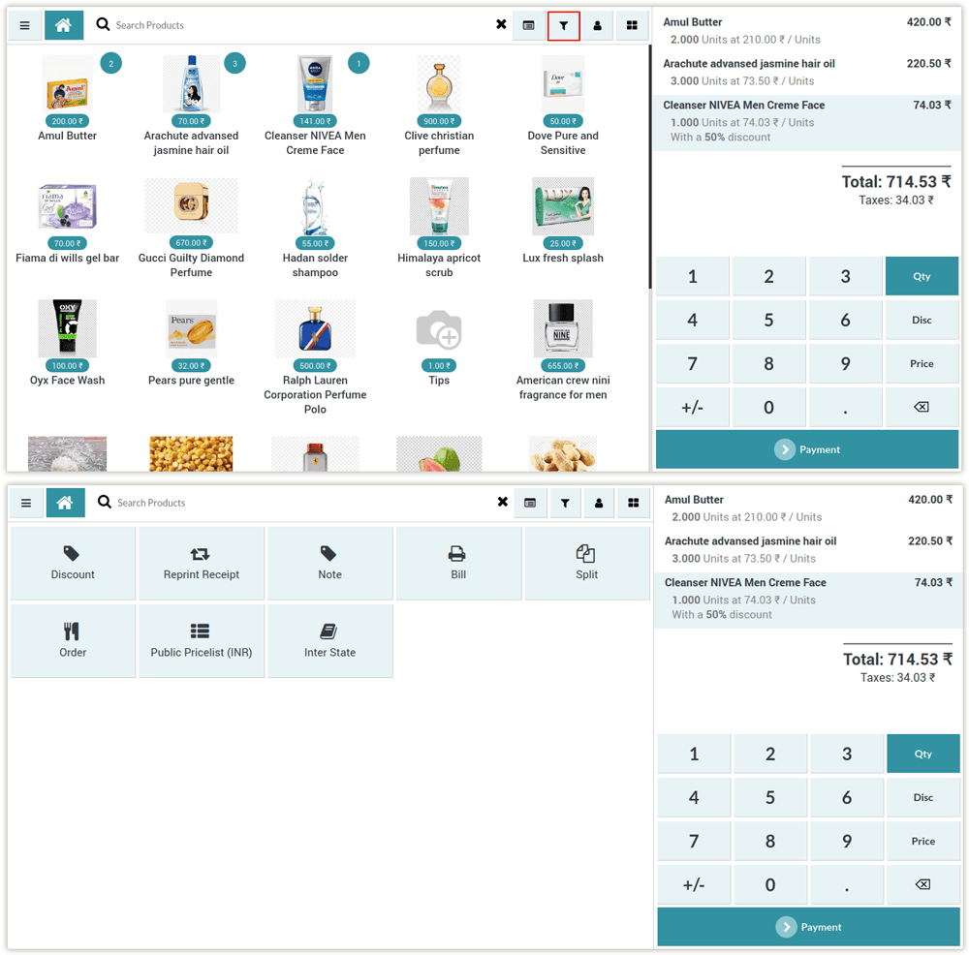

**Tablet View of other buttons**

- We have optimized the view and made it Tablet responsive.

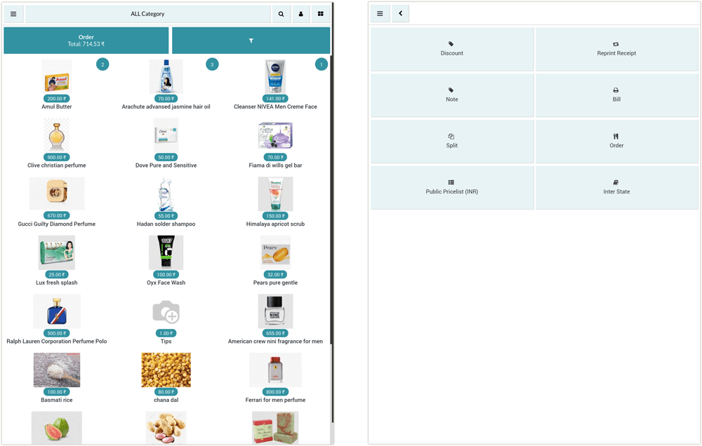

**Mobile View of other buttons**

- We have optimized the view and made it Mobile responsive.

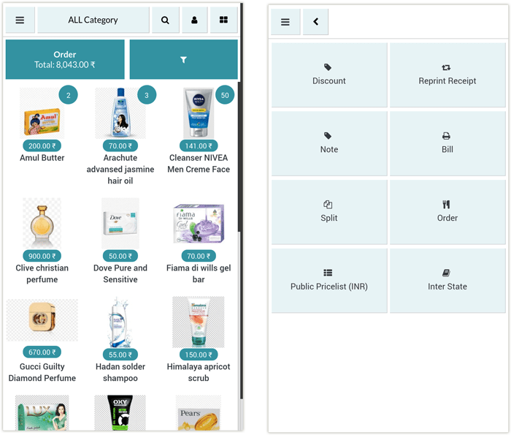

**Customer Selection**

- Easily check customer is set or not

- Check all details of customers

- Here users can manage customer screens.

- Users can set any customer, edit customers and create a new customer using screen easily.

- By clicking on customers by List view user can see their details at right side.

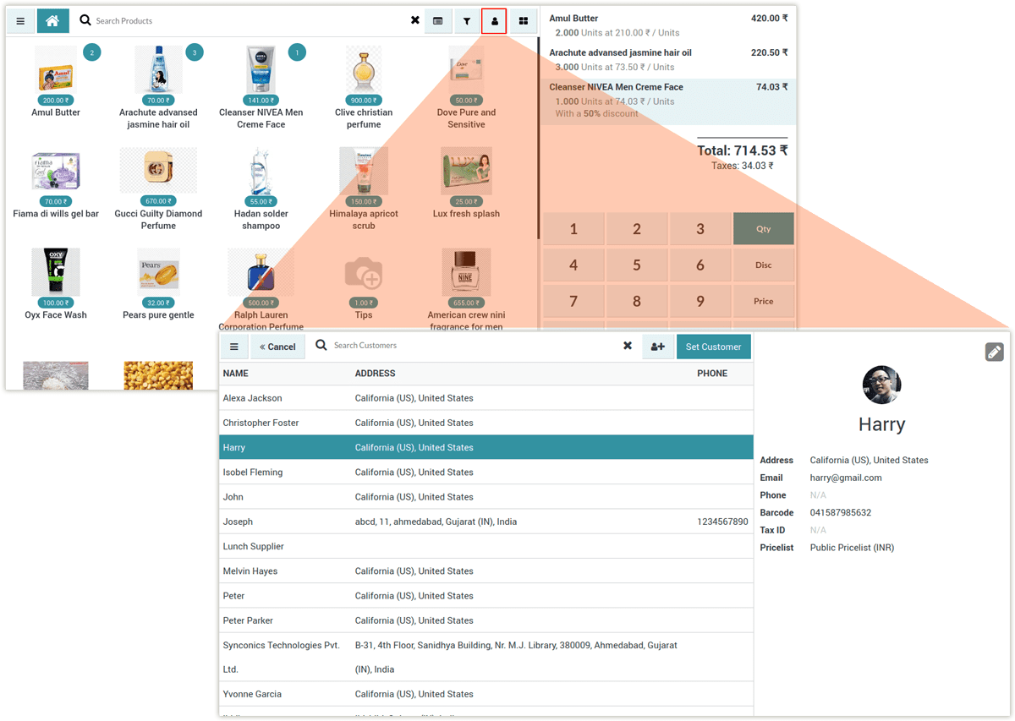

**Tablet View for customer**

- We have optimized the view and made it Tablet responsive.

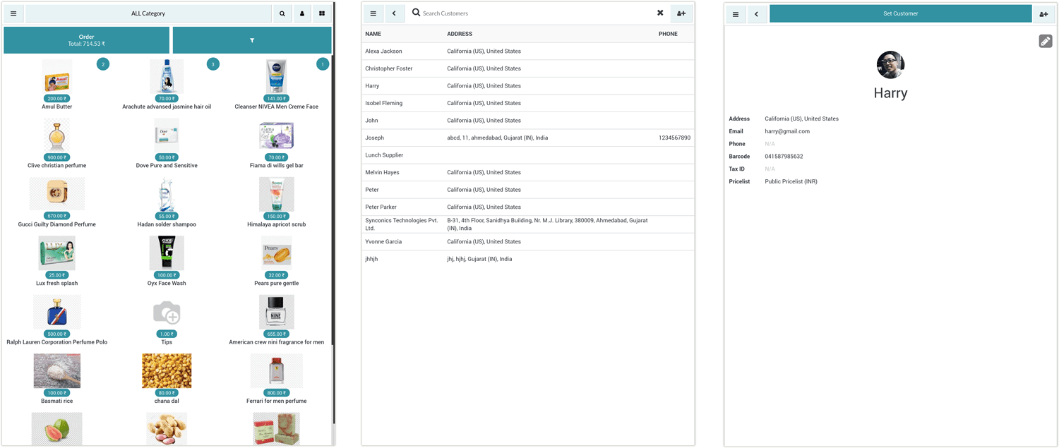

**Mobile View for customer**

- We have optimized the view and made it Mobile responsive.

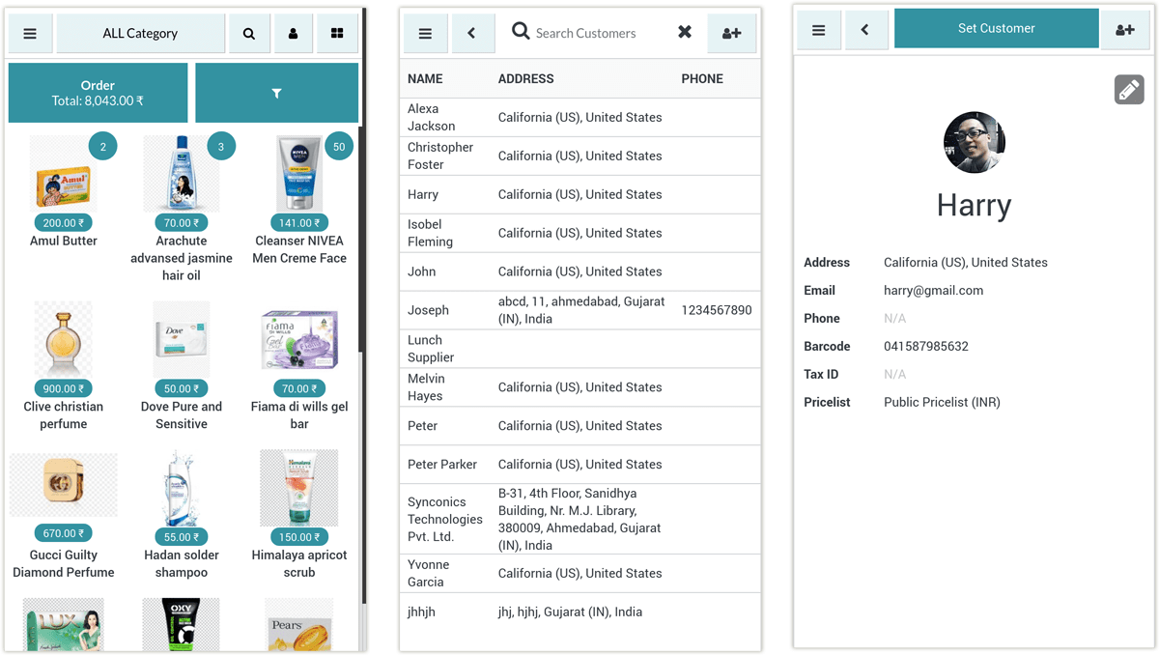

**Payment Screen**

- On Right top side all payment methods are listed, user can select payment method.

- Here users can view payment screen customized with fully flexible screen.

- On Right botton side amount numpad is available, cashier can selct amount there.

- Users can view multiple payment methods on right side & easily manage them.

- Easy to use full screen features.

- Here user can view changes in numpad.

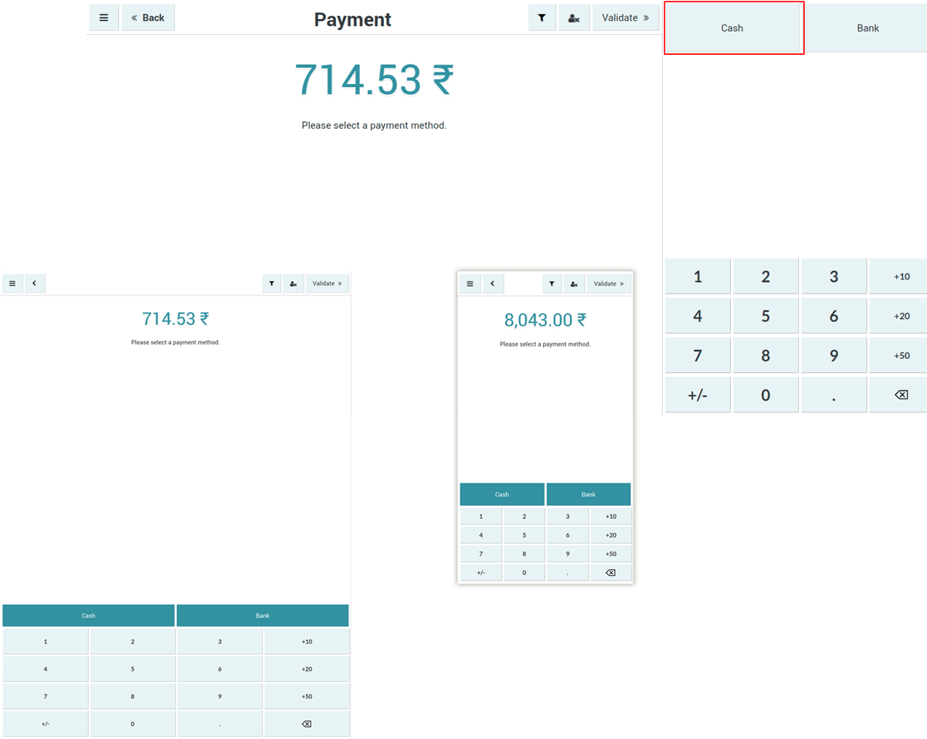

**Payment line view**

- Easy to add multiple payment lines.

- Here user can view changes of payment with proper format & add multiple payment line easily.

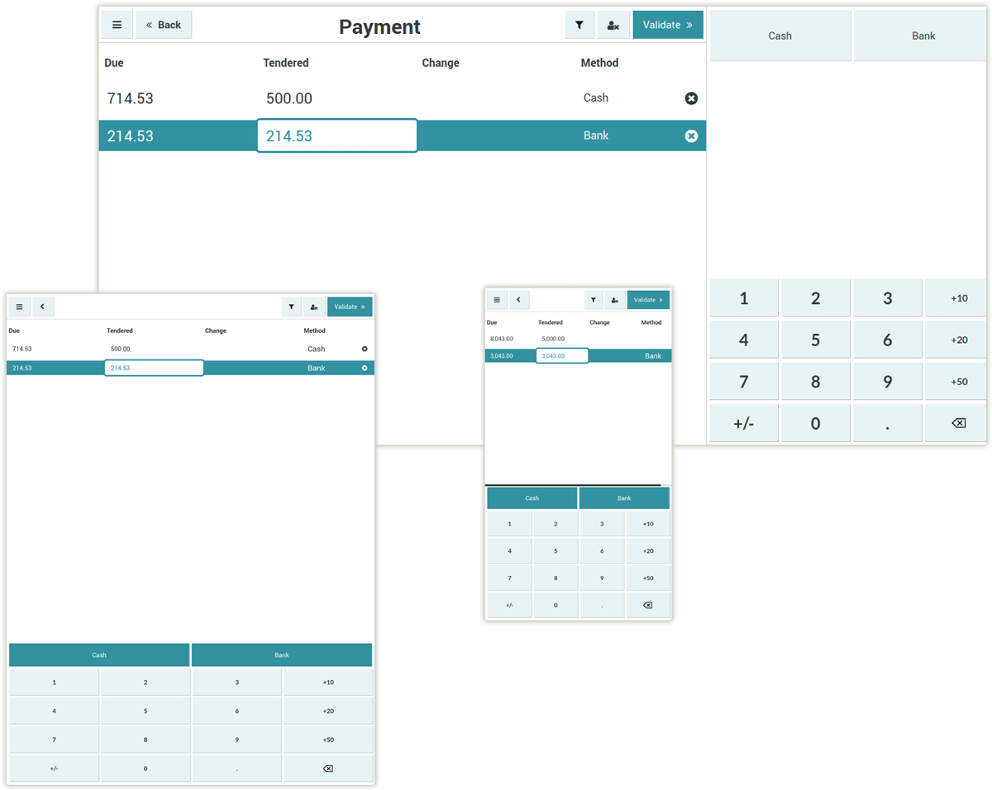

**Other customized feature buttons**

- Users can manage customized payment screen buttons on a single screen like Invoice, Email, Tip, etc.

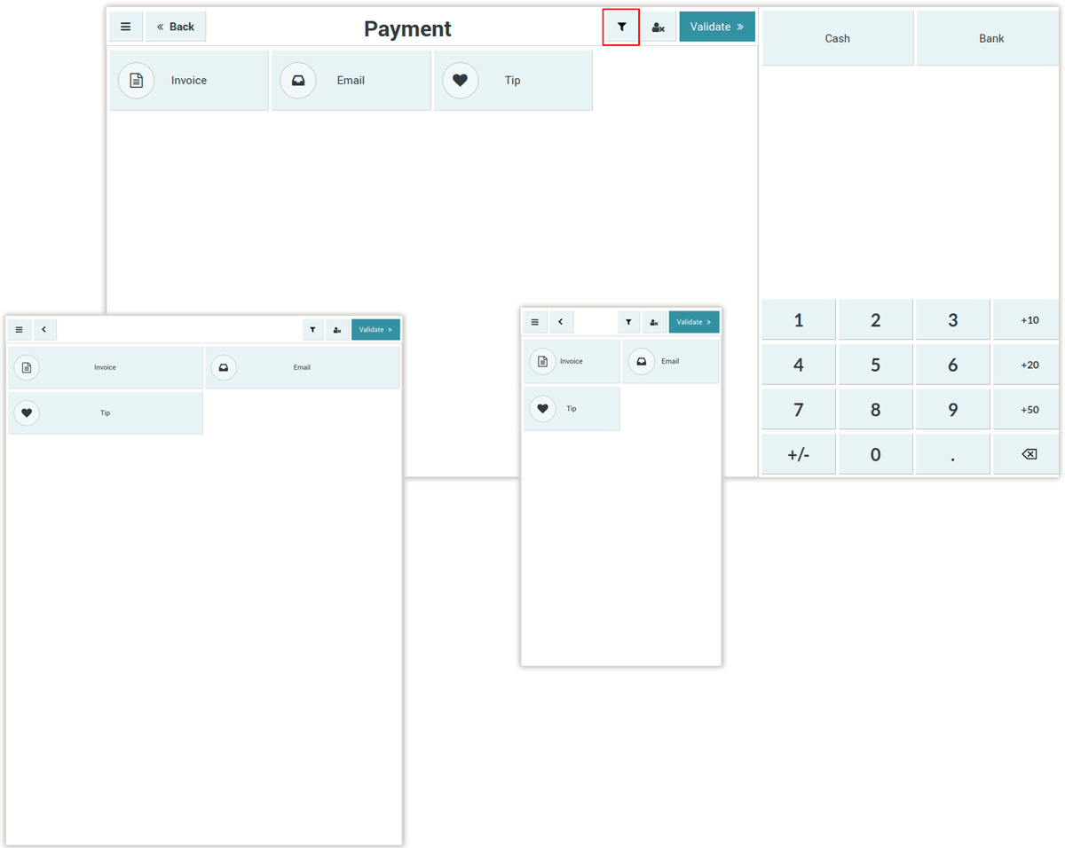

**Validate Order**

- Here user can view changes of POS validate button color.

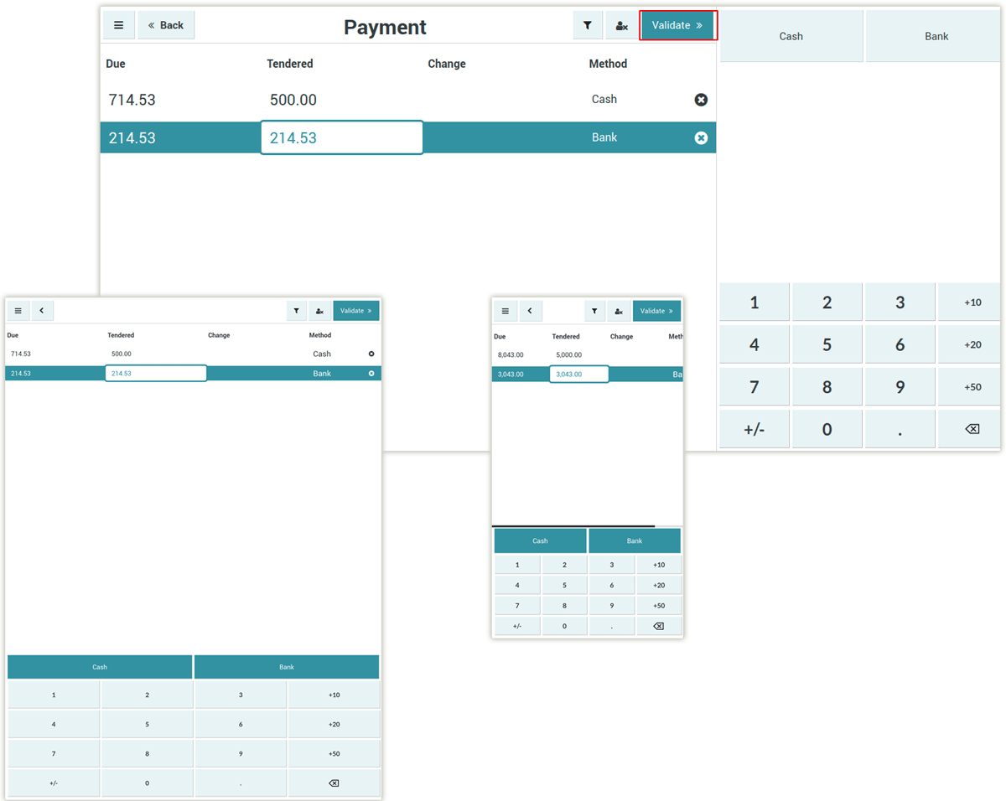

**Receipt Screen**

- Users can view receipt of POS order with proper format fully responsive.

- Users can differentiate between base receipt & our receipt format.

