**Getting Started with Data Visualization II: Elements of Design**

Activity Guide

1. Download the “Bad Examples” Tableau workbook here: https://public.tableau.com/views/BadExamples/AudienceScorevsWorldwideGross?:embed=y&:display_count=yes
2. Examine the data set: [HollywoodsMostProfitableStories.csv](https://drive.google.com/open?id=0Bz7G_jKybSBscFg0SXhpb1FWVnc)
3. Launch the Tableau application on your computer.
4. Open “Bad Examples.twbx” in Tableau.
5. You will see three examples of mediocre to poor data visualizations. Work individually or with your table mates to make your assigned visualization look better, using design principles.
6. Either sketch your improved version on paper or use Tableau to fix it if you are familiar with the software. Ask for help in using Tableau by raising your hand!
7. Email link or photo of your work to [ablaine@ncsu.edu](mailto:ablaine@ncsu.edu) 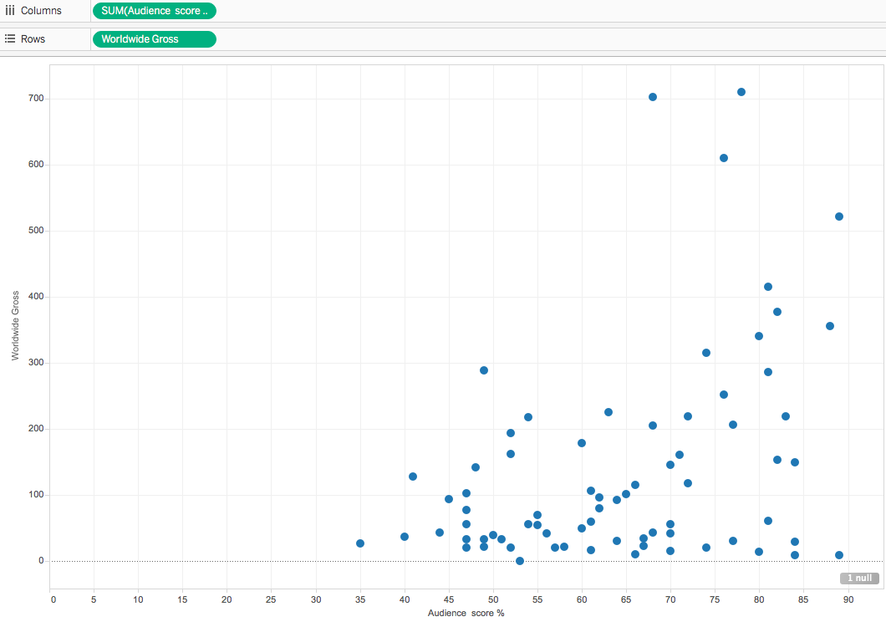

Tableau tips

**Example 1: Scatterplot**  
This graph shows audience score (X-axis) and Worldwide Gross revenue in millions of dollars (Y-axis). The purpose of this graph is to see if there is a correlation between box office gross revenue and a film’s audience score. What would help make this visualization better?

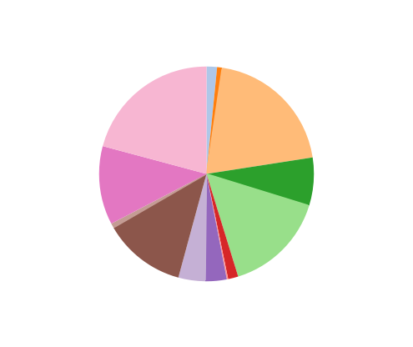

**Example 2: Pie Chart**

This pie chart attempts to show how much film studios compare in terms of gross revenue.

**Example 3: Bar chart**

This bar chart shows worldwide gross by film and genre. It’s too busy and needs help!

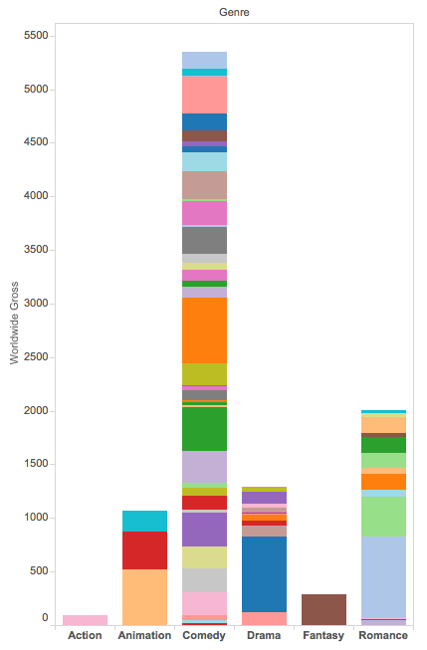

Tableau Tips:

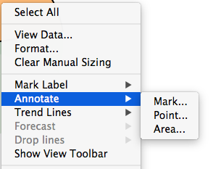

* Try different visualizations using the “Show Me” tab in Tableau. This can be a good way to get ideas!
* You can easily annotate charts in Tableau by double-clicking (or right-clicking) on data points and then selecting “Annotate…” from the dropdown menu.