Fall 2024 - SE PROJECT 3

Group 47

Team Members:

Gaurav Sheth (gpsheth@ncsu.edu)

Soham Gundewar ([sgundew@ncsu.edu](mailto:sgundew@ncsu.edu))

Anish Dhage (adhage@ncsu.edu)

Github Link-

<https://github.com/NCSU-SE-2024/PackTravel_v2>

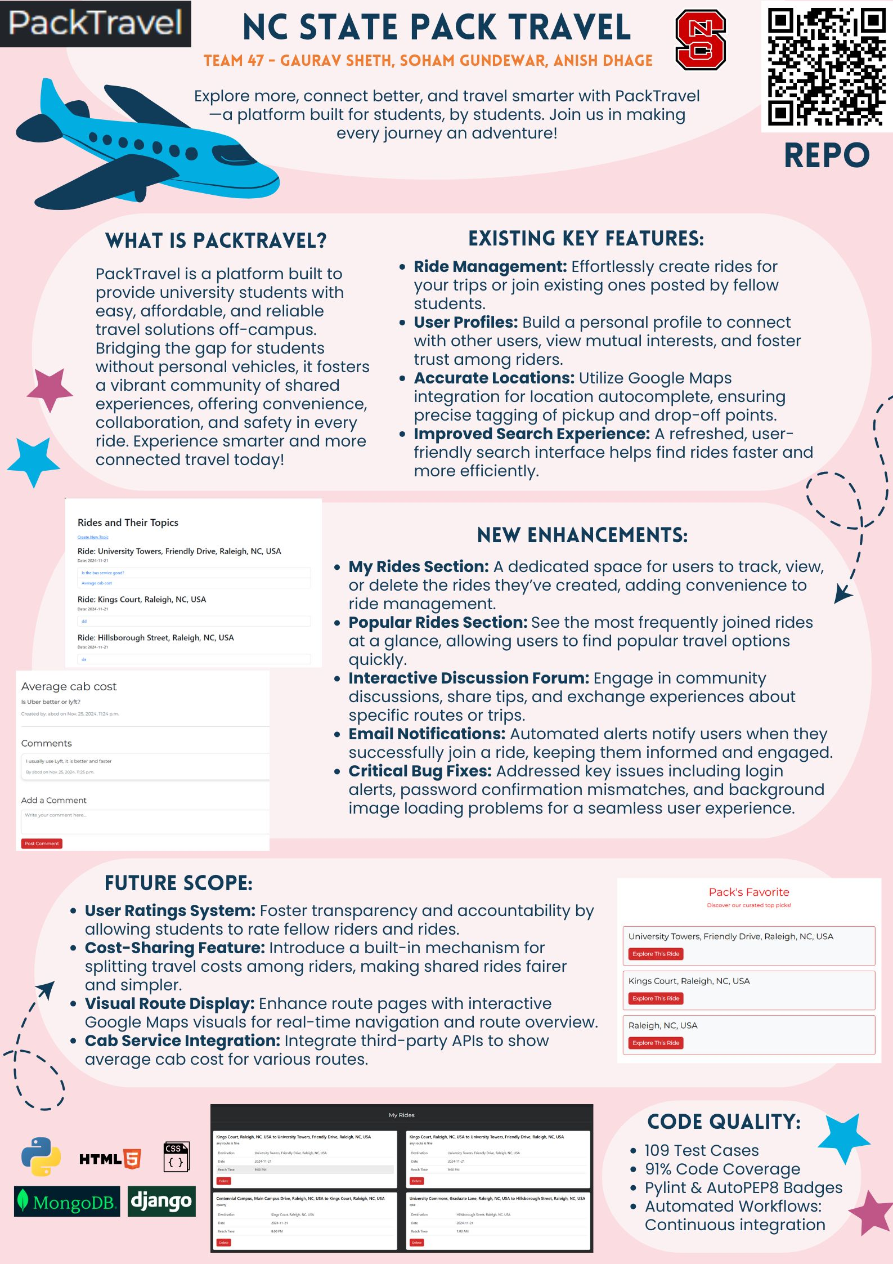

|  |  |  |
| --- | --- | --- |
| **Evaluation Points** | **Self-Assessment** | **Supporting Comments** |
| TOTAL ROWS = 105 | SUM OF COLUMN = 282 |  |
| Workload is spread over the whole team (one team member is often Xtimes more productive than the others… | 3 | Visible In GH Repo |
| but nevertheless, here is a track record that everyone is contributing a lot) | 3 | Visible In GH Repo |
| Number of commits | 3 | Visible In GH Repo |
| Number of commits: by different people | 3 | Visible In GH Repo |
| Issues reports: there are **many** | 3 | Visible In GH Repo |
| Issues are being closed | 3 | Visible In GH Repo |
| Docs: doco generated, format not ugly | 3 |  |
| Docs: what: point descriptions of each class/function (in isolation) | 3 | In Source Code files |
| Docs: how: for common use cases X,Y,Z mini-tutorials showing worked examples on how to do X,Y,Z | 3 | In ReadMe |
| Docs: why: docs tell a story, motivate the whole thing, deliver a punchline that makes you want to rush out and use the thing | 3 | In ReadMe |
| Docs: short video, animated, hosted on your repo. That convinces people why they want to work on your code. | 3 | In ReadMe |
| Use of version control tools | 3 | Evidence in GH |
| Test cases exist | 3 |  |
| Test cases are routinely executed | 3 | Added in CI CD  https://github.com/NCSU-SE-2024/PackTravel_v2/actions/workflows/run_test.yml |
| Issues are discussed before they are closed | 3 | Discussed on team channel |
| Chat channel: exists | 3 | Discord Channel exists |
| Test cases: a large proportion of the issues related to handling failing cases. | 2 |  |
| Evidence that the whole team is using the same tools: everyone can get to all tools and files | 3 | created venv and followed the req.txt, daily stand ups to align all tools |
| Evidence that the whole team is using the same tools (e.g. config files in the repo, updated by lots of different people) | 3 |  |
| Evidence that the whole team is using the same tools (e.g. tutor can ask anyone to share screen, they demonstrate the system running on their computer) | 3 |  |
| Evidence that the members of the team are working across multiple places in the code base | 3 |  |
| Short release cycles | 3 |  |
| The file .gitignore lists what files should not be saved to the repo. | 3 | Visible In GH Repo |
| The file INSTALL.md lists how to install the code | 3 | Visible In GH Repo |
| The file LICENSE.md lists rules of usage for this repo | 3 | Visible In GH Repo |
| The file CODE-OF-CONDUCT.md lists rules of behavior for this repo; | 3 | Visible In GH Repo |
| The file CONTRIBUTING.md lists coding standards and lots of tips on how to extend the system without screwing things up; | 3 | Visible In GH Repo |
| The file README.md contains all the following | 3 | Visible In GH Repo |
| Video | 3 | Visible In GH Repo |
| DOI badge: exists. To get a Digitial Object Identifier, register the project at [Zenodo](https://docs.github.com/en/repositories/archiving-a-github-repository/referencing-and-citing-content). | 3 | Visible In GH Repo |
| Badges showing your style checkers | 3 | Visible In GH Repo |
| Badges showing your code formaters. | 3 | Visible In GH Repo |
| Badges showing your syntax checkers. | 3 | Visible In GH Repo |
| Badges showing your code coverage tools | 3 | Visible In GH Repo |
| Badges showing any other automated analysis tools | 3 | Visible In GH Repo |
| Question 1.1: Does your website and documentation provide a clear, high-level overview of your software? | 3 | Refer Readme.md |
| Question 1.2: Does your website and documentation clearly describe the type of user who should use your software? | 2 |  |
| Question 1.3: Do you publish case studies to show how your software has been used by yourself and others? | 1 |  |
| Question 2.1: Is the name of your project/software unique? | 3 | Yes, its PackTravel |
| Question 2.2: Is your project/software name free from trademark violations? | 3 | Yes |
| Question 3.1: Is your software available as a package that can be deployed without building it? | 1 |  |
| Question 3.2: Is your software available for free? | 3 | Yes |
| Question 3.3: Is your source code publicly available to download, either as a downloadable bundle or via access to a source code repository? | 3 | Yes |
| Question 3.4: Is your software hosted in an established, third-party repository likeGitHub ([https://github.com](https://github.com/)), BitBucket ([https://bitbucket.org](https://bitbucket.org/)),LaunchPad ([https://launchpad.net](https://launchpad.net/)) orSourceForge ([https://sourceforge.net](https://sourceforge.net/))? | 3 | Yes, link to repo is provided already |
| Question 4.1: Is your documentation clearly available on your website or within your software? | 3 | its available on Repo as instructed |
| Question 4.2: Does your documentation include a "quick start" guide, that provides a short overview of how to use your software with some basic examples of use? | 3 | Yes, a quick guide video and install md is provided |
| Question 4.3: If you provide more extensive documentation, does this provide clear, step-by-step instructions on how to deploy and use your software? | 3 |  |
| Question 4.4: Do you provide a comprehensive guide to all your software’s commands, functions and options? | 3 | Yes, details are provided on the repo |
| Question 4.5: Do you provide troubleshooting information that describes the symptoms and step-by-step solutions for problems and error messages? | 1 |  |
| Question 4.6: If your software can be used as a library, package or service by other software, do you provide comprehensive API documentation? | 3 | Its in documentation |
| Question 4.7: Do you store your documentation under revision control with your source code? | 3 | in the readme |
| Question 4.8: Do you publish your release history e.g. release data, version numbers, key features of each release etc. on your web site or in your documentation? | 3 | github repo v2 |
| Question 5.1: Does your software describe how a user can get help with using your software? | 1 |  |
| Question 5.2: Does your website and documentation describe what support, if any, you provide to users and developers? | 1 |  |
| Question 5.3: Does your project have an e-mail address or forum that is solely for supporting users? | 2 |  |
| Question 5.4: Are e-mails to your support e-mail address received by more than one person? | 3 |  |
| Question 5.5: Does your project have a ticketing system to manage bug reports and feature requests? | 3 | Github issues |
| Question 5.6: Is your project's ticketing system publicly visible to your users, so they can view bug reports and feature requests? | 3 |  |
| Question 6.1: Is your software’s architecture and design modular? | 2 |  |
| Question 6.2: Does your software use an accepted coding standard or convention? | 3 |  |
| Question 7.1: Does your software allow data to be imported and exported using open data formats? | 1 |  |
| Question 7.2: Does your software allow communications using open communications protocols? | 3 |  |
| Question 8.1: Is your software cross-platform compatible? | 3 |  |
| Question 9.1: Does your software adhere to appropriate accessibility conventions or standards? | 3 |  |
| Question 9.2: Does your documentation adhere to appropriate accessibility conventions or standards? | 3 |  |
| Question 10.1: Is your source code stored in a repository under revision control? | 3 |  |
| Question 10.2: Is each source code release a snapshot of the repository? | 3 |  |
| Question 10.3: Are releases tagged in the repository? | 1 |  |
| Question 10.4: Is there a branch of the repository that is always stable? (i.e. tests always pass, code always builds successfully) | 3 |  |
| Question 10.5: Do you back-up your repository? | 3 |  |
| Question 11.1: Do you provide publicly-available instructions for building your software from the source code? | 3 |  |
| Question 11.2: Can you build, or package, your software using an automated tool? | 1 |  |
| Question 11.3: Do you provide publicly-available instructions for deploying your software? | 3 |  |
| Question 11.4: Does your documentation list all third-party dependencies? | 3 | requirements.txt |
| Question 11.5: Does your documentation list the version number for all third-party dependencies? | 3 |  |
| Question 11.6: Does your software list the web address, and licences for all third-party dependencies and say whether the dependencies are mandatory or optional? | 3 |  |
| Question 11.7: Can you download dependencies using a dependency management tool or package manager? | 3 | Using pip |
| Question 11.8: Do you have tests that can be run after your software has been built or deployed to show whether the build or deployment has been successful? | 3 |  |
| Question 12.1: Do you have an automated test suite for your software? | 3 |  |
| Question 12.2: Do you have a framework to periodically (e.g. nightly) run your tests on the latest version of the source code? | 3 | Github actions |
| Question 12.3: Do you use continuous integration, automatically running tests whenever changes are made to your source code? | 3 |  |
| Question 12.4: Are your test results publicly visible? | 3 |  |
| Question 12.5: Are all manually-run tests documented? | 3 |  |
| Question 13.1: Does your project have resources (e.g. blog, Twitter, RSS feed, Facebook page, wiki, mailing list) that are regularly updated with information about your software? | 1 |  |
| Question 13.2: Does your website state how many projects and users are associated with your project? | 1 |  |
| Question 13.3: Do you provide success stories on your website? | 1 |  |
| Question 13.4: Do you list your important partners and collaborators on your website? | 3 |  |
| Question 13.5: Do you list your project's publications on your website or link to a resource where these are available? | 3 | DOI |
| Question 13.6: Do you list third-party publications that refer to your software on your website or link to a resource where these are available? | 1 |  |
| Question 13.7: Can users subscribe to notifications to changes to your source code repository? | 3 | Github notifications |
| Question 13.8: If your software is developed as an open source project (and, not just a project developing open source software), do you have a governance model? | 3 |  |
| Question 14.1: Do you accept contributions (e.g. bug fixes, enhancements, documentation updates, tutorials) from people who are not part of your project? | 3 |  |
| Question 14.2: Do you have a contributions policy? | 3 |  |
| Question 14.3: Is your contributions' policy publicly available? | 3 |  |
| Question 14.4: Do contributors keep the copyright/IP of their contributions? | 2 |  |
| Question 15.1: Does your website and documentation clearly state the copyright owners of your software and documentation? | 3 | Licenses added in repo |
| Question 15.2: Does each of your source code files include a copyright statement? | 1 |  |
| Question 15.3: Does your website and documentation clearly state the licence of your software? | 3 | MIT License |
| Question 15.4: Is your software released under an open source licence? | 3 |  |
| Question 15.5: Is your software released under an OSI-approved open-source licence? | 3 |  |
| Question 15.6: Does each of your source code files include a licence header? | 3 | Visible in Repo |
| Question 15.7: Do you have a recommended citation for your software? | 3 | Visible in citation.cff  (Need to do) |
| Question 16.1: Does your website or documentation include a project roadmap (a list of project and development milestones for the next 3, 6 and 12 months)? | 3 |  |
| Question 16.2: Does your website or documentation describe how your project is funded, and the period over which funding is guaranteed? | 1 | No |
| Question 16.3: Do you make timely announcements of the deprecation of components, APIs, etc.? | 3 | yes, updates in endpoints were discussed |