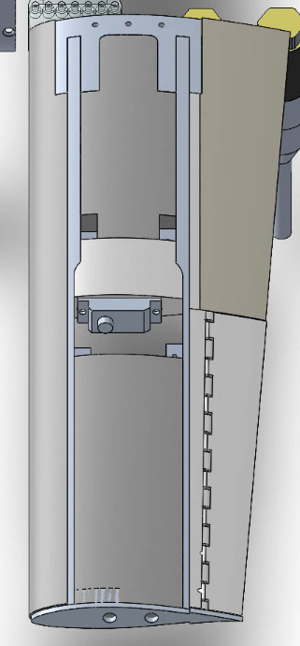

x/c = 0.661

x/c = 0.732