test case
<Test Case ID>#001<Test Case Name>
<Zand Book Store>

Author: Greyson Zhou
Current Owner: Greyson Zhou
Creation Date: 08-04-2024
Last Updated: 08-04-2024
Version: 1.0
Status: In Process

Functional System Test

Introduction/Overall Test Objectives

This test case is intended to verify that the following functionality is working successfully:

- 1. Retrieve available books
- 2. Add books

Test Case Limitations

None

Test Case Dependencies / Assumptions

- None

Default Setup
Project started successfully

Test Case

Retrieve available books successfully
Step Num | Step Description | Path and Action | Test Data | Expected Results | Pass/Fail | Comments
- 1 | Open swagger page | http://localhost:8082/swagger-ui.html |  |  | pass
- 2 | Retrieve Books | Go to BookStoreControllerApi/ “/book/retrieve-all”, and click “try it now”, then click “excute” |  | 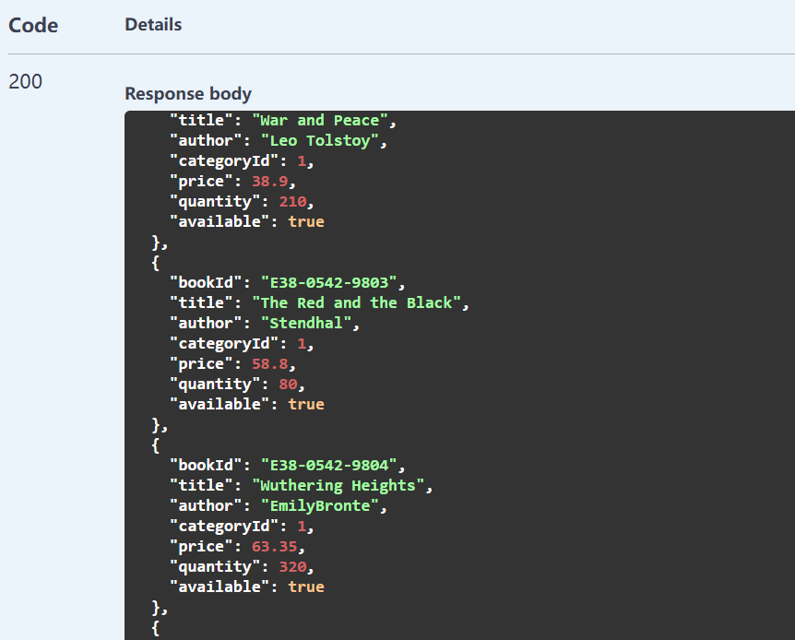 | pass | If got the response “500” means failed
End

Save books successfully
Step Num | Step Description | Path and Action | Test Data | Expected Results | Pass/Fail | Comments
- 1 | Open swagger page | http://localhost:8082/swagger-ui.html |  |  | pass
- 2 | Retrieve Books | Go to BookStoreControllerApi/ “/book/retrieve-all”, and click “try it now”, then click “excute” |  | 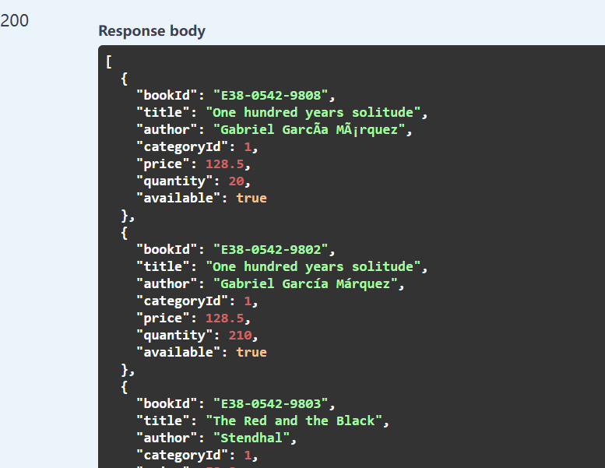 | pass
- 4 | Add Books | Go to BookStoreControllerApi/ “/book/add”, and click “try it now”, then input test data and click “excute” | [  {  "bookId": "E38-0542-9802",  "title": "One hundred years solitude",  "author": "Gabriel García Márquez",  "category": "Literature",  "price": 128.5,  "quantity": 2,  "available": true  },{  "bookId": "E39-0542-9809",  "title": "Love",  "author": "Ailing Zhang",  "category": "Fiction",  "price": 22.8,  "quantity": 52,  "available": true  }  ] | Check the database table “BOOK” ,Book "E38-0542-9802" quantity was changed from 210 to 212 and added a new Book “E39-0542-9809”  Api need return response:  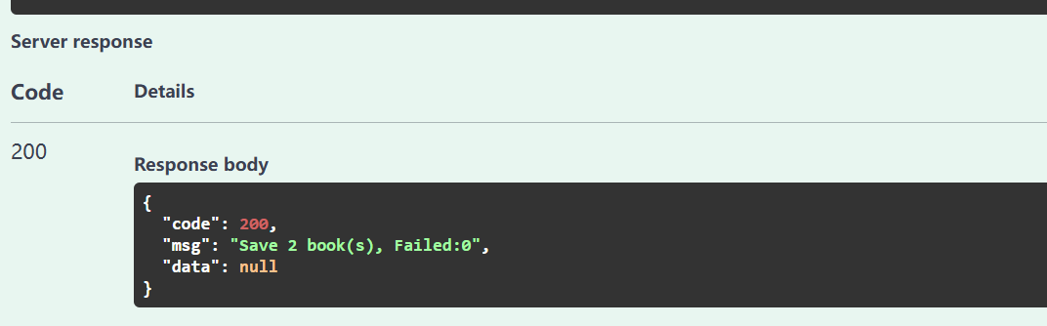 | pass
End

Save books Failed
Step Num | Step Description | Path and Action | Test Data | Expected Results | Pass/Fail | Comments
- 1 | Open swagger page | http://localhost:8082/swagger-ui.html |  |  | pass
- 2 | Retrieve Books | Go to BookStoreControllerApi/ “/book/retrieve-all”, and click “try it now”, then click “excute” |  | There is no book “E39-0542-9100” | pass
- 4 | Add Books | Go to BookStoreControllerApi/ “/book/add”, and click “try it now”, then input test data and click “excute” | [  {  "bookId": "E38-0542-9100",  "title": "One hundred years solitude",  "author": "Gabriel García Márquez",  "category": "Not Exist Catetory",  "price": 128.5,  "quantity": 2,  "available": true  }  ] | Check the database table “BOOK” ,didn’t added a new Book “E39-0542-9100”  Api need return response:  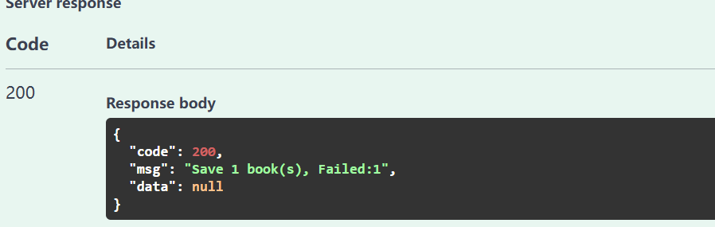 | pass
End

