test case
<Test Case ID>#002<Test Case Name>
<Zand Book Store>

Author: Greyson Zhou
Current Owner: Greyson Zhou
Creation Date: 08-04-2024
Last Updated: 08-04-2024
Version: 1.0
Status: In Process

Functional System Test

Introduction/Overall Test Objectives

This test case is intended to verify that the following functionality is working successfully:

- 1. Retrieve shopping-cart contents
- 2. Save shopping-cart
- 3. Checkout for shopping cart by userid

Test Case Limitations

None

Test Case Dependencies / Assumptions

- None

Default Setup
Project started successfully

Test Case

Retrieve shopping-cart contents successfully
Step Num | Step Description | Path and Action | Test Data | Expected Results | Pass/Fail | Comments
- 1 | Open swagger page | http://localhost:8082/swagger-ui.html |  |  | pass
- 2 | Retrieve shopping-cart contents | Go to ShoppingCartControllerApi  / “/shopping-cart/{userId}/retrieve”, and click “try it now”, then input userId,click “excute” | UserId: “404249022” | 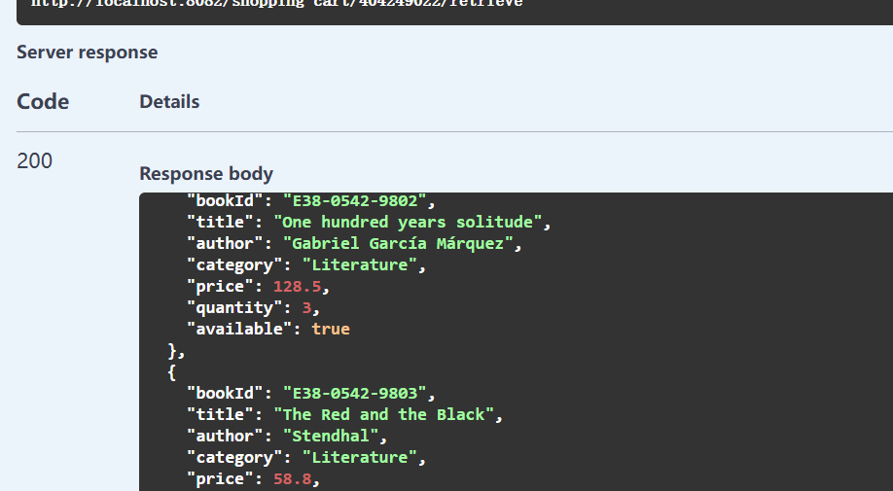 | pass | If got the response “500” means failed
End

Save shopping-cart successfully
Step Num | Step Description | Path and Action | Test Data | Expected Results | Pass/Fail | Comments
- 1 | Open swagger page | http://localhost:8082/swagger-ui.html |  |  | pass
- 2 | Retrieve shopping cart contents | Go to ShoppingCartControllerApi  - “/shopping-cart/{userId}/retrieve”, and click “try it now”, then input userId,click “excute” | userId: “noUser” | Will return empty return 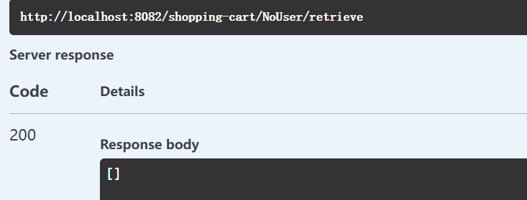 | pass
- 3 | Add Books | Go to ShoppingCartControllerApi -“/shopping-cart/{userId}/save”, and click “try it now”, then input test data and click “excute” | UserId: “noUser” and request body:  [  {  "bookId": "E38-0542-9802",  "title": "One hundred years solitude",  "author": "Gabriel García Márquez",  "category": "Literature",  "price": 128.5,  "quantity": 2,  "available": true  },{  "bookId": "E39-0542-9809",  "title": "Love",  "author": "Ailing Zhang",  "category": "Fiction",  "price": 22.8,  "quantity": 52,  "available": true  }  ] | 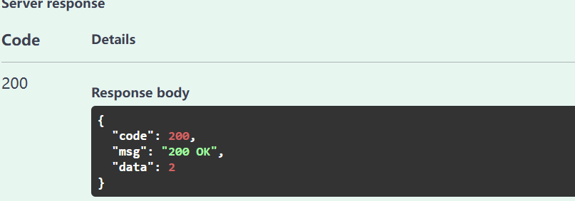 | pass
- 4 | Repeat step2: | Repeat step2 | Same as step2 | 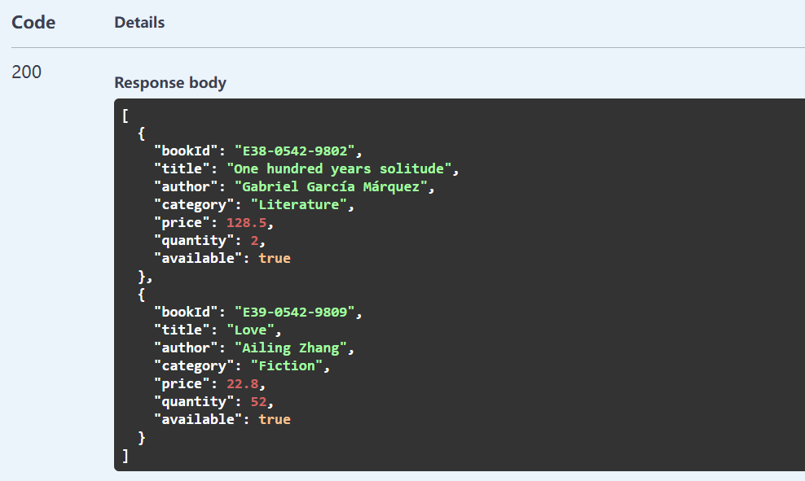
End

Checkout shopping-cart successfully
Step Num | Step Description | Path and Action | Test Data | Expected Results | Pass/Fail | Comments
- 1 | Open swagger page | http://localhost:8082/swagger-ui.html |  |  | pass
- 2 | Checkout shopping-cart | Go to ShoppingCartControllerApi -“/shopping-cart/{userId}/checkout”, and click “try it now”, then input test data and click “excute” | UserId: noUser  Request body:  [  {  "bookId": "E38-0542-9802",  "title": "One hundred years solitude",  "author": "Gabriel García Márquez",  "category": "Literature",  "price": 128.5,  "quantity": 2,  "available": true  },  {  "bookId": "E39-0542-9809",  "title": "Love",  "author": "Ailing Zhang",  "category": "Fiction",  "price": 22.8,  "quantity": 2,  "available": true  }  ] | 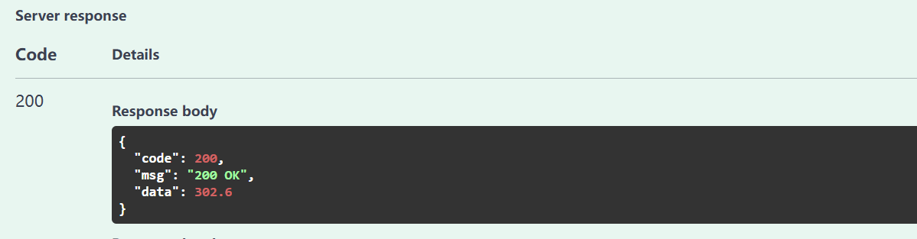 | pass
- 3 | Checkout the shopping cart content | Go to ShoppingCartControllerApi  / “/shopping-cart/{userId}/retrieve”, and click “try it now”, then input userId,click “excute” | UserId: “noUser” |  | 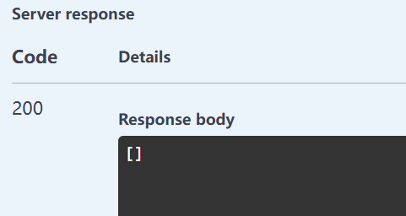 | Stock management can the database tbale “SHOPPING-CART”
End

Checkout shopping-cart failed
Step Num | Step Description | Path and Action | Test Data | Expected Results | Pass/Fail | Comments
- 1 | Open swagger page | http://localhost:8082/swagger-ui.html |  |  | pass
- 2 | Checkout shopping-cart | Go to ShoppingCartControllerApi -“/shopping-cart/{userId}/checkout”, and click “try it now”, then input test data and click “excute” | UserId: noUser  Request body:  [  {  "bookId": "E38-0542-9802",  "title": "One hundred years solitude",  "author": "Gabriel García Márquez",  "category": "Literature",  "price": 128.5,  "quantity": 2,  "available": true  },  {  "bookId": "E39-0542-9809",  "title": "Love",  "author": "Ailing Zhang",  "category": "Fiction",  "price": 22.8,  "quantity": 10000,  "available": true  }  ] | 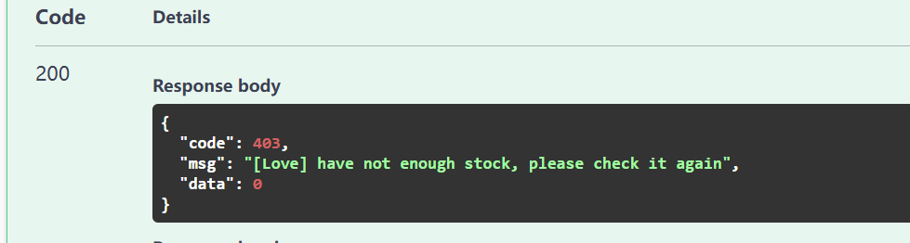 | pass
- 3 | Checkout the shopping cart content | Go to ShoppingCartControllerApi  / “/shopping-cart/{userId}/retrieve”, and click “try it now”, then input userId,click “excute” | UserId: “noUser” | Shopping-cart wasn’t deleted 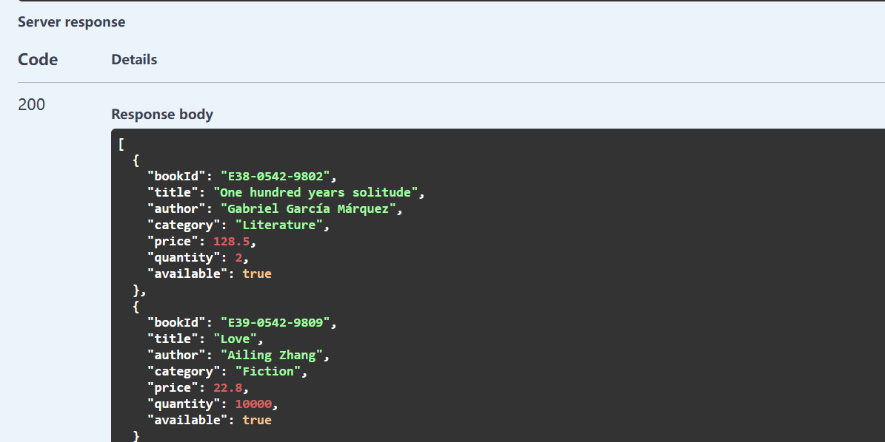 |  | Stock management can the database tbale “SHOPPING-CART”
End

