# GUI Netbeans Java

1. We are creating a simple Java GUI named:
   1. SimpleCalculator
2. This will just use the GUI to take in 2 numbers then:
   1. Add number1 + number2
   2. Subtract number1 – number2
3. If you do not send in an int from the entry boxes, it will throw an error.
4. Create new project 🡪 java 🡪 application.
5. Name the project
6. In the bottom entry: Create Main Class
   1. Delete the Netbeans entry and just replace with “Main”
   2. Finish
7. Create new ‘Class’, select:
   1. Categories: Swing GUI Forms
   2. File Types: JFrame Form
   3. Click Next
   4. Name and Location:
      1. Class Name: CalculatorForm
8. Now we have a main JavaGUI platform that pops up.
9. Right Menu Area
   1. Drag onto GUI:
      1. 2 Text Fields
      2. 2 Labels

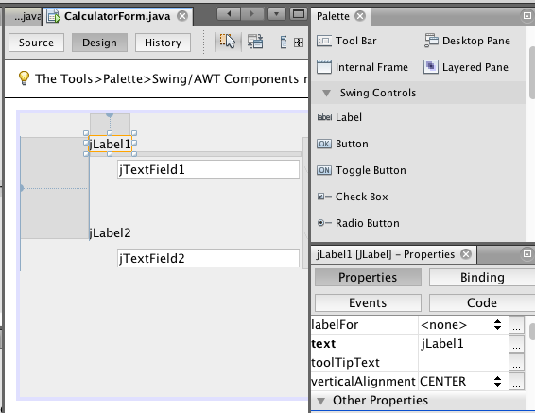

1. You can select the Labels that you dragged, then in the lower right menu area, make sure the “Properties” tab is selected. Rename them.
2. Delete the text (lower right area) from the “Text” fields.

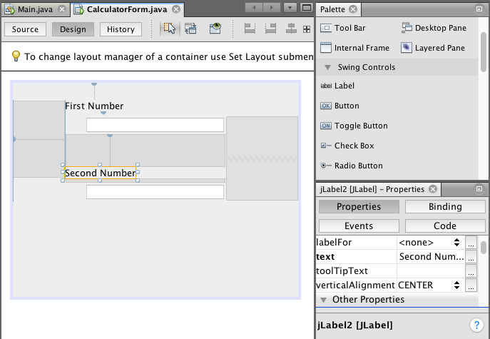

1. You can add a title to the main GUI. Click on the main background of the GUI, go to the bottom right menu area and scroll to the top of that. You will see “title”. Add in your title, here we did, “Simple Calculator”. Note, nothing will pop up right off the bat.
2. Now we will add two buttons, drag from the top right area, and rename the buttons, one a plus, and the other a minus.

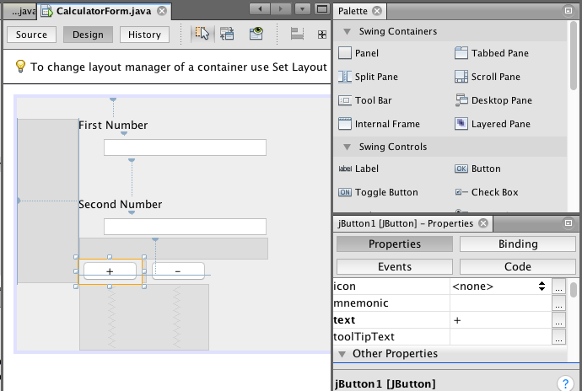

1. On the bottom right menu, just below that text line you changed, there is a line “toolTipText”. This is what will display when a user hovers over the button in the GUI. We changed ours to “Add” and “Subtract”.
2. Now place a label below the buttons for the answer.
   1. Bottom right menu, change the text to: “The Answer is:”
   2. And scroll up on the bottom right menu to “Font” with this you can change the Font, Style, and Size.

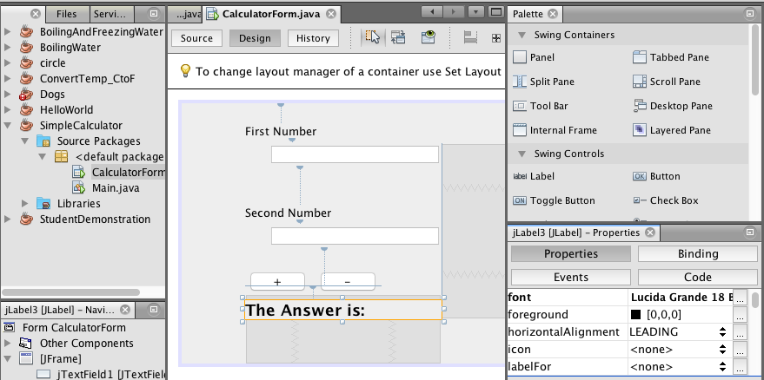

1. You can see in the lower Right menu area that we were in the “Properties” tab. If you select the “Code” tab here you can change the “Variable Name”
   1. First Number = firstNumberLabel
   2. Second Number = secondNumberLabel
   3. First Entry = firstNumberEntry
   4. Second Entry = secondNumberEntry
   5. + button = addButton
   6. – button = subtractButton
   7. The Answer is: = answerLabel

1. Now we will assign code to the button. Select the +button on the GUI, and on the bottom right menu, select the tab: “Events”. Here we can select how we want the button to be able to be accessed such as through: “MouseClicked” but we want the user to be able to click the mouse or press the spacebar.
2. “MouseClicked” is down at the bottom, but since we want both, scroll up to the top on “actionPerformed”, then select that and select the “addButtonActionPerformed” option.

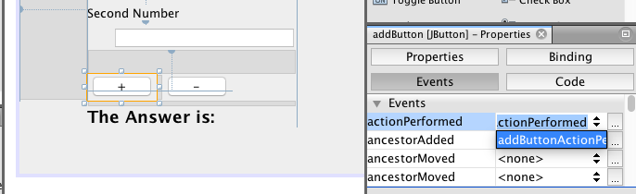

1. Once you select this, it will automatically create and transfer you to the Main-Source page with this to input code at.

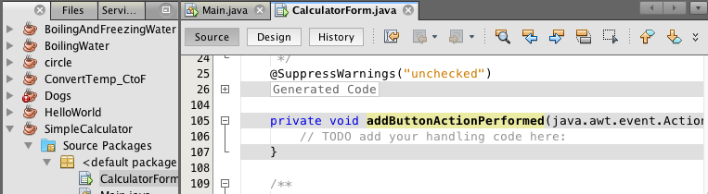

1. Shown below, we need code that creates a variable to hold a number that is imported from the entry boxes. Done for both entry box 1 and 2. For both, we also insert a catch that will throw an error if the number that is brought in is bad.

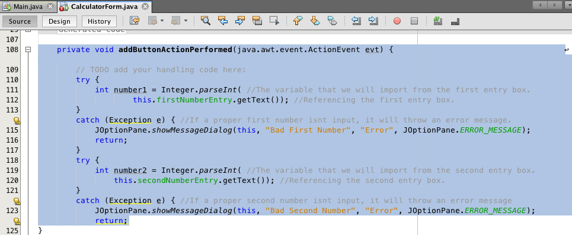

1. Assuming that we have the numbers now from the entry boxes, we need to turn those into an answer. Remember this is for the add button. Once we add the numbers together to get an answer, we need to display it on the GUI.

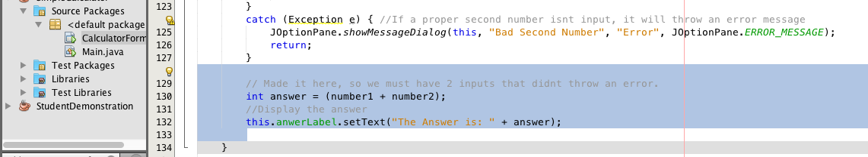

1. Repeat steps 15-19 for the subtractions button.
   1. You can copy and paste the inside of the addButton code.
   2. The pasted code may be off format.
      1. Select pasted code.
      2. Top Menu
         1. Select: Source
            1. Select: Format
   3. This should auto-format appropriately.
   4. Make sure that syou change the + to – in the answer.
2. Now if we hit run, it will build successful but nothing will happen. We need to build a calculator object to actually be used.
3. Go to main. Create an object from the CalculatorForm class.
4. Use the built-in function, “setVisible(true)” to display the GUI when you run.

