Assignment #1

110503507林亞誼

1.編譯結果

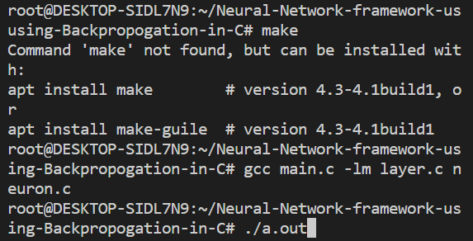

Figure 1: Compile file

2.執行結果

(迭代過程)

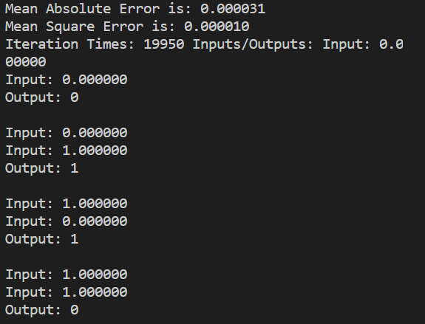

Figure 2: Iteration process

(輸入輸出)

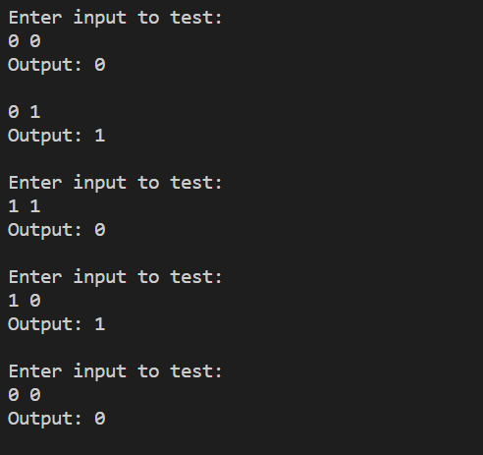

Figure 3: Compile file

3.分析

經由參考資料，得知有數種計算 loss function 的方法，於是我使用了均方誤差(Mean square error，MSE) 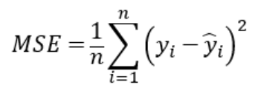和平均絕對值誤差(Mean absolute error，MAE) 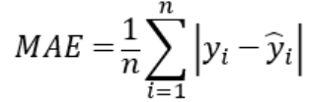兩種方法。在本次的類神經網路學習 XOR 的運算中，兩者運算後得出的數值沒有明顯差異。由此可知兩者皆可用於此實驗分析。

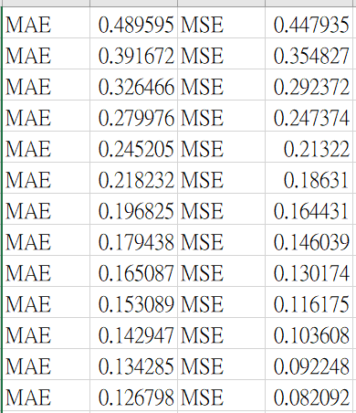

Figure4: Data of MAE and MSE

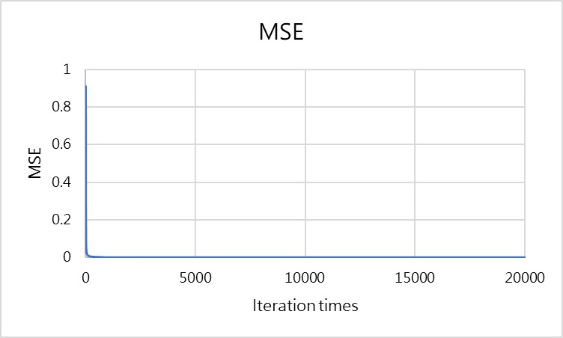

Figure 5: Compile file

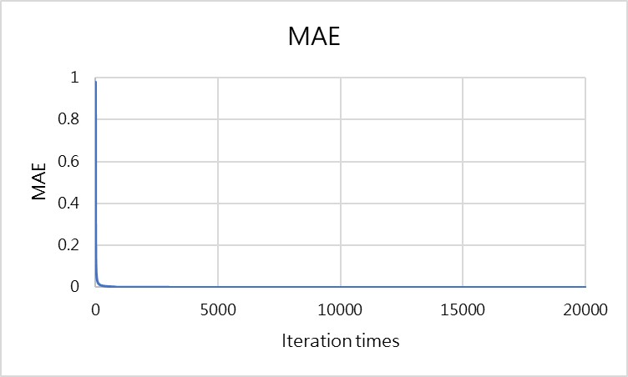

Figure 6: Iteration times

4.參考資料

(1) [Simple neural network implementation in C | by Santiago Becerra | Towards Data Science](https://towardsdatascience.com/simple-neural-network-implementation-in-c-663f51447547)

(2)[Build Neural Network Framework in C Backpropagation | Analytics Vidhya (medium.com)](https://medium.com/analytics-vidhya/building-neural-network-framework-in-c-using-backpropagation-8ad589a0752d)

(3) <https://chih-sheng-huang821.medium.com/%E6%A9%9F%E5%99%A8-%E6%B7%B1%E5%BA%A6%E5%AD%B8%E7%BF%92-%E5%9F%BA%E7%A4%8E%E4%BB%8B%E7%B4%B9-%E6%90%8D%E5%A4%B1%E5%87%BD%E6%95%B8-loss-function-2dcac5ebb6cb>