MySQL Install
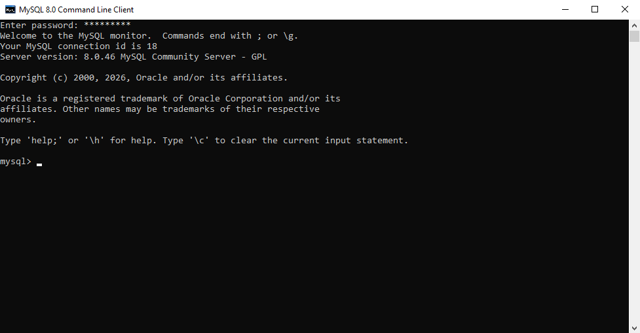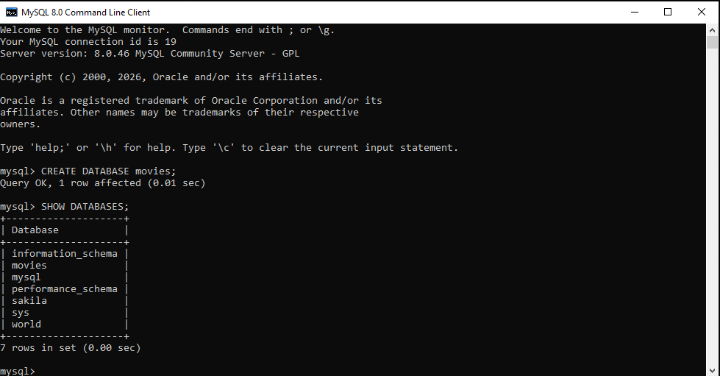

W3Schools
UPPER()
converts all letters in a string to uppercase. It is useful when you want text displayed consistently regardless of how it was originally entered.
SELECT UPPER('movies') AS Uppercase_Title;
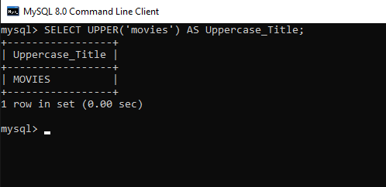
CONCAT()
Combines two or more strings into one string. It is commonly used to join names, addresses, or other text values.
SELECT CONCAT('Star', ' ', 'Wars') AS Movie_Title;
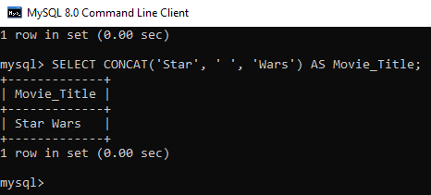
NOW()
Returns the current date and time. It is useful for recording timestamps when data is created or updated.
SELECT NOW() AS Current_Date_Time;
