Program Output
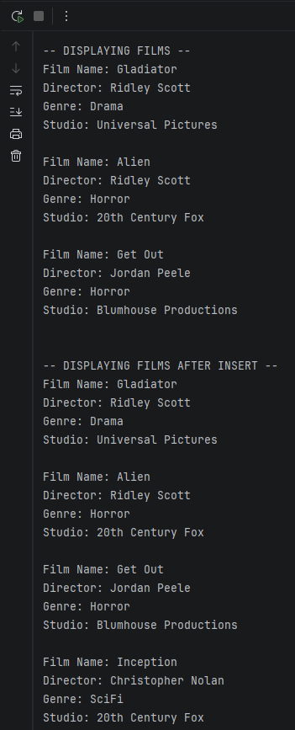
-- DISPLAYING FILMS --
Film Name: Gladiator
Director: Ridley Scott
Genre: Drama
Studio: Universal Pictures

Film Name: Alien
Director: Ridley Scott
Genre: Horror
Studio: 20th Century Fox

Film Name: Get Out
Director: Jordan Peele
Genre: Horror
Studio: Blumhouse Productions

-- DISPLAYING FILMS AFTER INSERT --
Film Name: Gladiator
Director: Ridley Scott
Genre: Drama
Studio: Universal Pictures

Film Name: Alien
Director: Ridley Scott
Genre: Horror
Studio: 20th Century Fox

Film Name: Get Out
Director: Jordan Peele
Genre: Horror
Studio: Blumhouse Productions

Film Name: Inception
Director: Christopher Nolan
Genre: SciFi
Studio: 20th Century Fox

-- DISPLAYING FILMS AFTER UPDATE --
Film Name: Gladiator
Director: Ridley Scott
Genre: Drama
Studio: Universal Pictures

Film Name: Alien
Director: Ridley Scott
Genre: Horror
Studio: 20th Century Fox

Film Name: Get Out
Director: Jordan Peele
Genre: Horror
Studio: Blumhouse Productions

Film Name: Inception
Director: Christopher Nolan
Genre: SciFi
Studio: 20th Century Fox

-- DISPLAYING FILMS AFTER DELETE --
Film Name: Alien
Director: Ridley Scott
Genre: Horror
Studio: 20th Century Fox

Film Name: Get Out
Director: Jordan Peele
Genre: Horror
Studio: Blumhouse Productions

Film Name: Inception
Director: Christopher Nolan
Genre: SciFi
Studio: 20th Century Fox

Process finished with exit code 0
Github Link
https://github.com/NCarbajalBellevue/csd-310.git

