Screenshot 1 – Original program
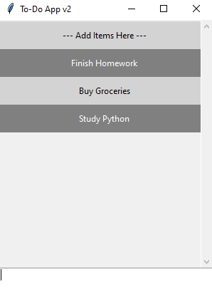
Screenshot 2 – Changed title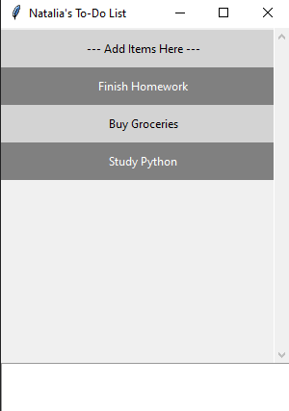
Screenshot 3 – Changed colors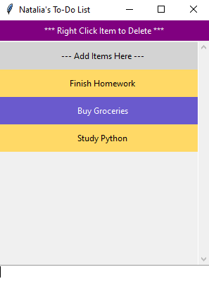
Screenshot 4 – Instructions added 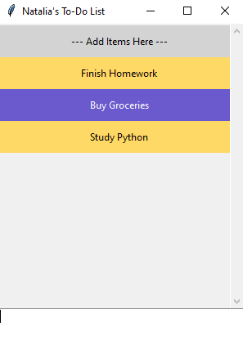

Screenshot 5 – File to Exit menu 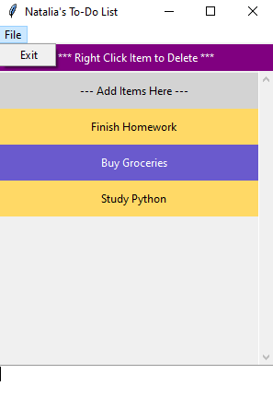
Screenshot 6 – Delete Confirmation
