API Connection Test
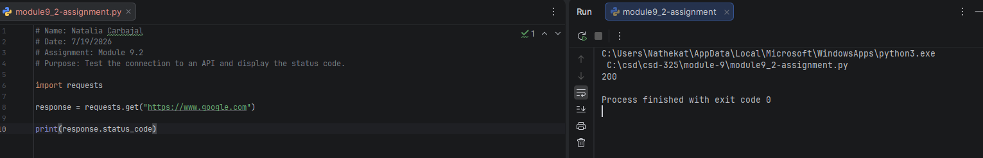
Open-Meteo API Program
