Screenshot 1 – Original city_functions.py Output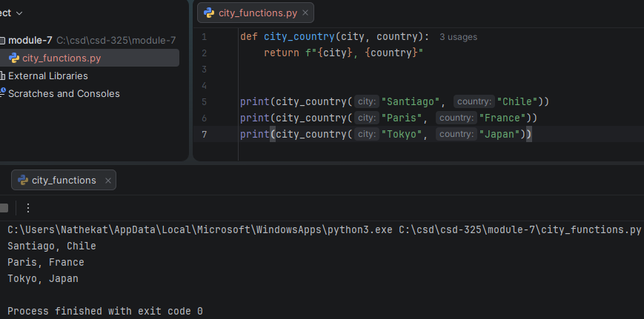
Screenshot 2 – test_cities.py Passed
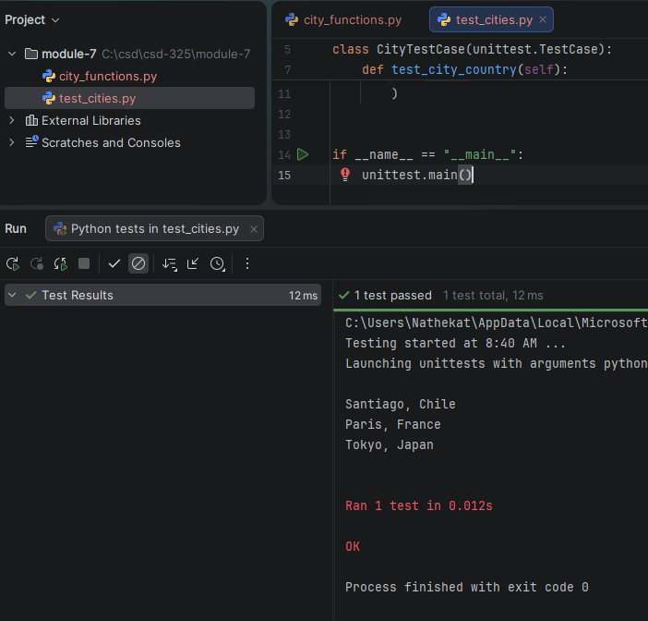
Screenshot 3 – Test Failed After Requiring Population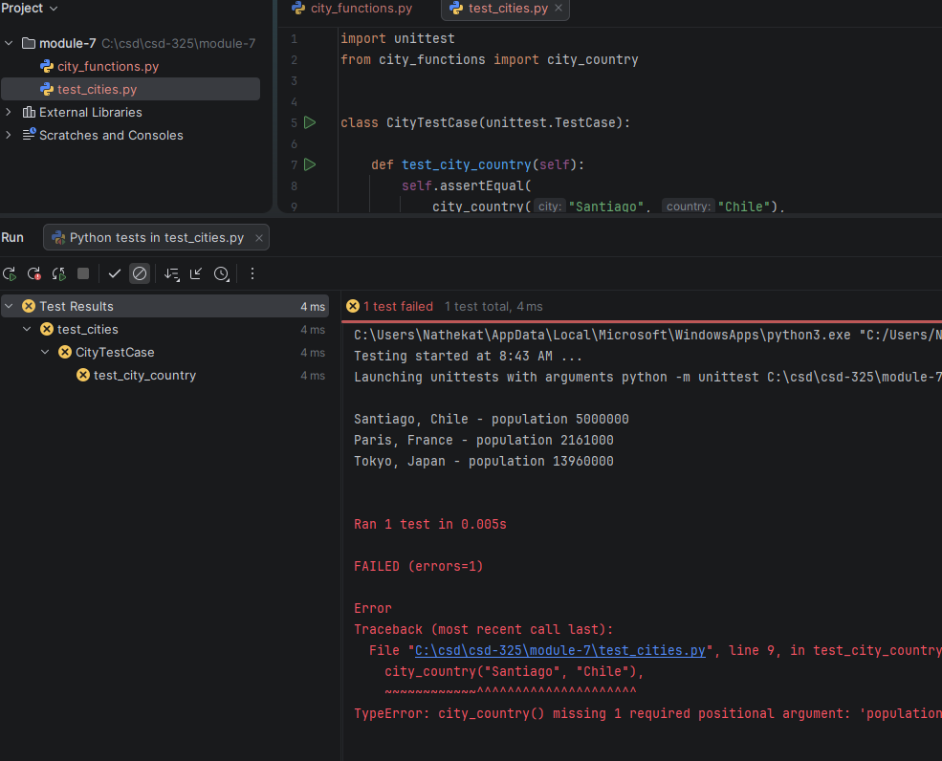
Screenshot 4 – Test Passed with Optional Population
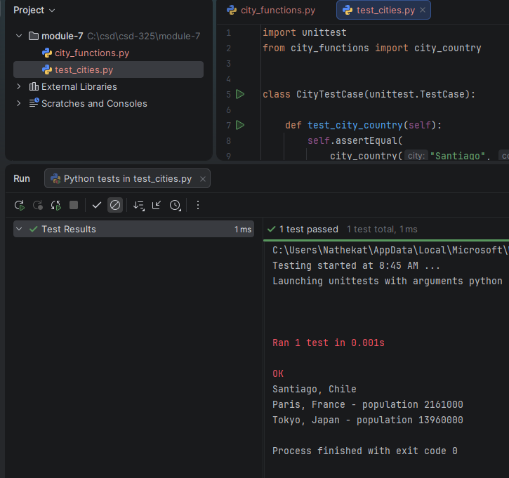

Screenshot 5 – Test Failed After Requiring Language
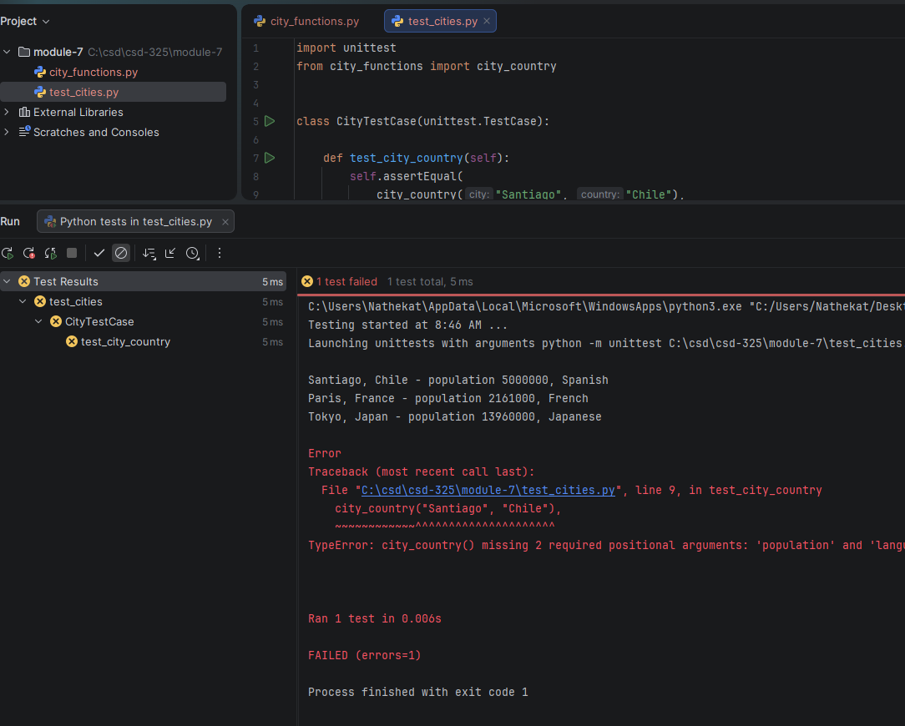
Screenshot 6 – Test Passed with Optional Language
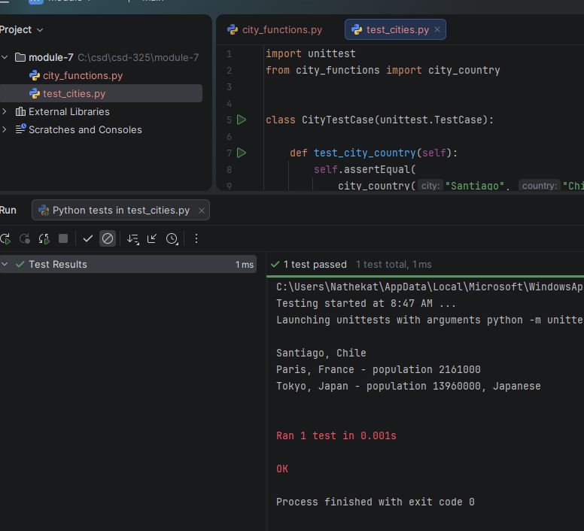
Screenshot 7 – Final city_functions.py Output
