Module 6.2 Group Assignment
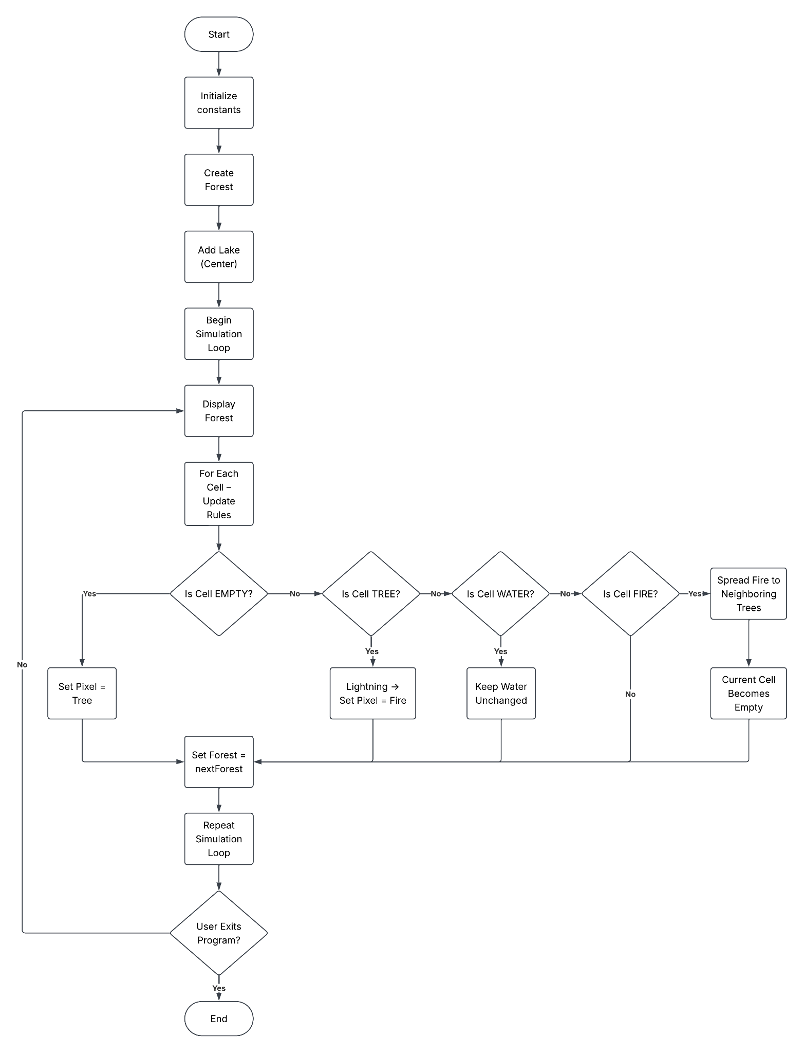
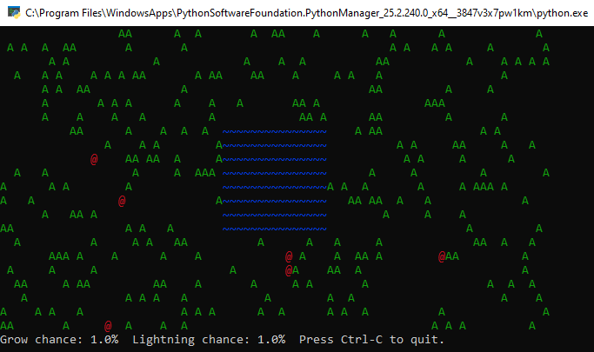
Project Summary
Our team modified the original Forest Fire Simulation by implementing the required water feature based on the project specifications. We added a lake roughly in the center of the forest, represented it with a unique blue water character (~), and updated the simulation so the lake remains permanent throughout execution. The program logic was also modified so the water acts as a firebreak, preventing flames from spreading across it. Finally, we updated the code documentation and flowchart to reflect the new functionality and accurately represent the modified program flow.
Github Repositories
Natalia Carbajal:https://github.com/NCarbajalBellevue/csd-325.git
Perla Garcia Cavazos: https://github.com/perlagc1/csd-325.git
Peter Ddamulira: https://github.com/psddam/csd-325.git

