Module 1.2 Assignment GitHub
Link to your GitHub repository:
https://github.com/NCarbajalBellevue/csd-340.git
Screenshot of your GitHub repository:
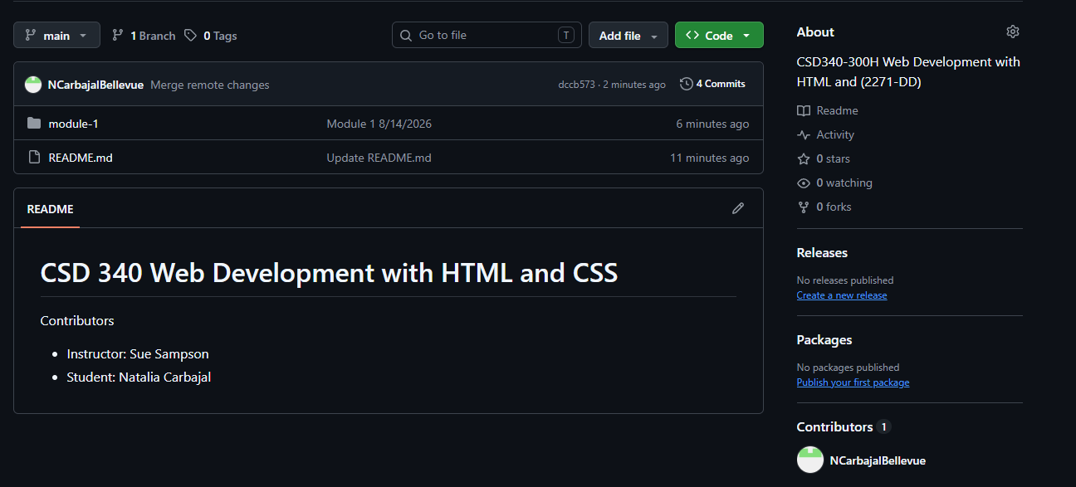
Screenshot of your local directory, following the structure format provided in the instructions below:
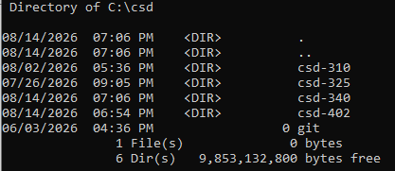
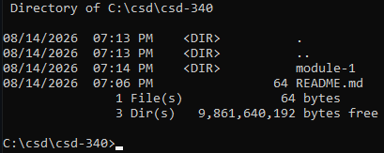
screenshot of your GitHub repository landing page:
