screenshot of the validators results (there should be one or more errors):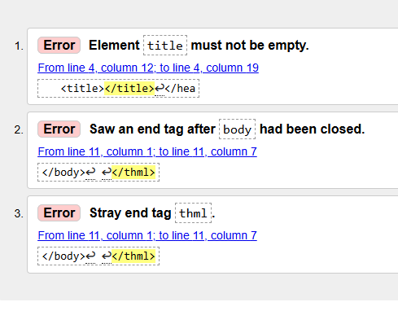
screenshot of the updated results (this time, there should be 0 errors:
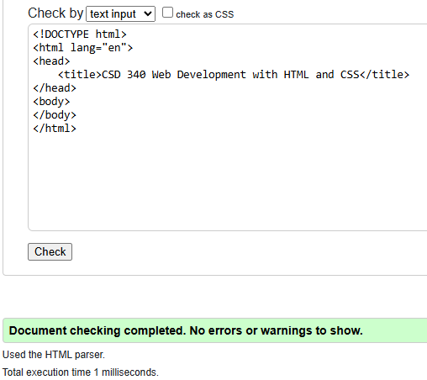

screenshot of the updated results (this time, there should be 0 errors):
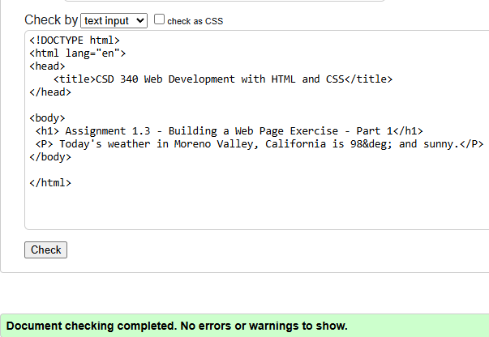

computer's default browser and take a screenshot of the web page:
