# PyPoll Challenge

## 1. Overview of Election Audit:

Purpose of this analysis is to assist a Colorado Board of Elections employee (Tom) to provide election results for auditing specific congressional precincts and report the total votes cast, total votes for each candidate, the percentage of votes for each candidate and the winner of the election. The audit is typically done in Excel using the election data provided in a comma delimited file however Tom's manager wants it automated using Python to process the results. If using Python is successful, this automation will be used to audit other congressional districts, senatorial districts and local elections.

*mail in ballots - hand counted in central office*

*punch cards - machine counted and sent to central office*

*direct recording electronic - memory cards sent to central office*

*all three are counted as the election results*

## 2. Election-Audit Results:

Specific screen shots taken from the election_results.txt file.

Coding specific shots (shown with borders) taken from the Python source code (PyPoll_Challenge.py).

Summary:

- How many votes were cast in this congressional election?

A total of 369,711 votes were cast in the three counties.

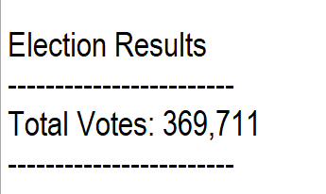

All records in the election_results.csv file were read by the Python script.



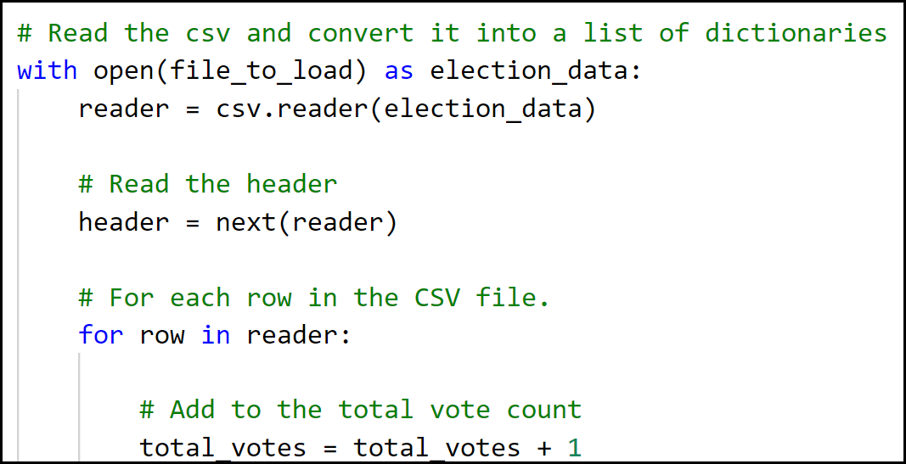

* Provide a breakdown of the number of votes and the percentage of total votes for each country in the precinct.

Votes were counted and summarized by county.

Total vote count and percentage of total votes is provided.

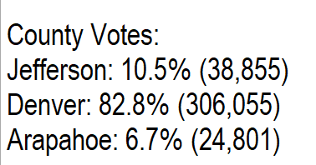

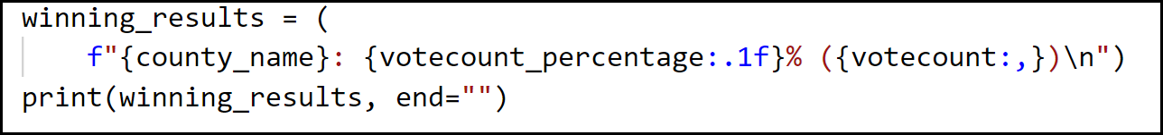

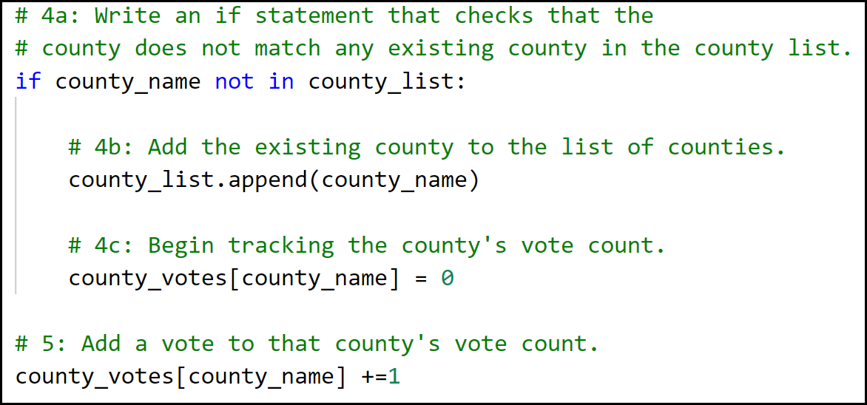

* Which county had the largest number of votes?

Votes were accumulated when details read by county.

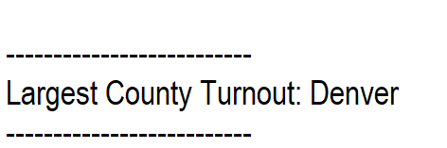

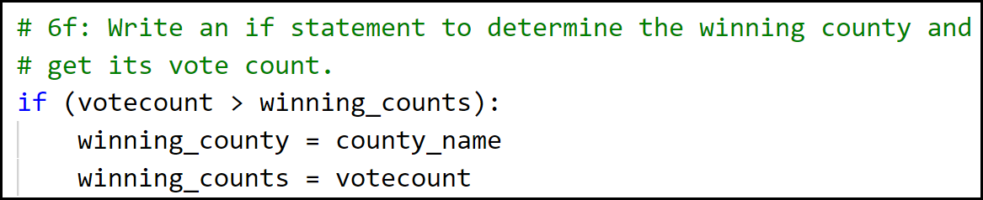

* Provide a breakdown of the number of votes and the percentage of the total votes each candidate received.

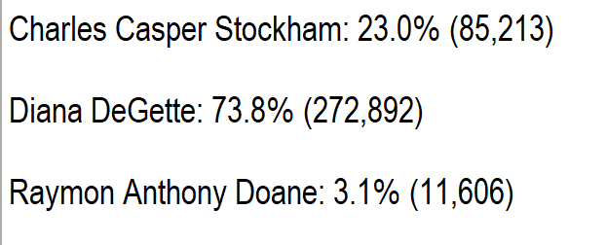

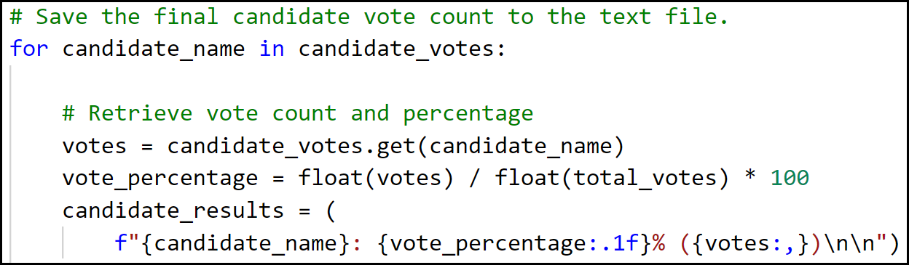

* Which candidate won the election, what was their vote count, and what was their percentage of the total votes?

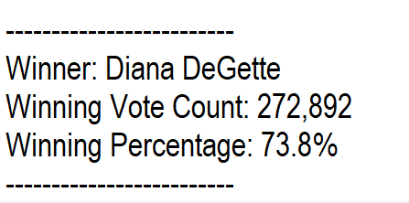

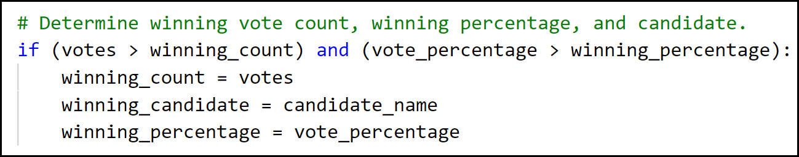

## 3. Election Audit Summary:

This Python script provided all the required information: total votes cast, votes by county, largest turnout by county, total votes for each candidate, percentage of votes for each candidate and the winner of the election.

With some modifications, the Python script can be used for any election. Two are listed below.

1. Modify script to read input file using different path or filename.

For the input or output files, modify path and filename in the os.path.join details.

The field delimiter can also be specified i.e. a ‘|’.

file_to_load = **os.path.join("Resources", "election_results.csv")**

file_to_save = **os.path.join("analysis", "election_results.txt")**

1. The format of the election_results.csv file included three columns: Ballot ID, County, Candidate

Files containing different heading columns will need changing to reflect these headings.

The script includes the **import csv** module for processing a CSV file.