**Analysis of NYC Motor Vehicle Collision Incidents**

Data Courtesy: NYC Open Data Initiative

The dataset was pulled from the NYC Open Data Initiative, which contains Motor Vehicle Crash Data ranging from 2012 to May 2020. The data is collected from the New York Police Department “MV104-AN report forms. Drivers involved in car accidents in the state of New York where there has been a fatality, personal injuries, or property damages totaling more than $1,000 are required to complete an “MV-104 form” within 10 days of the accident. So, this data contains information from these reports.

Three separate datasets are generated from this data: motor vehicle crashes by incident, by persons, and by Vehicle. Each set contained identifying key factors that we thought we could use for our analysis. So, combined all three and the final dataset consisted of 25 columns and 1.4 million rows.

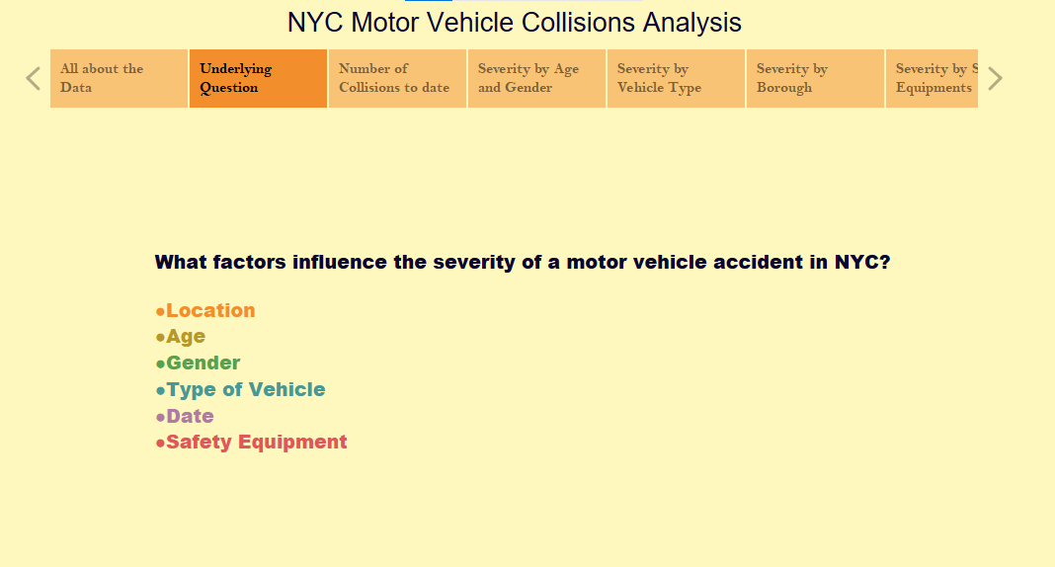

**Calculated Accident Severity Score**

The overall analysis of the dataset, which examines the many factors that may or may not contribute to accident severity, relied on the creation of a “point-based” accident score: calculated by utilizing a combination of categorical data points to calculate a cumulative severity score for each accident. Each accident in our dataset has been assigned a numerical value to describe the magnitude of the severity. The overall score is tallied by looking at the severity of each individual factor of the car accident. This method of scoring is loosely based on the “Injury Severity Score” developed by the Association for the Advancement of Automotive Medicine.

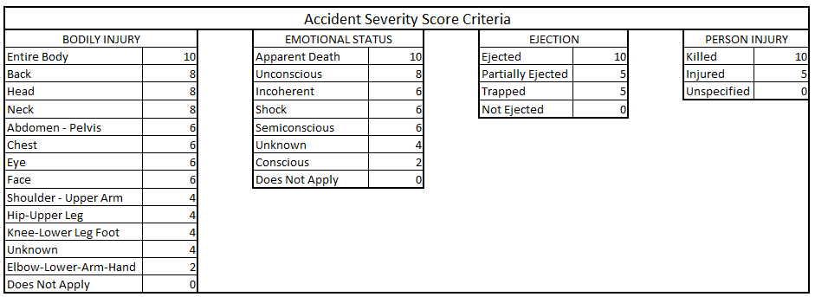

So, I started by looking at the **number** of collisions as year passed by, and I noticed that the greatest number of collisions had happened in fall 2019 during October last week and November first week, and then went down drastically.  The main reasons were driver distraction and following too closely (tailgating). Besides the injuries to the driver and passengers, the pedestrians and bicyclists who were involved in the collisions were also injured which is another story. This heat map clearly shows the days, months and year where the most collisions happened.

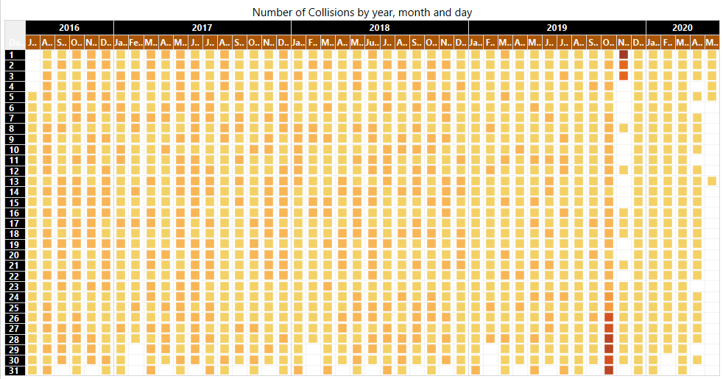

**Accident Severity vs Age & Gender – Butterfly Chart – Static Visualization**

Below, it shows the accident severity, in relation to the age, and broken down by the gender. The analysis shows us that out of any of the age groups, the males of ages 10 to 19 have a noticeably higher severity score than any other age groups or gender. However, as the age of males increases, the overall severity of accidents decreases more rapidly compared to the female counterparts of the same age group. One interesting thing to note is that the accident severity score for females is relatively stable throughout the age ranges.

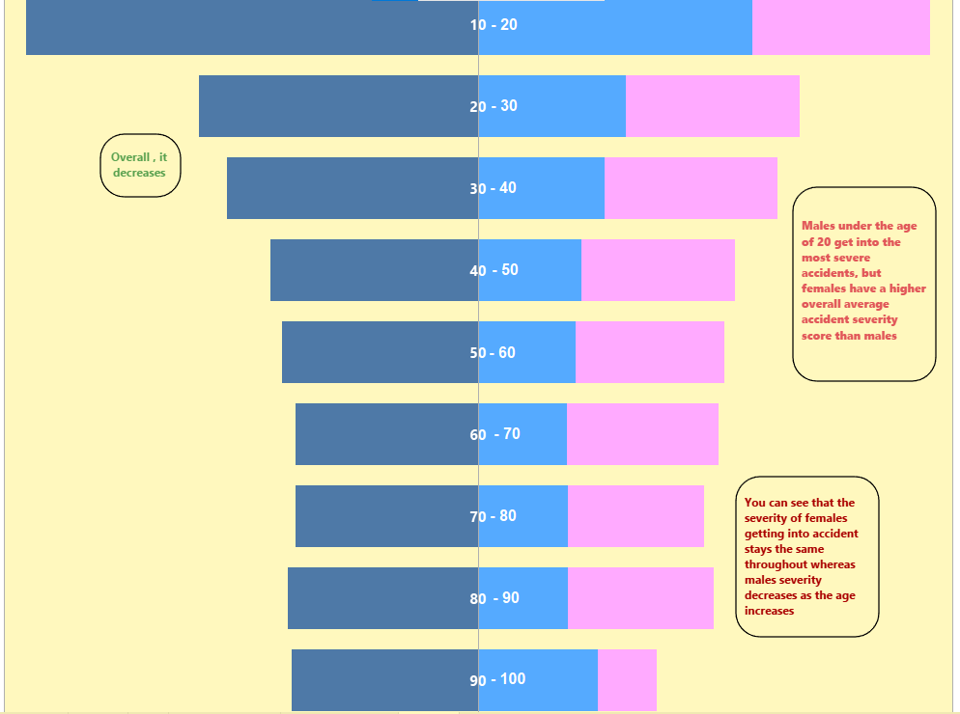

**Accident Severity vs. Vehicle Type – Area Chart – Static Visualization**

The top five vehicles involved in the most severe accidents include: 2 wheelers, like motorcycles, bicycles, and scooters. Sedans, which are mostly 4 door vehicles as well as SUVs, Taxis and Heavy Vehicles, such as trucks. This analysis shows us that 2 wheelers are significantly more susceptible to being involved in a severe motor vehicle accident. This would make sense given the fact that these types of vehicles offer little to no protection to their riders in the event of an accident. The analysis also shows us that heavy vehicles seem to provide better protection to their occupants than 2 wheelers, or 4 doored vehicles such as sedans, SUVs, and taxis.

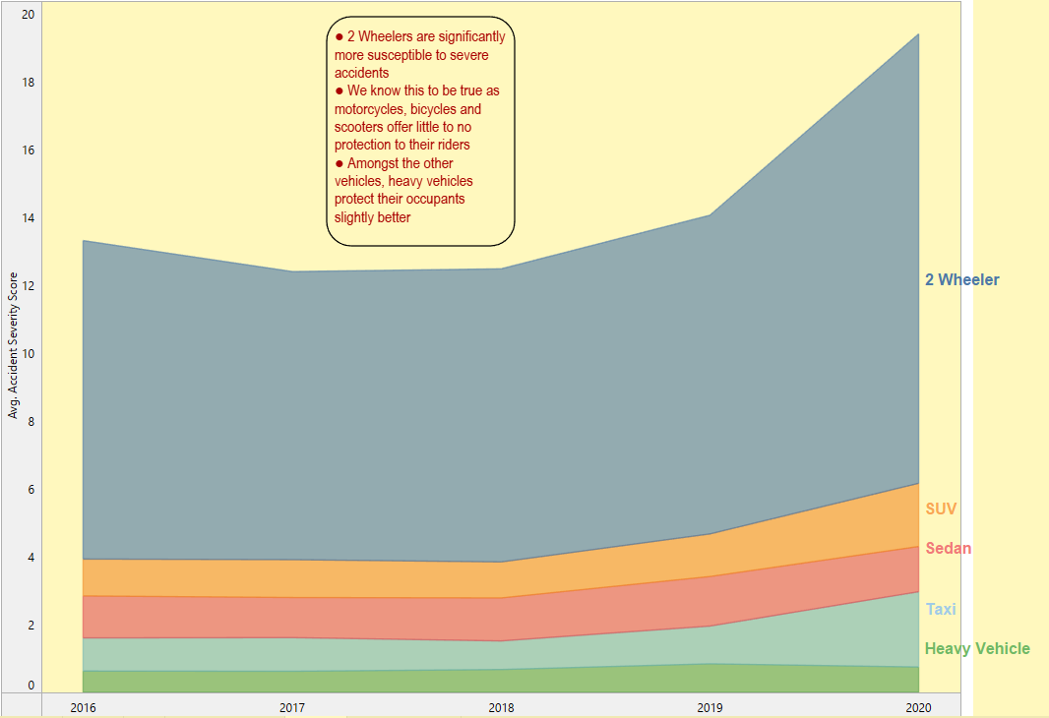

**Accident Severity by Borough – Interactive Visualization**

Here, I analyzed the accident severity by the 5 boroughs which are Brooklyn, Bronx, Queens, Manhattan, and Staten Island. When looking at the number of collisions, it is observed that most of them happened in the Brooklyn area, whereas the analysis projects that the most severe accidents happened in the Bronx, followed by Queens, Staten Island, and Brooklyn.

Manhattan has a noticeably lower average severity score than the other 4 boroughs. Consequently, we can conclude that this could be due to traffic patterns in Manhattan which prevents drivers from traveling at high speed. Therefore, accidents are less severe and mostly fender benders. The rest of the boroughs are much closer to average.

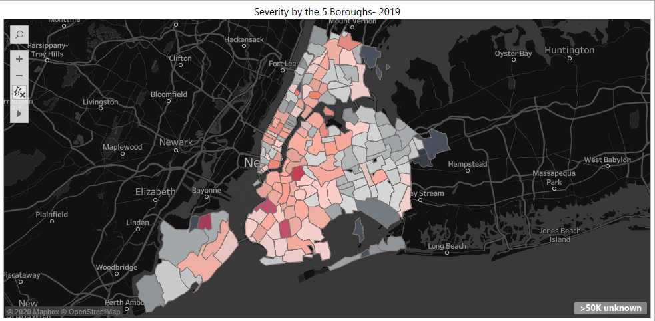

**Accident Severity vs. Safety Measures – Interactive Visualization**

Here you are observing accident severity in relation to the safety measures employed by the occupants or riders of the vehicles. These safety measures include things such as Wearing or not wearing a helmet for the 2-wheeler riders, Using or not using a restraint such as a seatbelt, and whether an airbag was deployed. According to observations from the analysis of the severity scores, we can see that across all vehicle classes, accidents that had an airbag deploy are more serious than those that do not. We can also see that the least severe type of accidents is those in which restraints are worn and no airbag was deployed.

It also shows that 2-wheeler accidents, regardless of whether a helmet was worn, they are more severe.

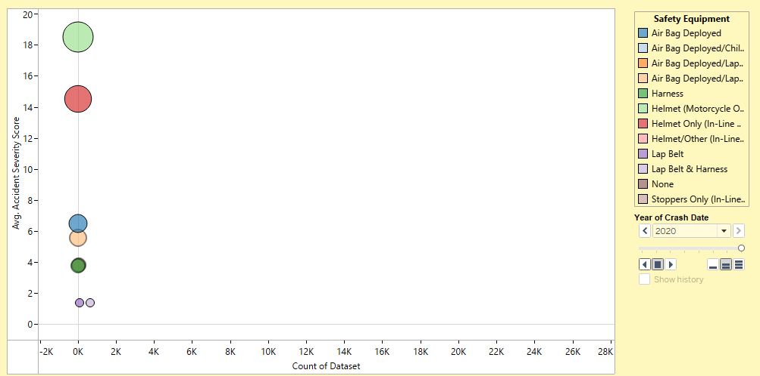

Tableau file attached: **My Story** shows all the visualizations in one place