Chancheep Mahacharoensuk 6288092

Kantapong Matangkarat 6288160

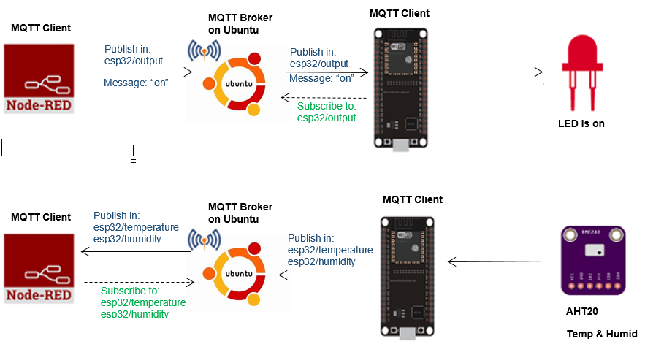

The above figure shows the architecture of this exercise where Ubuntu acts as MQTT broker. Node-RED and AHT20 is used for MQTT clients

ESP32:

AHT20 SDA -> GPIO21

AHT20 SCL -> GPIO22

AHT20 Vcc -> 3.3V

AHT20 GND -> GND

LED -> GPIO4

1. Wire up the above circuit on ESP32.
2. Upload “AHT20-LED-Node-RED.ino” to ESP32. Do not forget to specify your Wi-Fi SSID, password and MQTT server IP address.
3. Make sure that both your ESP32, Ubuntu, and working laptop are in the same network, e.g., your mobile phone hotspot or your home access point.
4. Copy and paste the “AHT20-LED-Node-RED.json” flow to your NodeRED (Import -> Clipboard). Then you should get the following flow.

Note: you have to install Node-RED-dashboard from Palette Manager.

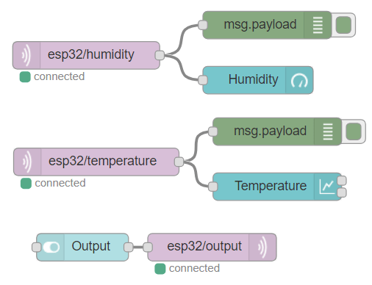

Deploy your flow then capture your finished Node-RED dashboard and put it below.



