**Chancheep Mahacharoensuk 6288092**

**Kantapong Matangkarat 6288160**

**Let’s do some basic usage of “function” and “dashboard” of NodeRED.**

Import “NodeRED-Basic-Functions-Dashboards.json” in your NodeRED workflow. There are 14 exercises. Answer the following questions with their respective screenshots.

Exercise 1: Show your input message at the “debug messages” console.

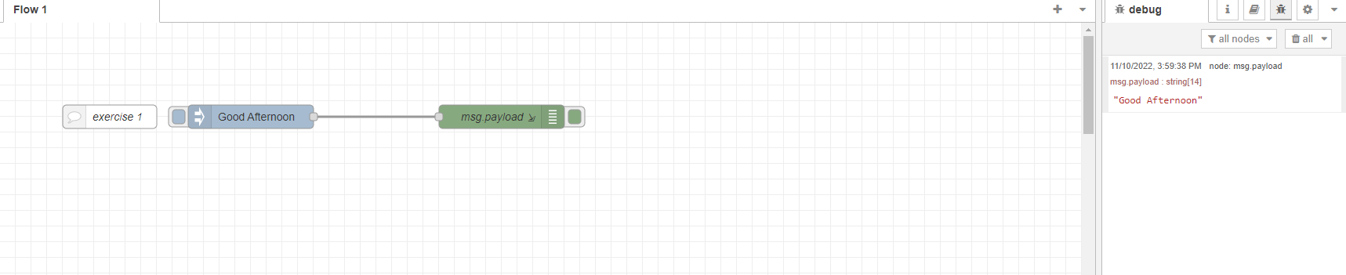

Exercise 2: Show your “data.txt” file and open it on your machine (Ubuntu).

Exercise 3: Open the web browser (<http://UbuntuIP:1880/hello>) and then compare the text with exercise 2. Are they the same? Why?

Ans: The context is the same but some text that use as a code will be apply on the html web.

Exercise 4: Show its output message at the “debug messages” console.

Exercise 5: Show its output message at the “debug messages” console. Explain about the “function 1” node.

Ans: On the node-red it is “function 2” and it will return msg anyway.

Exercise 6: Show its output message at the “debug messages” console. How do you understand this flow?

Ans: This flow first it will start with inject either true or false ,but the change node will be always return true anyway.

Exercise 7: Show its output message at the “debug messages” console. How do you understand this flow?

Ans: it will inject integer 1 or 2, and it will replace with the number that set on a middle function like 1 is 10 and 2 is 20.

Exercise 8: Show its output message at the “debug messages” console. How do you understand this flow?

Ans: It will inject integer 5 and it will add with 10 in the middle function ,so the output will be 15.

Exercise 9: Show its output message at the “debug messages” console. How do you understand this flow?

Ans: It this case it will inject 0 and 1. After that, it will define 0 and 1 to case1 and 2. After we define it, it will set the value to true and false.

Exercise 10: Go to your NodeRED dashboard. Can you control the light of LED?

Ans: Yes it can.

Exercise 11: Show its output message at the NodeRED dashboard.

Exercise 12: Show its output message at the NodeRED dashboard.

Exercise 13: Show its output message at the NodeRED dashboard.

Exercise 14: How to you understand the process of “function” node. Explain it and show your result.

Ans: Function node is like Javascript in the web coding. Since, it can make the logical coding to set or make some condition of it.

**Part A: Node-RED (LINE notification)**

1. Show your LINE notification result together with NodeRED dashboard.

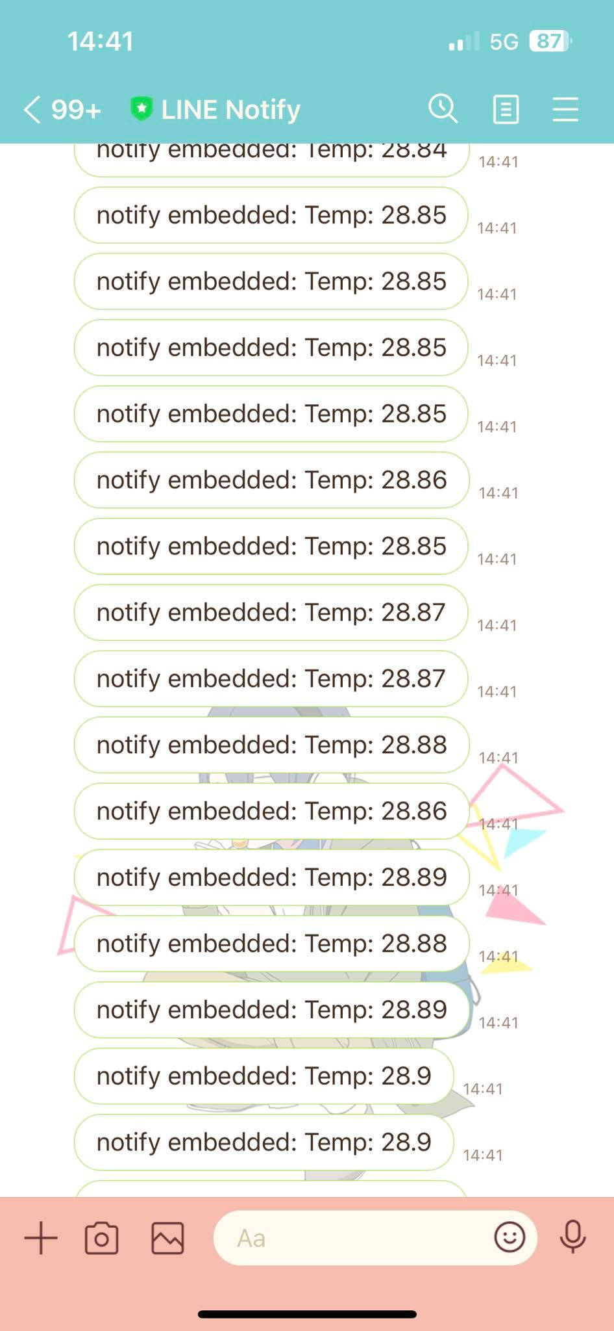

1. Modify Arduino program to use both slider and on/off button to control LED. Submit arduino program (ino) and NodeRED json files.

**Part B: Blynk**

1. Can you use blynk to control LED and monitor temperature and humidity at different other networks from your esp32? Why?

Ans: Yes, it can because blynk is the platform that you can use anywhere by connecting via wifi.

1. Video record link for your final blynk/node-red/line results.

Ans: <https://drive.google.com/file/d/1LbOzgGgYyZlCXgonv-bnArDnV9ny6JBt/view?usp=share_link>

**Part C: Noder-RED + RGB**

Run RGB-Web as an example to control RGB from a web browser. Program Node-RED and Arduino IDE to control RGB instead. Submit arduino program (ino) and json files.

Video record link for your final result.

Ans: <https://drive.google.com/file/d/1IABucYYaCx0wfOgnGaNrGQnp69ACAxKy/view?usp=share_link>