**Chancheep Mahacharoensuk 6288092**

**Kantapong Matangkarat 6288160**

**ESP32 as an MQTT Publisher and NETPIE2020 as an MQTT Broker**

Wire up the following program and complete the following questions

AHT20 SDA 🡪 GPIO21

AHT20 SCL 🡪 GPIO22

AHT20 Vcc 🡪 3.3V

AHT20 GND 🡪 GND

LED 🡪 GPIO4

1. Complete Lab10-NETPIE2020-AHT20.ino to send temperature and humidity values and show on NETPIE2020 dashboard and freeboard and submit the complete program on mycourses in the filename of Activity12-NETPIE2020-AHT20-<ID>-<FIrstname>.ino
2. What is the output message in Arduino IDE program for ESP32 to publish the temperature and humidity values to NETPIE2020?

1. Create the schema in NETPIE2020 to show temperature, humidity, and LED status from ESP32 in Feed.

1. Create widgets for temperature and humidity and also LED status.

Copy and paste each widget properties.

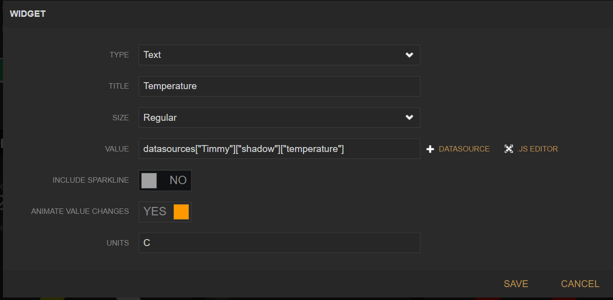

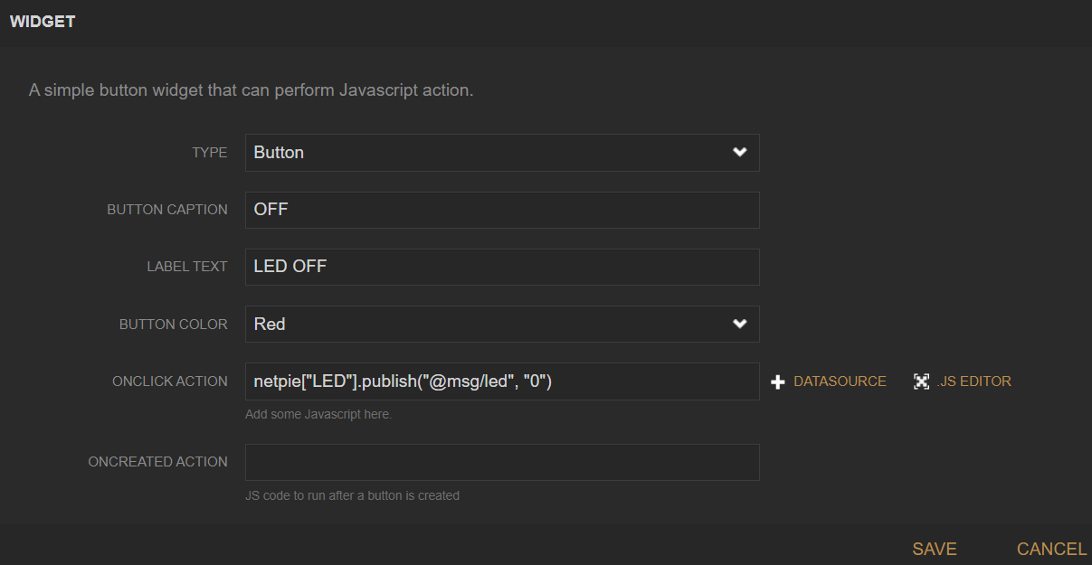

1. Copy and paste the result from your NETPIE2020 Dashboard here:

