**Part A: Basic Electronics**

**Part B: Voltage Divider**

**Part C: TinkerCAD**

**Part D: Fritzing**

**Part A: Basic Electronics**

**A1. Make the following conversions**

1. 3500 µA = ___3.5___ mA
2. 4.7 MΩ = __4700____ kΩ
3. 1510 kHz = ___1.51___ MHz
4. 0.3 µF = __300____ nF
5. 22 mA = ___22000___ µA
6. 100 nF = __100000____ pF
7. 30000 nF = __30____ µF
8. 150 µH = __ 0.15 __ mH
9. 2200 kΩ = _2.2_____ MΩ
10. 1.33 MHz = ___1330___ kHz

**A2. Write down the values and their colour codes of each given resistor.**

**Example**

5 Bands:

1st Band: White, 2nd Band: Brown, 3rd Band: Brown, 4th Band: Red, 5th Band: Brown

The value: 91 KΩ, %Error: 1%, Range: 90090 – 91910 Ω

|  |  |  |  |  |  |  |  |
| --- | --- | --- | --- | --- | --- | --- | --- |
| **1st**  **Band** | **2nd**  **Band** | **3rd**  **Band** | **4th**  **Band** | **5th**  **Band** | **Value** | **%**  **Error** | **Range** |
| Red | Red | Brown | - | Gold | 220 Ohm | 5 | 209-231 Ω |
| Brown | Orange | - | - | Brown | 1K Ohm | 1 | 990-1010 Ω |

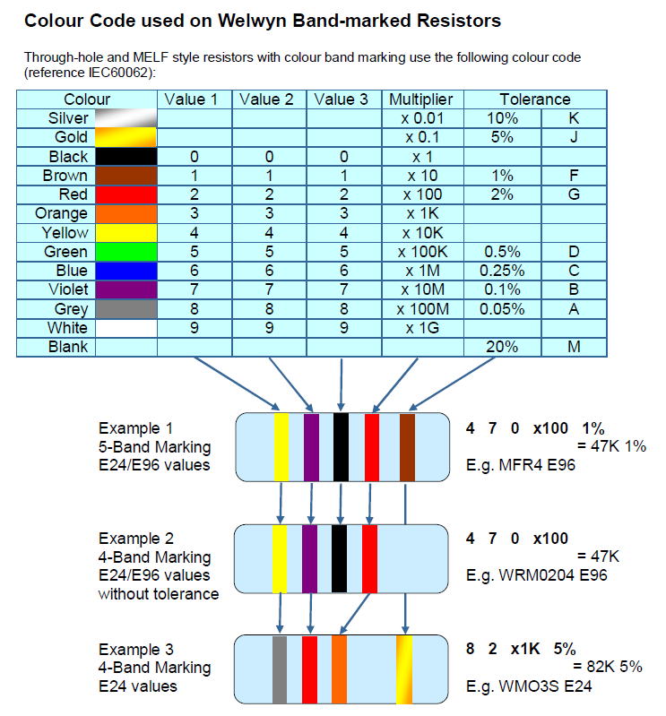

**A3: If any, consider series circuits**

**Using Ohm’s Law to calculate voltage flowing through each resistor**

As the resistors are connected in series, the current that passes through both resistors is the same. But the voltage is not the same for both resisters. The input voltage of the circuit divides into both resisters. And the value of individual voltage depends on the resistance.

Figure 2: Two resistors are connected in series with the voltage source Vs

As shown in the above figure, two resistors R1 and R2 are connected in series with the voltage source Vs. The total current supplied by the source is I ampere (A). As all elements are connected in series, it will make a single loop and the current that passes through all elements is the same (I A).

The voltage across resistor R1 is VR1 and the voltage across resistor R2 is VR2. And the total supplied voltage divides between both resistors. Hence, the total voltage is a sum of VR1 and VR2.

VS = VR1 + VR2 … (2)

According to Ohm’s Law, V = IR,

VR1 = IR1 … (3)

Similarly,

VR2 = IR2 … (4)

Therefore, substitute VR1 and VR2 in equation (2),

VS = IR1 + IR2

VS = I (R1 + R2)

I = VS / (R1 + R2)

Now, put the value of current I in the equation (3) and (3=4),

VR1 = {VS / (R1 + R2)} R1

VR2 = {VS / (R1 + R2)} R2

**Exercise 1:** How much is the current, I, in a 500-kΩ resistor if its voltage is 25 V? Show your calculation.

**Solution:** V = IR 25 = I x 500000 I = 25 / 500000 I = 5x10^-5A

**Exercise 2:** How much voltage will be dropped across a 40 kΩ resistance whose current is 250 µA? Show your calculation.

**Solution:**

V = IR

V = 250x10^-6 x 40x10^3

V = 10 V

**Exercise 3:**

Two resistors, 10 kΩ and 6.8 kΩ, connected in series with power supply 5V, find the following values.

* + Current through each resistor
  + Voltage dropped across each resistor

Show your calculation.

**Solution:**

I = VS / (R1 + R2)

I = 5 / (10x10^3 + 6.8x10^3 I = 5 / 16800

I = 297 µA

V1 = IR

V1 = 297x10^-6 x 10x10^3

V1 = 2.97V

V2 = IR

V2 = 297x10^-6 x 6.8x10^3

V2 = 2.0196V

**Exercise 4:**

How much current does a 800-W coffee maker draw from the 220 V power line? Show your calculation.

**Solution:**

P = IV

I = 800 / 220

I = 3.63 A

**Exercise 5:**

Find the output voltage of each resistor where R1 is 220Ω and R2 is 1kΩ, and the input voltage is 9V.

**Solution:**

Vs = I (R1 + R2)

9 = I (220 + 1000)

I = 9 / 1220

I = 7377 µA

V1 = 9 / 1220 * 220

V1 = 1.623V

V2 = 9 / 1220 * 1000

V2 = 7.377V

**Exercise 6:**

Find the output voltage of each resistor where R1 is 1kΩ and R2 is 220Ω, and the input voltage is 12V.

**Solution:**

Vs = I (R1 + R2)

12 = I (1000 + 220)

I = 12 / 1220

I = 9836 µA

V1 = 12 / 1220 * 1000

V1 = 9.836V

V2 = 12 / 1220 * 220

V2 = 2.164V

**Exercise 7:**

The input voltage is 5V, but the required output voltage is 3.3V, how much resistance value of resistors should be?

**Solution: -**

**A4: Consider the “RED LED” datasheet** (<https://www.alliedelec.com/m/d/6355b8aba0b01578df0bb7b871ceefd7.pdf> ), the LED can handle a current of 20 mA (forward current) and the forward voltage or the voltage drop is 2 V before it risks heating up. If the LED is connected to a 5 V supply, what value of a resistor should we place in series? Draw a circuit and show your calculation.

V = IR

2 = 20x10^-6 x R

R = 1 / 10^-5

**Part B: Voltage Divider**

A voltage divider is a simple circuit which turns a large voltage into a smaller one. The output voltage that is a fraction of the input, can be calculated by using two series resistors. These are various types of potentiometers aka variable resistors which can be used to create an adjustable voltage divider.

**Schematic Circuit**

A voltage divider involves applying a voltage source across a series of two resistors.

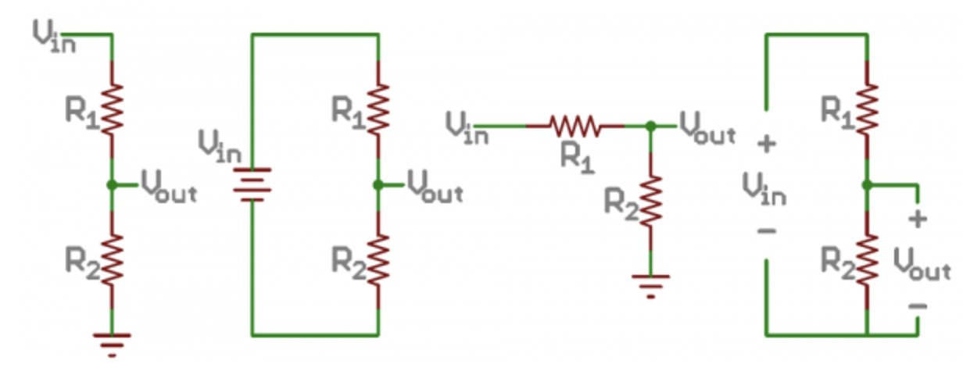

Figure 1: Examples of voltage divider schematics. Shorthand, longhand, resistors at same/different angles, etc.

The resistor closest to the input voltage (Vin) is R1, and the resistor closest to ground is R2. The voltage drop across R2 is called Vout, that is the divided voltage.

**Vout Computation**

The voltage divider equation assumes that the three values are already known, the input voltage (Vin), and both resistor values (R1 and R2). Given those values, we can use this equation to find the output voltage (Vout) as followed equation.

Vout = Vin * (R2 / (R1 + R2)) … (1)

This equation states that the output voltage is directly proportional to the input voltage and the ratio of R1 and R2.

These are simplifications that make evaluating a voltage dividing circuit just a little easier.

* + - First, if R2 and R1 are equal then the output voltage is half of the input, regardless of the resistors' values.
    - If R2 is much larger than R1, then the output voltage will be very close to the input. There will be very little voltage across R1.
    - Conversely, if R2 is much smaller than R1, the output voltage will be tiny compared to the input. Most of the input voltage will be across R1.

**Exercise 1: If R1 is equal R2,**

Find the divider voltage, when there are two resistors of 500Ω and the input voltage is 5V.

**Solution:**

Vin = 5V

R1 = R2 = 500Ω

According to the Voltage Divider Equation,

Vout = Vin * (R2 / (R1 + R2))

= 5 x (500 / 500 + 500))

= 2.5V

**Exercise 2: If R2 is larger than R1,**

Find the divider voltage, when there are two resistors valued 500Ω and 1kΩ, and the input voltage is 9V.

**Solution:**

Vin = 5V

R1 = 500Ω

R2 = 1kΩ = 1000Ω

According to the Voltage Divider Equation,

Vout = Vin * (R2 / (R1 + R2))

= 5 x (500 / (500 + 1000))

= 1.67V

**Exercise 3: If R2 is smaller than R1,**

Find the divider volage, when there are two resistors valued 1kΩ and 500Ω, and the input voltage is 12V.

**Solution:**

Vin = 5V

R1 = 1kΩ = 1000Ω

R2 = 500Ω

According to the Voltage Divider Equation,

Vout = Vin * (R2 / (R1 + R2))

= 5 x (1000 / (500 + 1000))

= 3.33V

**Part C: TinkerCAD**

Create your personal at “https://www.tinkercad.com/”.

Go to “Circuits” tab and click it. At there you can draw schematic and make simulation of your electronic circuit.

In the Tinkercad, you can share your circuit design with other people by clicking “Sent To” tab and then click “Invite People” button. At there you can see your Tinkercad circuit link which you can share to other people.

**Exercise 1:** Set up the voltage divider circuit as the following diagram in Tinkercad, where VS is 9V (used 9V battery). Define R1100 Ω and another R2 as POT. Find the value of R2 in order to obtain Vout = 3.3V. Let’s use “multimeters” to check the voltage of each resistor.

Example:

Copyright by Faculty of ICT, Mahidol University

Show your result with screenshot and program.

R2 = 1000 kΩ

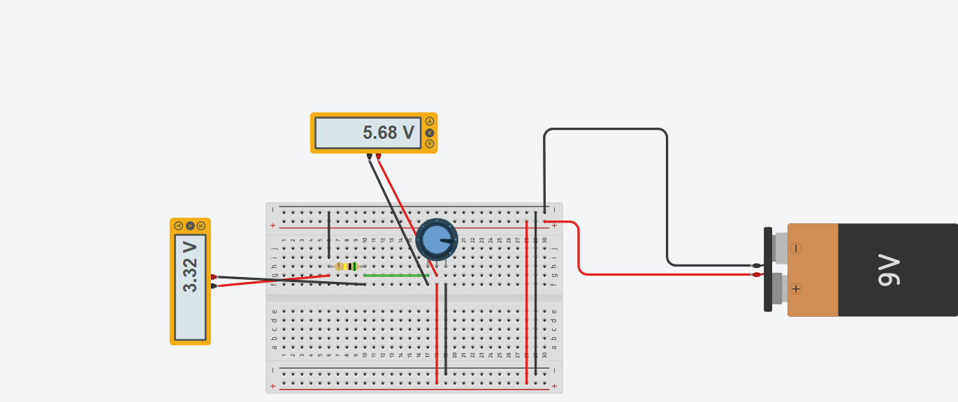

Your Tinkercad URL: <https://www.tinkercad.com/things/9InmRPGaDgP-sizzling-vihelmo/editel?sharecode=Bgbcegkuf75YGLJMBZi3JvpupcQZwQ-RtjWZxC7rZcw>

**Exercise 2:** Draw the following circuit at Tinkercad. Find out the output volage of LED and resistor using multimeter.

Components:

Arduino Uno R3

Breadboard

Resistors 220 Ω

LED

Two multimeters

Copyright by Faculty of ICT, Mahidol University

Show your result with screenshot and program.

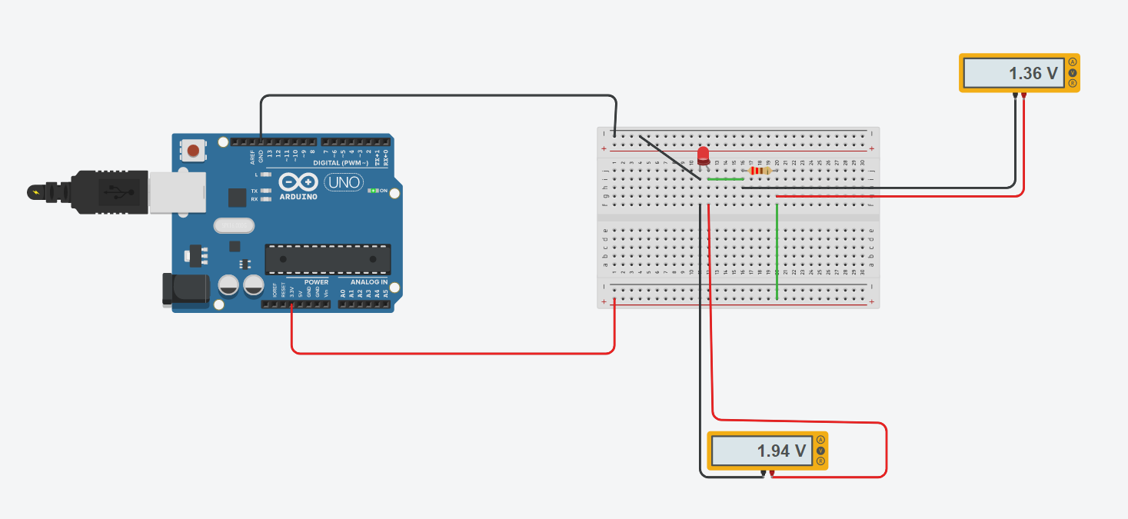

Your Tinkercad URL: https://www.tinkercad.com/things/apS5tJsa6be-smashing-kieran-gaaris/editel?sharecode=8y4Stjj3lFxEClDIIXJHlv3OJm3TV2n8zgNrQQ7OYWI

**Exercise 3:** Draw the following circuit at your Tinkercad.

Components:

Arduino Uno R3

Breadboard

Three Resistors each 220 Ω

RGB LED

Copyright by Faculty of ICT, Mahidol University

Copyright by Faculty of ICT, Mahidol University

Copy the following code at the coding section.

#define R 2

#define G 4

#define B 3

void setup(){

pinMode(R, OUTPUT);

pinMode(G, OUTPUT);

pinMode(B, OUTPUT);

}

void loop(){

analogWrite(R, random(255));

analogWrite(G, random(255));

analogWrite(B, random(255));

delay(200);

}

If you change the “delay” value in the code from 200 to 1000, What will happen?

Ans: it will delay the led to change the color.

Show your result with screenshot and program.

Your Tinkercad URL: https://www.tinkercad.com/things/5nP2721Vkdh-bodacious-leelo-waasa/editel?sharecode=4haGSmPMVcnt42vFoLen8UKRkEgo4T7LsMeo7m-TdFI

**Exercise 4**: Draw the following circuit at your Tinkercad.

Components:

Breadboard

Arduino Uno R3

Temperature Sensor [TMP36]

Copyright by Faculty of ICT, Mahidol University

Copy the following code at the coding section. Understand the code and answer the question.

int baselineTemp = 0;

int celsius = 0;

int fahrenheit = 0;

void setup()

{

pinMode(A0, INPUT);

Serial.begin(9600);

pinMode(2, OUTPUT);

pinMode(3, OUTPUT);

pinMode(4, OUTPUT);

}

void loop()

{

baselineTemp = 40;

celsius = map(((analogRead(A0) - 20) * 3.04), 0, 1023, -40, 125);

fahrenheit = ((celsius * 9) / 5 + 32);

Serial.print(celsius); // L1

Serial.print(" C, "); // L2

Serial.print(fahrenheit); // L3

Serial.println("F"); // L4

delay(1000);

}

Check the serial monitor and what is the output result.

Please change the program L1-L4 to print the output result in one line like

“XX degree Celsius = XX degree Fahrenheit”.

Show your result with screenshot and program.

Your Tinkercad URL: https://www.tinkercad.com/things/3n7NBXBNIvq-surprising-gaaris/editel?sharecode=Jdaf_u4-GlDsrogDXh7GICDvujFbB4-kGhj7xrVRcZc

**Part D: Fritzing**

Sign up a new account for Fritzing at here “**https://fritzing.org/**” and then download it for your respective operating system.

**Exercise**

Draw the following circuits in fritzing.

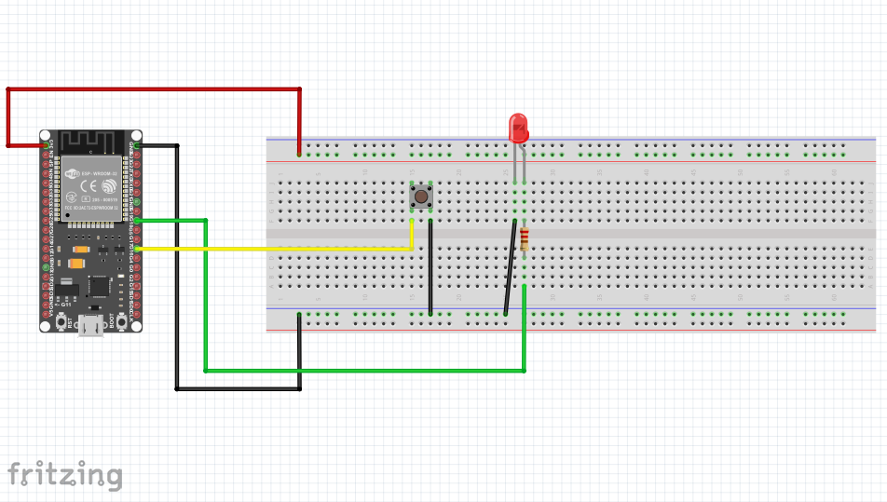

Copyright by Faculty of ICT, Mahidol University

Answer: Your circuit screenshot in Firtzing from both breadboard and schematic views.

