**Table of Contents**

|  |  |  |
| --- | --- | --- |
| **Contents** | | **Page No.** |
| A: Required Software Installation for Logic Analyzer | | **P2** |
|  | *Pulse View (Sigrok) Installation at Window Operating System* | **P2** |
|  | *USB Driver Installation (Window Operating System Case)* | **P3** |
| B: Required Software Installation for Pico Scope | | **P5** |

**A: Required Software Installation for Logic Analyzer**

***Pulse View (Sigrok) Installation at Window Operating System***

1. Use Firefox/Chrome browser to download “*Pulse View (Sigrok)*” application which is respective to your machine Operating System, from this link “https://sigrok.org/wiki/Downloads”.

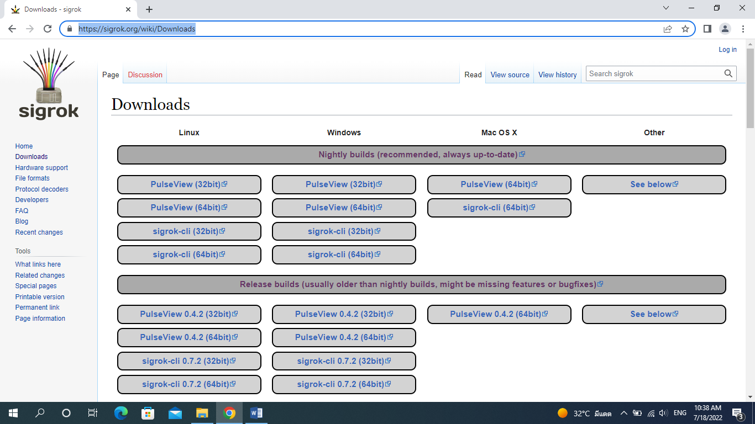

1. After downloading, install it on your machine as follows.

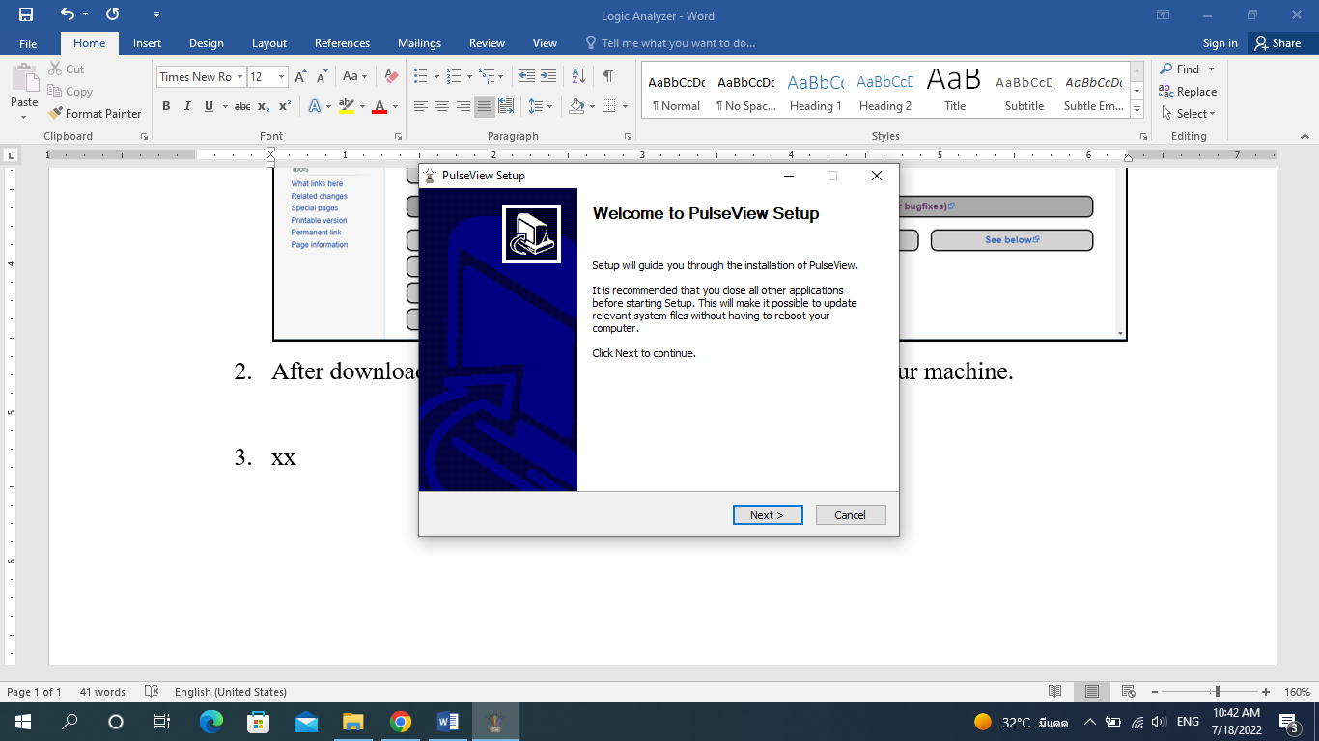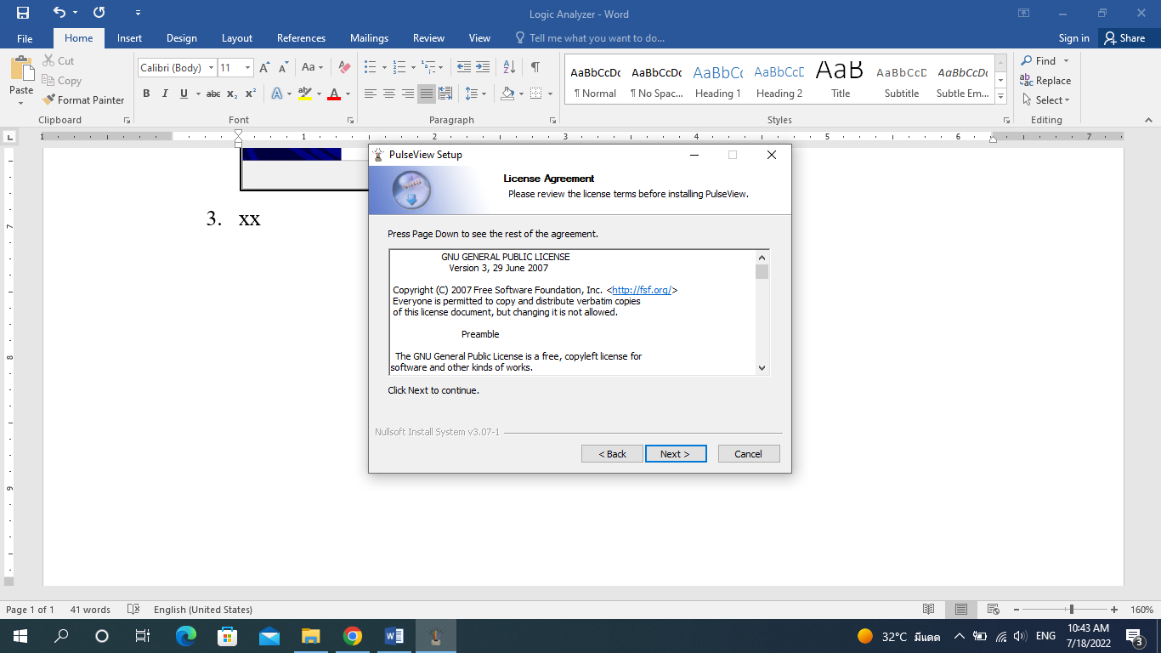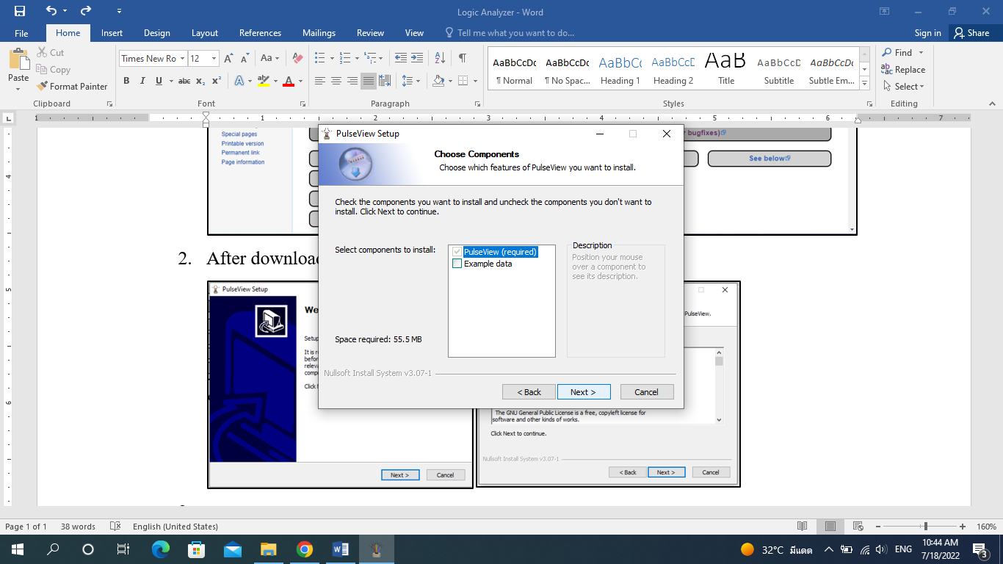 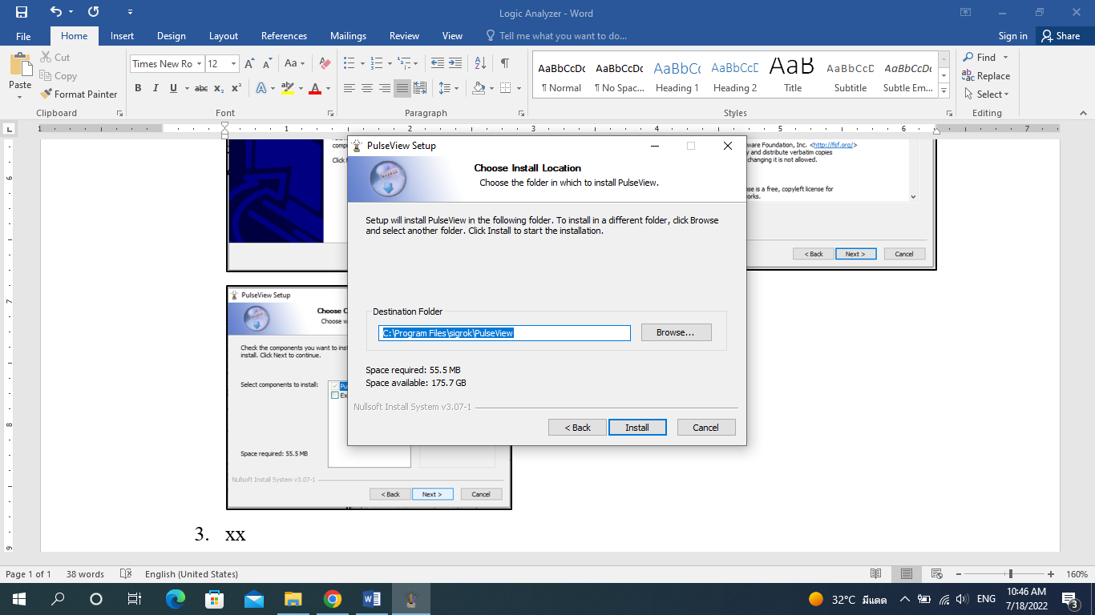

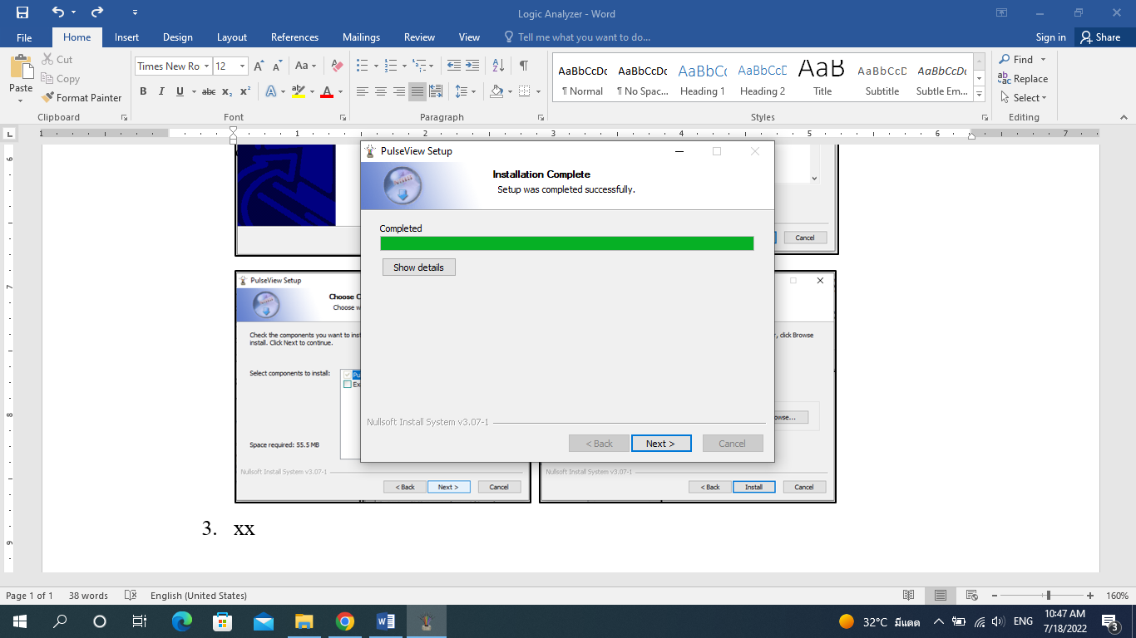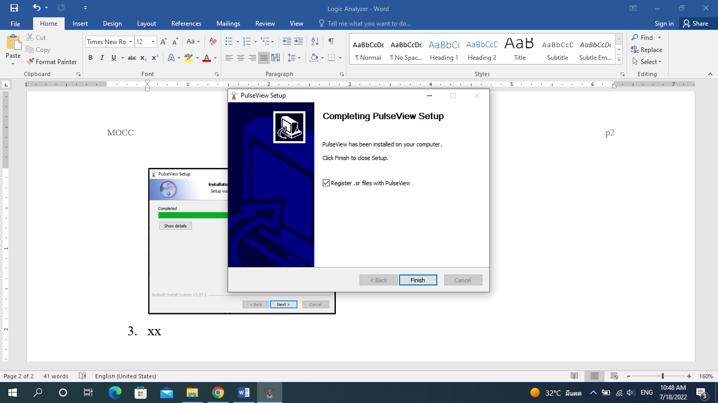

1. After installing, Pulse View application are seen as follow.

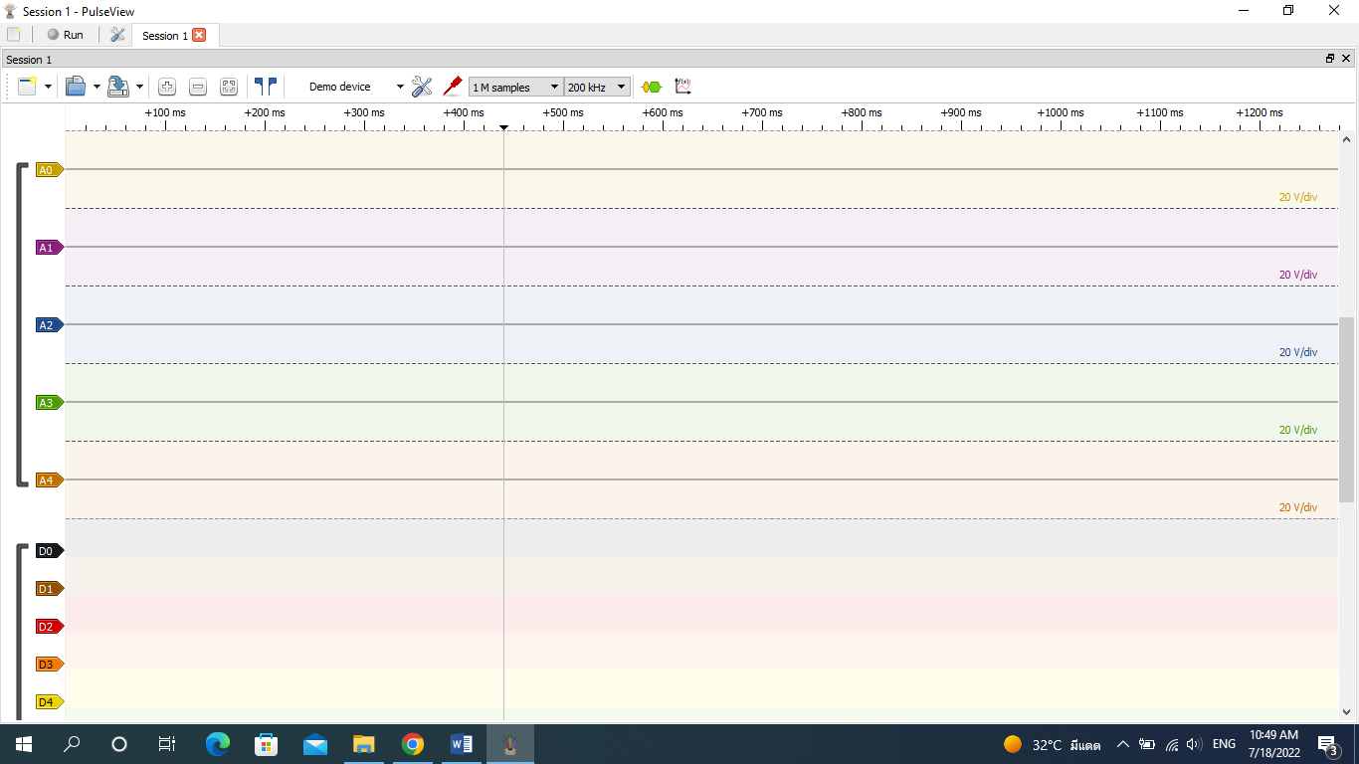

***USB Driver Installation (Window Operating System Case)***

1. Download “*Zadig (USB driver)*” for Logic Analyzer from this link “https://zadig.akeo.ie/”.

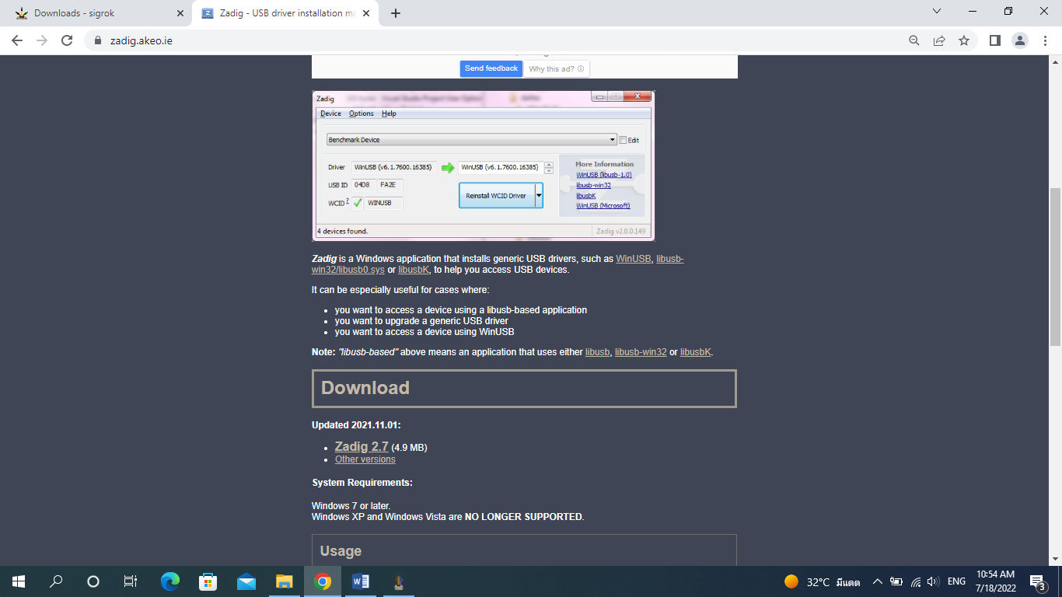

1. After downloading, install it by clicking “Install WCID Driver”.

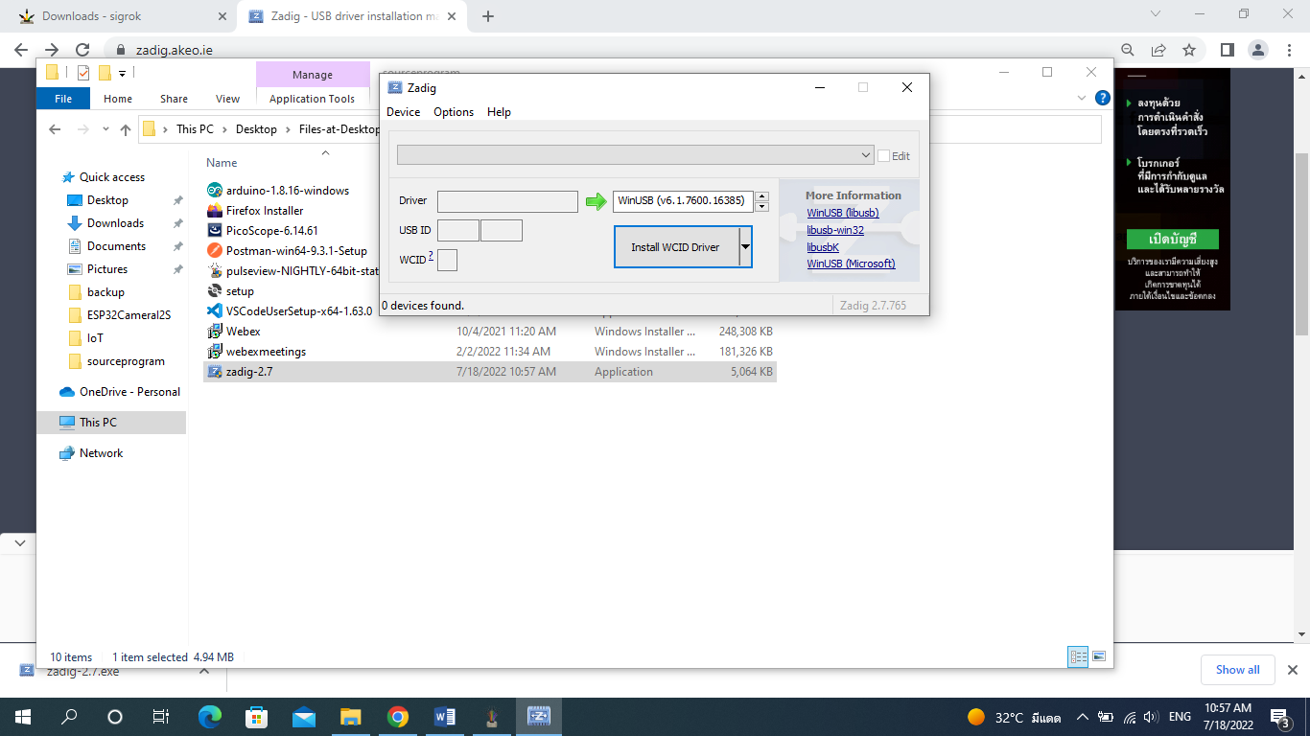 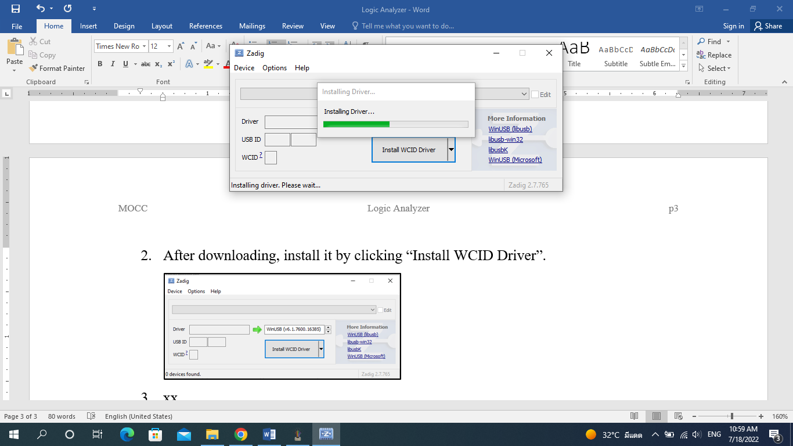

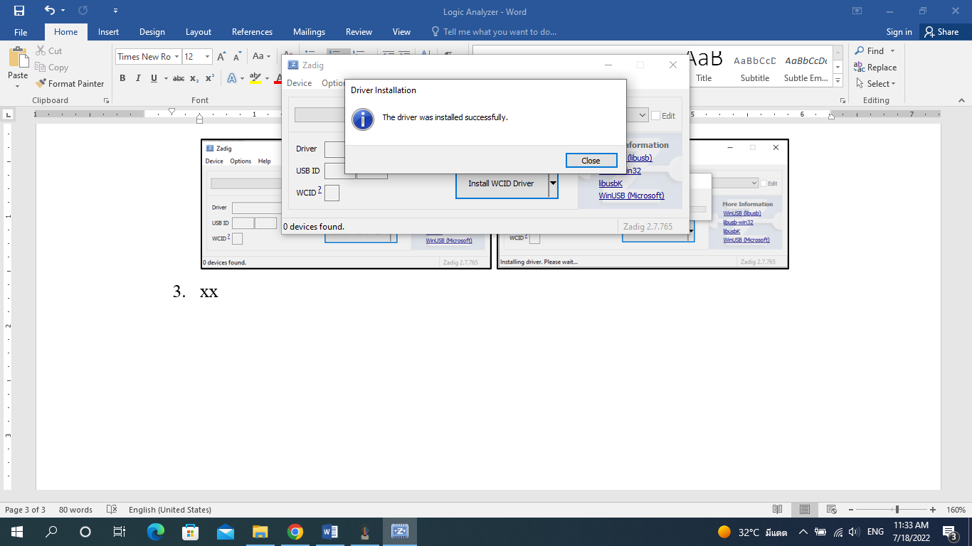

1. After installing driver, the Pulse View application can be seen as follow.

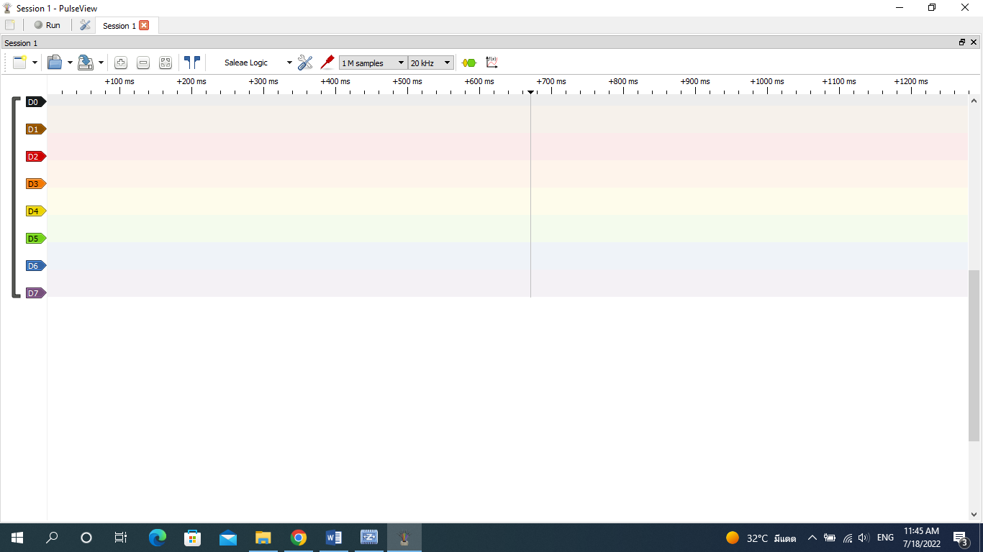

**B: Required Software Installation for Pico Scope**

***Pico Scope Installation***

1. Direct to the link “https://www.picotech.com/downloads” to download for Pico scope **2206B**.

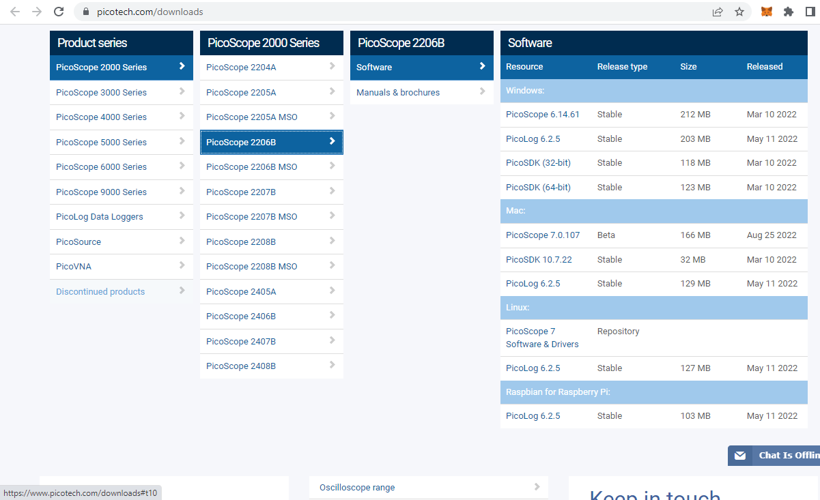

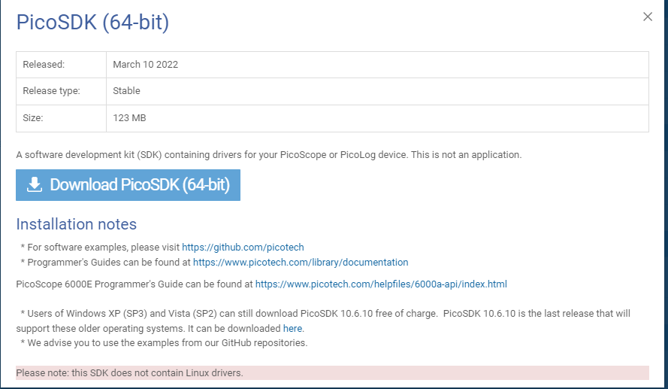

1. After downloading, install it on your machine as follows.

