**Table of Contents**

|  |  |
| --- | --- |
| **Contents** | **Page No.** |
| Part A: HC-SR04P Ultrasonic Distance Sensor | **P2** |
| Part B: OV7670 Camera | **P3** |
| Part C: FSM | **P7** |
| Part D: PID | **P9** |
| Part E: ESP32 Dual Core | **P12** |
|  |  |

***Part A: HC-SR04P Ultrasonic Distance Sensor***

1. In this scenario, we are going to study about Finite State Machine (FSM).
2. Hardware Required
   1. ESP32
   2. HC-SR04P
   3. Jumper Wires
   4. Breadboard
   5. Micro USB cable
3. Circuit Schematic
4. Trig -> GPIO23
5. Echo -> GPIO22
6. VCC -> Vin
7. GND -> GND

Note that HC-SR04P is compatible with both 3.3V and 5V power supply and logic levels, while HC-SR04 is compatible with only 5V power supply logic level.

1. Source Code

#define TRIG_PIN 23 // ESP32 pin GIOP23 connected to Ultrasonic Sensor's TRIG pin

#define ECHO_PIN 22 // ESP32 pin GIOP22 connected to Ultrasonic Sensor's ECHO pin

float duration_us, distance_cm;

void setup() {

// begin serial port

Serial.begin (9600);

// configure the trigger pin to output mode

pinMode(TRIG_PIN, OUTPUT);

// configure the echo pin to input mode

pinMode(ECHO_PIN, INPUT);

}

void loop() {

// generate 10-microsecond pulse to TRIG pin

digitalWrite(TRIG_PIN, HIGH);

delayMicroseconds(10);

digitalWrite(TRIG_PIN, LOW);

// measure duration of pulse from ECHO pin

duration_us = pulseIn(ECHO_PIN, HIGH);

// calculate the distance

distance_cm = 0.017 * duration_us;

// print the value to Serial Monitor

Serial.print("distance: ");

Serial.print(distance_cm);

Serial.println(" cm");

delay(500);

}

1. Sample Result

**Your Testing: Take a video record where you should show and explain when you are varying the distance and it effect the values in serial monitor.**

***Part B: OV7670 Camera***

1. In this scenario, we are going to study about OV7670 Camera.
2. Hardware Required
   1. ESP32
   2. OV7670 Camera
   3. Jumper Wires
   4. Breadboard
   5. Micro USB cable
3. Circuit Schematic

|  |  |
| --- | --- |
| **Camera Pin** | **ESP32 Pin** |
| 3.3 V | 3.3 V |
| GND | GND |
| SIOC/SCL | GPIO22/SCL |
| SIOD/SDA | GPIO21/SDA |
| VSYNC/VS | GPIO34 |
| HREF/HS | GPIO35 |
| PCLK/PLK | GPIO33 |
| XCLK/XLK | GPIO32 |
| D7 | GPIO4 |
| D6 | GPIO12 |
| D5 | GPIO13 |
| D4 | GPIO14 |
| D3 | GPIO15 |
| D2 | GPIO16 |
| D1 | GPIO17 |
| D0 | GPIO27 |
| RESET/RET | EN |

1. Source Code

#include "OV7670.h"

#include <WiFi.h>

#include <WiFiMulti.h>

#include <WiFiClient.h>

#include "BMP.h"

#include "Config.h"

const int SIOD = 21; //SDA

const int SIOC = 22; //SCL

const int VSYNC = 34;

const int HREF = 35;

const int XCLK = 32;

const int PCLK = 33;

const int D0 = 27;

const int D1 = 17;

const int D2 = 16;

const int D3 = 15;

const int D4 = 14;

const int D5 = 13;

const int D6 = 12;

const int D7 = 4;

//DIN <- MOSI 23

//CLK <- SCK 18

OV7670 *camera;

WiFiMulti wifiMulti;

WiFiServer server(80);

unsigned char bmpHeader[BMP::headerSize];

void serve()

{

WiFiClient client = server.available();

if (client)

{

//Serial.println("New Client.");

String currentLine = "";

while (client.connected())

{

if (client.available())

{

char c = client.read();

//Serial.write(c);

if (c == '\n')

{

if (currentLine.length() == 0)

{

client.println("HTTP/1.1 200 OK");

client.println("Content-type:text/html");

client.println();

client.print(

"<style>body{margin: 0}\nimg{height: 100%; width: auto}</style>"

"<img id='a' src='/camera' onload='this.style.display=\"initial\"; var b = document.getElementById(\"b\"); b.style.display=\"none\"; b.src=\"camera?\"+Date.now(); '>"

"<img id='b' style='display: none' src='/camera' onload='this.style.display=\"initial\"; var a = document.getElementById(\"a\"); a.style.display=\"none\"; a.src=\"camera?\"+Date.now(); '>");

client.println();

break;

}

else

{

currentLine = "";

}

}

else if (c != '\r')

{

currentLine += c;

}

if(currentLine.endsWith("GET /camera"))

{

client.println("HTTP/1.1 200 OK");

client.println("Content-type:image/bmp");

client.println();

client.write(bmpHeader, BMP::headerSize);

client.write(camera->frame, camera->xres * camera->yres * 2);

}

}

}

// close the connection:

client.stop();

//Serial.println("Client Disconnected.");

}

}

void setup()

{

Serial.begin(115200);

wifiMulti.addAP(ssid1, password1);

//wifiMulti.addAP(ssid2, password2);

Serial.println("Connecting Wifi...");

if(wifiMulti.run() == WL_CONNECTED) {

Serial.println("");

Serial.println("WiFi connected");

Serial.println("IP address: ");

Serial.println(WiFi.localIP());

}

camera = new OV7670(OV7670::Mode::QQVGA_RGB565, SIOD, SIOC, VSYNC, HREF, XCLK, PCLK, D0, D1, D2, D3, D4, D5, D6, D7);

BMP::construct16BitHeader(bmpHeader, camera->xres, camera->yres);

server.begin();

}

void loop()

{

camera->oneFrame();

serve();

}

**Note that you must change WiFi SSID and password in the “Config.h” source code to match your selected access point.**

1. Result

Find assigned IP address to ESP32 in the serial monitor. In a web server on your computer that connects to the same network as ESP32, type in http://<ESP32’s IP Address>.

**Your Testing: Take a video record where you should show the camera result at browser together with your circuit.**

***Part C: FSM***

1. In this scenario, we are going to study about Finite State Machine (FSM).
2. Hardware Required
   1. ESP32
   2. 2 x LEDs
   3. 2 x Push Buttons
   4. 2 x 220Ω Resistors
   5. Micro USB cable
   6. Jumper Wires
   7. breadboard
3. Circuit Diagram
   1. 1st LED ->220Ω Resistor -> GPIO4
4. 2nd LED ->220Ω Resistor ->GPIO2
5. 1st Push button -> GPIO13
6. 2nd Push button -> GPIO14

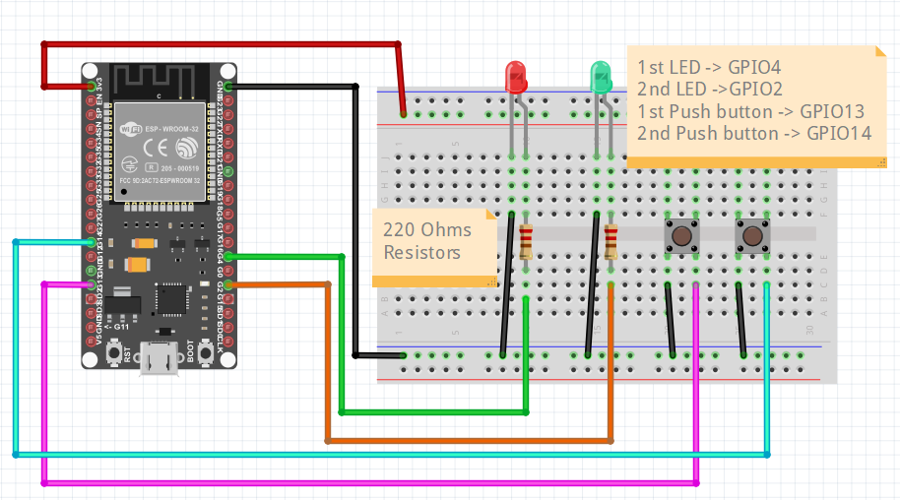

1. Source Code

**Complete “ESP32_FSM.ino” according to the following FSM diagram.**

//Complete this file according to the FSM

#define STATE1 1

#define STATE2 2

#define STATE3 3

#define STATE4 4

#define STATE_END 100

int sensor1 = 13;

int sensor2 = 14;

int led1 = 4;

int led2 = 2;

unsigned char state=4;

void setup() {

pinMode (sensor1, INPUT);

pinMode (sensor2, INPUT);

pinMode (led1, OUTPUT);

pinMode (led2, OUTPUT);

Serial.begin(9600);

}

void loop() {

Serial.println(state);

Serial.println(digitalRead(sensor1));

Serial.println(digitalRead(sensor2));

switch(state) {

case STATE1:

digitalWrite(led1, HIGH);

digitalWrite(led2, HIGH);

if((digitalRead(sensor1)==LOW) && (digitalRead(sensor2)==HIGH))

state = STATE2;

else if((digitalRead(sensor1)==HIGH) && (digitalRead(sensor2)==LOW))

state = STATE3;

else if((digitalRead(sensor1)==HIGH) && (digitalRead(sensor2)==HIGH))

state = STATE4;

break;

**//To be continued**

}

delay(100);

}

**Your Testing: Take a video record where you should explain your circuit together with your complete source code.**

***Part D: PID***

1. In this scenario, we are going to study about Proportional-Integral-Derivative (PID) with ESP32, LDR, and POT.
2. Hardware Required
   1. ESP32
   2. LED
   3. 220 Ω resistor and 1kΩ resistor
   4. LDR
   5. 10kΩ POT
   6. Bread board
   7. Micro USB cable
   8. Jumper Wires
3. Software Required
   1. ArcPID library

1. Circuit Schematic
2. LED -> 220 Ohms -> GPIO32
3. POT pin 2 -> GPIO34
4. LDR -> GPIO33 ->1k Ohms ->3.3V

1. Source Code

#include <PID.h> //ArcPID library

#define LED 32 //Output

#define LDR 33 //Input sensor

#define POT 34 //This potentiometer is to set PID target

#define PWM_CH_1 0

#define PWM_FREQ 15000

#define PWM_RES 10 // Resolution in bits

#define MAX 1023.0 //10-bit max value

arc::PID<double> ledPid(5,4,3); //Kp, Ki, Kd

void setup() {

Serial.begin(9600);

pinMode(LED, OUTPUT);

pinMode(LDR, INPUT);

pinMode(POT, INPUT);

ledcSetup(PWM_CH_1, PWM_FREQ, PWM_RES);

ledcAttachPin(LED, PWM_CH_1);

analogReadResolution(PWM_RES); //Set analog input resolution to be the same as PWM

}

unsigned int ledValue = 0;

void loop() {

delay(100);

unsigned short ldrRaw = analogRead(LDR);

unsigned short potRaw = analogRead(POT);

ledPid.setTarget(potRaw);

ledPid.setInput(ldrRaw);

Serial.print(",\"raw led\":");

Serial.print(ledValue,DEC);

ledValue = min(MAX, max(0.0,ledValue + ledPid.getOutput()));

Serial.print("{\"ldr\":");

Serial.print(ldrRaw,DEC);

Serial.print(",\"pot\":");

Serial.print(potRaw,DEC);

Serial.print(",\"adjusted led\":");

Serial.print(ledValue,DEC);

Serial.println("}");

ledcWrite(PWM_CH_1, ledValue);

}

1. Sample Result

**Your Testing: Take a video record where you should explain your circuit together with the result from serial monitor.**

***Part E: ESP32 Dual Core***

1. In this scenario, we are going to study how to use ESP32 Dual Core with Arduino IDE. We will create two tasks running on different cores.

Task 1 runs on Core 0 and Task 2 runs on Core 1.

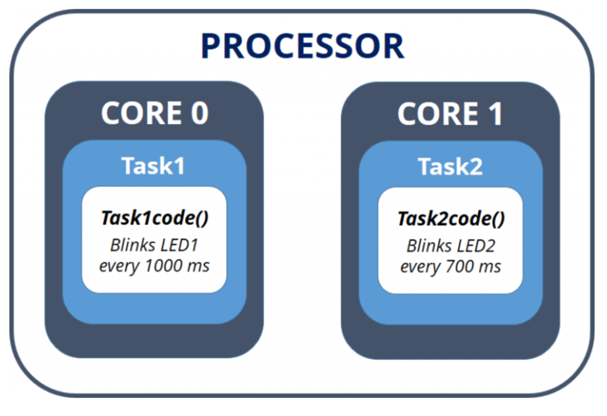

1. Hardware Required
   1. ESP32
   2. 2 x LED
   3. 2 x 220 Ω resistors
   4. Bread board
   5. Micro USB cable
   6. Jumper Wires
2. Circuit Diagram

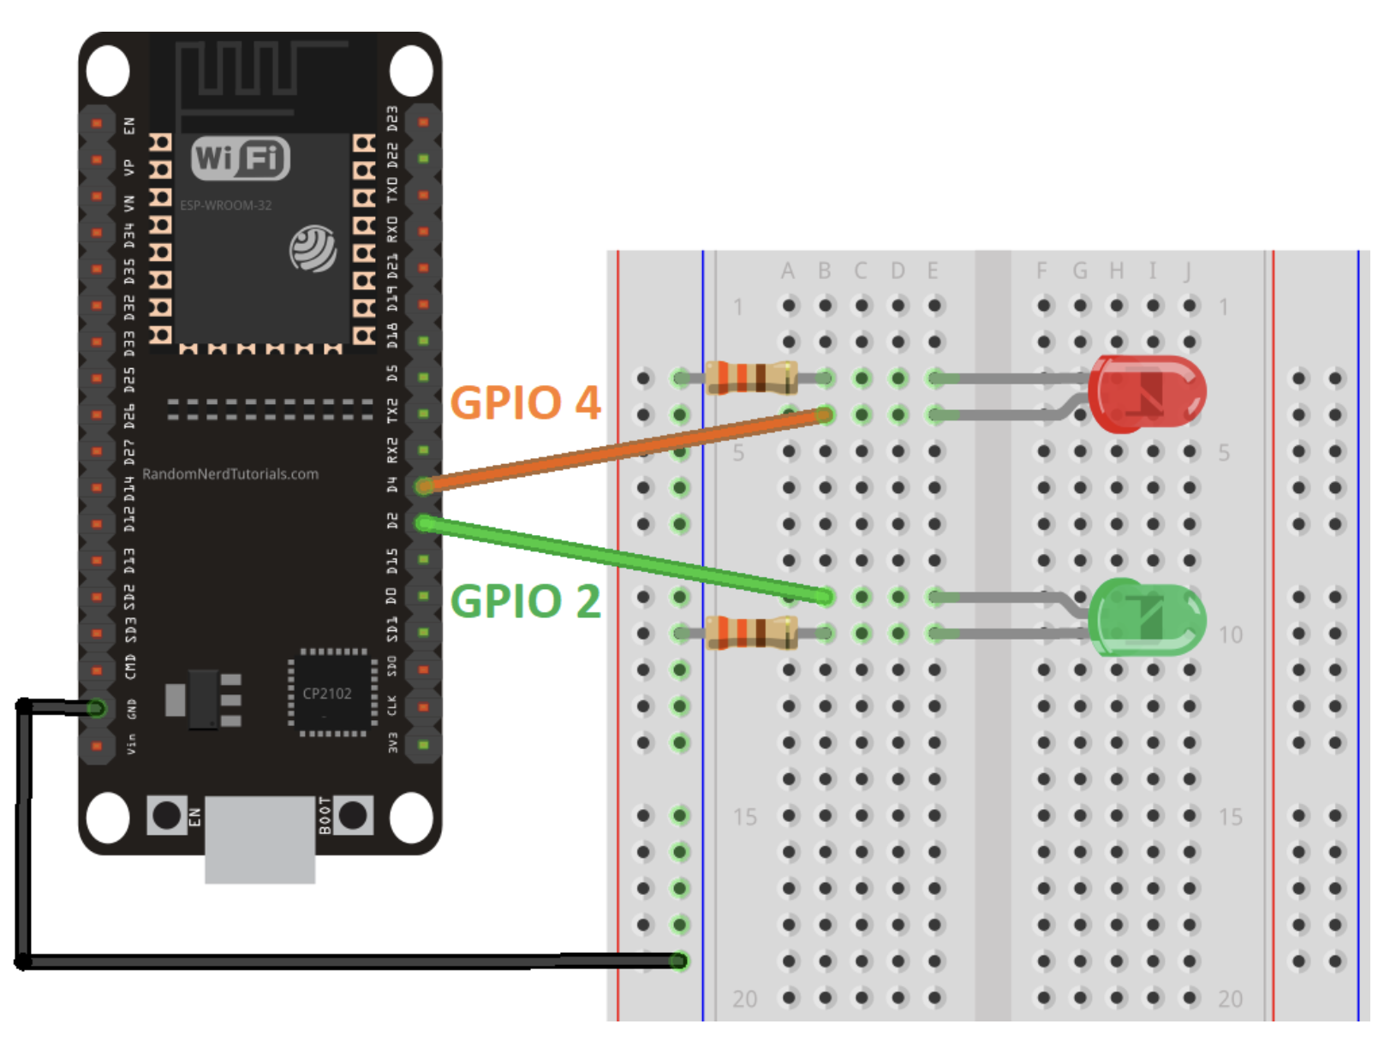

1. Source Code

TaskHandle_t Task1;

TaskHandle_t Task2;

// LED pins

const int led1 = 2;

const int led2 = 4;

void setup() {

Serial.begin(115200);

pinMode(led1, OUTPUT);

pinMode(led2, OUTPUT);

//create a task that will be executed in the Task1code() function, with priority 1 and executed on core 0

xTaskCreatePinnedToCore(

Task1code, /* Task function. */

"Task1", /* name of task. */

10000, /* Stack size of task */

NULL, /* parameter of the task */

1, /* priority of the task */

&Task1, /* Task handle to keep track of created task */

0); /* pin task to core 0 */

delay(500);

//create a task that will be executed in the Task2code() function, with priority 1 and executed on core 1

xTaskCreatePinnedToCore(

Task2code, /* Task function. */

"Task2", /* name of task. */

10000, /* Stack size of task */

NULL, /* parameter of the task */

1, /* priority of the task */

&Task2, /* Task handle to keep track of created task */

1); /* pin task to core 1 */

delay(500);

}

//Task1code: blinks an LED every 1000 ms

void Task1code( void * pvParameters ){

Serial.print("Task1 running on core ");

Serial.println(xPortGetCoreID());

for(;;){

digitalWrite(led1, HIGH);

delay(1000);

digitalWrite(led1, LOW);

delay(1000);

}

}

//Task2code: blinks an LED every 700 ms

void Task2code( void * pvParameters ){

Serial.print("Task2 running on core ");

Serial.println(xPortGetCoreID());

for(;;){

digitalWrite(led2, HIGH);

delay(700);

digitalWrite(led2, LOW);

delay(700);

}

}

void loop() {}

**Your Testing: Take a video record where you should explain your circuit together with the result from serial monitor.**