**Chancheep Mahacharoensuk 6288092**

**Kantapong Matangkarat 6288160**

**Please answer the following questions with their respective video records and screenshots.**

1. **ESP32 as Web Server (LED on/off)**: Connect LED to ESP32 (GPIO4) (please revise previous activities for circuit diagram) and upload “/esp32_webserver/LED_Web/LED_Web.ino” to your ESP32. At serial monitor, check the IP address of ESP32. Then connect your ESP32 web server as http://<ESP32 IP address> to control your LED on/off. Take a video record where you control your LED on/off via ESP32 web browser.

**Remark: Fill in your WiFi credentials (SSID and Password) at “config.h”.**

Link your video record:

1. **ESP32 as Web Server (Servo Motor)**: Connect a servo motor to GPIO23 (please revise previous activities for circuit diagram) and upload “/esp32_webserver/LED_Web/Servo_Web.ino” to your ESP32. At serial monitor, check the IP address of ESP32. Then connect your ESP32 web server as http://<ESP 32 IP address> to control the rotation of servo motor. Take a video record how do you control the rotation of servo motor via ESP32 web browser.

**Remark: Fill in your WiFi credentials (SSID and Password) at “config.h”.**

Link your video record:

1. **MQTT (MQTT broker and client)**: Testing mosquitto on the local system (show your results on two terminals). See the example commands at “MQTT Worksheet Page 2”.

**Ans:**

1. **MQTTBox (MQTT Client)**: At MQTT Box, use two different topics (e.g., test/topic1 and test/topic2) to publish messages. And then use two subscribers to subscribe your messages. Show your screenshot results. See the example result at “MQTT Worksheet Page 5”.

**Remark: Fill in your MQTT Broker Credentials (IP address, username, password, and topic) at MQTTBox configuration.**

**Ans:**

1. **ESP32 (MQTT Client)**: Use ESP32 to publish MQTT messages to MQTT Broker (Mosquitto). Show your screenshot results. See the example result at “MQTT Worksheet Page 7”.

**Remark: Fill in your WiFi credentials (SSID, password) and MQTT Broker credentials (IP address, username, and password) at “config.h”.**

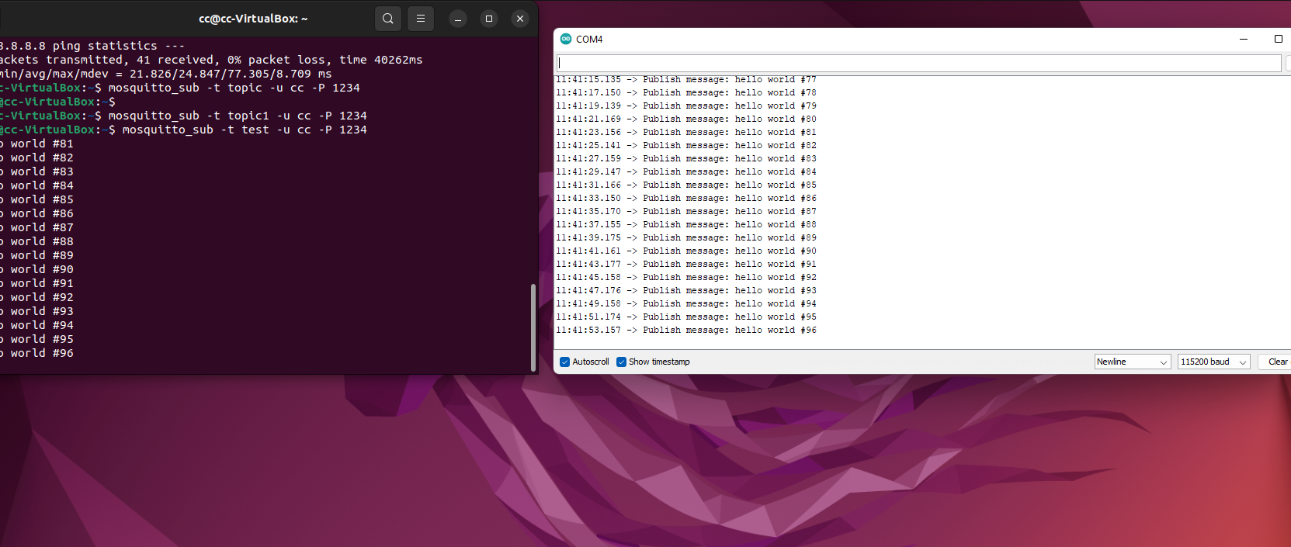

1. **ESP32 MQTT AHT20 & LED on/off**: In this exercise, we are going to study how to subscribe the AHT20 temp&humid values and how to control LED on/off via MQTT protocol (pub/sub/broker). Connect AHT20 and LED to ESP32 (please revise previous activities for circuit diagram) and upload “esp32-mqtt-aht20-led/esp32-mqtt-aht20-led.ino” to your ESP32.
2. Which command is used to subscribe temperature and humidity from MQTT broker (Ubuntu terminal)?

Ans: -

1. Which command is used to control LED on/off from MQTT broker (Ubuntu terminal)?

Ans: -

1. Use Wireshark to trace your MQTT communications and show your screenshot results for the above two questions (a) and (b).

Show your screenshot results.

Ans:

**Remark: Fill in your WiFi credentials (SSID, password) and MQTT Broker credentials (IP address, username, and password) at “config.h”.**

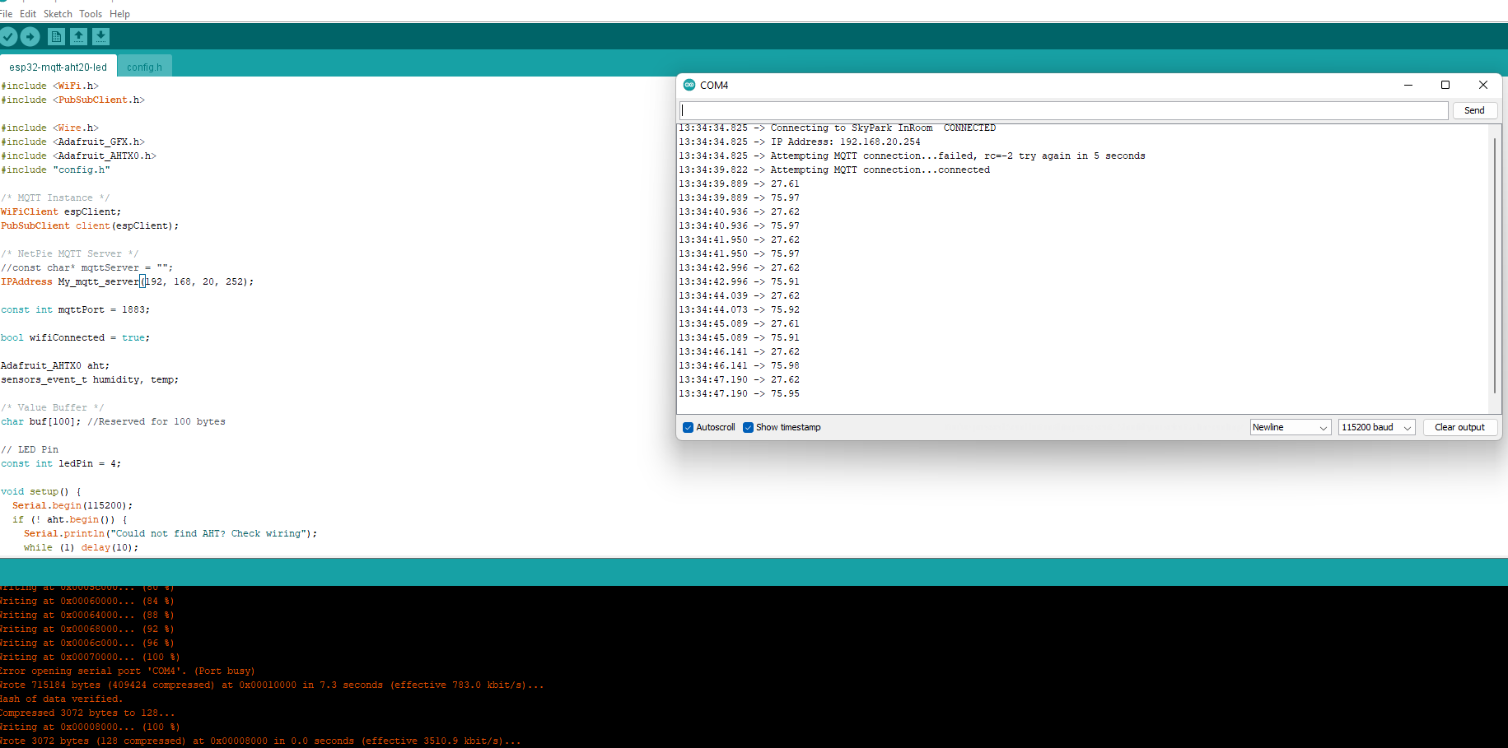

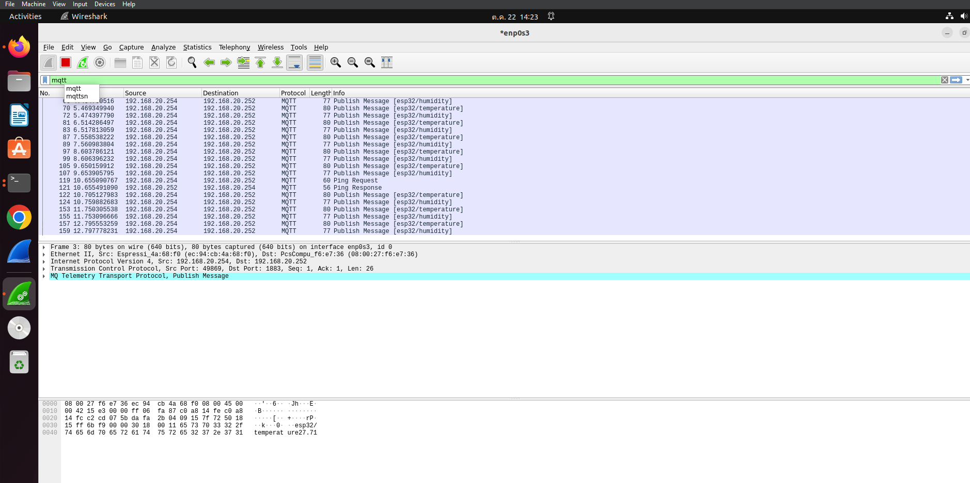

1. **ESP32 MQTT AHT20 & LED on/off:** Modify the code from Exercise 6 to show temperature and humidity values at Web Browser. Take a video record to explain your code and result together.

Reference :

https://randomnerdtutorials.com/esp32-web-server-with-bme280-mini-weather-station/

Link your video record:

