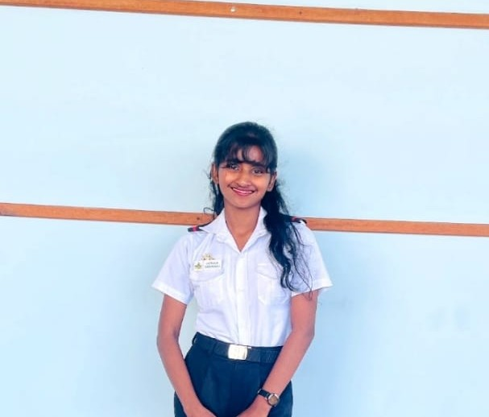
Chethana
Contact Me:
0759964854
chethi@gmail.com
Wimalasara Rd, Kalubowila , Dehiwala.
Skills:
Leadership:
Database:
Creativity:
HTML:
CSS:
Communication:
Teamwork:
Languages:
English
Sinhala
Social:
 Facebook
Twitter
Linkedin

Dissanayaka
UNDERGRADUATE
Personal Summery


I am a motivated Computer Science undergraduate at General Sir John Kotelawala Defence University, with strong interest in software development, machine learning, and networking. I have completed professional courses in Machine Learning (IIT) and Introduction to Networking (Cisco), and I enjoy building practical projects that solve real-world problems. I am passionate about learning new technologies, improving my skills, and contributing to impactful, innovative work.

Job Experience 
Cashier — Sakya Institute
2024r –May– November
- Managed daily cash transactions accurately and efficiently.
- Provided friendly customer service and assisted students/parents with payments and inquiries.
- Maintained records, receipts, and updated payment logs.
- Ensured smooth operation of the front desk during busy hours.
- Handled cash balancing and supported administrative tasks when needed.

- Presbytarian Girls’ National Scool
- St. Lawrence’s Convent, Colombo 06
- General Sir John Kotelawela Defence University, Rathmalana
Education 

