Name: Christina Noronha

PID: 191081

Roll No.: 51

Class & Batch: TE IT B

Subject: IP Lab:

Date of Conduction: 30/07/2021

Date of Submission: 06/08/2021

**EXPERIMENT 2**

**Aim:** To design a registration form using HTML5

**Code:**

CODE: Exp2Frame1.html

<!DOCTYPE html>

<html>

<head>

<title>VisionMission</title>

</head>

<body style="background-color:lightblue">

<p>

<b><h3>Vision</h3></b>

To be a chrysalis where bright youngsters are transformed into technological

entrepreneurs and innovative leaders of tomorrow’s world, consistent with the

Franciscan vision of integrity, peace and love.

<br>

<p>

<b><h3>Mission</h3></b>

To churn highly competent engineering graduates with a commitment to result

oriented work, a perennial zest for learning, a quest for excellence, an open

mind and the universal values of honesty, dignity and mutual care.</p>

</body>

</html>

CODE: Exp2Frame2.html

<!DOCTYPE html>

<html>

<head>

<title>Building</title>

</head>

<body style="background-color:bisque">

<img src="building.jpg" width="1480px" height="600px">

</body>

</html>

CODE: Exp2.html

<!DOCTYPE html>

<html lang="en">

<head>

<meta charset="UTF-8">

<meta http-equiv="X-UA-Compatible" content="IE=edge">

<meta name="viewport" content="width=device-width, initial-scale=1.0">

<title>FORM</title>

</head>

<div style="background-color:beige;">

<p style="text-align:center" > <br>

<img src="sfitlogo.png" ; width="70" height="70"; >

<h1 style="text-align:center">St. Francis Institute of Technology </h1>

<p style="text-align:center"> Mount Poinsur, Borivali (W), Mumbai - 400 103

<br>

<b>Phone No. </b> 022-28908585, 022-28908787 <b> Email:</b> sfedu@sfit.ac.in <b>Website:</b> www.sfit.ac.in</p>

</p>

</div>

<hr></hr>

<form>

<div style="background-color:grey;color:white;padding:20px;">

<P style="text-align:center">Admission Enquiry Registration</P>

<p><i>General Instructions</i></p>

<p>1.Please enter correct details</p>

<p>2.Fill all boxes </p>

<label> Firstname </label>

<input type="text" name="Firstname:" size="15" required/>

<label> Middlename: </label>

<input type="text" name="Middlename" size="15"/>

<label>Lastname: </label>

<input type="text" name="Lastname" size="15" required/> <br> <br>

<label>Address:</label>

<input type="Address" name="Address" size="40" required /> <br> <br>

<label for="city">City:</label>

<select id="city" name="city">

<option value="Mumbai">Mumbai</option>

<option value="Delhi">Delhi</option>

<option value="Banglore" selected>Banglore</option>

<option value="Chennai">Chennai</option>

</select>

<label for="state">State:</label>

<select id="state" name="state">

<option value="Maharashtra">Maharashtra</option>

<option value="Delhi">Delhi</option>

<option value="Banglore" selected>Banglore</option>

<option value="TamilNadu">Tamil Nadu</option>

</select>

<label>Pincode: </label>

<input type="text" name="pincode" size="10" required/> <br> <br>

<label>Email: </label>

<input type="email" name="Email" size="20" required/>

<label>Phone No: </label>

<input type="tel" name="phone" size="15" required /> <br> <br>

<label required>Gender: </label> <br>

<input type="radio" id="Male" name="Gender" value="Male">Male</input> <br>

<input type="radio" id="Female" name="Gender" value="Female">Female</input> <br>

<input type="radio" id="Other" name="Gender" value="Other">Other</input><br> <br>

<label for="DOB" >Date of Birth:</label>

<input type="date" id="DOB" name="birthday" required><br><br>

<label>Choice of Branch:</label><br>

<input type="checkbox" id="B1" name="B1" value="IT">Information Technology</input><br>

<input type="checkbox" id="B2" name="B2" value="CS">Computer Science</input><br>

<input type="checkbox" id="B3" name="B3" value="ME">Mechanical Engineering </input><br><br >

<label for="File">Upload CET Scoree Card:</label>

<input type="file" id="file" name="avatar" accept="file/pdf,image/png, image/jpeg" required><br><br>

<label> Enter Username: </label>

<input type="text" name="Username:" size="15"required><br><br>

<label>Enter Password:</label>

<input type="Password" id="pwd" name="pwd" required> <br> <br>

<label>Re-type password:</label>

<input type="Password" id="repwd" name="repwd" required> <br> <br>

<input type="submit" value="Submit">

</div>

</form>

<iframe src="Exp2Frame1.html" width="1500px" height="200px" frameborder="1"></iframe>

<iframe src="Exp2Frame2.html" width="1500px" height="620px" frameborder="1"></iframe>

</html>

**Output:**

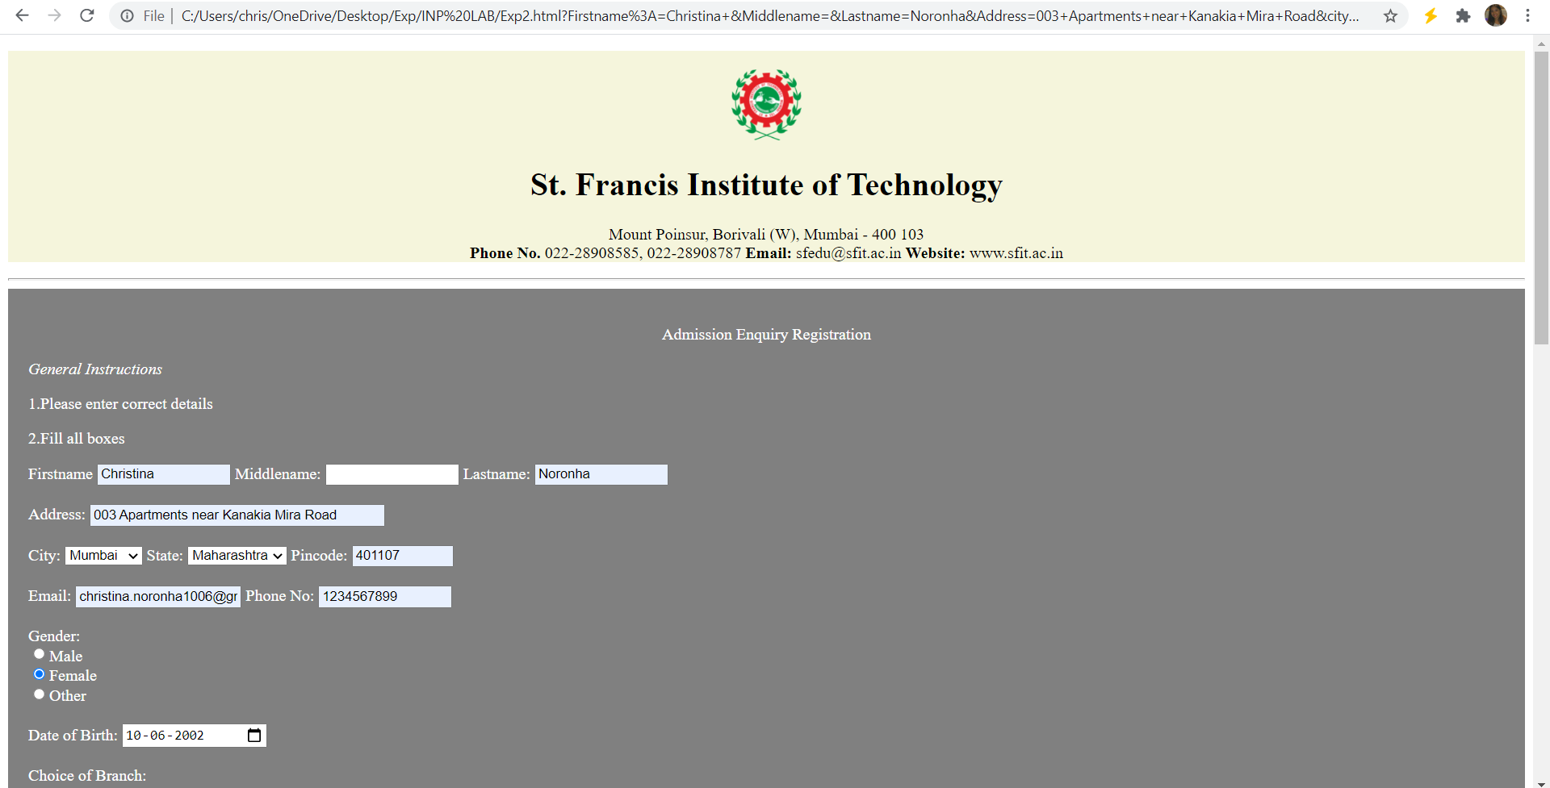

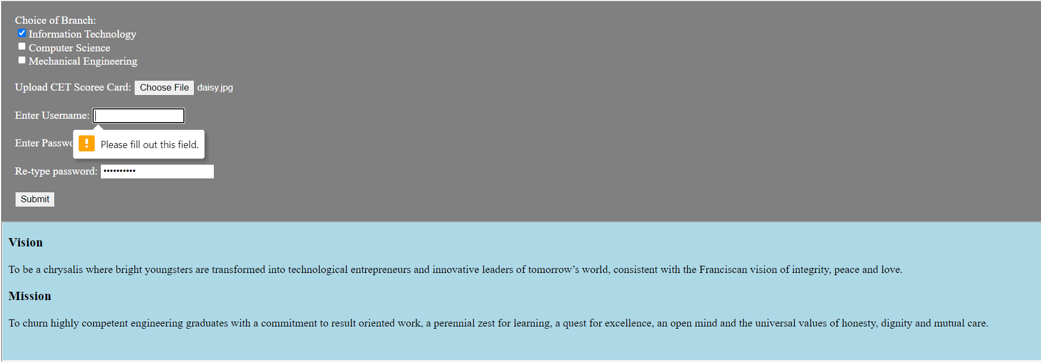

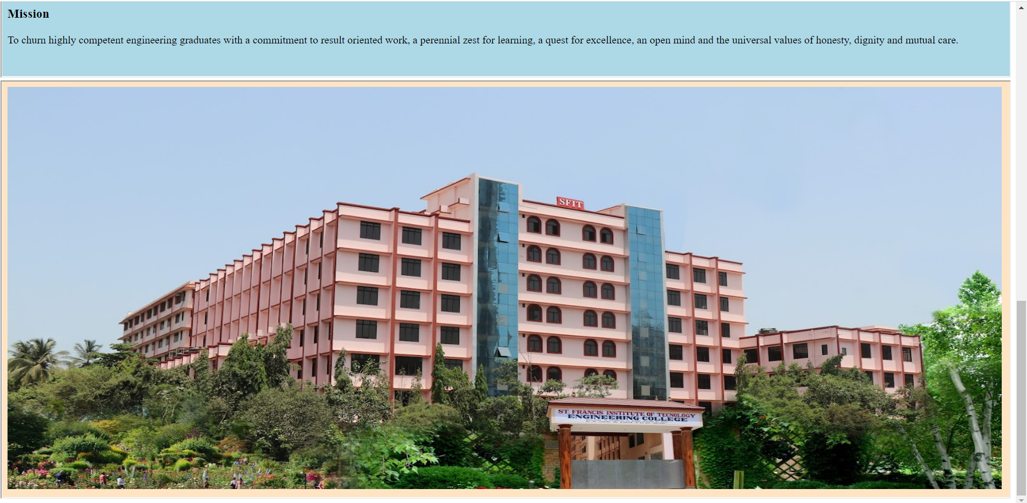

**Conclusion:** Write conclusion as per guidelines in the writeup

Write what was performed in the experiment

In this experiment we created a registration form website using the HTML5 features. We particularly used the form related features like submit button, passwords, required fields etc.. We also added iframes of Vision and Mission and an image in another frame.

Write which all features of HTML you used to perform the experiment

Here is the list of all the features I used to create this HTML page. <form>, <div>, <h2>,<img src=””>, <input type=”text”>, <br>, <select id="" name="">, <label>, <option value="">, <input type="radio" id="">, <input type="date">, <title>, <input type="checkbox">, <input type="Password">, <b>, <hr>, <iframe src=””>, <input type="submit" value="Submit">, <input type="file" id="file" accept="image/png, image/jpeg" required>

Insert Digital signature with date

