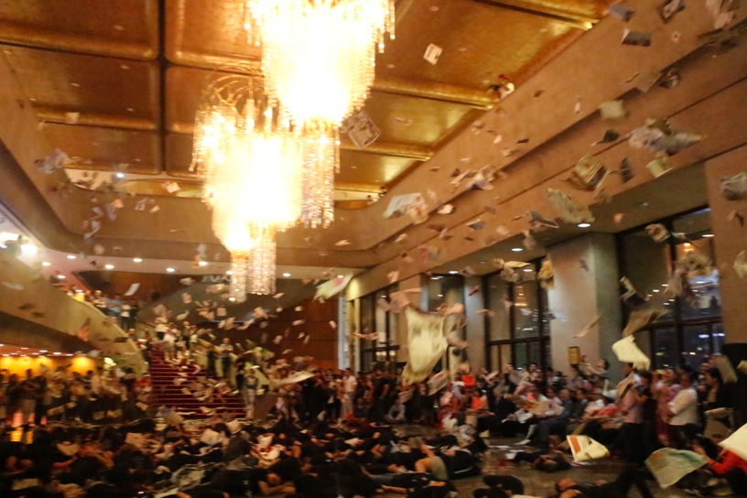

Figure 5.1 Jose Maceda, *Cassettes 100* (1971) restaged, Cultural Center of the Philippines, 2017

(Photograph courtesy of the Cultural Center of the Philippines)

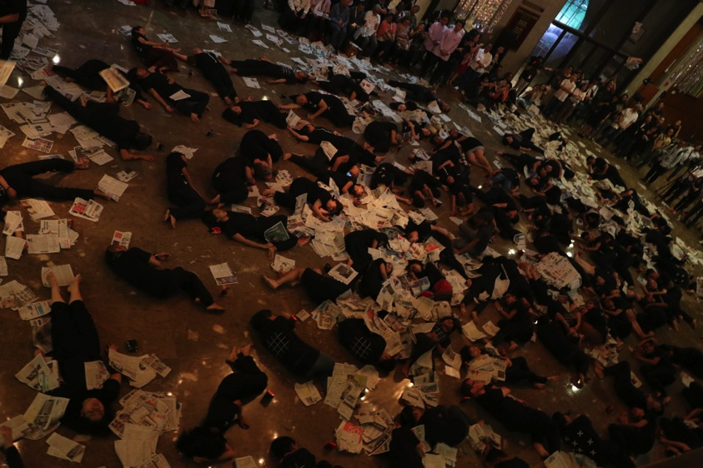

Figure 5.2 Jose Maceda, *Cassettes 100* (1971) restaged, Cultural Center of the Philippines, 2017

(Photograph courtesy of the Cultural Center of the Philippines)

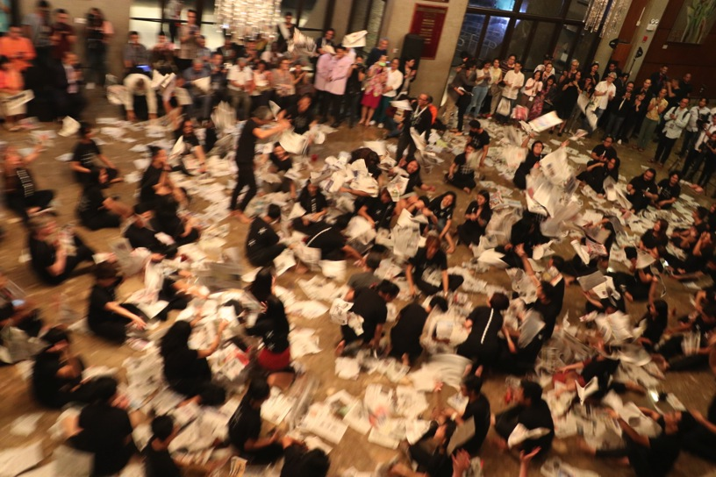

Figure 5.3 Jose Maceda, *Cassettes 100* (1971) restaged, Cultural Center of the Philippines, 2017

(Photograph courtesy of the Cultural Center of the Philippines)

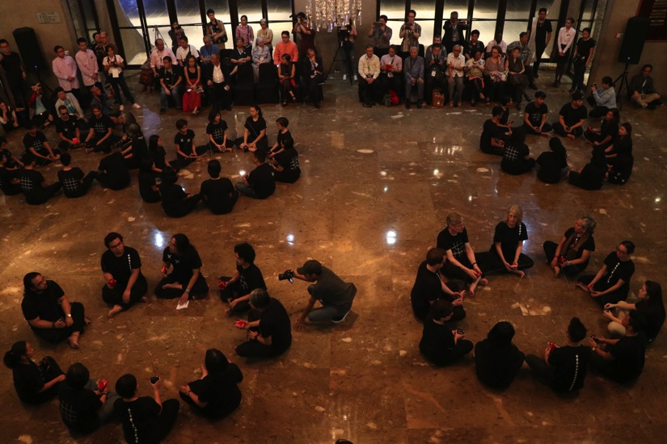

Figure 5.4 Jose Maceda, *Cassettes 100* (1971) restaged, Cultural Center of the Philippines, 2017

(Photograph courtesy of the Cultural Center of the Philippines)

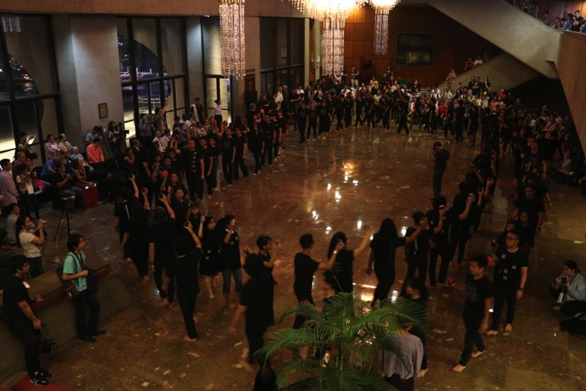

Figure 5.5 Jose Maceda, *Cassettes 100* (1971) restaged, Cultural Center of the Philippines, 2017

(Photograph courtesy of the Cultural Center of the Philippines)

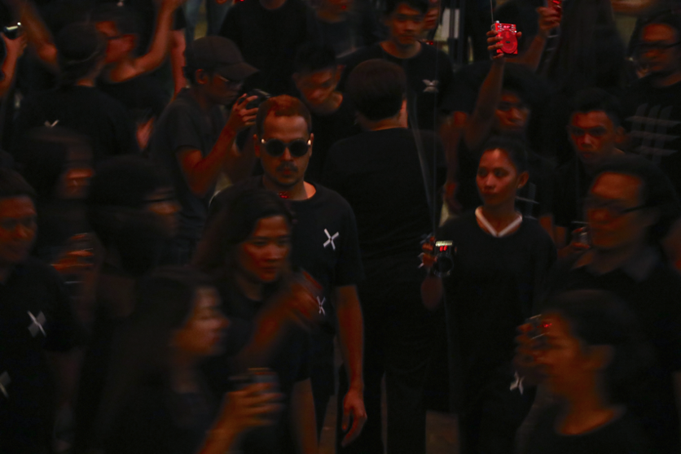

Figure 5.6 Jose Maceda, *Cassettes 100* (1971) restaged, Cultural Center of the Philippines, 2017

(Photograph courtesy of the Cultural Center of the Philippines)

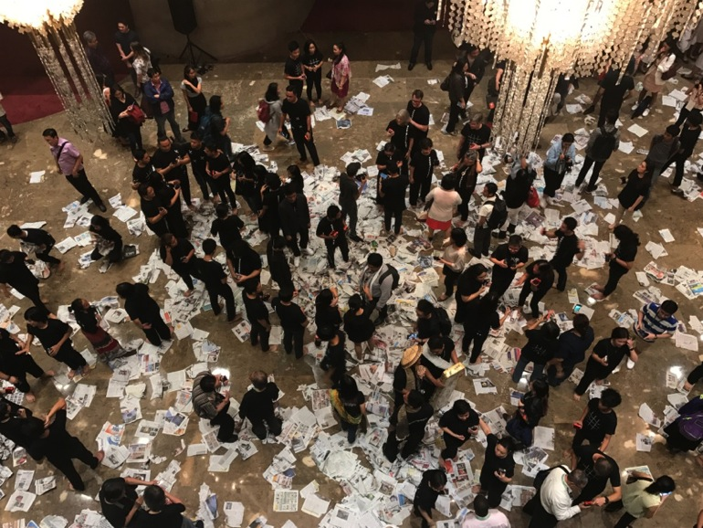

Figure 5.7 Jose Maceda, *Cassettes 100* (1971) restaged, aftermath Cultural Center of the Philippines, 2017

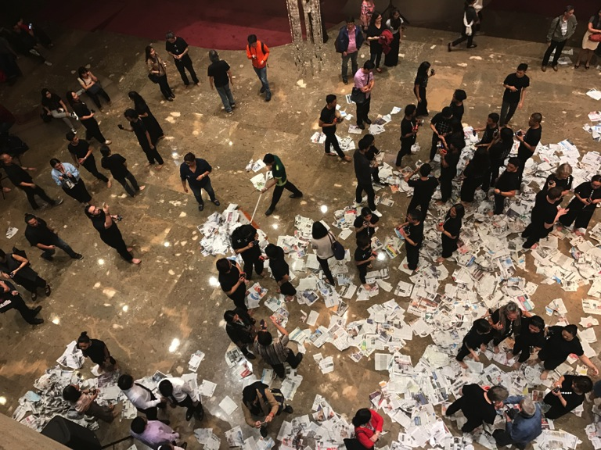

Figure 5.8 Jose Maceda, *Cassettes 100* (1971) restaged, aftermath Cultural Center of the Philippines, 2017

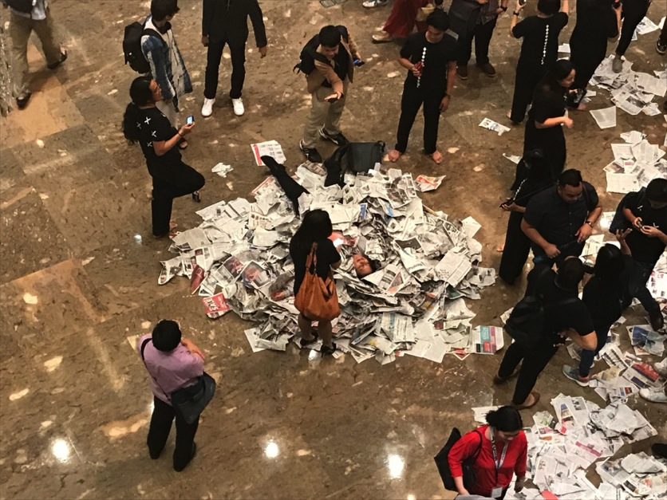

Figure 5.9 Jose Maceda, *Cassettes 100* (1971) restaged, aftermath Cultural Center of the Philippines, 2017