Project Report on

**EPlanner**

*For Application Developpement II – FSD10*

Prepared By

Nicholas Comeau

Sophie Hsu (0754336)

Benjamin Pye

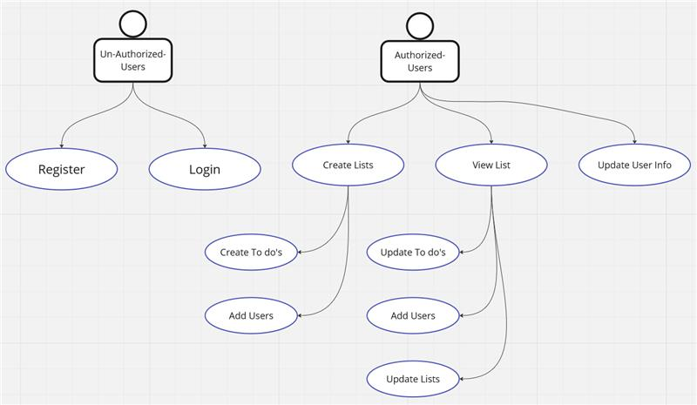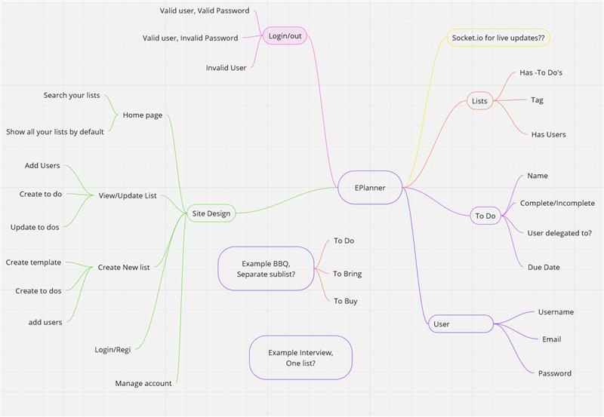

### **Functional Requirements:**

* **Authentication and Authorization:**
  + Users should be able to register for an account.
  + Users should be able to log in and log out securely.
  + Only authenticated users should have access.
* **List Management:**
  + Users should be able to view all their lists on the homepage.
  + Users should be able to create new lists.
  + Users should be able to delete lists they own.
  + Users should be able to edit the title and description of their lists.
* **Item Management:**
  + Users should be able to view all items within a list.
  + Users should be able to add new items to a list.
  + Users should be able to mark items as completed.
  + Users should be able to delete items from a list.
  + Users should be able to edit the details of items.
* **List Templates:**
  + Users should be able to select from predefined list templates.
  + Users should be able to customize and save their own list templates.
  + Users should be able to apply templates to create new lists.
* **Collaboration:**
  + Users should be able to add collaborators to their lists.
  + Collaborators should have permissions to view and modify shared lists.
  + Owners of lists should be able to manage collaborators (add/remove).
* **Real-Time Updates:**
  + Changes made by one user to a shared list should be immediately visible to other collaborators in real-time.
  + Real-time updates should be efficient and scalable.
* **Account Management:**
  + Users should be able to update their profile information (e.g., name, email, password).
  + Users should have the option to delete their account.

### **Non-Functional Requirements:**

* **Performance:**
  + The application should respond to user actions promptly.
  + The system should be able to handle a large number of concurrent users.
  + Page load times should be minimal.
* **Security:**
  + User authentication and authorization should be secure to prevent unauthorized access.
  + Passwords should be securely stored using hashing algorithms.
  + Data transmitted between the client and server should be encrypted (HTTPS).
* **Reliability:**
  + The application should be stable and reliable, with minimal downtime.
  + Data integrity should be maintained at all times.
* **User Interface:**
  + The user interface should be intuitive and easy to use.
  + The application should be responsive and work seamlessly across different devices and screen sizes.
* **Compatibility:**
  + The application should be compatible with popular web browsers (e.g., Chrome, Firefox, Safari).
* **Maintainability:**
  + The codebase should be well-organized and easy to maintain.

ERD

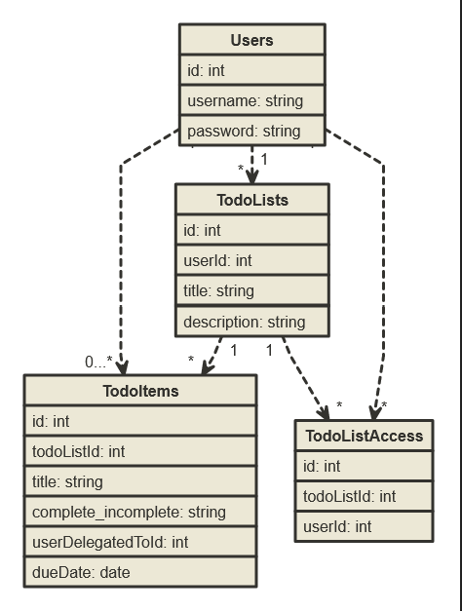

Class Diagram

