**Practical 10**

**Aim: Regular Expression**

1. **Write a program to identify employees with the address pincode 388120 using regular expressions. Store the names along with their salaries in a file. Additionally, update the records in the file by changing the pincode from 388120 to 388325 for all employees whose address previously had the old pincode.**

**Code:**

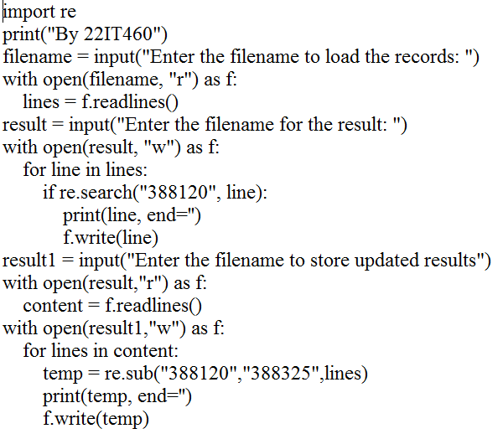

**Output:**

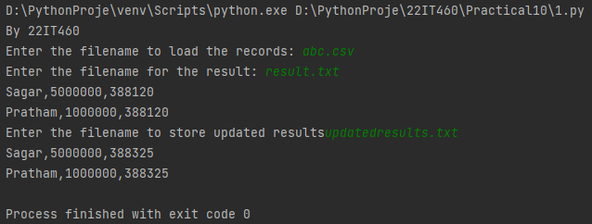

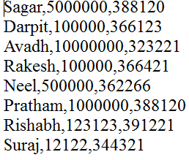abc.csv

result.txt

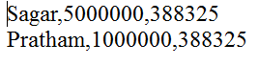updatedresults.txt

1. **Write a program to find out name starts with letter R or S and ends with H or J.**

**Code:**

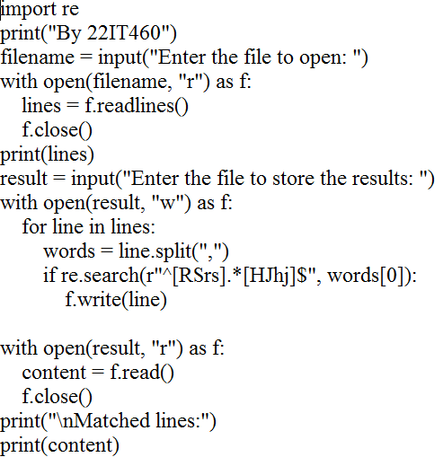

**Output:**

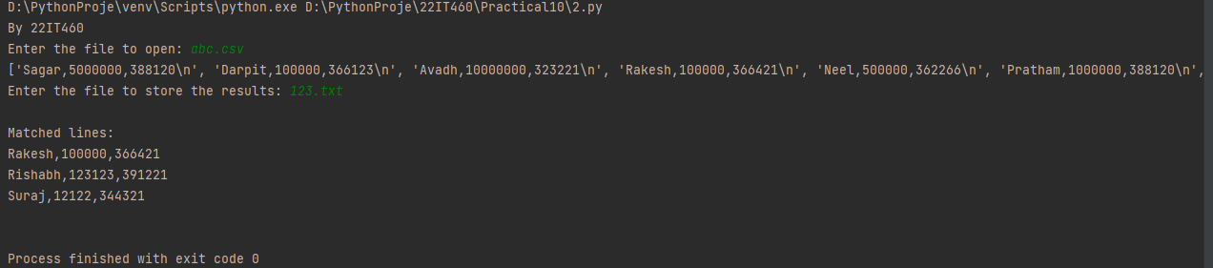

abc.csv

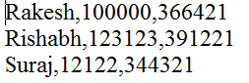123.txt