**Practical 12**

**Aim: Numpy**

1. **Write a program to search (min, max) element and sort in the given array using NumPy.**

**Code:**

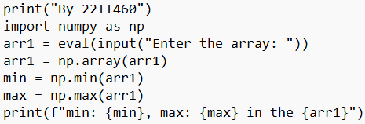

**Output:**

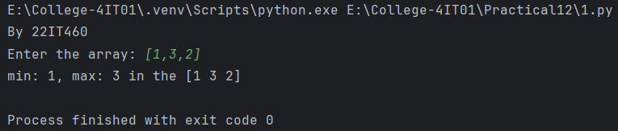

1. **Write a program to extract common item from two different array using NumPy.**

**Code:**

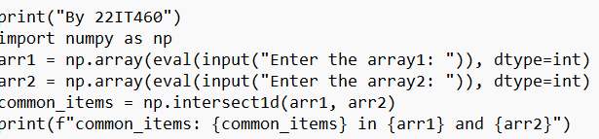

**Output:**

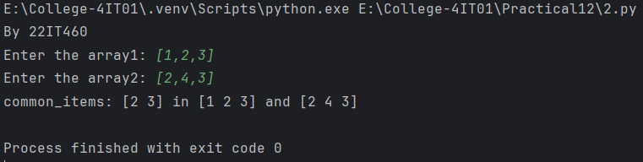

1. **Develop a Python program that utilizes NumPy to generate an array of random numbers, compute basic statistics such as mean, median, and standard deviation, and visualize the data using histograms or plots.**

**Code:**

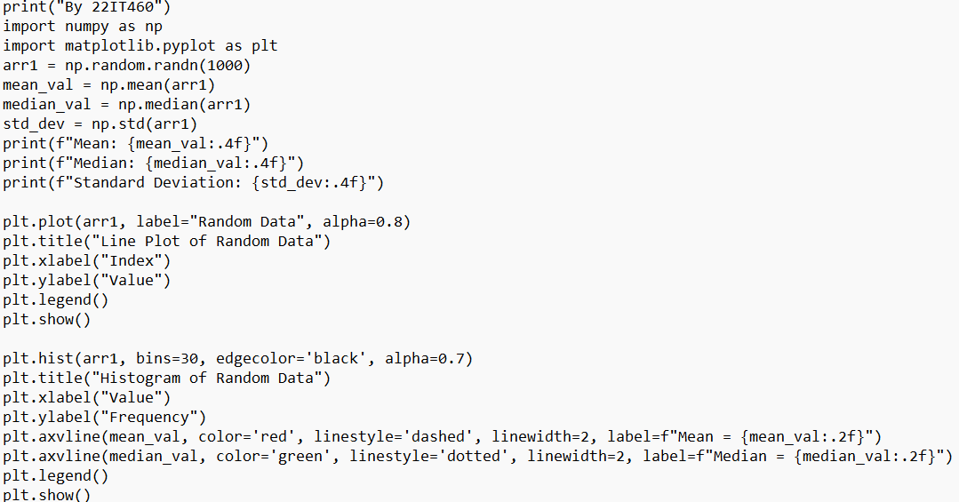

**Output:**

