**Practical 3**

**Aim: Loops**

1. **Write a program to print all even numbers between 1 to 100 using while loop.**

**Code:**

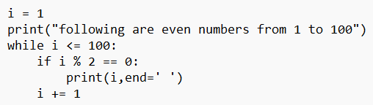

**Output:**

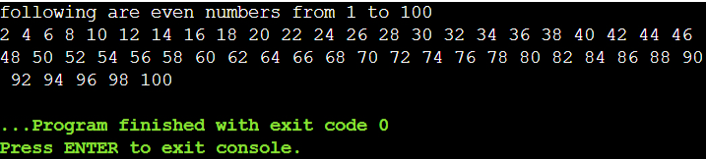

1. **Write a program to print all prime numbers between 1 to 50 using for loop.**

**Code:**

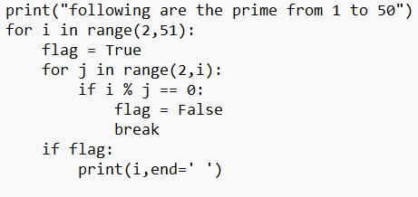

**Output:**

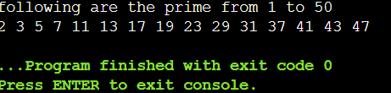

1. **Write a program to print the pattern ‘D’**

**Code:**

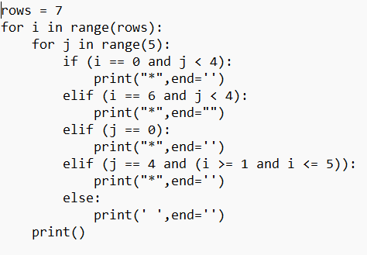

**Output:**

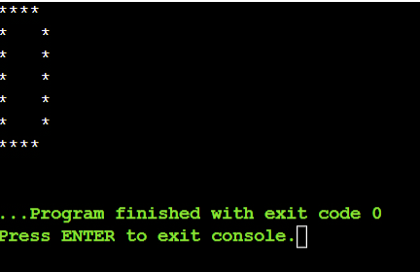

1. **Write a program to calculate factorial of a number.**

**Code:**

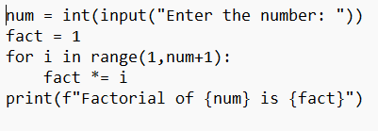

**Output:**

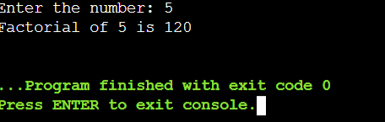

1. **Write a program to takes in a number and finds the sum of digits in a number.**

**Code:**

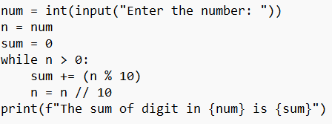

**Output:**

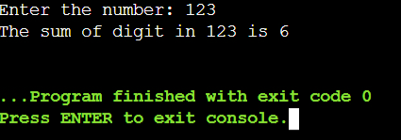

1. **Write a program to print bottom to top pyramid of ‘$’.**

**Code:**

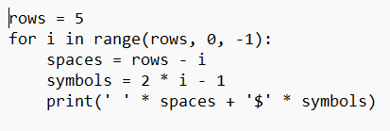

**Output:**

