**Practical 4**

**Aim: Tuple, List and Dictionaries**

1. **Write a program to find min and max value from list of tuples.**

**Code:**

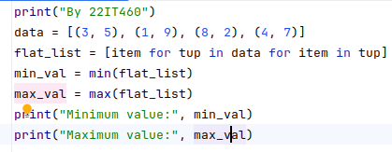

**Output:**

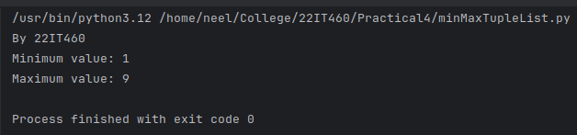

1. **Write a program to convert Celsius to Fahrenheit and vice versa using tuples for unit conversions.**

**Code:**

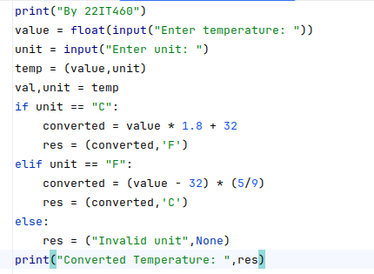

**Output:**

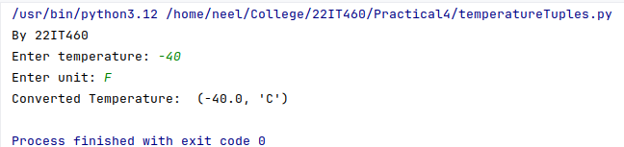

1. **Write a program to sum all the items in a list.**

**Code:**

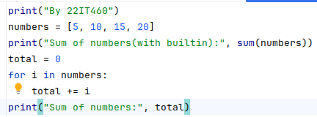

**Output:**

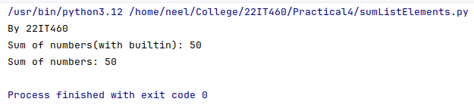

1. **Write a program to Find the Union of Two Lists.**

**Code:**

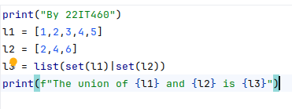

**Output:**

1. 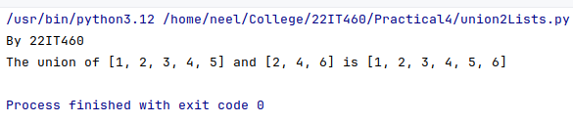**Write a program to transpose a matrix using nested lists.**

**Code:**

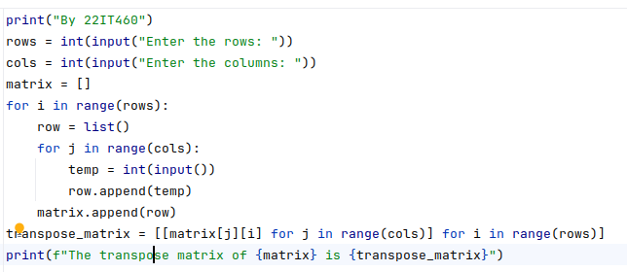

**Output:**

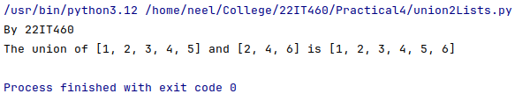

1. **Write a program to combine two dictionary adding value of a common key.**

**Code:**

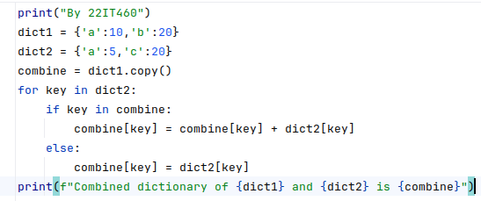

**Output:**

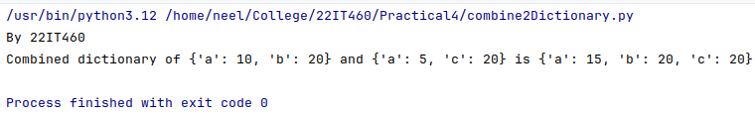

1. **Write a program to Multiply All the Items in a Dictionary.**

**Code:**

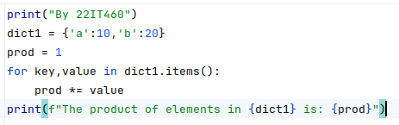

**Output:**

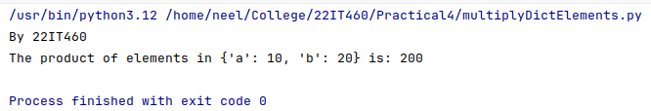

1. **Write a program to to find the factorial of a number using recursion and store result with a dictionary.**

**Code:**

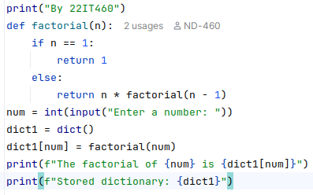

**Output:**

