**Practical 5**

**Aim: String (with and without using inbuilt function)**

1. **Write a program to remove left and right hand side space form the string.**

**Code:**

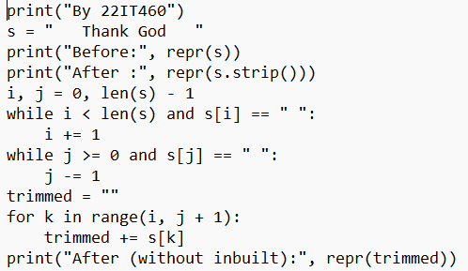

**Output:**

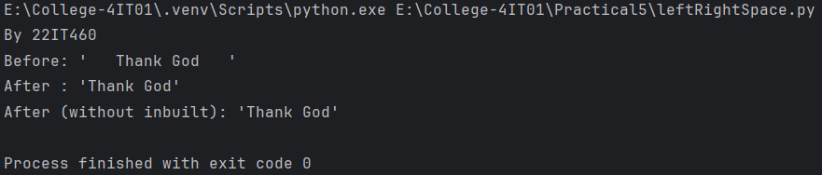

1. **Write a program to find the longest word in a string.**

**Code:**

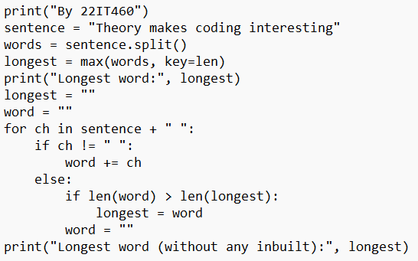

**Output:**

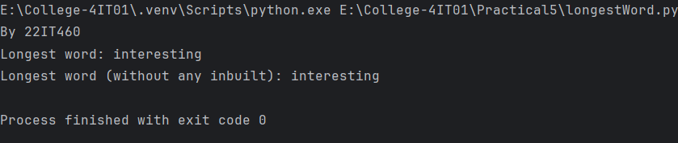

1. **Write a program to count the number of vowels in a string.**

**Code:**

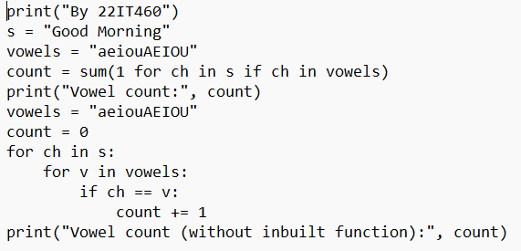

**Output:**

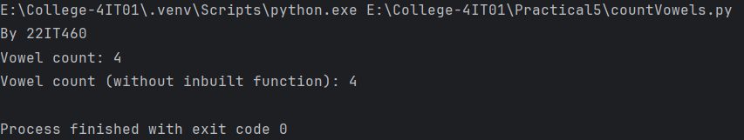

1. **Write a program to reverse a given String without using function.**

**Code:**

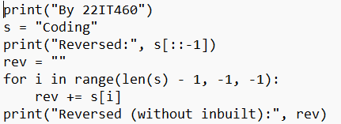

**Output:**

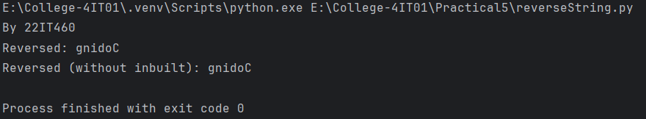

1. **Write a program to check if a string is a palindrome.**

**Code:**

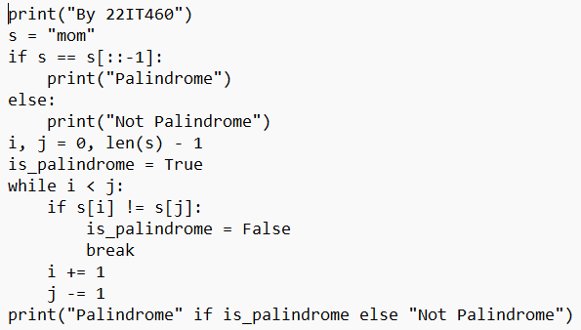

**Output:**

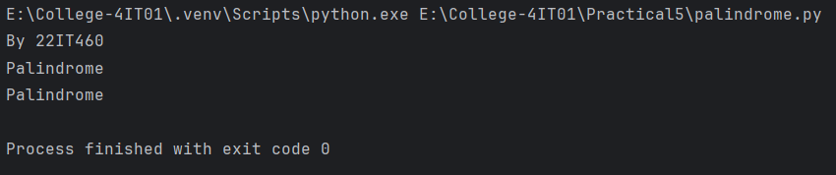

1. **Write a program to check if two strings are anagrams of each other.**

**Code:**

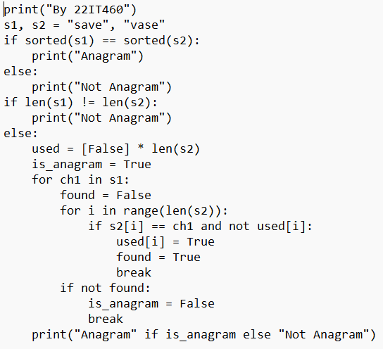

**Output:**

