**Practical 6**

**Aim: Functions**

1. **Write a program to create a function that takes a number as a parameter and check the number is prime or not.**

**Code:**

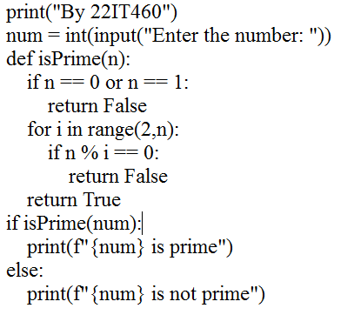

**Output:**

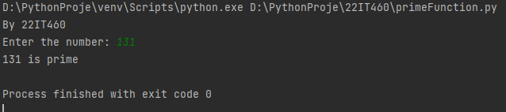

1. **Write a program to create a function that takes a list of numbers as a parameter and returns the sum of squares of all numbers.**

**Code:**

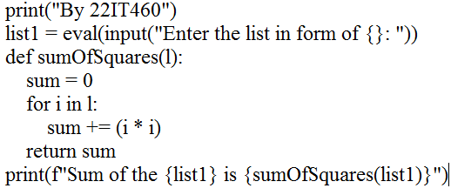

**Output:**

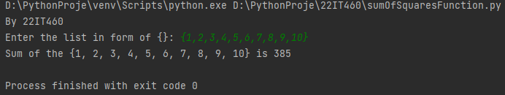

1. **Write a program to calculate total upper case and lower case letter of a given string.**

**Code:**

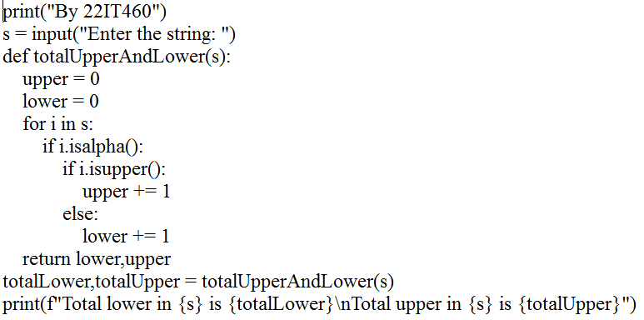

**Output:**

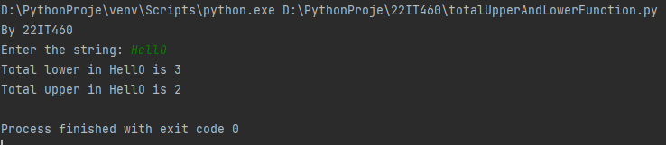

1. **Write a program to create a function that takes a list of integers as a parameter and calculates the product of all the numbers.**

**Code:**

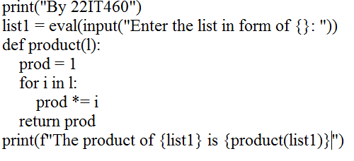

**Output:**

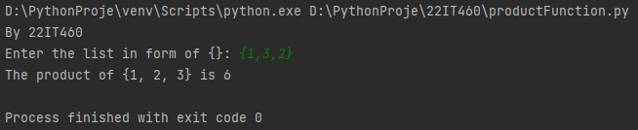

1. **Write a program to create a function that takes two strings as parameters and checks if the first string ends with the second string.**

**Code:**

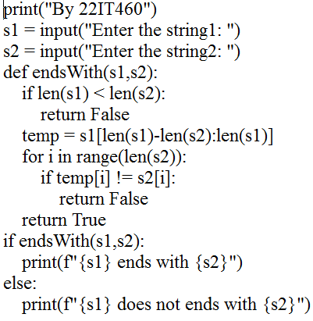

**Output:**

