**Practical 7**

**Aim: OOPs**

1. **Write a program to add complex number using class and object.**

**Code:**

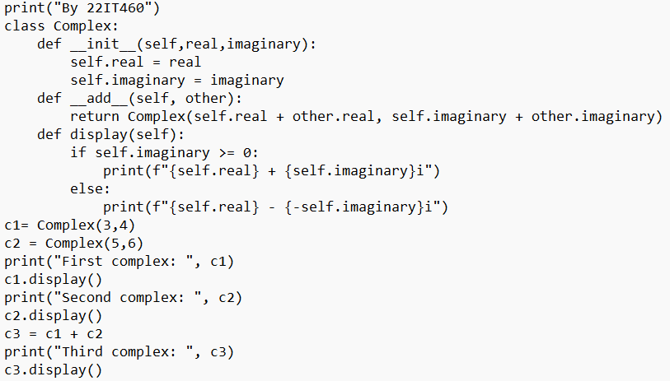

**Output:**

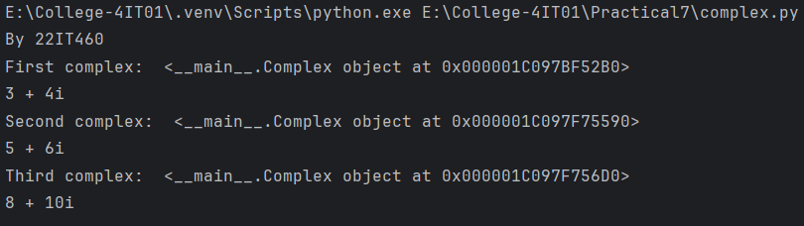

1. **Write a program to check string is palindrome or not using class.**

**Code:**

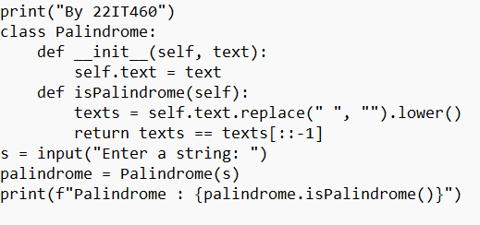

**Output:**

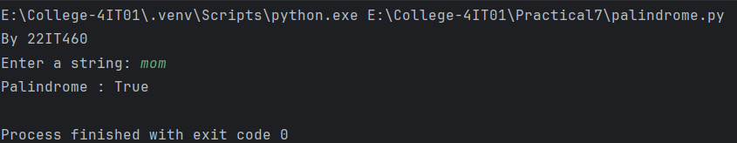

1. **Write a program to multiply the positive numbers using multiple inheritance.**

**Code:**

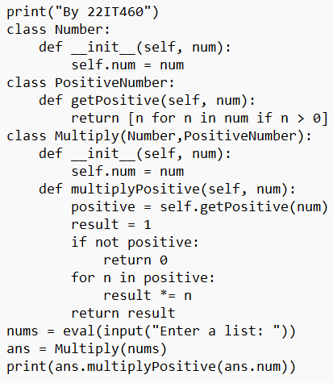

**Output:**

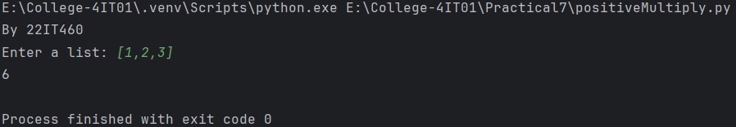

1. **Write a program to create employee salary system for PF, TDS and 80C.**

**Code:**

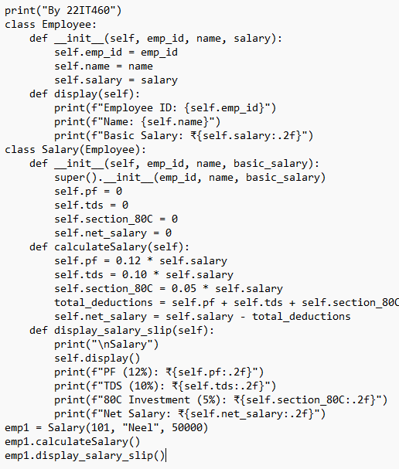

**Output:**

