**Practical 8:**

**Aim: Exceptions**

1. **Write a program to handle division by zero in a Python program that also validates numeric input to avoid ZeroDivisionError and ValueError.**

**Code:**

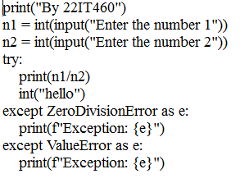

**Output:**

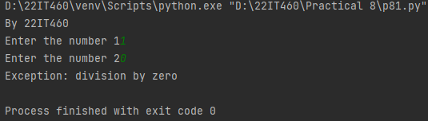

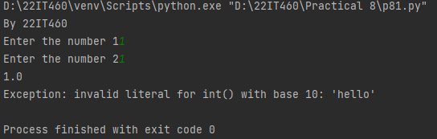

1. **Write a program to create a custom Python exception class MyCustomException with detailed error messages and context-specific information for exceptional conditions.**

**Code:**

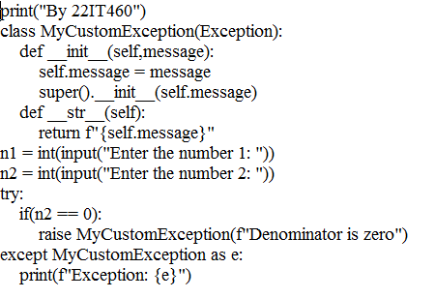

**Output:**

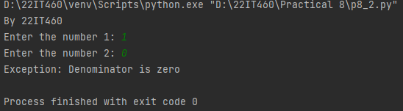

1. **Write a program to incorporate exception handling for various errors like FileNotFoundError, PermissionError, and TypeError during input processing and operations.**

**Code:**

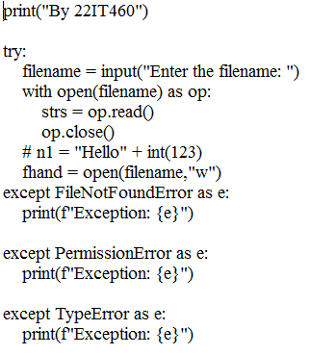

**Output:**

