**Practical 9**

**Aim: File**

1. **Write a program to create a file and store given text and calculate total number of line and space and display it on shell.**

**Code:**

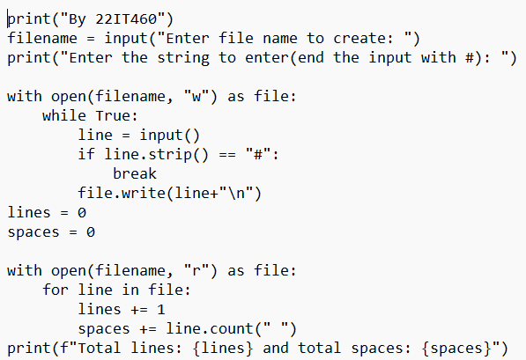

**Output:**

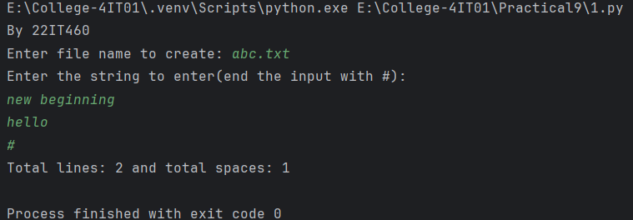

1. **Write a program to store content of two file into one file and do addition of all the digit available in file.**

**Code:**

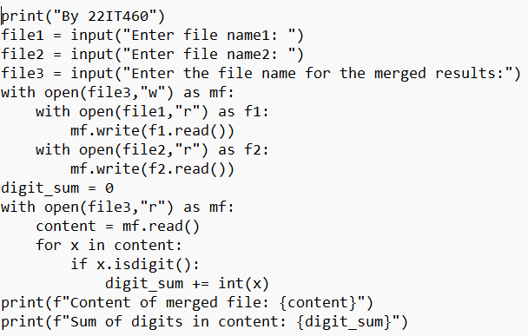

**Output:**

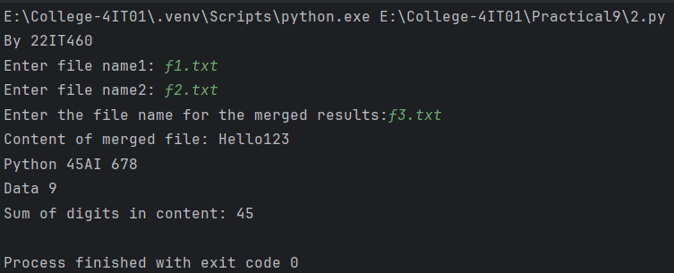

1. **Write a program to reads a file, generates a histogram (frequency distribution) of all letters (both uppercase and lowercase) present in the file, and displays this histogram.**

**Code:**

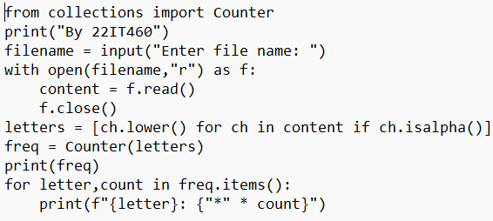

**Output:**

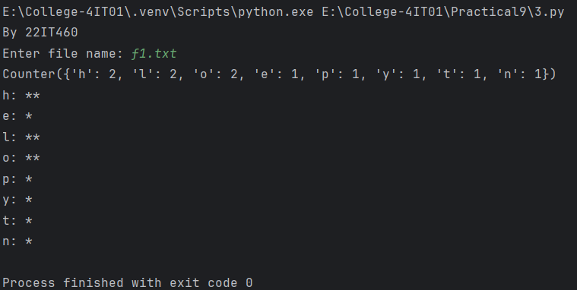

1. **Write a program to Calculates the size of multiple files in a directory, generates a report listing file names along with their sizes (in bytes, kilobytes, and megabytes), and saves this report to a text file.**

**Code:**

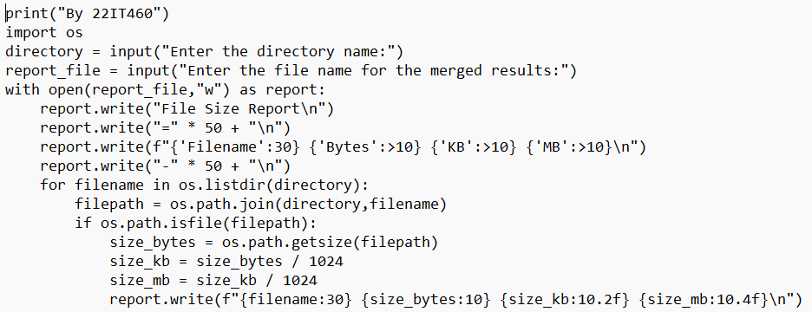

**Output:**

