**Dela Cruz, Joshua O.**

**BSCS 4C**

**Seatwork #03**

**9. Construct an nfa with three states that accepts the language {ab, abc}∗.**

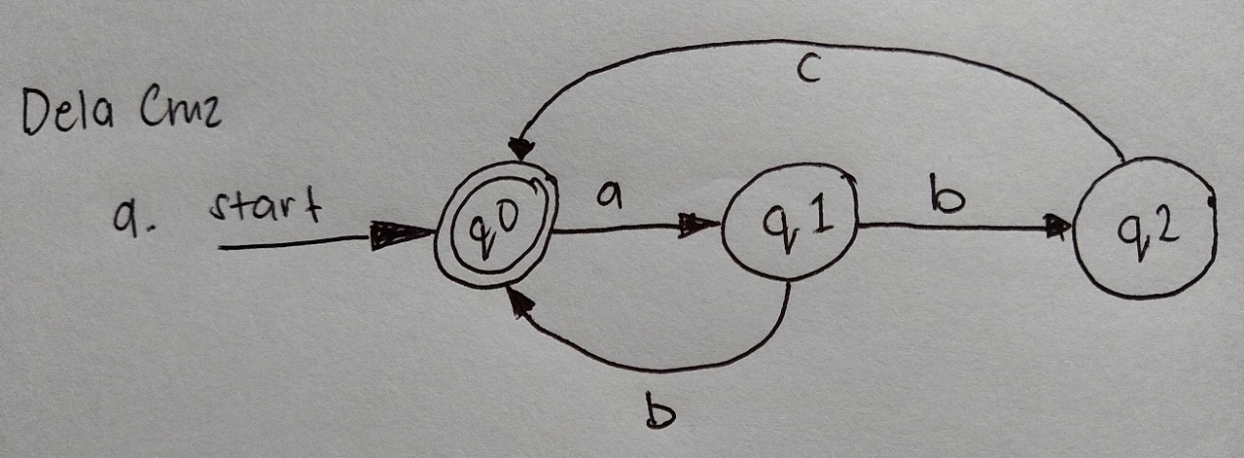

**10. Do you think Exercise 9 can be solved with fewer than three states?**

No, since only that exact language can be accepted by 3 states in this NFA.

**11. (a) Find an nfa with three states that accepts the language**

**L = {an : n ≥ 1} ∪ { bmak: m ≥ 0, k ≥ 0 }**

**Answer:**

L = {an : n ≥ 1} ∪ { bmak: m ≥ 0, k ≥ 0 }.

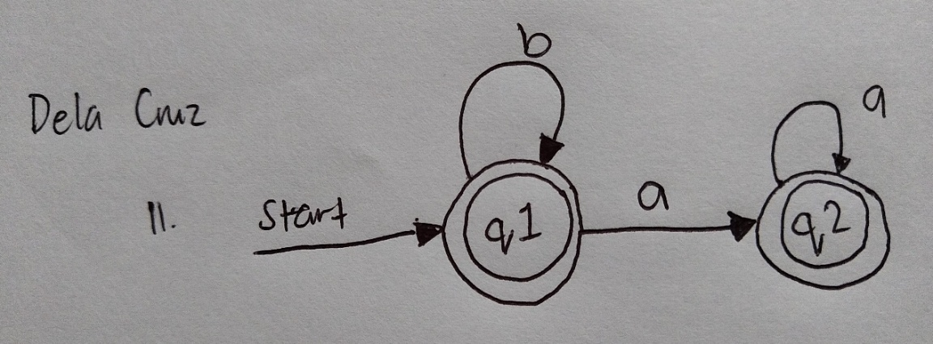Their union will therefore be : { bmak: m ≥ 0, k ≥ 0 }

**(b) Do you think the language in part (a) can be accepted by an nfa with fewer than three states?**

As the question asks for an NFA, we are not required to show all transitions. A dead state results from missing links.

**12. Find an nfa with four states for**

**L = {an : n ≥ 0} ∪ {bna : n ≥ 1}.**

**Answer:**

L = {an : n ≥ 0} ∪ {bna : n ≥ 1}.

= ( a*+bb*a )

