CONSTRUCTION CHANGE ORDER
AND RFI ANALYTICS
Root-Cause, Cycle-Time, and Impact Analysis
for Construction Decision Workflows

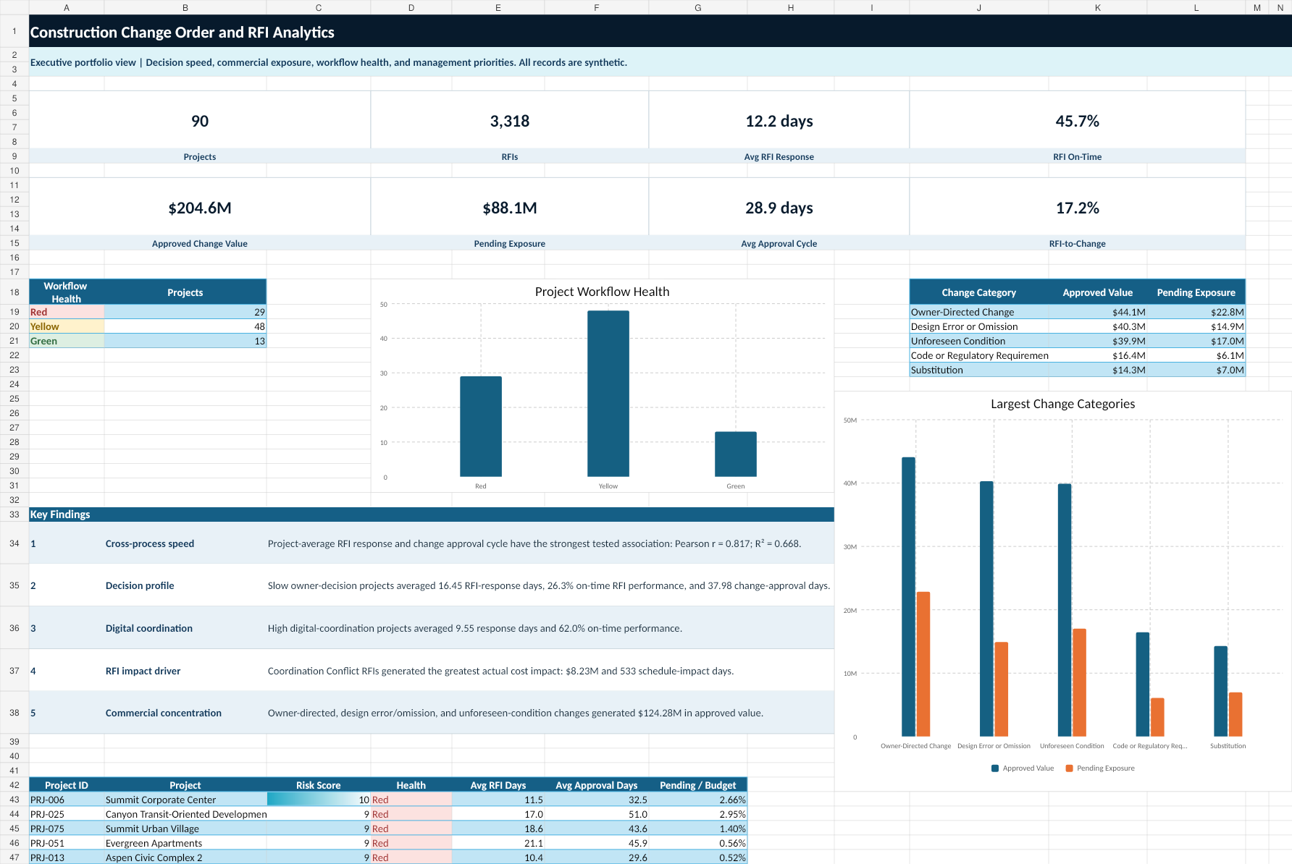
Project code: IP-DA-002
Sponsor: In Project LLC
Analyst: Narciso M. Dickson, PMP®
Synthetic-data disclosure: All project names, organizations, people, budgets, schedules, RFIs, changes, and performance records are fictional. The case study does not represent actual In Project LLC clients or confidential construction records.

Contents
1. Executive Summary
2. Business Problem and Analytical Questions
3. Professional Analytics Lifecycle
4. Dataset and Relational Model
5. Data Preparation and Quality
6. Analytical Results
7. RFI Performance
8. Change Order and Commercial Exposure
9. Workflow Bottlenecks
10. Project Priority and Statistical Evidence
11. Dashboards and Communication
12. Act Plan and Management Recommendations
13. Governance, Controls, and Automation
14. Limitations and Responsible AI
15. Conclusion and Sources

1. Executive Summary
This case study analyzes construction RFI and change-order workflows as connected decision systems. The purpose is to identify where response, review, revision, approval, and forecast processes create commercial and schedule exposure and to convert those findings into an implementation-ready management plan.
Portfolio | RFI Performance | Change Performance | Workflow Health
90 projects  3,318 RFIs  1,119 changes | 12.21 avg. days  45.7% on time  295 overdue open | $204.57M approved  $88.10M pending  28.91 avg. days | 29 Red  48 Yellow  13 Green

Principal findings
- Project-average RFI response and project-average change approval cycle produced the strongest tested portfolio relationship: Pearson r = 0.817 and R² = 0.668.
- Slow owner-decision projects averaged 16.45 RFI-response days and 37.98 change-approval days.
- High digital-coordination projects averaged 9.55 RFI-response days and 62.0% on-time performance.
- Coordination Conflict RFIs generated the greatest actual RFI cost impact, approximately $8.23 million.
- Owner-Directed Change, Design Error or Omission, and Unforeseen Condition generated approximately $124.28 million in approved change value.
- Submission-only attributes did not reliably predict later RFI-to-change linkage; the exploratory model is not approved for production use.

2. Business Problem and Analytical Questions
Construction RFIs and change orders move through multiple reviews, handoffs, revisions, pricing steps, and approval gates. When decision workflows are slow or incomplete, projects may experience unpriced work, forecast uncertainty, delayed field decisions, rework, and commercial disputes.

Primary business question
Which change-order causes and RFI workflow conditions create the greatest cost and schedule exposure, and where should management intervene to improve response and approval performance?

Stakeholder decisions
Stakeholder | Decision need
Executive Sponsor | Prioritize intervention and allocate decision resources.
Project Controls Lead | Monitor health, cycle time, exposure, and forecast incorporation.
Design Manager | Improve RFI quality, response accountability, and coordination.
Change Manager | Control pricing, aging, negotiation, approval, and documentation.
Project Manager | Own project recovery actions and unresolved decisions.
Data Analyst | Maintain reproducible metrics, data quality, dashboards, and alerts.

3. Professional Analytics Lifecycle
The project uses the six-phase Ask–Prepare–Process–Analyze–Share–Act structure. Professional terminology from other frameworks is included to show conceptual alignment without treating the models as identical.
Project phase | CRISP-DM | DMAIC | Microsoft | PMI governance
Ask | Business Understanding | Define | Business Understanding | Initiating / Planning
Prepare | Data Understanding | Measure | Data Acquisition and Understanding | Planning
Process | Data Preparation | Measure / early Analyze | Data Acquisition and Understanding | Executing / Monitoring
Analyze | Modeling and Evaluation | Analyze | Modeling | Executing / Monitoring
Share | Evaluation | Analyze / Improve design | Customer Acceptance | Stakeholder engagement
Act | Deployment | Improve and Control | Deployment / Customer Acceptance | Executing / Monitoring / Closing
The practical workflow is iterative. Data quality, analytical logic, business interpretation, and action planning may require returning to earlier phases.

4. Dataset and Relational Model
A deterministic synthetic dataset was created because public datasets rarely combine project attributes, RFI lifecycle dates, change lifecycle dates, workflow events, impact values, forecast-incorporation dates, and explicit RFI-to-change links.
Table | Clean records | Grain
Projects | 90 | One row per project
RFI Log | 3,318 clean | One row per RFI
Change Orders | 1,119 clean | One row per change item
Workflow Events | 11,286 clean | One row per transition or handoff
RFI Change Links | 677 clean | One row per explicit relationship

Relational structure
Projects relate one-to-many to RFIs, change orders, and workflow events. RFIs and changes relate many-to-many through the RFI Change Links bridge. The bridge prevents direct-join duplication and supports conversion analysis.

5. Data Preparation and Quality
The raw package contained 16,536 records. The Process phase produced 16,490 clean records after removing 28 duplicates and quarantining 18 records whose relationships could not be trusted.
Control | Result
Raw records | 16,536
Clean records | 16,490
Duplicate removals | 28
Quarantined records | 18
Cleaning actions | 226
Quality checks | 22 of 22 passed
Foreign-key violations | 0 unresolved
SQLite integrity | ok
Raw files were preserved. Cleaning occurred only in clean and processed layers. Invalid parent relationships were quarantined rather than guessed, and repairs were made only when workflow evidence was unambiguous.

6. Analytical Results
The analysis combined descriptive statistics, aging, cycle-time analysis, Pareto comparisons, workflow-stage duration, project-level transparent risk scoring, correlation tests, and exploratory classification.
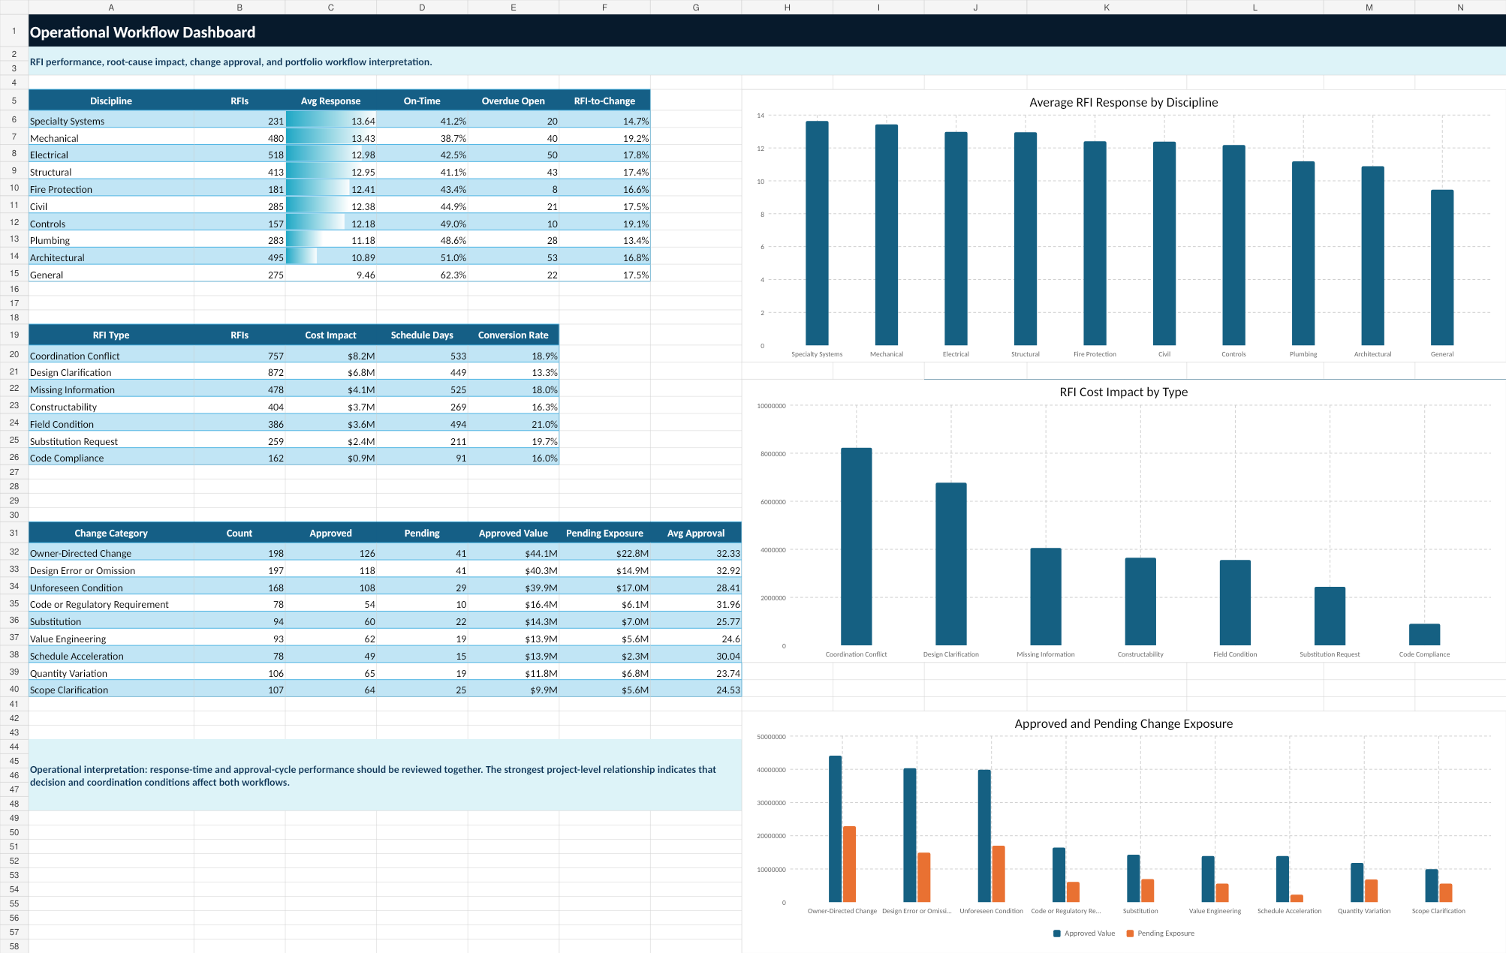
Figure 1. Operational workflow dashboard.

7. RFI Performance
The portfolio contained 3,318 RFIs. Average final response time was 12.21 days and the on-time rate was 45.7%.
Discipline | RFIs | Avg. days | On-time | Cost impact
Specialty Systems | 231 | 13.64 | 41.2% | $1.87M
Mechanical | 480 | 13.43 | 38.7% | $4.94M
Electrical | 518 | 12.98 | 42.5% | $5.15M
Structural | 413 | 12.95 | 41.1% | $2.97M
Fire Protection | 181 | 12.41 | 43.4% | $2.02M
Civil | 285 | 12.38 | 44.9% | $2.36M
Mechanical, Electrical, Structural, and Specialty Systems displayed longer average response cycles than the portfolio average. The result supports discipline-specific response governance rather than a single undifferentiated backlog target.

8. Change Order and Commercial Exposure
The portfolio contained 1,119 change orders. Approved value was $204.57 million and pending absolute exposure was $88.10 million.
Category | Count | Approved value | Pending exposure | Avg. approval
Owner-Directed Change | 198 | $44.09M | $22.85M | 32.3 days
Design Error or Omission | 197 | $40.30M | $14.91M | 32.9 days
Unforeseen Condition | 168 | $39.88M | $17.02M | 28.4 days
Code or Regulatory Requirement | 78 | $16.44M | $6.09M | 32.0 days
Substitution | 94 | $14.28M | $6.96M | 25.8 days
Value Engineering | 93 | $13.92M | $5.60M | 24.6 days

9. Workflow Bottlenecks
Workflow-event analysis distinguishes volume from duration. A stage may accumulate total time because it is slow, because it has high volume, or both.
Item | Status | Assigned role | Avg. stage days | Total stage days
Change Order | Approved | Project Manager | 20.31 | 14335.35
RFI | Closed | Subcontractor | 9.93 | 9411.6
RFI | Closed | General Contractor | 9.57 | 8854.16
Change Order | Returned for Revision | Cost Manager | 16.7 | 8552.62
Change Order | Submitted | Owner Representative | 7.03 | 7850.68
RFI | Returned for Clarification | General Contractor | 11.95 | 4109.42
RFI | Returned for Clarification | Subcontractor | 10.86 | 3345.12
RFI | Answered | General Contractor | 9.48 | 3319.07
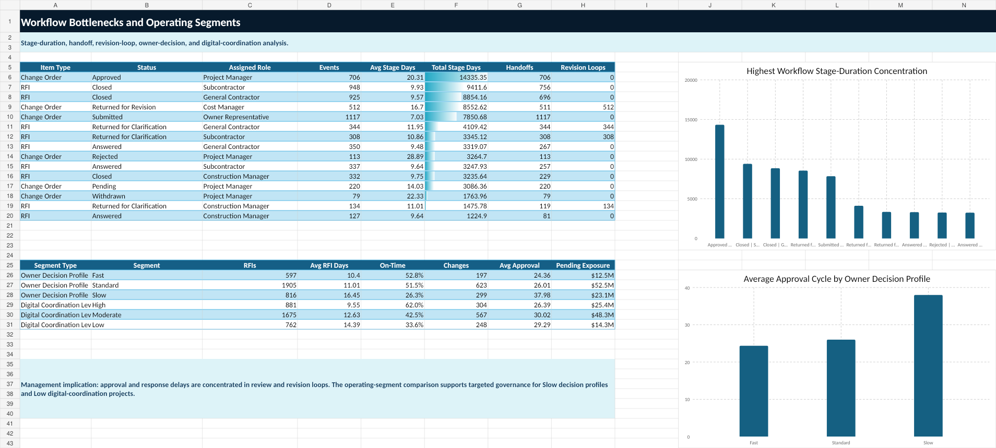

10. Project Priority and Statistical Evidence
The project-health framework uses seven transparent indicators. Each indicator receives 0 points when Green, 1 when Yellow, and 2 when Red. Overall status is Green for 0–2 points, Yellow for 3–5 points, and Red for 6 or more.
Rank | Project | Score | RFI days | Approval days | Pending / budget
1 | Summit Corporate Center | 10 | 11.5 | 32.5 | 2.66%
2 | Canyon Transit-Oriented Development | 9 | 17.0 | 51.0 | 2.95%
3 | Summit Urban Village | 9 | 18.6 | 43.6 | 1.40%
4 | Evergreen Apartments | 9 | 21.1 | 45.9 | 0.56%
5 | Aspen Civic Complex 2 | 9 | 10.4 | 29.6 | 0.52%
6 | Evergreen Town Center | 8 | 17.0 | 35.6 | 1.83%
7 | Silver Creek Urban Village 2 | 8 | 12.3 | 39.3 | 1.40%

Statistical interpretation
Relationship | Method | Statistic | Interpretation
Project avg. RFI response vs avg. approval cycle | Pearson r | 0.817 | Strong positive portfolio-level association
Project avg. RFI response vs avg. approval cycle | Spearman ρ | 0.804 | Strong monotonic association
RFI revisions vs response time | Spearman ρ | 0.432 | Moderate positive association
Change revisions vs approval time | Spearman ρ | 0.468 | Moderate positive association
Response quality vs response time | Spearman ρ | -0.510 | Longer cycles associated with lower quality

Exploratory models
The submission-only logistic model achieved mean cross-validated AUC 0.510, approximately chance level. A diagnostic model using response, revision, quality, and impact indicators improved AUC to 0.631. Neither model is approved for production use.

11. Dashboards and Communication
The Share phase created executive, operational, workflow, and project-priority dashboards, plus Power BI and Tableau build specifications.
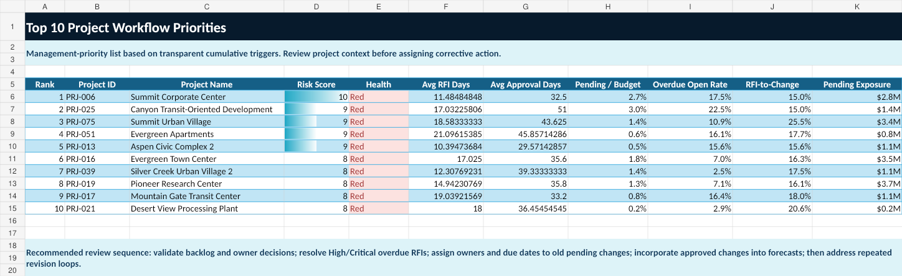
The dashboard design emphasizes decisions required, responsible roles, exposure, cycle time, and evidence. Health is communicated through both color and status text.

12. Act Plan and Management Recommendations
The Act phase proposes a 30/60/90-day operating plan. Targets are management objectives for this synthetic case study and require validation before real use.
Measure | Baseline | 90-day target
RFI on-time rate | 45.7% | 70.0%
Average RFI response | 12.21 days | 10.0 days
Average change approval | 28.91 days | 24.0 days
Pending exposure | $88.10M | ≤$66.08M
Overdue open RFIs | 295 | ≤148
Forecast incorporation lag | 6.58 days | ≤5.0 days
Old pending changes >35 days | 219 | ≤131
Red projects | 29 | ≤18

Recommended sequence
- Days 0–30: stabilize exceptions, validate backlog, establish decision forums, and reconcile forecast gaps.
- Days 31–60: reduce backlog, introduce quality gates, review root causes, and pilot digital coordination.
- Days 61–90: standardize reporting, generate governed alerts, close priority actions, and measure benefits.
- Days 91–180: sustain controls, expand successful pilots, and review thresholds with evidence.

13. Governance, Controls, and Automation
The governance model uses daily exceptions, twice-weekly RFI coordination, weekly change and project-health reviews, weekly forecast reconciliation, monthly executive and root-cause reviews, and quarterly methodology review.
Automation output | Count | Severity
Field-Impact Overdue RFI | 71 | Critical
High/Critical Overdue RFI | 84 | Critical
Red Project | 29 | Critical
High Pending Exposure | 15 | Critical
Approved Not Incorporated | 56 | High
Forecast Incorporation Lag | 299 | High
Old Pending Change | 219 | High
The tested alert script generated 773 synthetic management alerts: 199 Critical and 574 High. This demonstrates exception generation; it does not create a live scheduled service or send external notifications.

14. Limitations and Responsible AI
- All data is synthetic and is not an industry benchmark.
- Thresholds and targets are management assumptions for the case study.
- Associations do not establish causality.
- Project-level aggregation may conceal item-level variation.
- The backlog is intentionally severe in portions of the synthetic dataset.
- The exploratory models require real governed data, temporal validation, leakage controls, calibration, subgroup review, monitoring, and stakeholder acceptance.
- No automated alert should be sent externally until recipients, suppression rules, escalation, and data governance are approved.

15. Conclusion and Sources
The case study demonstrates how construction project-management knowledge and data analytics can be combined to move from raw workflow records to reproducible analysis, executive communication, and implementation-ready controls.

Professional capability demonstrated
- Construction project controls and workflow governance
- Relational data design, cleaning, and validation
- Excel, SQL, SQLite, and Python analytics
- Power BI and Tableau dashboard planning
- Statistical interpretation and model governance
- Management action planning, RACI, KPIs, and benefits realization
- Responsible AI leadership and human oversight

Methodology references
IBM CRISP-DM overview: https://www.ibm.com/docs/en/spss-modeler/18.6.0?topic=dm-crisp-help-overview
ASQ DMAIC: https://asq.org/quality-resources/dmaic
Microsoft Data Science Lifecycle: https://learn.microsoft.com/en-us/shows/dev-intro-to-data-science/what-is-the-data-science-lifecycle-2-of-28
PMI Process Groups: https://www.pmi.org/standards/process-groups

End of Report

