CONSTRUCTION PROJECT CONTROLS
ANALYTICS
Early Warning Analysis for Cost and Schedule Performance

Prepared by | Narciso M. Dickson
Organization | In Project LLC
Framework | Google Data Analytics: Ask, Prepare, Process, Analyze, Share, Act
Date | July 2026

Synthetic-data disclosure: all projects, organizations, people, budgets, schedules, changes, and RFIs in this case study are fictional. The analysis demonstrates methodology and decision support; it does not represent actual client performance.

Professional portfolio | Construction analytics | Project controls | Executive reporting

Contents
Executive Summary
1. Project Overview and Business Task
2. Ask Phase
3. Prepare Phase
4. Process Phase
5. Analyze Phase
6. Share Phase
7. Act Phase
8. Automation Strategy
9. Limitations, Ethics, and Use Controls
10. Conclusion
Appendix A - Metric Definitions and Thresholds
Appendix B - Top 10 Priority Projects
Appendix C - Deliverables and File Structure
References
The report is designed as a portfolio-ready case study and an In Project LLC capability demonstration. Detailed datasets, SQL, workbooks, dashboards, and automation files are included in the final project package.

Executive Summary
Construction organizations often review budgets, schedules, change orders, RFIs, contingency, and progress through separate reports. This fragmentation can delay recognition of deteriorating performance and make it difficult for leaders to prioritize intervention.
This case study developed a synthetic relational portfolio of 75 U.S. construction projects, cleaned and validated 3,899 raw records, calculated project-control and earned-value indicators, communicated the results through executive dashboards, and converted the findings into a 90-day management and automation program.
Portfolio KPI | Result
Projects | 75
Portfolio BAC | $5,831,436,600
Forecast EAC | $6,586,989,966
Forecast variance | $755,553,366 unfavorable
Forecast overrun | 13.0%
Weighted CPI | 0.884
Weighted SPI | 0.987
Average forecast delay | 33.7 days
Health distribution | 50 Red / 13 Yellow / 12 Green

Principal Findings
- Cost performance was the principal exposure. Weighted CPI was 0.884, and aggregate EAC was 13.0% above BAC.
- Calendar delay remained material even though weighted SPI was near 1.00; average forecast delay was 33.7 days.
- Contingency burn ratio had the strongest tested association with forecast overrun (Pearson r = 0.901).
- Average RFI response time had a moderate positive association with schedule delay (Pearson r = 0.517).
- Approved change value totaled $151,618,700, with owner-directed changes producing the largest approved value.
- The highest-priority projects showed simultaneous cost inefficiency, forecast overrun, delay, and contingency exhaustion.

Recommended Decision
Approve a 90-day Project Controls Recovery and Automation Program: intervene on the top 10 projects, standardize cost/schedule/contingency/change/RFI governance, automate Power BI refresh and alerts, and pilot governed predictive analytics with In Project AI.

1. Project Overview and Business Task

1.1 Business Scenario
In Project LLC sought a portfolio-ready demonstration of how construction project-control data can support earlier intervention. The simulated source environment included budgets, monthly earned-value data, completion forecasts, change orders, RFIs, and contingency use.

1.2 Business Task
Which construction projects are most at risk of exceeding their approved budgets or planned completion dates, and what project-control indicators provide the earliest evidence of that risk?

1.3 Stakeholders
- Executive leadership and portfolio owners
- Project-controls management
- Project managers and superintendents
- Cost managers and schedulers
- Design managers and discipline leads
- In Project LLC and portfolio reviewers

1.4 Analytical Framework
Phase | Purpose
Ask | Define the problem, stakeholders, scope, questions, KPIs, and success criteria.
Prepare | Select a transparent data strategy, relational model, dictionary, and integrity rules.
Process | Profile, clean, validate, and document transformations while preserving raw data.
Analyze | Calculate project-control metrics, compare segments, test associations, and prioritize projects.
Share | Communicate portfolio exposure, project exceptions, patterns, and limitations.
Act | Assign owners, interventions, governance, automation, and implementation targets.

1.5 Scope
- Included: cost, schedule, EVM, forecasts, change orders, RFIs, contingency, project attributes, descriptive and diagnostic analytics.
- Excluded: actual client data, legal claims, safety, quality, subcontractor solvency, detailed cash flow, and production deployment.

2. Ask Phase

2.1 Problem Statement
Fragmented project-control information can cause late recognition of deteriorating cost and schedule performance, inconsistent prioritization, and weak executive visibility.

2.2 Primary and Supporting Questions
1. Which projects have the greatest forecast cost or schedule exposure?
2. Which projects have unfavorable CPI, SPI, EAC, VAC, or completion-date variance?
3. How do approved and pending changes affect exposure?
4. Are RFI response times or backlogs associated with schedule pressure?
5. Is contingency being consumed faster than physical progress?
6. Which indicators should trigger management intervention?

2.3 KPI Framework
Area | Measures
Cost | CPI, CV, EAC, ETC, VAC, forecast overrun, cost growth
Schedule | SPI, SV, forecast delay days, planned vs forecast completion
Change | Approved CO %, pending CO %, approval time, schedule impact
RFI | Average response days, late rate, open count, impact rate
Contingency | Utilization %, burn ratio
Decision | Green/Yellow/Red status and transparent priority rank

2.4 Initial Health Thresholds
Health | CPI/SPI | Forecast Overrun | Delay | Contingency | Burn Ratio
Green | CPI/SPI ≥ 0.95 | Overrun ≤5% | Delay ≤15 days | Contingency ≤75% | Burn ≤1.20x
Yellow | CPI/SPI 0.90-0.95 | Overrun >5%-10% | Delay >15-30 days | Contingency >75%-90% | Burn >1.20x-1.50x
Red | CPI/SPI <0.90 | Overrun >10% | Delay >30 days | Contingency >90% | Burn >1.50x
These thresholds are portfolio assumptions for the case study. They are not universal construction standards.

3. Prepare Phase

3.1 Data Strategy
A realistic synthetic dataset was selected because public construction datasets rarely provide monthly Planned Value, Earned Value, Actual Cost, contingency consumption, change-order detail, and RFI response data in one complete model. The synthetic approach enabled a transparent, reproducible portfolio without exposing confidential information.

3.2 Dataset Scope
Component | Scope
Projects | 75 intended unique projects
Reporting period | January 2022 through December 2025
Monthly performance | Approximately 1,743 clean records
Change orders | 553 clean records
RFIs | 1,514 clean records
Sectors | Residential, Commercial, Institutional, Industrial, Heavy Civil & Infrastructure, Mixed-Use
States | Ten western and southern U.S. states

3.3 Relational Model
Table | Grain | Primary Key | Relationship
Projects | One row per project | Project_ID | Parent table
Monthly Performance | One row per project/reporting month | Performance_Record_ID | Many-to-one with Projects
Change Orders | One row per change order | Change_Order_ID | Many-to-one with Projects
RFI Log | One row per RFI | RFI_ID | Many-to-one with Projects

3.4 Integrity, Privacy, and Bias Controls
- Unique parent and child identifiers
- Valid foreign-key relationships
- Logical date sequences
- Valid missingness distinguished from data errors
- No real client, employee, address, contract, or performance data
- Variation within every project type and delivery method
- No predetermined category automatically classified as successful or unsuccessful

4. Process Phase

4.1 Raw-to-Clean Profile
Table | Raw Rows | Clean Rows
Projects | 77 | 75
Monthly Performance | 1,747 | 1,743
Change Orders | 557 | 553
RFI Log | 1,518 | 1,514
Total | 3,899 | 3,885

4.2 Cleaning Results
- Removed 12 duplicate records.
- Quarantined 2 child records with unverifiable Project_ID values rather than guessing.
- Repaired 16 critical values using documented evidence-based rules.
- Standardized at least 111 categorical, date, identifier, currency, or percentage values.
- Passed all 22 final validation checks.
- Confirmed zero SQLite foreign-key violations.

4.3 Principal Treatments
Table | Treatment
Projects | Deduplicated Project_ID; standardized labels, dates, budgets, percentages; classified missing contract type as Unknown.
Monthly Performance | Removed duplicates; reconstructed six missing Actual_Cost values; corrected one impossible cumulative spike.
Change Orders | Standardized cause/status; repaired two approved values; corrected two impossible approval dates; quarantined one invalid project relationship.
RFIs | Standardized discipline/status; reconstructed three response dates; corrected two invalid dates; quarantined one invalid project relationship.

4.4 Reproducibility
Raw files were preserved unchanged. Cleaned CSVs, a cleaning log, validation results, a populated SQLite database, SQL quality checks, and process documentation were retained in the project package.

5. Analyze Phase

5.1 Metrics
The latest monthly performance record for each project was joined with aggregated change-order and RFI information. The analysis calculated CPI, SPI, CV, SV, EAC, ETC, VAC, cost growth, forecast overrun, delay days, change exposure, contingency use, contingency burn, RFI response performance, and health status.

5.2 Portfolio Results
Metric | Result
Projects | 75
Portfolio BAC | $5,831,436,600
Forecast EAC | $6,586,989,966
Forecast variance | $755,553,366 unfavorable
Forecast overrun | 13.0%
Weighted CPI | 0.884
Weighted SPI | 0.987
Average forecast delay | 33.7 days
Health distribution | 50 Red / 13 Yellow / 12 Green

5.3 Findings
Finding | Result
Cost efficiency | Weighted CPI 0.884; forecast variance $755.6M unfavorable.
Schedule | Weighted SPI 0.987; average delay 33.7 days.
Health | 50 Red, 13 Yellow, 12 Green.
Contingency | Burn ratio vs forecast overrun: r = 0.901, the strongest tested early-warning relationship.
RFI | Average response days vs delay: r = 0.517; response timeliness was more useful than raw RFI density.
Changes | Approved change value $151.6M; pending exposure $30.9M.

5.4 Important Interpretation Controls
- Correlation measures association and does not establish causation.
- Cost Growth % is definitionally linked to approved changes because Current Budget was constructed from Original Budget plus approved changes.
- SPI may converge near completion, so calendar delay must also be monitored.
- Group comparisons are portfolio observations, not industry benchmarks.

6. Share Phase

6.1 Executive Communication
The Share phase translated the analysis into an executive dashboard, operational diagnostic view, personal portfolio page, In Project LLC case-study page, GitHub-ready summary, and Tableau/Power BI build specification.
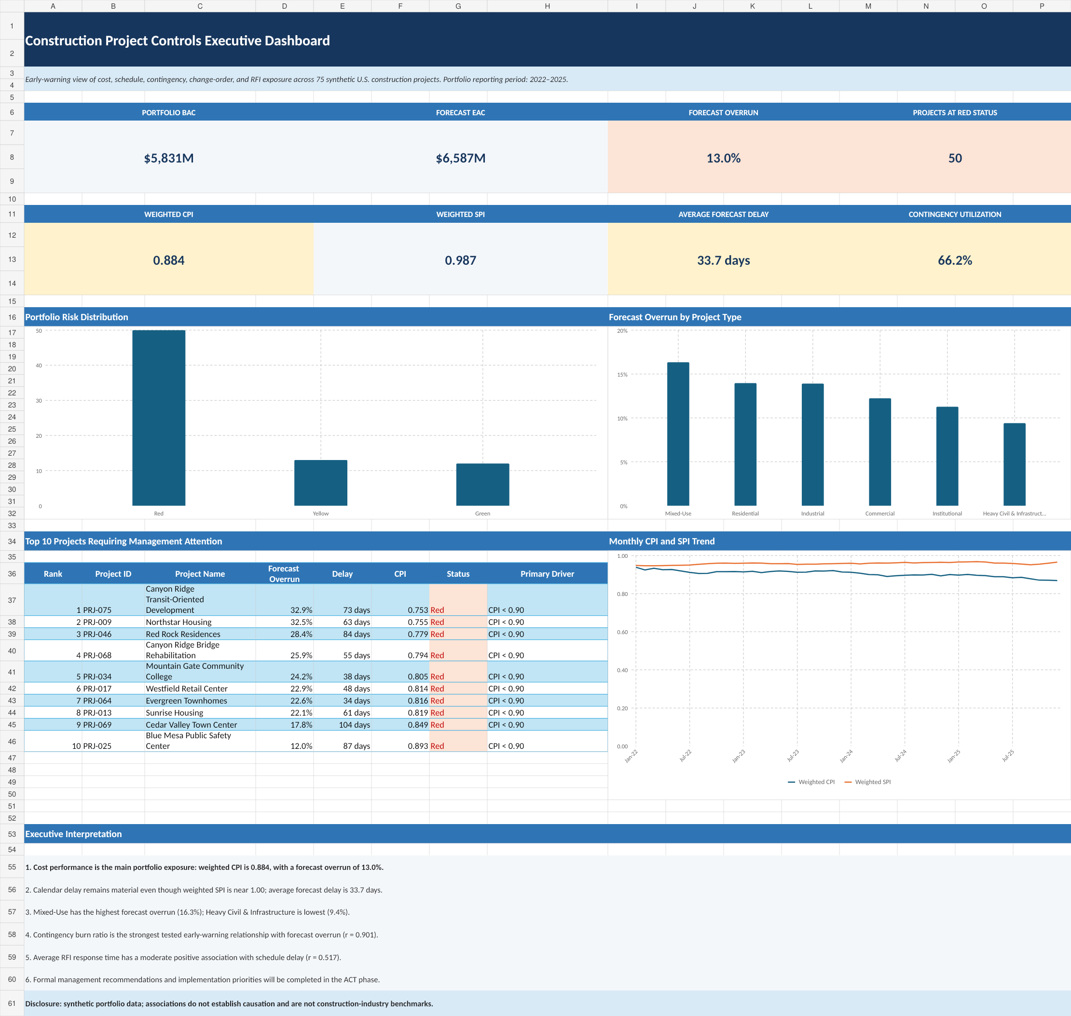
Figure 1. Executive project-controls dashboard.

6.2 Visual Narrative
1. Portfolio exposure and status
2. Projects requiring management attention
3. Performance by project type
4. Monthly cost and schedule trends
5. Operational causes and response performance
6. Limitations and ethical disclosure

6.3 Operational Insights
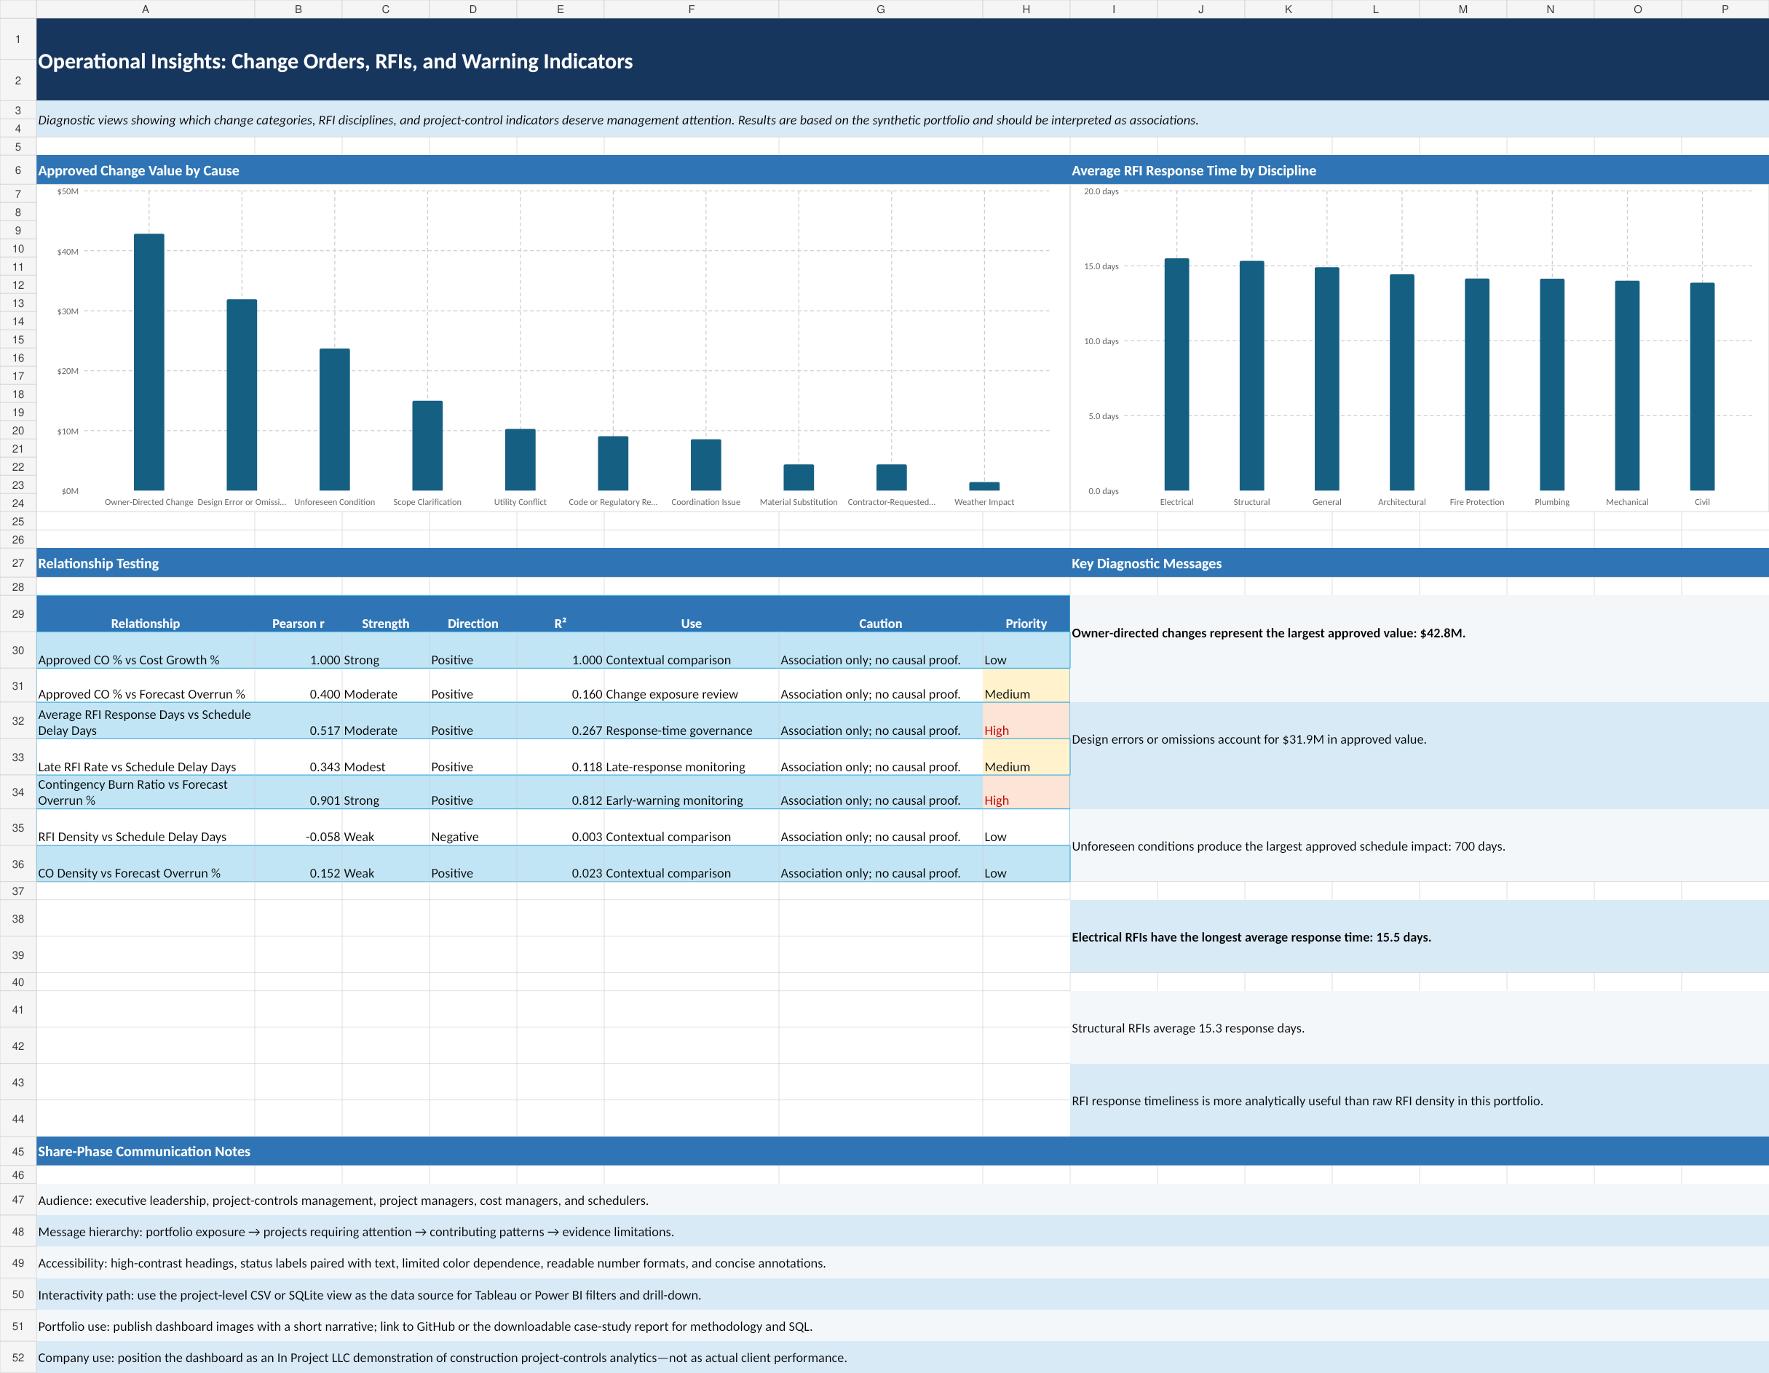
Figure 2. Change-order, RFI, and relationship diagnostics.

6.4 Accessibility and Ethics
- Status labels accompany color coding.
- High-contrast headings and readable number formats are used.
- Synthetic-data disclosure appears in every public-facing version.
- Correlation cautions are included next to relationship findings.
- The company-facing page demonstrates capability without claiming actual client results.

7. Act Phase

7.1 Recommended Program
Approve a 90-day Project Controls Recovery and Automation Program.

7.2 Immediate Management Actions
1. Assign accountable owners and recovery plans to the top 10 projects within 3 business days.
2. Independently review ETC and EAC assumptions for cost recovery.
3. Complete critical-path, constraint, procurement, and look-ahead schedule reviews.
4. Require approved risk/change linkage for every contingency drawdown.
5. Run an RFI closure sprint, prioritizing overdue High and Critical RFIs.
6. Establish weekly change triage and incorporate approved changes into forecasts within 5 business days.

7.3 30/60/90-Day Roadmap
Period | Focus | Deliverables
First 30 days | Control and recover | Top-10 interventions; EAC and schedule recovery; contingency controls; RFI sprint; change board; forecast certification.
Days 31-60 | Automate and govern | Publish Power BI; scheduled refresh; failure and threshold alerts; reporting views; refresh runbook.
Days 61-90 | Predict and integrate | Python risk pilot; prediction table; In Project AI read-only tools; security testing; pilot decision.

7.4 Proposed Targets
- 100% top-10 intervention ownership within 3 business days
- 100% weekly review coverage for Red projects
- CPI improvement of at least 0.02 over 90 days
- Average forecast-delay reduction of at least 10 days over 90 days
- At least 90% on-time response for High/Critical RFIs
- At least 98% Power BI scheduled-refresh success
- 100% source and reporting-date traceability for AI numerical answers
- Zero cross-client data leakage
These are proposed operating targets. They are not achieved results and must be tailored to actual client requirements.

8. Automation Strategy

8.1 Can the Work Be Automated?
Yes. Data preparation, alert generation, model execution, refresh, distribution, and selected actions can be automated. Dashboard design, governance decisions, investigation of exceptions, and approval of management actions remain human responsibilities.

8.2 Recommended Architecture
Level | Components | Outcome
Current local | Windows Task Scheduler + Python + CSV | Automates validation, scoring, alerts, and logs; Power BI Desktop refresh remains manual.
Power BI cloud | OneDrive/SharePoint + Power BI Service + Power Automate | Automates scheduled refresh, failure notifications, and contextual action flows.
Live data and AI | Supabase/PostgreSQL + scheduled Python/Azure Function + Power BI + In Project AI | Automates data updates, predictions, dashboard refresh, and governed agent retrieval.
Enterprise | Microsoft Fabric pipelines, notebooks, semantic models, and alerts | Adds coordinated scheduling, event triggers, enterprise governance, and scale.
Tableau | Tableau Cloud/Server + extracts or Bridge | Supports scheduled extract refresh and private-network connectivity.

8.3 Immediate Power BI Automation Path
1. Move the analytical CSV files from the local project folder to a controlled OneDrive for work or school or SharePoint folder, or connect Power BI to a governed database.
2. Publish the PBIX report to a Power BI workspace.
3. Configure data-source credentials and scheduled refresh.
4. Review refresh history and create failure escalation.
5. Create a Power Automate workflow for Red projects or overdue High/Critical RFIs.
6. Later, schedule the Python risk model and write its outputs to a prediction table.

8.4 What Remains Manual
- Validating new source-system schemas
- Approving business rules and thresholds
- Reviewing project exceptions
- Authorizing contingency, change, and recovery decisions
- Validating model performance and drift
- Managing client access and security

8.5 Current Cost Position
Power BI Desktop report authoring is available through the free Power BI offering. Publishing and sharing generally requires Power BI Pro, currently listed at $14 per user per month when paid yearly. Local Python and Windows Task Scheduler automation can be implemented without an additional cloud platform charge. Tableau Cloud and Fabric should be adopted only when their collaboration, governance, connectivity, or scale benefits justify licensing and implementation costs.
Recommended now: finish the PBIX locally, publish with Power BI Pro when sharing is required, automate refresh and alerts, and delay Fabric until a pilot demonstrates value.

9. Limitations, Ethics, and Use Controls

9.1 Analytical Limitations
1. The dataset is synthetic and cannot establish actual industry benchmarks.
2. EAC uses the simplified BAC/CPI formula.
3. Correlation does not prove causation.
4. Project complexity is incompletely observed.
5. Some delivery-method and contract groups have small sample sizes.
6. Health thresholds are portfolio assumptions.
7. The analysis uses latest-record cross-sectional comparison for priority ranking.

9.2 AI and Automation Controls
- Use read-only, authorized data tools for agent access.
- Include Project_ID, reporting date, and source in numerical responses.
- Separate observed metrics, forecasts, predictions, and recommendations.
- Do not allow unrestricted SQL or cross-client retrieval.
- Version models and store prediction dates.
- Monitor refresh failures, schema changes, model drift, and user access.

9.3 Appropriate Use
The case study is suitable for education, portfolio demonstration, interviews, methodology discussion, and proof-of-concept development. It is not a substitute for contractual review, professional cost or schedule certification, legal advice, or decisions on an actual construction project.

10. Conclusion
The project demonstrates an end-to-end construction analytics workflow: business framing, relational data design, data-quality control, earned-value and project-controls analysis, executive visualization, management action planning, and automation architecture.
The analysis identified cost efficiency, contingency burn, completion-date variance, RFI response time, and change exposure as important management signals within the synthetic portfolio. The final 90-day program provides a credible path from a portfolio case study to a Power BI demonstration, a predictive analytics pilot, and a governed In Project AI service.
The project is complete. The next operational milestone is to finish the Power BI report, publish the portfolio case study, and run the first automated refresh-and-alert pilot.

Appendix A - Metric Definitions and Thresholds
Metric | Formula | Interpretation
CPI | EV / AC | Cost efficiency; below 1.00 is unfavorable.
SPI | EV / PV | Schedule efficiency; interpretation weakens at completion.
CV | EV - AC | Negative is unfavorable.
SV | EV - PV | Negative is unfavorable.
EAC | BAC / CPI | Simplified forecast final cost.
ETC | EAC - AC | Forecast cost remaining.
VAC | BAC - EAC | Negative indicates forecast overrun.
Forecast delay | Forecast end - planned end | Positive days indicate delay.
Contingency utilization | Used / original contingency | Share of original contingency consumed.
Contingency burn | Utilization / physical progress | Above 1.00 means contingency use is ahead of progress.
Health rule: a project is Red if any Red threshold is breached. If no Red threshold is breached, it is Yellow if any Yellow threshold is breached; otherwise Green.

Appendix B - Top 10 Priority Projects
Rank | Project | CPI | Overrun | Delay | Primary Driver
1 | PRJ-075 - Canyon Ridge Transit-Oriented Development | 0.753 | 32.9% | 73 days | CPI < 0.90
2 | PRJ-009 - Northstar Housing | 0.755 | 32.5% | 63 days | CPI < 0.90
3 | PRJ-046 - Red Rock Residences | 0.779 | 28.4% | 84 days | CPI < 0.90
4 | PRJ-068 - Canyon Ridge Bridge Rehabilitation | 0.794 | 25.9% | 55 days | CPI < 0.90
5 | PRJ-034 - Mountain Gate Community College | 0.805 | 24.2% | 38 days | CPI < 0.90
6 | PRJ-017 - Westfield Retail Center | 0.814 | 22.9% | 48 days | CPI < 0.90
7 | PRJ-064 - Evergreen Townhomes | 0.816 | 22.6% | 34 days | CPI < 0.90
8 | PRJ-013 - Sunrise Housing | 0.819 | 22.1% | 61 days | CPI < 0.90
9 | PRJ-069 - Cedar Valley Town Center | 0.849 | 17.8% | 104 days | CPI < 0.90
10 | PRJ-025 - Blue Mesa Public Safety Center | 0.893 | 12.0% | 87 days | CPI < 0.90

Appendix C - Deliverables and File Structure
Area | Deliverables
Data | Raw and cleaned CSV files; processed SQLite database
Documentation | Dataset methodology, data dictionary, cleaning log, phase reports, automation runbook
SQL | Schema, quality checks, analytical views, business queries
Analysis | Formula-driven Excel workbook and analytical CSV tables
Share | Executive dashboard workbook, PNGs, HTML case-study pages, BI build specification
Act | Management action-plan workbook, governance cadence, KPI targets, automation scripts
Final report | Consolidated DOCX and PDF case study

References
Microsoft. Data refresh in Power BI. https://learn.microsoft.com/en-us/power-bi/connect-data/refresh-data
Microsoft. Configure scheduled refresh. https://learn.microsoft.com/en-us/power-bi/connect-data/refresh-scheduled-refresh
Microsoft. Create a Power Automate visual for Power BI. https://learn.microsoft.com/en-us/power-bi/create-reports/power-bi-automate-visual
Microsoft. Power BI pricing. https://www.microsoft.com/en-us/power-platform/products/power-bi/pricing
Microsoft. Run, schedule, or use events to trigger a Fabric pipeline. https://learn.microsoft.com/en-us/fabric/data-factory/pipeline-runs
Microsoft. Job scheduler in Microsoft Fabric. https://learn.microsoft.com/en-us/fabric/fundamentals/job-scheduler
Tableau. Schedule Refreshes on Tableau Cloud. https://help.tableau.com/current/online/en-us/schedule_add.htm
Tableau. Tableau Bridge FAQ. https://help.tableau.com/current/online/en-us/to_bridge_faq.htm

