In Silico Identification Of Novel Inhibitors Against NRAS In Melanoma

Abstract
Melanoma is a type of non-curable skin cancer till date. It is most frequently seen in people with fairer skin and lesser melanin production. Melanoma is widely spread in the western parts of the world. The most important targets of melanoma are BRAF and NRAS. Despite the focus being on BRAF, NRAS was the first melanoma oncogene to be known. The mutations occurring at places 12, 13 and 61 amino acid positions of NRAS are seen in almost 15/20 % of melanomas. Binimetinib, being the most effective MEK inhibitor for NRAS had been given to patients with solid tumors, yet again the survival rate was low. There are certain clinical trials been observed targeting NRAS, but are limited to progression- free survivals and not an overall cure to it. Therefore, deep understanding of NRAS- mutant melanoma to find new inhibitors have become extremely essential. In the present study, Virtual Screening and Molecular Docking were performed to find novel inhibitors targeting mutant NRAS. Based on the docking results, we indicate that three potential natural compounds can act as an inhibitor, stabilized by network of intramolecular hydrogen bonding and internal residue contacts enabled by Phe-28 and Asp-119 which are critical stabilizers. This gave us an idea about how strongly the compounds can bind to NRAS and show inhibitory activity. This study has led us to a wide understanding of NRAS, it’s interactions and it’s structural function in causing Melanoma.
Keywords – NRAS, Melanoma, Molecular docking, PDB , MAPK signalling pathway , PI3K-Akt signalling pathway, MEK inhibitor.

1. Introduction
Melanoma is a deadly form of skin cancer occurring in humans and animals and is responsible for most deaths. At the basal level of the epidermis melanocytes are found, which produce the UV absorbing pigment melanin. (2) It's a combination of environmental and genetic factors, the majority of melanomas arise from somatic mutations acquired later in life. The four major types include Superficial spreading melanoma, Nodular melanoma, Lentigo maligna, Acral lentiginous (2) One of the most known mutated pathways in melanoma that has received a lot of importance for targeted therapeutic purposes, is the MAP kinase signalling pathway. (2) Mutations in each of the identified driver genes lead to deregulation of the MAPK/ERK pathway, leading to uncontrolled cell growth. BRAF subtype show 52% of somatic mutations tumours, following that is NRAS. (4) The average age of diagnosis is 65 but before age 50, the number of women diagnosed are more than men. Among all people with melanoma of the skin, from the time of initial diagnosis, the 5-year survival is 93%. (5) The primary or Stage I melanoma is found only in the skin and is relatively thin. Stage II melanoma extends through the epidermis and further into the dermis. It has a higher chance of spreading through the lymphatic system to a regional lymph node. Stage III is dependent on the size and number of lymph nodes. (6) Stage IV describes melanoma that has spread through the bloodstream to other parts of the body, such as distant locations like soft tissue, distant lymph nodes, or other organs like the lung, liver, brain, bone, or gastrointestinal tract. (6) There have been some clinically approved drugs against melanoma. Trametinib was basically designed for BRAF. But a few patients who had mutant NRAS affected cells were tested with this drug. (8) Patients with solid tumours were targeted using Binimetinib. It is a type of MEK inhibitor specifically for mutant NRAS (7). A cysteine residue of post translational modification of RAS are the Farnesyltransferase inhibitors. Initially they were developed for targeting NRAS in combination to other drugs. But since no potential output was obtained, clinical trials have stopped taking place now. (7) Cobimetinib shows a great yield of activity when combined with Vemurafenib. About more than 80% reactivity of BRAF 600-mutant was observed with this therapy. (7) A MEK associated inhibitor. In humans it shows a half way response to NRAS activity while in xenographs it is a therapy for RAS and RAF. Presently under clinical trials. Dabrafenib was developed for treatment against BRAF. (7)
NRAS (Neuroblastoma Ras viral oncogene) gene produces NRAS protein. It acts like a switch for GTP and GDP molecules which is turned On and Off. The N-Ras protein must be turned on by attaching to a molecule of GTP. The N-Ras protein is turned off when it converts the GTP to GDP.When switch is turned off no activation and no signalling is seen by NRAS. This gene belongs to oncogenic family which are cancer causing genes. The proteins produced from NRAS are GTPases. These proteins play important roles in cell division, cell differentiation, cell proliferation. In N-Ras the differences cluster at residues 94–95 (helix 3) and 131–132 (helix 4) (1)
A clear difference between isoforms of NRAS is the binding of (RBD) Ras Binding Domain. (1). The G-domain, which catalyses GTP hydrolysis and mediates downstream signalling, is 95% conserved between the Ras isoforms. The Wild Type NRAS has a total of 189 amino acids. The overall structure is divided into a catalytic G domain, which is comprised (residues 1-86) and (residues 87-166).
A clear difference between isoforms of NRAS is the binding of (RBD) Ras Binding Domain. (1) The G-domain, which catalyses GTP hydrolysis and mediates downstream signalling, is 95% conserved between the Ras isoforms. (1) The Wild Type NRAS has a total of 189 amino acids. The overall structure can be divided into a catalytic G domain, which is comprised (residues 1-86) and (residues 87-166). This is the first crystal structure of NRAS solved at 1.67Å resolution. (1) A clear difference between isoforms of NRAS is the binding of (RBD) Ras Binding Domain. (1) The G-domain, which catalyses GTP hydrolysis and mediates downstream signalling, is 95% conserved between the Ras isoforms. The Wild Type NRAS has a total of 189 amino acids. The overall structure can be divided into a catalytic G domain, which is comprised (residues 1-86) and (residues 87-166). This is the first crystal structure of NRAS solved at 1.67Å resolution. (1)

2. Materials and Methods
Melanoma Pathway
The KEGG database was used to study the melanoma pathway (KEGG PATHWAY: Melanoma - Homo sapiens (human) (genome.jp). Dysregulation of MAPK pathway is very common in many cancers due to mutations in RAS genes (Inamdar GS, Madhunapantula SV, Robertson GP 2010). The MAPK pathway is one of the major pathways involved in progress of melanoma and so it was chosen. It harbours BRAF, NRAS, ERK and MEK as it’s components. About 28% of the mutations are seen in NRAS of this pathway (3).
NRAS Structure
PDB (Protein Data Bank) The Wild Type NRAS structure with best resolution and curated in Uniprot was selected. The PDB ID is 5UHV.The uniport ID is P01111. N-Ras is a small GTPase structure. A clear difference between isoforms of N-Ras is the binding of Ras Binding Domain. (1) NRAS has only A chain associated with it. Hence, docking was carried out on the A chain of NRAS on the active site. The G-domain, catalysing GTP hydrolysis and mediating downstream signalling is 95% conserved between the Ras isoforms. (1) The Wild Type NRAS has a total of 189 amino acids. The overall structure can be divided into a catalytic G domain, which is comprised (residues 1-86) and (residues 87-166). This is the first crystal structure of NRAS solved at 1.67Å resolution. (1)
Structure Validation
ProSA is frequently in use for protein structure validation. ProSA calculates an overall quality score for a specific input structure. The z-score indicates overall model quality. (9) Its value is displayed in a plot that contains the z-scores of all protein chains in current PDB. ProSA-web visualizes the 3D structure of the input protein using the molecule viewer Jmol. ProSA was used for validation of the structure of Mutant NRAS build in SPDBV. PROCHECK (10) being a model evaluation and validation tool. PROCHECK checks for the stereochemical quality of a protein structure, producing several PostScript plots analysing its residue-by-residue geometry. It includes PROCHECK-NMR for checking the quality of structures solved by NMR technique. The G-factor will give measure of how normal or how unusual the property in itself is. It gives the Ramachandran plot to understand if the residues are in allowed or disallowed regions. PROCHECK was used for validation of the structure of Mutant NRAS build in SPDBV. Database used for obtaining natural compounds for screening was Zinc DB (11). Natural Products occupy an important part of small molecule space because they are recognized by at least two proteins: the end of their biosynthetic pathway and their evolutionary biological target. The natural compounds that were to be screened were obtained from Zinc Database natural product library.
Filtering of Compounds
FAFdrugs4 FAF-Drugs4 (Free ADME-Tox Filtering Tool) is a program for filtering large compound libraries prior to in silico screening experiments or related modelling studies. (12) The tool can perform computational prediction of some ADME-Tox properties (Adsorption, Distribution, Metabolism, Excretion and Toxicity) in order to assist hit selection before chemical synthesis or ordering (12). This tool was used to filter out the natural compounds present in Zinc database to remove the interfering compounds and only use the lead compounds and the main aim is to have starting point molecules after screening that have the potential to be optimized with comparatively small log P and thus molecules that could be used further to increase affinity. PAINS moieties, standing for Pan Assay Interference Compounds, are compounds that frequently occurred in biochemical high throughput screens.

PyRx is a virtual screening tool which was used for docking of natural compounds. This uses AutoDock 4.2 suite for docking. The algorithm used is Lamarckian GA. The tool was first evaluated using NRAS mutant structure and the ligand phosphoaminophosphonic acid-guanylate ester which is a non-hydrolyzable analog of GTP. The nucleotide is a potent stimulator of adenylate cyclase was docked. The RMSD tolerance of 2.0 Å which indicated the good stability of the software. The Grid box was set to 50 x 50 x 50 with spacing of 0.3750 Å. All the ligands chosen were converted to pdbqt format in PyRx tool. The Autodock was set to run after which there were 10 poses for each compound. Only the ones with the best binding score were chosen and tabulated for each compound in the sdf files. This generated the best protein ligand binding for further analysis. Analysis of docking results was done using LigPlot+. It is an advanced version of LIGPLOT program for automatic generation of 2D ligand-protein interaction diagrams (13). The analysis of docked poses with best scores was done using this tool. The hydrophobic interactions and hydrogen bond interactions contribute to the stability of the protein-ligand complex. This helps us to determine the potential of each compound to be an inhibitor of mutant NRAS.

3. Results and Discussion
The Melanoma pathway was obtained from KEGG database. Further Wild-type NRAS structure was obtained from PDB (5UHV) which had the least resolution among all other structures of NRAS. The mutant structure of NRAS was built in SPDBV (Swiss PDB Viewer). The three amino acid residues at 12 13 and 61 positions G-D = 12 (Glycine-Aspartic Acid), G-D = 13 (Glycine-Aspartic Acid),20 Q-R = 61 (Glutamine-Arginine) were mutated. The structure was further evaluated and analysed using PROSA, PROCHECK servers. According to PROSA results, the negative values indicate good results and positive values indicate erroneous points. Most of the part of the structure is found in the negative part and therefore, erroneous points are lesser. PROCHECK results indicate that most of the residues are in the allowed region. The black dots are the residues in allowed region.

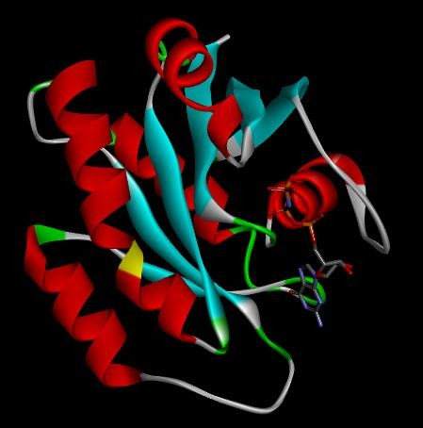
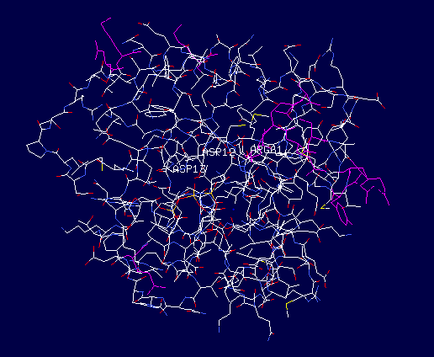
Mutant NRAS structure built in SPDBV Mutant NRAS structure visualized using discovery studio

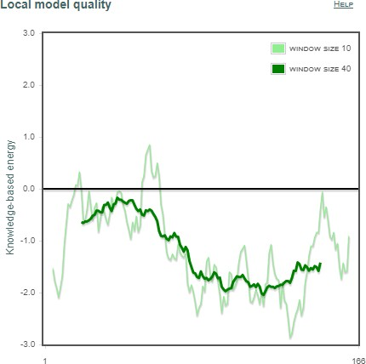
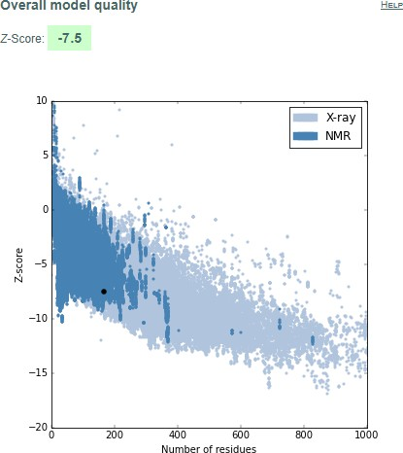
PROSA analysis of Mutant NRAS PROSA analysis of Mutant NRAS

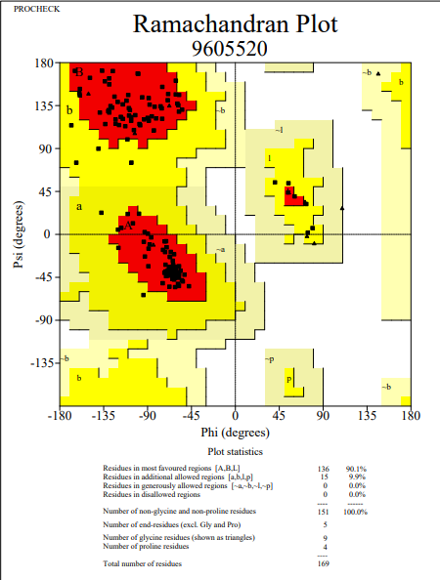
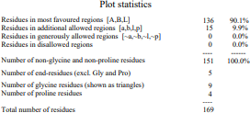
PROCHECK analysis of Mutant NRAS PROCHECK analysis of Mutant NRAS

Virtual Screening using Pyrx Autodock 4.2 was performed with 5322 natural compounds from Zinc Database after filtration by FAFDrugs4 tool. The binding site was defined using AutoGrid in the Pyrx virtual screening tool. Below are the best poses that were selected after screening 5322 compounds.

ZINC ID | Binding free  energy  (kcal/mol) | Hydrogen bonding pairs HD::HA | Residues in Hydrophobic Interactions or van der Waals contact
ZINC02107288 | -10.62 | Lys-16(N):: Unk0(C)OXT  Lys-16(NZ):: Unk0(C)OXT  Gly-15(N):: Unk0(C)OXT  Ser-17(N)::Unk0(C)O  Asp-33(N)::Unk0(C11)O | Val-14, Asp-13, Gly-60, Asp-12,  Tyr-32, Glu-31, Ala-18, Asn-116, Lys-117, Asp-119, Lys-147,  Phe-28, Pro-34
ZINC02096813 | -10.61 | Thr-35(N):: Unl1(C23) O5  Asp-12(OD1):: Unl1(N)  Gly-60(N):: Unl1(OXT)  Lys-16(NZ):: Unl1(OXT) | Ser-17, Gly-15, Asn-116, Lys-117, Phe-28, Lys-147, Ala-146, Asp-119, Ser-145, Ala-18, Tyr-32,  Asp-13
ZINC02096815 | -10.33 | Lys-16(N):: Unl1(C23)O5  Lys-16(NZ):: Unl1(C23)OXT Gly15(N):: Unl1(C23)O5  Ser17(OG):: Unl1(C20)O4 | Asp-12, Thr-58, Asp-13, Asp-33,  Try-32, Glu-31, Phe-28, Lys-147, Asp-119, Ala-146,  Lys-117, Asn-116, Thr-35
ZINC02114326 | -10.23 | Asn-116(ND2):: Unl1(CL) Lys-147(NZ):: Unl1(OXT) Asp-33(N):: Unl1 (C12) O4 | Phe-28, Asp-119, Leu-120, Gly-15, Lys-117, Asp-30, Lys-16, Ser-17, Ala-18, Tyr-32, Glu-31
ZINC01020381 | -10.16 | Gly-15(N):: Unl1(C24) O2 Lys-16(N):: Unl1(C24) O2 Lys-16(NZ):: Unl1(C24) O2 | Asp-119, Lys-147, Asn-116, Ala-146, Ser-145, Glu-31, Phe-28, Asp-30, Asp-13, Thr-58, Asp-33
ZINC06167356 | -10.16 | Thr-58(O)::Unl1(C6) O6 Gly-60(N):: Unl1(C6) O6 Lys-117(NZ):: Unl1(C18) O5 Asp-30(N):: Unl1(C16) O4 Glu-31(N):: Unl1(C16) O 4 Ala-18(N):: Unl1(C9) O 2 Ser-17(N):: Unl1(O1) | Asp-33, Asp-12, Lys-16, Thr-35, Gly-15, Pro-34, Ala-59, Asp-13, Val-29
ZINC02120343 | -10.14 | Asp-33(N):: Unl1(C9) O2 Ser-17(N):: Unl1(C22) O5 Lys-16(N):: Unl1(C22) O4 Lys-16(NZ):: Unl1(C22) O 4 Asp-13(N):: Unl1(C22) O4 Gly-15(N):: Unl1(C22) O4 | Asp-119,Ser-145, Lys-147,Ala-146, Phe-28,Ala-18,Asn-116, Lys-117,Glu-31,Tyr-32, Pro-34,Asp-12,Val-14
ZINC02102162 | -10.14 | Lys-16(N):: Unl1(C22) O6 Lys-16(N)::Unl1(C22) O5 Val-14(N):: Unl1(C22) O5 Gly-15(N):: Unl1(C22) O5 Ser-17(N):: Unl1(C22) O6 | Pro-34,Asp-12, Asp-13,Asp-33, Glu-31,Tyr-32, Phe-28,Lys-117, Asn-116,Ala-18, Ala-146,Lys-147, Asp-119
ZINC02114643 | -10.1 | Asp-33(N)::Unl1(C16) O4 Lys-16(N)::Unl1(C24) O5 Lys-16(NZ)::Unl1(C24) O6 Gly-15(N)::Unl1(C24) O5 | Asp-19,Phe-28, Lys-147,Lys-147, Leu-120,Tyr-32, Ala-18,Ala-146, Lys-117,Thr-35, Glu-31,Pro-34,Asp-13
ZINC00518885 | -10.06 | Lys-117(N):: Unk0(C9) O2 Ala-146(N):: Unk0(C9) O2 Asn-116(ND2)::Unk0(O3) Asp-13(N):: Unk0(OXT) Lys-16(N)::Unk0(O) Lys-16(NZ)::Unk0(O) Gly-15(N)::Unk0(O) Val-14(N)::Unk0(O) | Asp-119,Phe-28, Asp-33,Pro-34,Asp-12, Ala-18,Ser-17,Lys-147, Ser-145
ZINC03882094 | -10.04 | Lys-16(NZ)::Unl1(C21) O3 Gly-15(N):: Unl1(C21) O3 Ser-17(N)::Unl1(C22) O4 | Thr-35,Asp-13, Val-14,Asp-12, Asp-30,Glu-13, Asp-119,Lys-117, Phe-28,Asp-57, Ala-18,Thr-58

Summary of docking results

The above are the top eleven compounds with the best binding energy score. The binding free energy gives the nature of the protein and the ligand that has bound to it. Also, the conserved residues that take part in the hydrophobic interaction around the protein which are an indicative of stability to the structure and hydrogen bond formation between donor and acceptor atoms and residues of the protein are tabulated in the same table. The conserved hydrophobic residues like Asp-119, Phe-28 etc. along with hydrogen bond forming residues like Gly-15, Asp-33 and so on are reported in the table
2D interaction diagrams of the selected ligands after docking
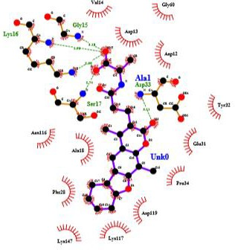

Molecular Docking Interaction of ZINC02107288
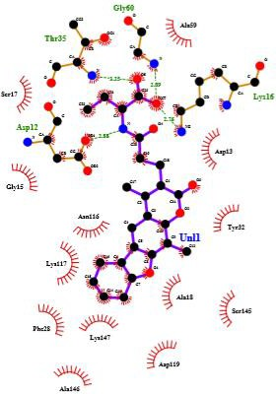
Molecular Docking Interaction of ZINC02096813

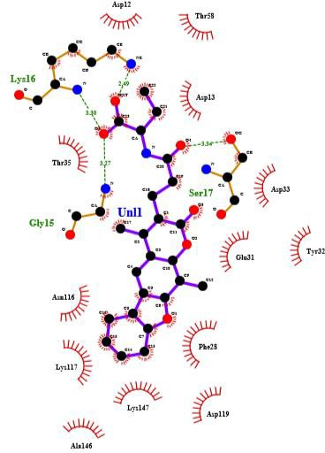
Molecular Docking Interaction of ZINC02096815
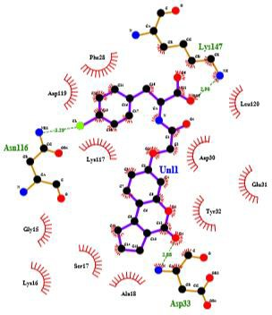
Molecular Docking Interaction of ZINC02114326

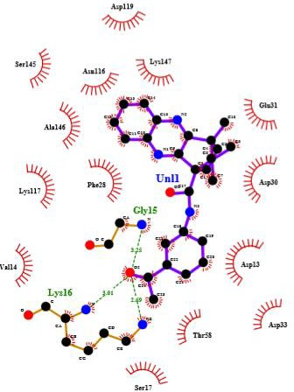

Molecular Docking Interaction of ZINC01020381
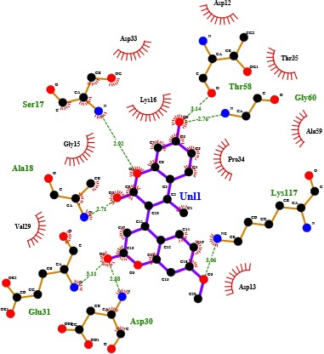
Molecular Docking Interaction of ZINC06167356
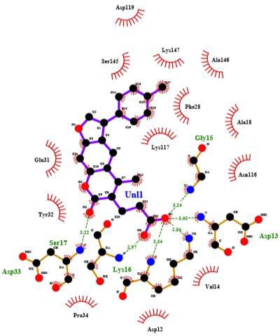
Molecular Docking Interaction of ZINC02120343

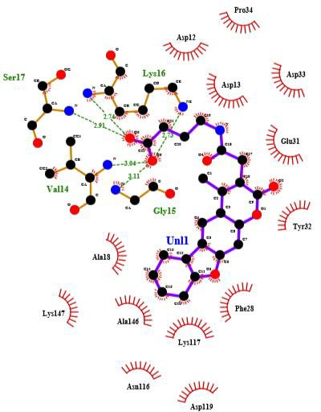
Molecular Docking Interaction of ZINC02102162

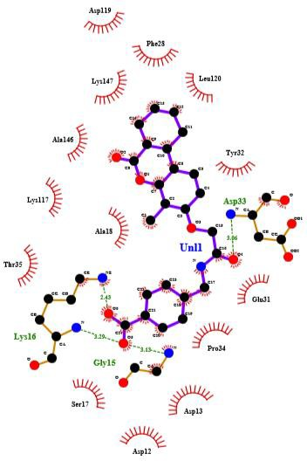

Molecular Docking Interaction of ZINC02114643


Molecular Docking Interaction of ZINC00518885

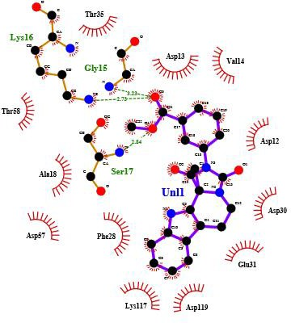
Molecular Docking Interaction of ZINC03882094

The role of conserved residues in inhibition of NRAS differs from one to another. Thr-35 residue shows hydrophobic interactions which are responsible for the stability of the structure. They residues are important for Mg2 coordination and interactions.( Johnson CW, Reid D, Parker JA, et al. 2017) In complex 2 with Zinc ID ZINC02096813_6040 Thr-35 forms a hydrogen bond between N of Thr-35 and O5 of Unl1(ligand) at a distance of 3.25 Å. In complex nine and eleven with Zinc IDs- ZINC02114643_7056 and ZINC03882094_17080 respectively it shows hydrophobic interactions.
The crystal structure of NRAS-GppNHp has switch I ordered in the active site, with Tyr-32 interacting with the γ-phosphate of a neighbouring symmetry-related molecule of NRAS.( Johnson CW, Reid D, Parker JA, et al. 2017).When the switch 1 is in state 2 then Tyr-32 is turned away from active site in state 1.In complex one, three, seven, eight and nine with Zinc IDs- ZINC02107288_19972,ZINC02096815_6057, ZINC02120343_9364, ZINC02102162_14892 and ZINC02114643_7056 respectively Tyr-32 shows hydrophobic interaction stabilizing the complex.
Phe-28 is a residue showing hydrophobic interactions in complex three, four, seven, eight, nine, ten, eleven with Zinc ID- ZINC02107288_19972, ZINC02114326_14245, ZINC02120343_9364,ZINC02102162_14892,ZINC02114643_7056, ZINC00518885_18475, ZINC03882094_17080 respectively. Aided by effector lobe residue Phe-28, helps to stabilize nucleotide binding (Johnson CW, Reid D, Parker JA, et al. 2017).
Asp-119 makes nucleotide-specific interactions with the guanine base and is critical for nucleotide binding. ( Johnson CW, Reid D, Parker JA, et al. 2017).It does not show hydrophobic interactions or Van der Waals contact in complex six and nine with Zinc IDs- ZINC06167356_6831, ZINC02114643_7056 respectively. It is found to be showing stability in rest of the nine complexes.
In compound two with Zinc ID- ZINC02096813, the glycine residue at position 12 in wild type NRAS being mutated to Asp- 12 in mutant type NRAS shows formation of hydrogen bond with the ligand at a distance of 2.88 and Asp-13 forms hydrophobic interaction around the compound. Similarly in compound seven and ten with Zinc ID- ZINC02120343 and ZINC00518885 respectively Asp-13 which is also a mutated residue of Gly in mutant NRAS shows formation of hydrogen bond at a distance of 3.05 and 2.84 respectively and Asp-12 forms hydrophobic interaction around the compound. Phe-28 shows hydrophobic interaction in compound seven and ten which is very important in stabilizing nucleotide binding. And Asp-119, a critical residue in nucleotide biding stability, is present in all the complexes except six and nine with Zinc IDs- ZINC06167356_6831, ZINC02114643_7056 respectively.
Simulations
4. Conclusion
This study using computational methodology has resulted into understanding of the wild type and mutant NRAS structure drastically. We mutated three distinct residues at 12,13, and 61 positions of wild type NRAS present in PDB and validated the structure. Further screened natural compounds over it’s active site after filtering them on the basis of Lipinski’s rule and drug like compounds. This eliminated the interfering compounds and those with more toxicity. This approach enabled us to widely spread through the different and diverse compounds in nature which could act as a novel potential inhibitor for mutant NRAS in future. Docking results determined the binding affinity of the protein and ligand exhibiting the binding free energy score that helped to further narrow down to more potential compounds. The analysis of interactions after molecular docking gave a point towards comprehending the interactions of mutant residues with the active site of the protein. Three compounds with the best scores, having strong hydrogen bond formation and stable hydrophobic interaction between the mutant residues and the ligand were selected. We believe that the stability of the compound was determined more with presence of Phe-28 and Asp-119 residues which are critical stabilizers located at important positions showing interaction with surrounding residues. Based on molecular docking studies, these three compounds with Zinc ID-ZINC02096813, ZINC02120343 and ZINC00518885 can act as a potential inhibitor of mutant NRAS. This study provides structural level explanation of NRAS role in melanoma and potential inhibitors to cease it’s activity. The present study makes way to many additional and fascinating studies to illustrate the significance of computational techniques in finding drug targets for melanoma.
5. References
1. Johnson CW, Reid D, Parker JA, et al. The small GTPases K-Ras, N-Ras, and H-Ras have distinct biochemical properties determined by allosteric effects. J Biol Chem. 2017;292(31):12981–12993. doi:10.1074/jbc.M117.778886
2. Davis LE, Shalin SC, Tackett AJ. Current state of melanoma diagnosis and treatment. Cancer Biol Ther. 2019;20(11):1366-1379. doi:10.1080/15384047.2019.1640032
3. Wellbrock C, Arozarena I. The Complexity of the ERK/MAP-Kinase Pathway and the Treatment of Melanoma Skin Cancer. Front Cell Dev Biol. 2016;4:33. Published 2016 Apr 27. doi:10.3389/fcell.2016.00033
4. https://www.cancer.gov/about-nci/organization/ccg/research/structural-genomics/tcga/studied-cancers/melanoma-skin
5. https://www.cancer.net/cancer-types/melanoma/statistics#:~:text=Many%20people%20with%20melanoma%20are,%2Dyear%20survival%20is%2093%25.
6. https://www.cancer.net/cancer-types/melanoma/stages
7. Douglas B. Johnson, M.D. and Igor Puzanov, M.D. Department of Medicine, Division of Hematology/Oncology, Vanderbilt-Ingram Cancer Center, Vanderbilt University Medical Center, 777 Preston Research Building, 2220 Pierce Avenue, Nashville, TN 37232, USA. Treatment of NRAS-Mutant Melanoma. Curr Treat Options Oncol. 2015 April ; 16(4): 15. doi:10.1007/s11864-015-0330-z
8. AHMAD NAJEM1*, MOHAMMAD KRAYEM1*, ANNE PERDRIX1,2, JOSEPH KERGER3, AHMAD AWADA3, FABRICE JOURNE1,4 and GHANEM GHANEM. New Drug Combination Strategies in Melanoma: Current Status and Future Directions. ANTICANCER RESEARCH 37: 5941-5953 (2017) doi:10.21873/anticanres.12041
9. https://prosa.services.came.sbg.ac.at/prosa.php
10. https://www.ebi.ac.uk/thornton-srv/software/PROCHECK/
11. https://zinc.docking.org/
12. http://fafdrugs4.mti.univ-paris-diderot.fr/).
13. https://www.ebi.ac.uk/thornton-srv/software/LigPlus /

