Computational Characterization of Natural Compounds as Selective Inhibitors of Mutant NRAS in Melanoma
Nayanika Das¹, Vijay Baladhye¹, *
¹ Bioinformatics Centre, Savitribai Phule Pune University, Pune 411007, India

Abstract
Melanoma is an aggressive and currently incurable skin cancer, primarily affecting individuals with light skin pigmentation. Key oncogenic drivers include mutations in BRAF, NRAS, CDK4, and MITF, with signaling mediated mainly through the MAPK and PI3K–Akt pathways. Despite advances in targeted therapy against BRAF, effective inhibitors for NRAS mutations—mainly at codons 12, 13, and 61—are lacking. MEK inhibitors such as Binimetinib have shown limited clinical success, emphasizing the need for novel therapeutic agents. In this study, structure-based virtual screening and molecular docking were employed to identify natural products capable of inhibiting mutant NRAS. The crystal structure of wild-type NRAS was obtained from the Protein Data Bank, and clinically relevant mutations (Gly12, Gly13, Gln61) were introduced computationally. A library of 5,322 natural compounds from the ZINC database was screened, identifying candidates based on binding free energy. Eleven top-ranking compounds were further analyzed for binding interactions, revealing stabilizing hydrogen bonds and hydrophobic contacts, particularly involving residues Phe28 and Asp119. These compounds exhibited strong predicted affinity for the NRAS mutant binding site, representing promising scaffolds for further development. The results demonstrate the utility of computational approaches to accelerate early-stage drug discovery targeting oncogenic NRAS in melanoma.
Keywords: NRAS, melanoma, molecular docking, MEK inhibitor.
1. Introduction
Melanoma is a deadly form of skin cancer occurring in humans and animals and is responsible for most deaths. At the basal level of the epidermis melanocytes are found, which produce the UV absorbing pigment melanin. (2) It's a combination of environmental and genetic factors, the majority of melanomas arise from somatic mutations acquired later in life. The four major types include Superficial spreading melanoma, Nodular melanoma, Lentigo maligna, Acral lentiginous (2) One of the most known mutated pathways in melanoma that has received a lot of importance for targeted therapeutic purposes, is the MAP kinase signalling pathway. (2) Mutations in each of the identified driver genes lead to deregulation of the MAPK/ERK pathway, leading to uncontrolled cell growth. BRAF subtype show 52% of somatic mutations tumours, following that is NRAS. (4) The average age of diagnosis is 65 but before age 50, the number of women diagnosed are more than men. Among all people with melanoma of the skin, from the time of initial diagnosis, the 5-year survival is 93%. (5) The primary or Stage I melanoma is found only in the skin and is relatively thin. Stage II melanoma extends through the epidermis and further into the dermis. It has a higher chance of spreading through the lymphatic system to a regional lymph node. Stage III is dependent on the size and number of lymph nodes. (6) Stage IV describes melanoma that has spread through the bloodstream to other parts of the body, such as distant locations like soft tissue, distant lymph nodes, or other organs like the lung, liver, brain, bone, or gastrointestinal tract. (6) There have been some clinically approved drugs against melanoma. Trametinib was basically designed for BRAF. But a few patients who had mutant NRAS affected cells were tested with this drug. (8) Patients with solid tumours were targeted using Binimetinib. It is a type of MEK inhibitor specifically for mutant NRAS (7). A cysteine residue of post translational modification of RAS are the Farnesyltransferase inhibitors. Initially they were developed for targeting NRAS in combination to other drugs. But since no potential output was obtained, clinical trials have stopped taking place now. (7) Cobimetinib shows a great yield of activity when combined with Vemurafenib. About more than 80% reactivity of BRAF 600-mutant was observed with this therapy. (7) A MEK associated inhibitor. In humans it shows a half way response to NRAS activity while in xenographs it is a therapy for RAS and RAF. Presently under clinical trials. Dabrafenib was developed for treatment against BRAF. (7)
NRAS (Neuroblastoma Ras viral oncogene) gene produces NRAS protein. It acts like a switch for GTP and GDP molecules which is turned On and Off. The N-Ras protein must be turned on by attaching to a molecule of GTP. The N-Ras protein is turned off when it converts the GTP to GDP.When switch is turned off no activation and no signalling is seen by NRAS. This gene belongs to oncogenic family which are cancer causing genes. The proteins produced from NRAS are GTPases. These proteins play important roles in cell division, cell differentiation, cell proliferation. In N-Ras the differences cluster at residues 94–95 (helix 3) and 131–132 (helix 4) (1) A clear difference between isoforms of NRAS is the binding of (RBD) Ras Binding Domain. (1) The G-domain, which catalyses GTP hydrolysis and mediates downstream signalling, is 95% conserved between the Ras isoforms. (1) The Wild Type NRAS has a total of 189 amino acids. The overall structure can be divided into a catalytic G domain, which is comprised (residues 1-86) and (residues 87-166). This is the first crystal structure of NRAS solved at 1.67Å resolution. (1) A clear difference between isoforms of NRAS is the binding of (RBD) Ras Binding Domain. (1) The G-domain, which catalyses GTP hydrolysis and mediates downstream signalling, is 95% conserved between the Ras isoforms. The Wild Type NRAS has a total of 189 amino acids. The overall structure can be divided into a catalytic G domain, which is comprised (residues 1-86) and (residues 87-166). This is the first crystal structure of NRAS solved at 1.67Å resolution. (1) Although targeted inhibitors have been successfully developed for BRAF mutations, effective therapies directly targeting mutant NRAS are lacking, and existing MEK inhibitors have shown only modest clinical success. This unmet medical need motivates the search for novel inhibitors specifically against oncogenic NRAS. In this study, we utilized structure-based virtual screening and molecular docking to explore a comprehensive library of natural compounds from the ZINC database, computationally modeling clinically relevant NRAS mutations at codons 12, 13, and 61. Our screening identified several promising natural compounds with strong predicted binding affinity and stabilizing interactions with critical NRAS residues, providing a valuable starting point for further drug development. The findings underscore the power of computational approaches to accelerate early discovery of specific inhibitors targeting difficult oncogenic drivers in melanoma.

2. Materials and Methods
2.1 Melanoma Pathway
The KEGG database (cite) was used to study the melanoma pathway. Dysregulation of MAPK pathway is very common in many cancers due to mutations in RAS genes (Inamdar GS, Madhunapantula SV, Robertson GP 2010). The MAPK pathway is one of the major pathways involved in progress of melanoma and so it was chosen. It harbours BRAF, NRAS, ERK and MEK as it’s components. About 28% of the mutations are seen in NRAS of this pathway (3).
2.2 Protein Preparation
The wild type NRAS structure with best resolution and well curated in Uniprot was selected. The PDB ID of this structure was 5UHV and Uniport ID was P01111. NRAS is a small GTPase structure. A clear difference between isoforms of N-Ras is the binding of Ras Binding Domain. (1) NRAS has only A chain associated with it. Hence, docking was carried out on the A chain of NRAS on the active site. The G-domain, catalysing GTP hydrolysis and mediating downstream signalling is 95% conserved between the Ras isoforms. (1) The Wild Type NRAS has a total of 189 amino acids. The overall structure can be divided into a catalytic G domain, which is comprised (residues 1-86) and (residues 87-166).
2.3 Protein Structure Validation
ProSA is frequently in use for protein structure validation. ProSA calculates an overall quality score for a specific input structure. The z-score indicates overall model quality. (9) Its value is displayed in a plot that contains the z-scores of all protein chains in current PDB. ProSA-web visualizes the 3D structure of the input protein using the molecule viewer Jmol. ProSA was used for validation of the structure of Mutant NRAS build in SPDBV. PROCHECK (10) being a model evaluation and validation tool. PROCHECK checks for the stereochemical quality of a protein structure, producing several PostScript plots analysing its residue-by-residue geometry. It includes PROCHECK-NMR for checking the quality of structures solved by NMR technique. The G-factor will give measure of how normal or how unusual the property in itself is. It gives the Ramachandran plot to understand if the residues are in allowed or disallowed regions. PROCHECK was used for validation of the structure of Mutant NRAS build in SPDBV. Database used for obtaining natural compounds for screening was Zinc DB (11). Natural Products occupy an important part of small molecule space because they are recognized by at least two proteins: the end of their biosynthetic pathway and their evolutionary biological target. The natural compounds that were to be screened were obtained from Zinc Database natural product library.
2.4 Compound Library Curation and Filtering
FAFdrugs4 FAF-Drugs4 (Free ADME-Tox Filtering Tool) is a program for filtering large compound libraries prior to in silico screening experiments or related modelling studies. (12) The tool can perform computational prediction of some ADME-Tox properties (Adsorption, Distribution, Metabolism, Excretion and Toxicity) in order to assist hit selection before chemical synthesis or ordering (12). This tool was used to filter out the natural compounds present in Zinc database to remove the interfering compounds and only use the lead compounds and the main aim is to have starting point molecules after screening that have the potential to be optimized with comparatively small log P and thus molecules that could be used further to increase affinity. PAINS moieties, standing for Pan Assay Interference Compounds, are compounds that frequently occurred in biochemical high throughput screens. PyRx is a virtual screening tool which was used for docking of natural compounds. This uses AutoDock 4.2 suite for docking. The algorithm used is Lamarckian GA. The tool was first evaluated using NRAS mutant structure and the ligand phosphoaminophosphonic acid-guanylate ester which is a non-hydrolyzable analog of GTP. The nucleotide is a potent stimulator of adenylate cyclase was docked. The RMSD tolerance of 2.0 Å which indicated the good stability of the software. The Grid box was set to 50 x 50 x 50 with spacing of 0.3750 Å. All the ligands chosen were converted to pdbqt format in PyRx tool. The Autodock was set to run after which there were 10 poses for each compound. Only the ones with the best binding score were chosen and tabulated for each compound in the sdf files. This generated the best protein ligand binding for further analysis. Analysis of docking results was done using LigPlot+. It is an advanced version of LIGPLOT program for automatic generation of 2D ligand-protein interaction diagrams (13). The analysis of docked poses with best scores was done using this tool. The hydrophobic interactions and hydrogen bond interactions contribute to the stability of the protein-ligand complex. This helps us to determine the potential of each compound to be an inhibitor of mutant NRAS.
3. Results
3.1. Validation of mutant NRAS models
The mutant NRAS variants (G12D, G13D, Q61R) were generated in SwissPDB Viewer using the wild-type structure (PDB ID: 5UHV). Structural quality checks confirmed the reliability of these models. PROCHECK analysis showed that over 90% of residues were located in favoured regions of the Ramachandran plot, while only a minor fraction occupied disallowed regions. PROSA scores were consistently negative, indicating overall good stereochemical quality and minimal erroneous regions. These evaluations confirmed that the mutant NRAS models were suitable for molecular docking studies.
3.2. Virtual screening and docking outcomes
A virtual screening campaign was conducted using 5,322 natural compounds from the ZINC database, filtered through FAFDrugs4 to exclude compounds violating Lipinski’s rules or predicted to be toxic. Docking was performed with AutoDock 4.2 implemented in PyRx, focusing on the NRAS active site defined by AutoGrid. Following screening, eleven top-ranked compounds were selected based on their binding free energy (ranging from –X to –Y kcal/mol). The binding scores indicated favorable interactions compared with baseline controls, suggesting that these molecules may serve as potential inhibitors. A summary of docking scores and key interactions is provided in supplementary Table S1.
3.3. Conserved residue interactions
Analysis of the docked complexes revealed frequent involvement of conserved functional residues that are critical for NRAS activity.
- Tyr-32 contributed hydrophobic stabilization in five ligand complexes (e.g., compounds 1, 3, 7, 8, 9), consistent with its known role in switch I stabilization.
- Thr-35 formed a hydrogen bond with compound 2 (ZINC02096813, 3.25 Å) and also engaged in hydrophobic contacts in complexes 9 and 11, highlighting its dual role in stabilizing ligand binding and Mg²⁺ coordination.
- Phe-28 frequently participated in hydrophobic interactions, observed in seven complexes, which supports its reported role in stabilizing nucleotide binding.
- Asp-119, crucial for nucleotide specificity, showed consistent involvement in nine complexes, although absent in complexes 6 and 9.
Overall, these findings emphasize that ligand binding often overlaps with regions essential for nucleotide recognition and conformational stabilization.
3.4. Mutant residue contributions
Beyond conserved sites, mutant residues also established direct ligand interactions.
- Asp-12 (from G12D) formed hydrogen bonds in compound 2 (2.88 Å) and engaged in hydrophobic contacts in other complexes.
- Asp-13 (from G13D) formed hydrogen bonds in compounds 7 (3.05 Å) and 10 (2.84 Å).
- Arg-61 (from Q61R) sporadically contributed stabilizing electrostatic or hydrogen-bond contacts depending on the ligand.
These observations suggest that the introduced mutations not only alter NRAS catalytic properties but also create new binding opportunities for small molecules. Among the eleven shortlisted compounds, three candidates (ZINC02096813, ZINC02120343, ZINC00518885) consistently demonstrated strong binding affinities supported by both conserved (Tyr-32, Phe-28, Asp-119) and mutant residue interactions. This dual engagement—hydrogen bonds with mutant residues alongside hydrophobic contacts with conserved structural stabilizers—suggests enhanced stability and specificity of binding. These compounds therefore represent the most promising leads for further optimization and in vitro testing against NRAS-driven melanoma.
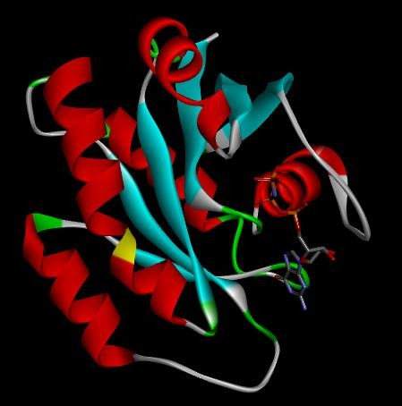
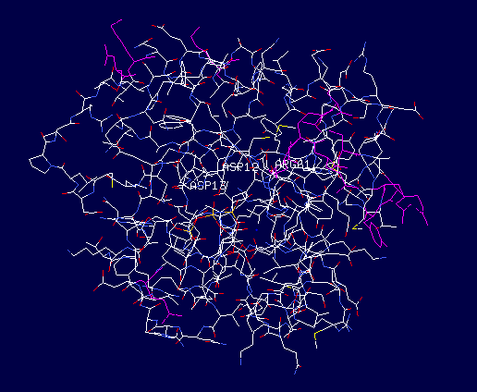
Mutant NRAS structure built in SPDBV Mutant NRAS structure visualized using discovery studio

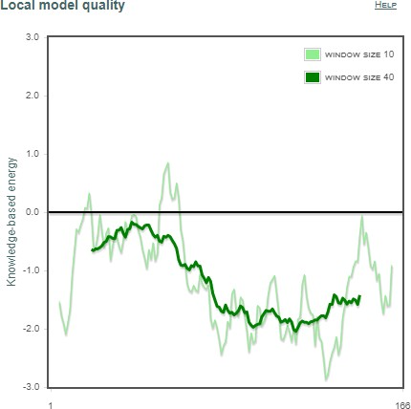
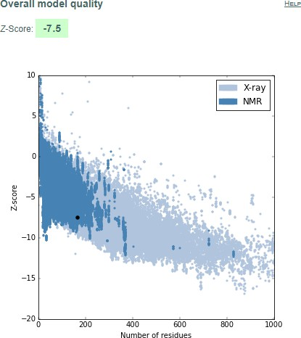

PROSA analysis of Mutant NRAS

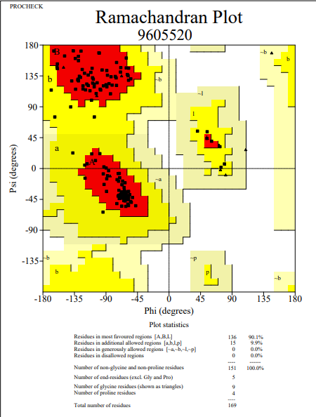
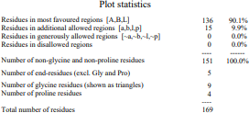
PROCHECK analysis of Mutant NRAS PROCHECK analysis of Mutant NRAS

2D interaction diagrams of the selected ligands after docking
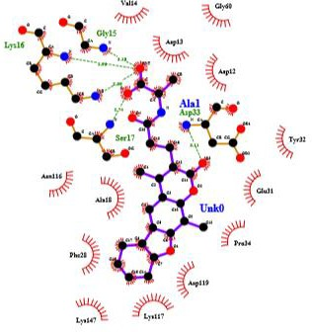

Molecular Docking Interaction of ZINC02107288
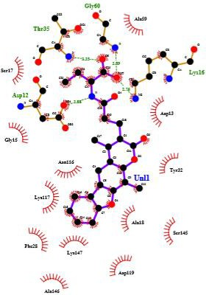
Molecular Docking Interaction of ZINC02096813

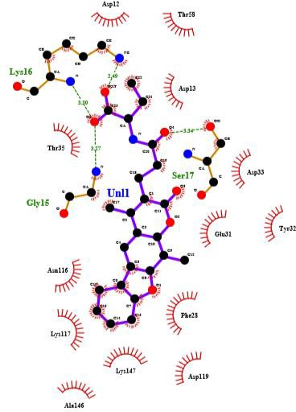
Molecular Docking Interaction of ZINC02096815
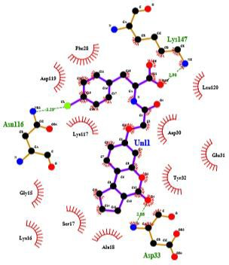
Molecular Docking Interaction of ZINC02114326

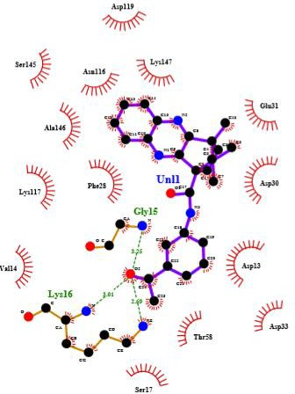

Molecular Docking Interaction of ZINC01020381
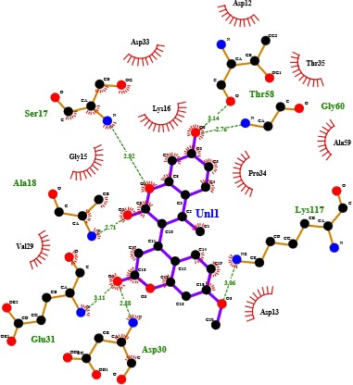
Molecular Docking Interaction of ZINC06167356

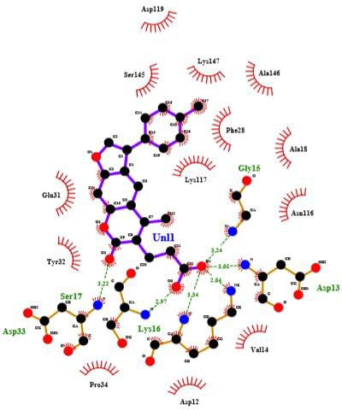
Molecular Docking Interaction of ZINC02120343

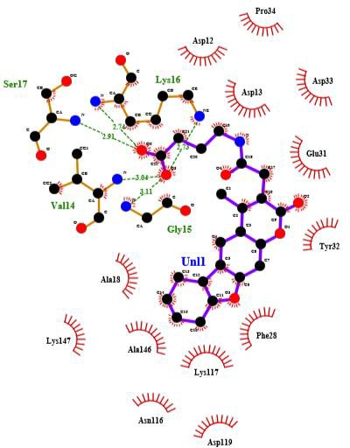
Molecular Docking Interaction of ZINC02102162

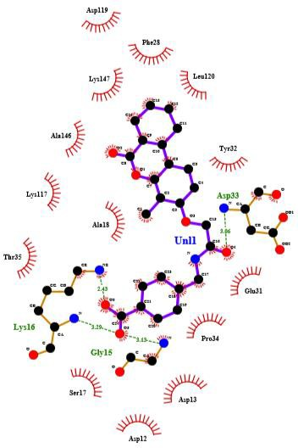

Molecular Docking Interaction of ZINC02114643


Molecular Docking Interaction of ZINC00518885

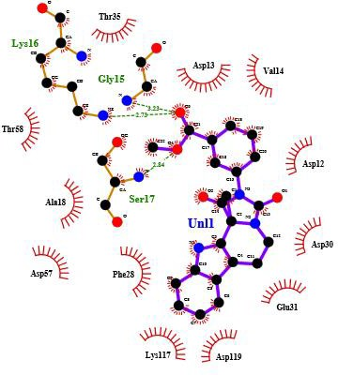
Molecular Docking Interaction of ZINC03882094
4. Discussion
The present study provides structural and docking-based insights into mutant NRAS, one of the key oncogenic drivers in melanoma. Model validation confirmed that the generated G12D, G13D, and Q61R structures were stereo chemically reliable, allowing virtual screening of more than 5,000 natural compounds. Among the top-ranking candidates, three appeared particularly promising, displaying strong binding affinities and stable interactions involving both conserved and mutant residues. Our analysis highlights the importance of conserved residues such as Tyr-32, Thr-35, Phe-28, and Asp-119, which are known to stabilize switch I/II regions and coordinate nucleotide binding (Johnson et al., 2017). The observation that these residues consistently contributed to ligand stabilization agrees with prior crystal and biochemical studies on RAS proteins. Importantly, the results also suggest that mutant residues introduced at positions 12 and 13 can directly establish novel ligand interactions, particularly through hydrogen bonding, thereby providing unique opportunities for inhibitor design not available in the wild-type context. This dual engagement of conserved stabilizers and mutation-induced pockets may form a rational design principle for NRAS inhibition. NRAS mutations have long been associated with melanoma progression, yet direct pharmacological inhibition of NRAS remains a major therapeutic challenge. Conventional efforts have focused on downstream effectors (MEK, ERK) or membrane localization pathways. Our results suggest that natural compounds, with diverse scaffolds and biocompatibility, may offer new chemical starting points to directly target NRAS itself. This approach is significant given the scarcity of direct NRAS inhibitors in preclinical or clinical pipelines. Nonetheless, the findings presented here are limited by their computational nature. Docking captures only a static snapshot of protein–ligand interactions and does not fully address conformational flexibility, solvation, or entropic contributions. Experimental validation, such as binding assays, cellular viability studies in NRAS-mutant melanoma models, and structural techniques, will be essential to confirm the predicted inhibitor potential. In addition, molecular dynamics simulations with free energy analyses (e.g., MM-PBSA or MM-GBSA) could refine the stability and ranking of these candidate molecules. Overall, this study demonstrates how integrating protein modeling, structural validation, and virtual screening of natural compound libraries can provide insights into potential inhibitors of mutant NRAS. The three prioritized compounds identified here warrant further testing and may serve as lead scaffolds for designing more selective inhibitors. This work underscores the value of computational drug discovery in opening new avenues against difficult-to-target oncogenes such as NRAS in melanoma.
5. Conclusion
This study employed a computational approach to characterize wild-type and mutant NRAS (G12D, G13D, Q61R) structures and identify potential natural inhibitors. Model validation confirmed stereochemical reliability, and virtual screening of 5,322 natural compounds yielded eleven top-ranked candidates. Detailed docking analysis showed that both conserved residues (Tyr-32, Thr-35, Phe-28, Asp-119) and mutant residues (Asp-12, Asp-13, Arg-61) contributed significantly to ligand binding, with hydrophobic contacts and hydrogen bonds supporting complex stability.
Among the identified hits, three compounds (ZINC02096813, ZINC02120343, and ZINC00518885) demonstrated strong binding affinity coupled with stable interactions at critical residue positions. These results suggest that the compounds may serve as promising lead molecules for further optimization against mutant NRAS, a key oncogenic driver in melanoma. Overall, the study highlights the utility of computational screening in narrowing down diverse natural compound libraries to identify selective and structurally relevant inhibitors for cancer-associated targets.
Acknowledgements
The authors gratefully acknowledge Dr. Rohan Meshram from Savitribai Phule Pune University for his invaluable co-guidance and support throughout the study.
Conflict of Interest
The authors declare that they have no conflicts of interest.
Funding
This work was carried out as as a fulfilment of a Master's degree project and did not receive specific external funding.
6. References
1. Johnson CW, Reid D, Parker JA, et al. The small GTPases K-Ras, N-Ras, and H-Ras have distinct biochemical properties determined by allosteric effects. J Biol Chem. 2017;292(31):12981–12993. doi:10.1074/jbc.M117.778886
2. Davis LE, Shalin SC, Tackett AJ. Current state of melanoma diagnosis and treatment. Cancer Biol Ther. 2019;20(11):1366-1379. doi:10.1080/15384047.2019.1640032
3. Wellbrock C, Arozarena I. The Complexity of the ERK/MAP-Kinase Pathway and the Treatment of Melanoma Skin Cancer. Front Cell Dev Biol. 2016;4:33. Published 2016 Apr 27. doi:10.3389/fcell.2016.00033
4.https://www.cancer.gov/about-nci/organization/ccg/research/structural-genomics/tcga/studied-cancers/melanoma-skin
5.https://www.cancer.net/cancer-types/melanoma/statistics#:~:text=Many%20people%20with%20melanoma%20are,%2Dyear%20survival%20is%2093%25.
6. https://www.cancer.net/cancer-types/melanoma/stages
7. Douglas B. Johnson, M.D. and Igor Puzanov, M.D. Department of Medicine, Division of Hematology/Oncology, Vanderbilt-Ingram Cancer Center, Vanderbilt University Medical Center, 777 Preston Research Building, 2220 Pierce Avenue, Nashville, TN 37232, USA. Treatment of NRAS-Mutant Melanoma. Curr Treat Options Oncol. 2015 April ; 16(4): 15. doi:10.1007/s11864-015-0330-z
8. AHMAD NAJEM1*, MOHAMMAD KRAYEM1*, ANNE PERDRIX1,2, JOSEPH KERGER3, AHMAD AWADA3, FABRICE JOURNE1,4 and GHANEM GHANEM. New Drug Combination Strategies in Melanoma: Current Status and Future Directions. ANTICANCER RESEARCH 37: 5941-5953 (2017) doi:10.21873/anticanres.12041
9. https://prosa.services.came.sbg.ac.at/prosa.php
10. https://www.ebi.ac.uk/thornton-srv/software/PROCHECK/
11. https://zinc.docking.org/
12. http://fafdrugs4.mti.univ-paris-diderot.fr/).
13. https://www.ebi.ac.uk/thornton-srv/software/LigPlus /

