--Assignment 2 Question 1

--1)Create a view named OrderItemProducts that returns columns from the Orders, OrderItems, and Products tables.

--This view should return these columns from the Orders table: OrderID, OrderDate, TaxAmount, and ShipDate.

--This view should return these columns from the OrderItems table: ItemPrice, DiscountAmount, FinalPrice (the discount amount subtracted from the item price), Quantity, and ItemTotal (the calculated total for the item).

--This view should return the ProductName column from the Products table.

create view OrderItemProducts

as

select O.OrderID, O.OrderDate, O.TaxAmount, O.ShipDate, Ord.ItemPrice,

Ord.DiscountAmount, sum(Ord.ItemPrice-Ord.DiscountAmount) as FinalPrice,

Quantity, sum(Quantity*(Ord.ItemPrice-Ord.DiscountAmount)) as TotalItem,

ProductName

from OrderItems as Ord join Orders as O on O.OrderID = Ord.OrderID

join Products as P on Ord.ProductID = P.ProductID

group by O.OrderID, O.OrderDate, O.TaxAmount, O.ShipDate, Ord.ItemPrice,

Ord.DiscountAmount,Quantity, ProductName

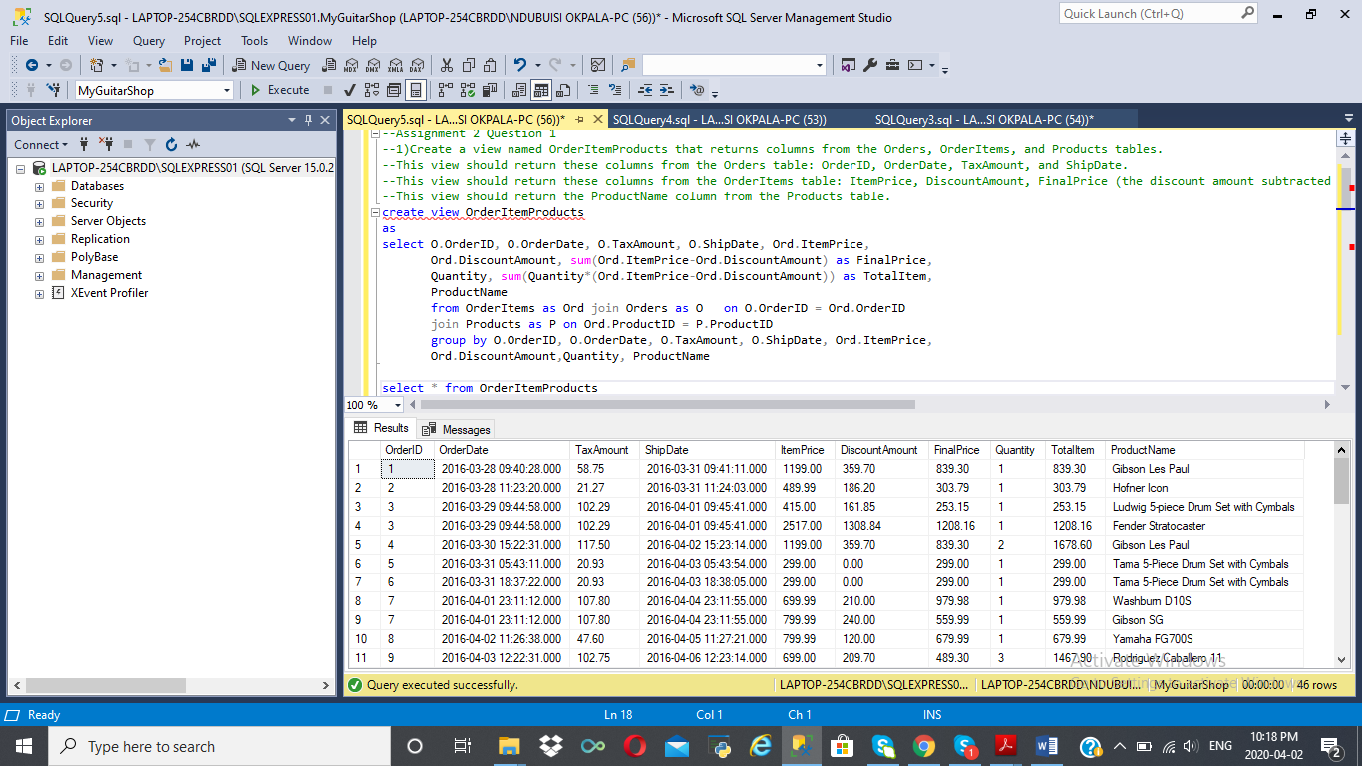

-- Assignment 2 Question 2

--Create a view named ProductSummary that uses the view you created in point 1.

--This view should return some summary information about each product.

--Each row should include these columns: ProductName, OrderCount (the number of times the product has been ordered),

--and OrderTotal (the total sales for the product).Write a SELECT statement that uses the

--view that you created in point 2 to get total sales for the five best selling products.

--Take a screenshot that shows results returned from this query.

create view ProductSummary

as

select ProductName, count(Quantity) as OrderCount, sum(TotalItem) as OrderTotal

from OrderItemProducts

group by ProductName

select top 5 ProductName, OrderCount, OrderTotal

from ProductSummary

order by OrderTotal Desc

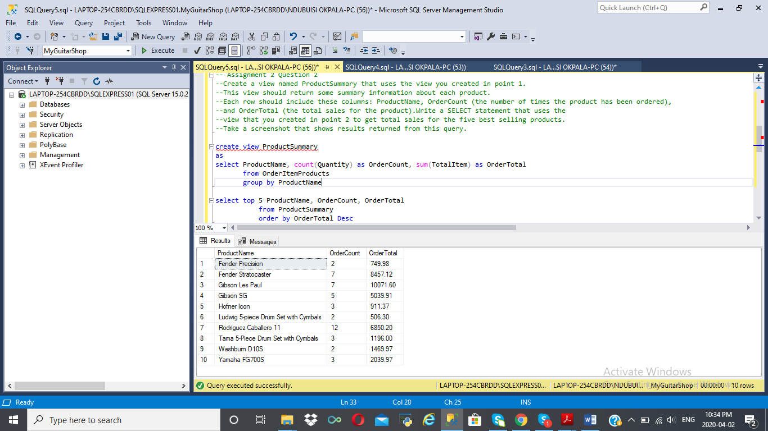

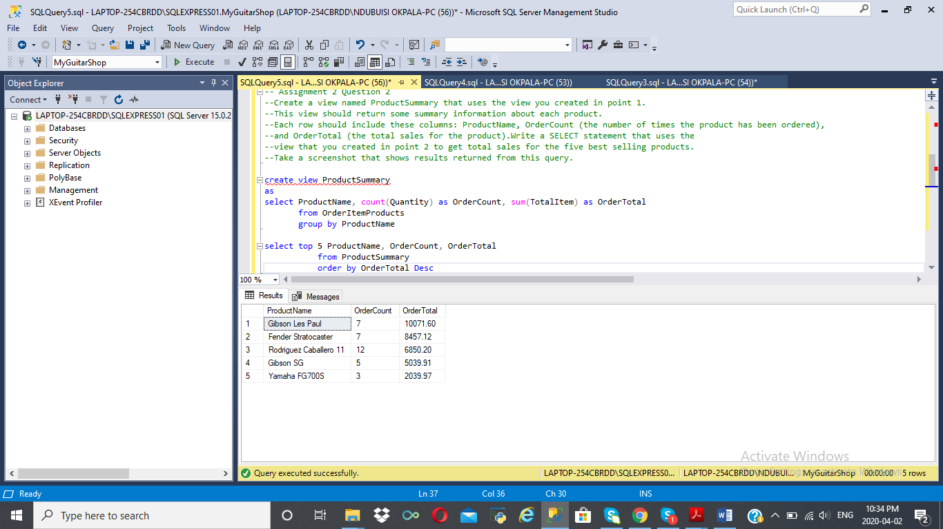

-- Assignment 2 Question 3

--Suppose an application will often search Products based on ProductName. Create an index that makes

--such search more efficient. Take a screenshoot that shows your command succeeded.

create index INDX_ProductName

on Products (ProductName)

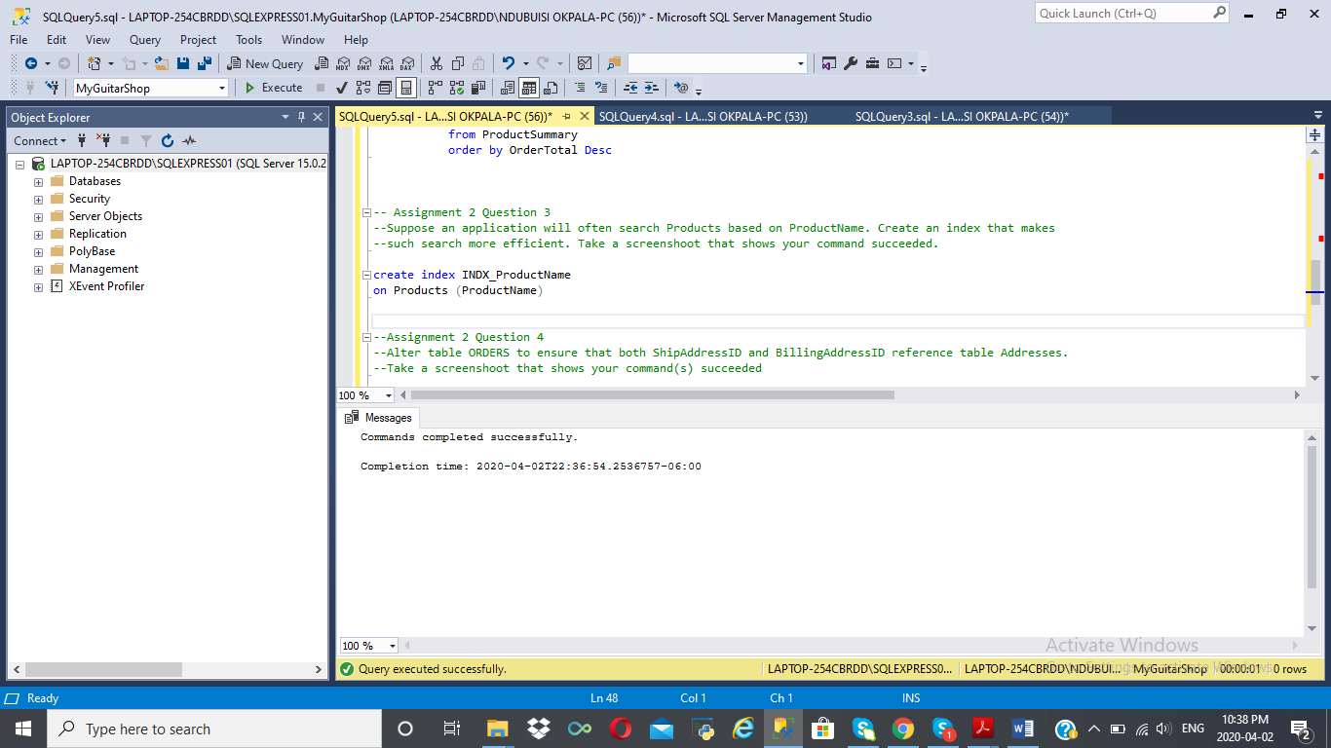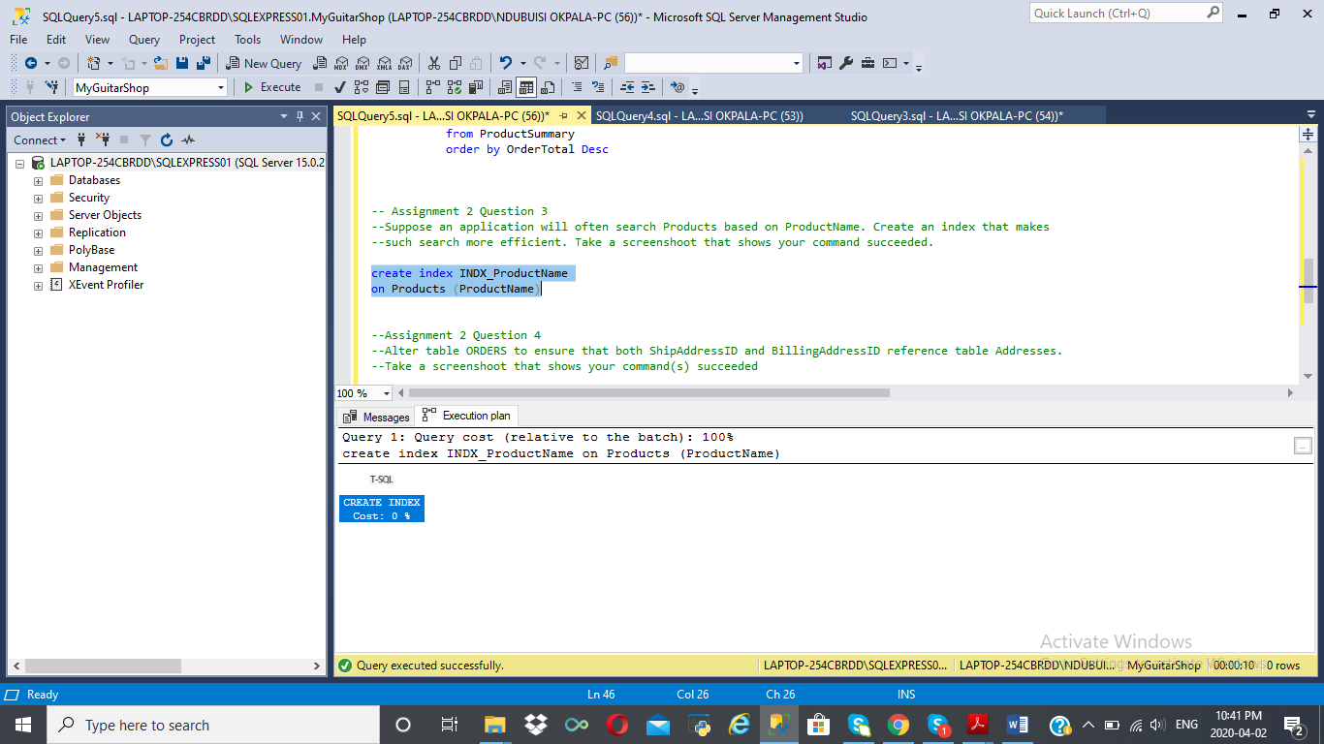

--Assignment 2 Question 4

--Alter table ORDERS to ensure that both ShipAddressID and BillingAddressID reference table Addresses.

--Take a screenshoot that shows your command(s) succeeded

select * from orders

select * from Addresses

alter table Orders

add constraint FK_Orders_Ship_Address foreign key(ShipAddressID) references Addresses(AddressID)

alter table Orders

add constraint FK_Billing_Address foreign key(BillingAddressID) references Addresses(AddressID)

