Emotional Context and Predictability in Naturalistic Reading Aloud

Jessica M. Alexandera and George A. Buzzella

aFlorida International University and the Center for Children and Families, Miami, FL, USA

Corresponding author: Jessica M. Alexander (jess.alexander@gmail.com)

Keywords: naturalistic reading, lexical processing, word frequency, emotional valence, discourse context

# ABSTRACT

Robust effects of word frequency in lexical processing have been found at the level of the individual word. Effects of lexical valence on visual word processing have been more conflicted, with all emotional words (positive and negative) favored in some studies while only positive stimuli receive a processing boost in others. Frequency and valence are also known to interact: both with one another and with the ongoing accrual of discourse context that modulates lexical predictability. Importantly, however, prior work in the field has focused on word-level effects within traditional laboratory tasks. This study seeks to expand the current knowledge of how word frequency and lexical valence, along with their interactions, influence performance during the oral reading of multi-sentence stimuli in a naturalistic context.

# INTRODUCTION

In reading, the meaning of individual words is accessed and integrated into the developing discourse context. This process is influenced by a broad range of lexical features, including word frequency (Balota & Chumbley, 1984) and emotional valence (Larsen et al., 2006). These various properties interact during visual perception and lexical processing (Kuperman et al., 2014), and can be moderated or subsumed by discourse-level constraints such as the build-up of discourse context (Chou et al., 2020; Van Petten & Kutas, 1990). However, despite recent calls for increasing ecological validity within reading science (Schotter & Payne, 2019), most research in the field is based on highly-constrained experimental designs that use stand-alone words or simplified sentences: there remains scant evidence for how linguistic features impact reading behavior in naturalistic contexts that more closely mirror our day-to-day interactions with the written word. In the current study, we sought to close this gap in the literature by examining the influence of word frequency and lexical valence on reading speed and comprehension within the context of naturalistic, passage-length stimuli. Manipulating the emotional valence of passages also allowed us to probe the impact of higher-level context processing within an ecologically-valid setting.

Effects of word frequency are well-attested in the visual word recognition literature (Balota & Chumbley, 1984; Balota & Spieler, 1999). Specifically, words that are encountered more often–that is, high-frequency words–are typically recognized faster than low-frequency words. This is particularly true in contexts where frequency-based expectation strategies can improve task performance, such as making a lexical decision (Barriga-Paulino et al., 2022; Kuchinke et al., 2007; Larsen et al., 2008; Scott et al., 2012) or reading single words aloud (Fischer-Baum et al., 2014). It has been argued that word frequency effects may emerge from denser and/or stronger connections within the mental lexicon’s associative network (Hulme et al., 1991; Stuart & Hulme, 2000). As a result of such connectivity, high-frequency words are thought to exhibit a higher resting activation that may serve to reduce the threshold for activation (Plaut et al., 1996). This view is supported by pupillometry studies showing lower peak dilations for high-frequency words during lexical decision (Haro et al., 2017; Kuchinke et al., 2007), as well as in eye-tracking, where high-frequency words demonstrate shorter fixation durations (Kliegl et al., 2004; Scott et al., 2012), indicating that readers process high-frequency words more rapidly.

Message-level constraints, however, can override the effects of word-level properties like frequency. For example, studies show that readers use prior context to anticipate the semantic features of upcoming words (see Federmeier, 2007 for a review), leading to attenuated frequency effects when discourse context is high. In electrophysiology, the N400 ERP component has been the focus of significant research in predictive processing for visual word recognition. The N400 is believed to index access to semantic memory, such that incoming content that binds more easily into ongoing neural activity produces smaller N400 amplitudes. In single-word presentation, high-frequency words demonstrate smaller N400 amplitudes than low-frequency words (Barber et al., 2004; Fischer-Baum et al., 2014; Rugg, 1990). Within sentential frames, however, effects of word frequency on N400 amplitudes are diminished for words that are more predictable from the established semantic or syntactic context (open-class words: Payne et al., 2015; Payne & Federmeier, 2019; Van Petten & Kutas, 1990, 1991; closed-class words: Payne et al., 2015; Van Petten & Kutas, 1991).

Across a variety of experimental paradigms, word frequency interacts with other lexical properties to modulate performance. One such property is emotional valence: words range on an emotional continuum from intrinsically appetitive ("kitten") to fundamentally aversive ("puke"). There is substantial evidence that valenced words are processed differently, both from each other (Herbert et al., 2008, 2009; Keuper et al., 2013) as well as in comparison to neutral words (Barriga-Paulino et al., 2022; Delaney-Busch & Kuperberg, 2013; Herbert et al., 2008; Kissler et al., 2007, 2009; Kissler & Herbert, 2013; Schacht & Sommer, 2009; Schindler & Kissler, 2016; Scott et al., 2009). The existing literature remains unclear on the nature of this differential processing, however, with different studies producing conflicting results. Some studies find that reaction times for negative words are slower than those for positive (Barriga-Paulino et al., 2022; Estes & Adelman, 2008; Estes & Verges, 2008; Kuperman et al., 2014; Larsen et al., 2008; Scott et al., 2014); in other studies, both positive and negative words are processed faster than neutral, but neither positive nor negative words significantly outpace the other (F. Knickerbocker et al., 2019; H. Knickerbocker et al., 2014; Kousta et al., 2009; Kuchinke et al., 2007; Schacht & Sommer, 2009; Scott et al., 2009; Vinson et al., 2014; Yap & Seow, 2014).

Interactions between word frequency and emotional valence offer evidence that these two lexical properties influence at least one shared stage of visual word processing. In lexical decisions, both positive and negative words enable faster response times for low-frequency stimuli. For high-frequency stimuli, however, negative and neutral words pattern together, demonstrating slower speeds than positive words (Kuchinke et al., 2007; Méndez-Bértolo et al., 2011; Scott et al., 2009, 2014). A similar pattern emerges for single fixation duration in eye-tracking when these words are embedded within sentential frames: a consistent advantage for positive words when compared to neutral, but a selective advantage only for low-frequency negative words (Scott et al., 2012).

The current understanding of how word frequency and emotional valence influence reading behavior is built on a foundation of highly-constrained laboratory tasks, particularly the lexical decision paradigm. It is difficult to generalize findings to more naturalistic reading contexts, however, given the additional task demands involved in traditional lexical decision tasks (i.e., explicit lexicality decisions and execution of motor movements to register these decisions) and the limitations of processing context-less, standalone words. Beyond lexical decision paradigms, many sentence-level reading tasks present words on-screen individually, with either the participant–or, in the case of rapid serial visual presentation (RSVP), the experimenter–controlling speed of presentation. However, the onset of the N400 has been found to shift by more than 100 milliseconds in natural reading compared to RSVP designs (Kliegl et al., 2012) and single-word presentation precludes parafoveal previewing of upcoming content, which has been found to have a substantial impact on the neural time course of visual word processing. N400 effects track semantically unexpected words presented in the parafovea (Li et al., 2022) and such N400 effects for parafoveal viewing are not duplicated when target words are subsequently processed foveally (Payne et al., 2019). These modulations of N400 amplitudes imply that word form processing involves, at least in part, a fast process that can be completed in the parafovea. It therefore remains unclear whether the extant knowledge of lexical processing in highly-constrained experimental paradigms will generalize to naturalistic tasks, especially where readers are able to visually sample upcoming content parafoveally.

While prior work has focused on investigating word frequency effects on reading/processing speed at the single-word level, either in single-item presentation or embedded within carefully manipulated sentential frames, natural interactions with written text entail engaging with longer-form content; in these scenarios, the time it takes to read a passage as a whole (or a partial excerpt of a passage) may be of greater relevance. Traditional effects of word frequency that are observable at the single-word level may or may not manifest in the aggregate (i.e., across multiple sentences within a passage). Specifically, it is unknown whether the time to read a given passage can be predicted by the average word frequency of the words comprising that passage, and, if so, whether the relation between average word frequency and oral reading speed would reflect the traditional pattern observed for words read in isolation—faster speeds for higher frequency. Relatedly, given that prior work at the single-word level demonstrates that message level constraints can attenuate the effects of word frequency on processing speeds, it also remains unclear whether message-level constraints would similarly impact any possible link between average word frequency and reading speed at the passage level.

Previous studies investigating the role of emotional valence on reading/processing speed have been similarly limited and, in much the same manner, it is unknown whether effects of lexical valence, and the ways in which valence interacts with word frequency, would likewise manifest in the aggregate, across an entire passage. Prior work suggests that both subjective evaluation of the emotional tone of a passage and the averaging of word-level lexical valence are comparable predictors of brain activity during reading (Hsu et al., 2015). Thus, it is reasonable to expect that valence effects would also average over the course of a passage, and any underlying facilitation of either positive or negative words should be borne out by reading speeds over multiple sentences.

In the current study, we sought to investigate potential effects of average word frequency and average valence on naturalistic oral reading speed. To this end, we constructed twenty short passages on diverse topics (one topic per passage, each 140-223 words), with each passage coded for average word frequency and valence. Critically, passages were constructed such that the average emotional valence switched between the first and second half of a given passage. Participants read these passages aloud in a naturalistic setting, and we used the audio recordings to calculate the time elapsed during reading. Reading comprehension was assessed following each passage to rule out potential speed-accuracy tradeoffs. Collectively, this naturalistic design allowed us to test whether traditional effects of word frequency and emotional valence, as well as potential interactions with higher-level discourse context, impacted oral reading speed at the multi-sentence level.

Our hypotheses were premised on the assumption that averaged lexical effects would resemble effects previously demonstrated at the single-item level. We anticipated that passages halves with higher average word frequency would be read faster than those lower in average word frequency. Regarding word valence effects, prior work supports two opposing hypotheses. Based on theories of negativity bias, whereby negative stimuli preferentially capture attention and slow task-based responses (e.g. automatic vigilance: Pratto & John, 1991), as well as theories that posit a positivity bias that enhances responses to positive stimuli (e.g., the density hypothesis: Unkelbach et al., 2008), one would predict that reading speeds for more negative passage halves (i.e., those with lower average lexical valence) would be slower than reading speeds for more positive passage halves (i.e., those with higher average lexical valence). Alternatively, based on theories that confer processing advantages to all emotionally-valenced stimuli, positive or negative (e.g., affective primacy: Zajonc, 1980; motivated attention: Lang et al., 1990), one would not expect to observe a significant difference in reading speeds across positive and negative passage halves. Importantly, prior work has demonstrated an interaction between word frequency and emotional valence that selectively disfavors high-frequency negative words (Kuchinke et al., 2007; Méndez-Bértolo et al., 2011; Scott et al., 2009, 2012, 2014). We therefore anticipate a similar pattern in oral reading speeds, with slower speeds for negative passage halves of higher average word frequency.

Given that discourse context can mitigate the positive relation between word frequency and reading speed (Payne et al., 2015; Payne & Federmeier, 2019; Van Petten & Kutas, 1990, 1991), we expected that the positive relation between average word frequency and reading speed would be most pronounced in the first half of each passage, when discourse context is relatively low. However, in the second half of each passage, and following a shift in emotional valence, there are two possible hypotheses. First, if positive and negative content contribute to a similar predictive frame (i.e., an increased expectancy for emotional words), then a reversal in emotional valence would not disrupt the accrual of higher-level discourse context (Delaney-Busch & Kuperberg, 2013), and readers would presumably expect the continuation of a highly emotional discourse context in the second half of each passage. If this is the case for naturalistic oral reading, then the relatively high discourse context available in the second half of each passage would lead us to predict a reduction in the positive link between word frequency and reading speed. However, if the midpassage switch in emotional valence disrupts the accrual of higher-level discourse context due to positive and negative content contributing to different predictive frames, then it is reasonable to assume that oral reading speed would revert to being primarily driven by word frequency effects in the lower discourse context available following such a disruption. In this case, the positive association between word frequency and reading speed expected for the first half of the passage would be likely to manifest in the second half, as well.

# METHODS

**Participants**

Fifty-eight students from Florida International University (see Table 1 for participant demographics) participated in this experiment for course credit from January-June 2022. Inclusion criteria included normal or corrected-to-normal vision, no diagnosis of colorblindness, and no prior head injury. Participants were required to have an internet connection, webcam, and microphone, and to express willingness to record themselves as part of the study. Additionally, participants were required to have a desktop or laptop computer on which to complete the study, as the experimental task was not designed to be compatible with a phone or tablet. Research protocols were approved by the Institutional Review Board of Florida International University and informed consent was obtained from all participants. Participants reported no history of communication disorders. Given that 72% of residents in Miami-Dade County, where our research was performed, speak a language other than English at home (U.S. Census Bureau, 2015), we chose to include both monolingual and multilingual participants. All participants self-reported having learned English prior to the age of 6. Prior work in bilinguals who acquired English at an early age demonstrates comparable behavior in valenced lexical decision tasks to monolingual English participants (Kazanas & Altarriba, 2016).

**Table 1. Participant Demographics**



**Stimuli**

Twenty reading passages (see supplement) were drafted with the explicit intent of serving as quasi-naturalistic stimuli. In order to investigate behavioral differences in processing and reading aloud positive and negative words, ten passages were constructed to be positively valenced for the first half of the passage and negatively valenced for the second half ("positive-to-negative"); ten passages were the reverse ("negative-to-positive"). Passages ranged in length from 140 to 223 words (208 to 335 syllables) with a "switch" word positioned at the midway point. Averaging across all word lemmas available in the Warriner et al. (2013) dataset, positive passage halves scored above 6.1 on a 9-point scale while negative passage halves scored below 4.8. Switch words were designed to be dramatic points of departure from the ongoing passage valence: positive-to-negative switch words fell below 2.5 and negative-to-positive switches landed above 7.5 on the same 9-point scale. Pairwise t-tests were used to confirm successful manipulation: positive passage halves in both preswitch and postswitch position (*t*(16.035) = 0.285, p = 0.779) were not significantly different in valence, neither were negative passage halves in each position (*t*(14.462) = 1.979, p = 0.067). However, both positive preswitch and negative preswitch passage halves (*t*(17.989) = 41.956, p < 0.001), as well as positive postswitch and negative postswitch passage halves (*t*(17.601) = 28.011, p < 0.001), were significantly different from one another in average lexical valence. No explicit effort was made to control for word frequency during the drafting of stimulus passages, resulting in content that varied naturally in frequency and allowing us to analyze our results as a function of the average word frequency of passage halves. For frequency analyses, we used the log-transformed frequency counts from the SUBTLEXus (Brysbaert & New, 2009) corpus of American English, extracted from the English Lexicon Project (Balota et al., 2007). Due to experimenter error, a typographical mistake was present in the final sentence of one of the passages (“broccoli” passage); this passage was therefore dropped from all analyses.

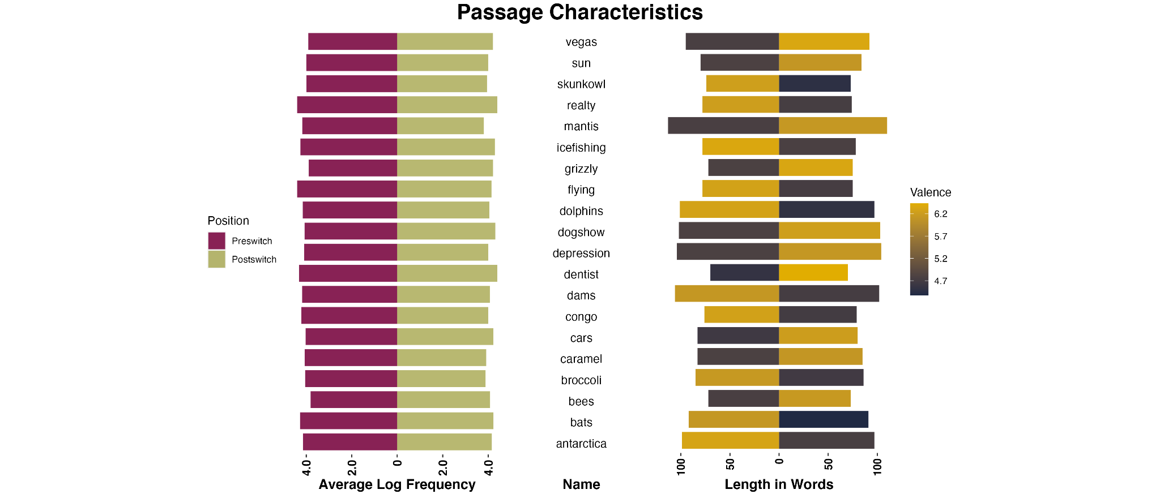

**Figure 1. Passage Characteristics.** On the left, bar length represents the average log frequency for each passage half (preswitch/postswitch). On the right, bar length represents the length (in words) for each passage half (preswitch/postswitch), color represents average valence for that passage half.

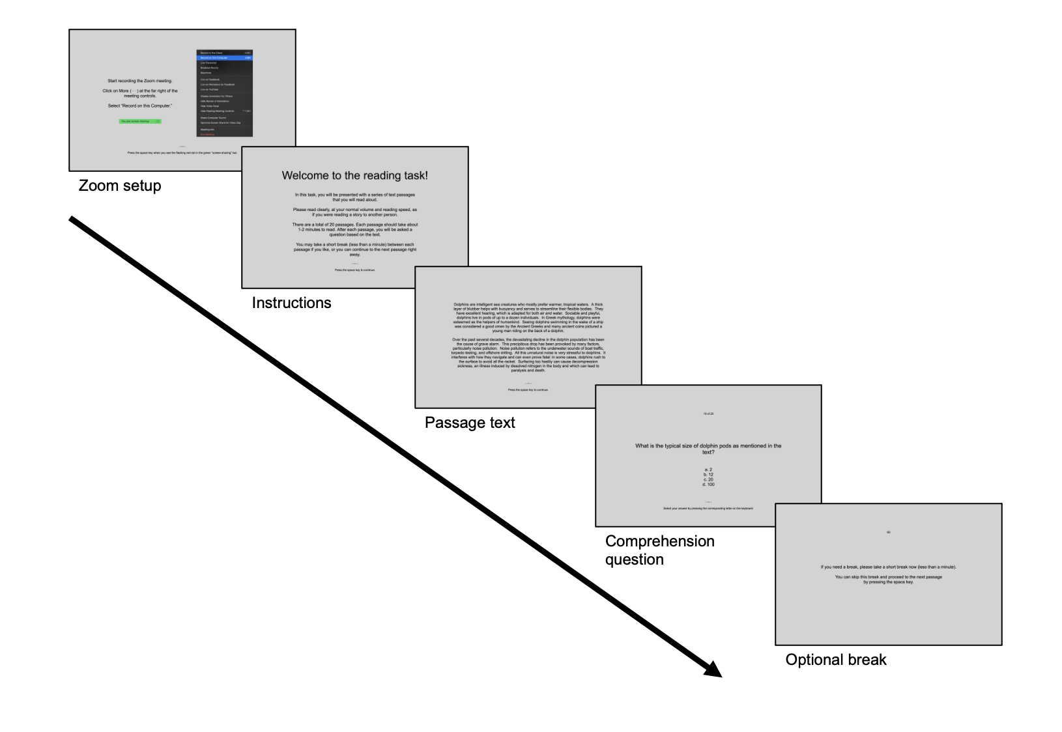

**Figure 2. Task Procedure.** The PsychoPy task, hosted by Pavlovia, led participants through setting up their Zoom recording, after which they were given task instructions. Participants proceeded through task screens by pressing the spacebar. There were no time limits for each screen. Screens with passage text were each followed by a multiple-choice comprehension question based on the prior passage, which participants answered by selecting the associated keyboard letter (‘a’, ‘b’, ‘c’, or ‘d’). The comprehension question letter press took participants to an optional 60-second break screen, which could be skipped by pressing the spacebar to continue to the next passage text.

**Procedure**

Using either a desktop or laptop computer, participants completed self-paced questionnaires relating to demographic information, mood, and mental health via REDCap (Harris et al., 2019) before clicking a link to a PsychoPy (Peirce et al., 2019) task hosted by Pavlovia (pavlovia.org; see: Bridges et al., 2020). They were informed that they would read twenty passages aloud, that each passage would take 1-2 minutes to read, that they would be asked to answer a comprehension question after each text, and that they would be able to take a short break between passages. Using Zoom (Zoom Video Communications, Inc., San José, California) to record their screen and microphone, they were instructed not to "pre-read" passages, but rather to begin reading aloud immediately and to read each passage at their normal volume and speed. For each passage, all text appeared on-screen at once, as black Arial text, centered on a light grey background. The experimental task used the “height” unit for font sizing (PsychoPy: Peirce et al., 2019), so that text would scale for each individual user’s screen without distortion. After reading each passage, participants pressed the spacebar to proceed to a multiple-choice comprehension question, which served to confirm task engagement and reading comprehension. For each question, four possible answers were presented (chance performance = 25%) and questions were drawn equally from the four categories of passage halves: preswitch positive, preswitch negative, postswitch positive, and postswitch negative. That is, we counterbalanced the location in the passage from which the information required to successfully answer the comprehension question was selected. There was no time limit for reading each passage nor for answering each comprehension question. Following each comprehension question, participants were given an optional 60-second break prior to proceeding to reading the next passage. Given that each reading passage was either positive-to-negative or negative-to-positive, we aimed to keep valence switches passage internal, rather than allowing a valence shift between passages. This was achieved by semi-randomization of the passage stimuli within the task setup: ten sets of passage pairs (positive-to-negative + negative-to-positive) were created so that their presentation could be randomized across participants. A second set of passage pairs (negative-to-positive + positive-to-negative) was additionally created, and participants were randomly assigned to one of the two sets, such that half of the participants began the experiment with a positive-to-negative passage and half began with a negative-to-positive passage.

**Acoustic Preprocessing**

In order to extract reading speed, timestamps were obtained using Praat (Boersma & Weenink, 2001). For each passage, for each reader, three time points were recorded: the onset of the first syllable in the first word of the passage, the onset of the first syllable in the switch word (denoting the border between the first and second half of the passage), and the end of the coda of the last syllable in the passage. Two coders trained by the first author annotated 57% of the recordings. The first author annotated the remaining recordings and cross-annotated 20% of the timestamps for each participant that were annotated by each of the two coders. The psych package (Revelle, 2022) in R (R Core Team, 2021) was used to calculate inter-rater reliability for the 20% of cross-annotated recordings from a two-way agreement model; this was done individually for each coder. Single measure intra-class correlation coefficients were found to be very high (coder 1: 192 timestamps (16 participants × 4 passages × 3 timestamps each), kappa > 0.999; coder 2: 276 timestamps (23 participants × 4 passages × 3 timestamps each), kappa > 0.999).

Reading speed per participant was calculated as the total number of seconds spent reading each passage half, divided by the maximum number of syllables required to produce the text–that is, syllables per second–such that higher values for reading speed correspond to faster rates of oral reading. Syllable counts were determined by conventional standards; for any word with multiple, standardly accepted pronunciations, the largest syllable count was used (e.g., "everyone" was computed as a four-syllable word, although some participants may have pronounced it with three).

**Preliminary Analyses**

Reading comprehension questions after each stimulus passage were included to confirm task engagement, as well as to assess potential speed-accuracy tradeoffs in analyses of reading speed. We removed four participants from further analysis due to low overall accuracy (≤ 50%) across all passage comprehension questions. Overall accuracy for the remaining participants was 79.7% (SD = 11.3%).

Passages for which the reading speed of either the first or second passage half could not be calculated (e.g., if the participant failed to read the full passage text aloud in the recording) were removed prior to analysis. Given that participants recorded themselves outside a laboratory environment, infrequent instances of participant interruption (for example, by family members) were observed during the task. For this reason, we also removed passages where the difference in reading speed between the first and second passage halves was ±3 standard deviations from the individual delta of each participant. In combination, this eliminated 13 (1.3% of all passages) from further analysis.

**Statistical Analyses**

To analyze the effects of stimulus characteristics on the measures of interest, lme4 (Bates et al., 2015) and the lmerTest wrapper (Kuznetsova et al., 2017) in R (R Core Team, 2021), were used to construct mixed effects models. For each passage half, position (preswitch/postswitch), average valence, average frequency, and their interactions were entered into the models as fixed effects, with random intercepts per participant and per passage. The position variable was contrast coded (preswitch: -1, postswitch: +1) and, following outlier removal, the two continuous variables were mean centered across all data points. Separate models were fit for reading speed and comprehension accuracy.

*Reading Speed*

A linear mixed effects model was constructed via restricted maximum likelihood estimation as described above, with reading speed, calculated in syllables per second, as the dependent measure. Only passages for which the correct response was provided to the reading comprehension question were considered for the analysis of reading speed. In addition, passages whose reading speed was ±3 standard deviations from the mean reading speed were removed prior to analysis. These trimming procedures resulted in the removal of a further 221 passages (21.5%).

*Reading Comprehension Question Accuracy*

A logistic mixed effects model was constructed as described above, with comprehension question accuracy as the dependent measure. Only passage halves that contained the information required to correctly answer the comprehension question were included in the model.

# RESULTS

**Reading Speed**

As described above, reading speed (in syllables per second) for each passage half was analyzed via a linear mixed effects model with position (preswitch/postswitch), average valence, average frequency, and their interactions as fixed effects, and random intercepts per participant and per passage. The reading speed model revealed a significant position × frequency interaction (β = -0.50, SE = 0.06, p < 0.001); the nature of this interaction was such that higher average word frequency was associated with faster reading speeds within preswitch passage halves, whereas higher average word frequency actually slowed reading speeds within postswitch passage halves (see Figure 3A). There was also a significant valence × frequency interaction (β = 0.62, SE = 0.08, p < 0.001), indicating that, across both passage halves, negatively valenced texts with lower average word frequency were read at faster speeds than negatively valenced texts of higher average word frequency (see Figure 4). No other significant main effects or interactions were identified for the model of reading speed.

**Comprehension Question Accuracy**

Accuracy was analyzed via a logistic mixed effects model with position (preswitch/postswitch), average valence, average frequency, and their interactions as fixed effects, and random intercepts per participant and per passage. The accuracy model revealed main effects of position (β = 0.59, SE = 0.19, p = 0.003) and valence (β = -0.52, SE = 0.25, p = 0.040), which were moderated by two interactions. First, a significant position × frequency interaction (β = ‑4.18, SE = 1.43, p = 0.004) was identified; the nature of this interaction was such that higher average word frequency was associated with more accurate responses within preswitch passage halves, whereas higher average word frequency was associated with less accurate responses within postswitch passage halves (see Figure 3B). There was also a significant position × valence interaction (β = 0.60, SE = 0.25, p = 0.017): more positive passage halves were associated with lower accuracy, but only in the preswitch position, whereas comprehension accuracy remained high across valence levels within the postswitch position. No other significant main effects or interactions were identified for the model of comprehension question accuracy.

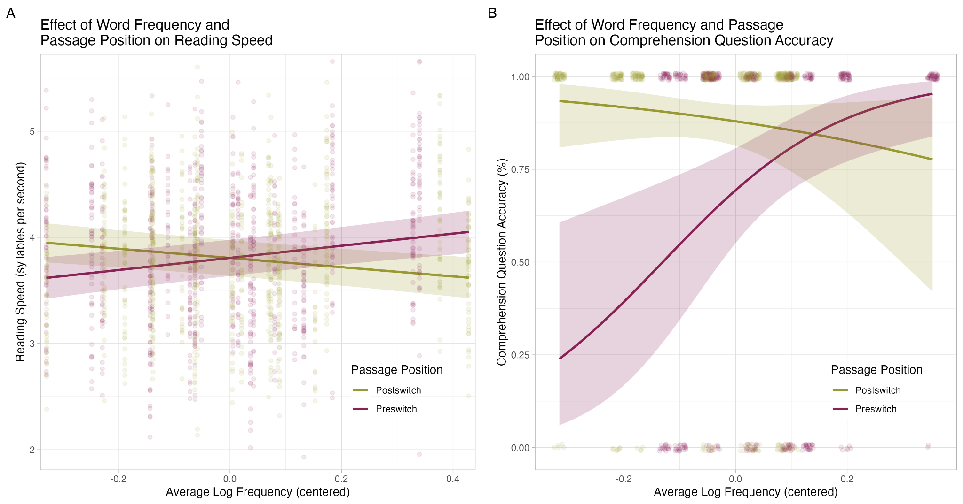

**Figure 3. Frequency × Position Interaction Effects in Reading Speed and Comprehension Question Accuracy.** (A) Shape of the frequency × position interaction on reading speed (p < 0.001) and (B) comprehension question accuracy (p = 0.004). Points represent individual performance on each passage half, and are jittered in plot B for improved visualization.

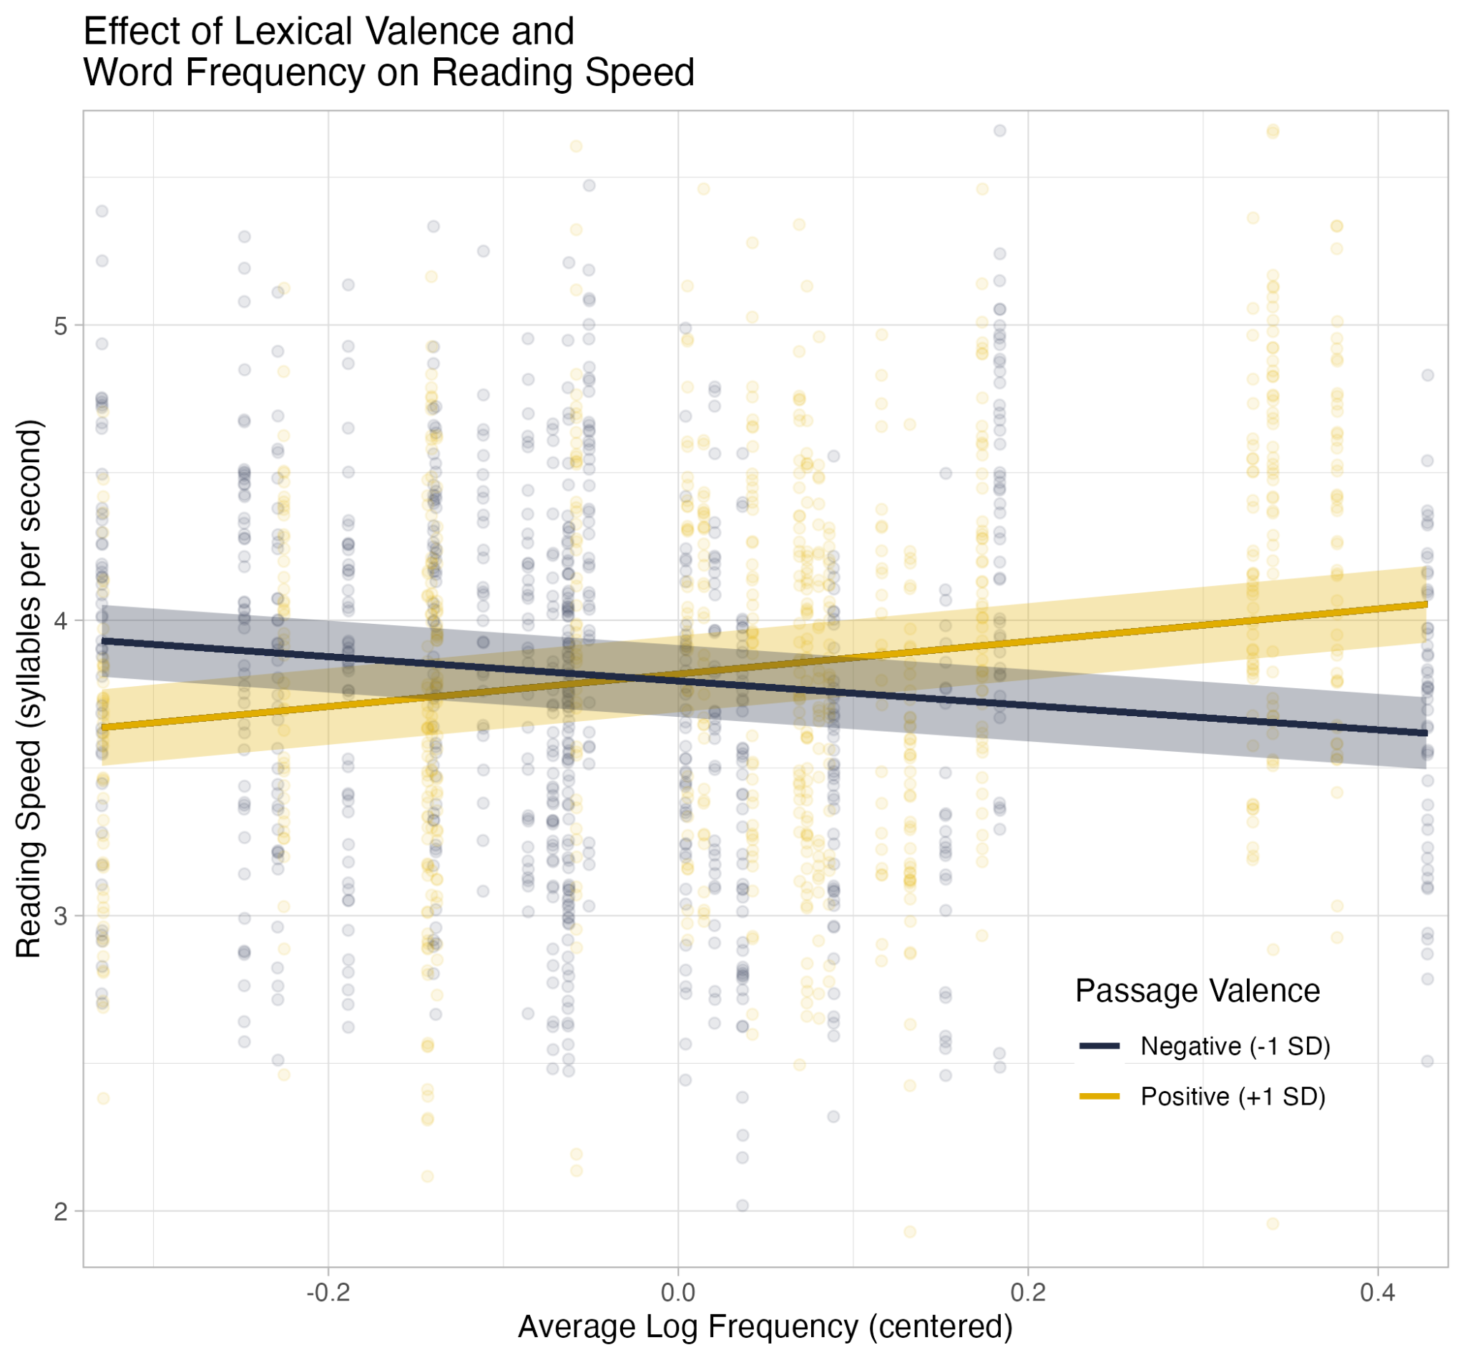

**Figure 4. Frequency × Valence Interaction Effects in Reading Speed.** Shape of the valence × frequency interaction (p < 0.001) on reading speed. Points represent individual performance on each passage half. Negative passage valence values represent performance on passage halves whose centered valence rating was less than 1 standard deviation (SD) below the mean; positive values represent performance on passage halves whose centered valence rating was greater than 1 standard deviations (SD) above the mean. Given that emotional valence was manipulated to bias each passage half toward strongly positive or strongly negative average ratings, the mean valence value was not representative of any passage halves and is therefore not plotted.

# DISCUSSION

We examined the influence of word frequency and lexical valence on reading speed in a naturalistic oral reading task. Effects of word frequency, lexical valence, and their interaction have been found at the single-word level (e.g., Balota & Chumbley, 1984; Kuperman et al., 2014; Larsen et al., 2006), but little is known about whether these effects accumulate over the course of multi-sentence passages. Furthermore, the current literature on the role of emotional valence in lexical processing is conflicted, leaving it unclear whether all emotional words benefit from a processing advantage (e.g., Kousta et al., 2009), whether such an advantage is only maintained by positive words (e.g., Kuperman et al., 2014), or whether the effects of emotional valence only become salient in interaction with word frequency (e.g., Scott et al., 2012). As a corollary, we also manipulated emotional valence within each passage to investigate whether a sudden shift in valence during the reading of a passage would disrupt the processing of the higher-level discourse context, further impacting effects of word frequency on reading speed.

Overall, we found that effects of lexical frequency on oral reading speed, measured in syllables per second over a naturalistic passage, is generally consistent with the pattern of results reported in more traditional studies that employ highly-constrained experimental designs and use stand-alone words or simplified sentences. In the first half of each passage, reading speed and comprehension question accuracy displayed traditional frequency effects, with faster speeds and more accurate responses for passage halves with higher average word frequency. Moreover, as reading speeds did not revert to being driven primarily by average word frequency in the second half of each passage, our results suggest that reversing the polarity of emotional valence midpassage did not significantly disrupt the accrual of discourse context used to predict upcoming content. Finally, while we did not identify an overall advantage for positive content, we did replicate previously reported interactions whereby the processing of high-frequency negative words is slowed (Kuchinke et al., 2007; Méndez-Bértolo et al., 2011; Scott et al., 2009, 2012, 2014). We discuss each of these findings below.

**Word frequency effects extend to passage-length stimuli**

In single word reading aloud, response latencies for high-frequency words are shorter than those for low-frequency words (Balota & Spieler, 1999; Fischer-Baum et al., 2014). That is, participants require less time to process and produce words that are more frequently encountered. A similar pattern emerges in eye-tracking research, where high-frequency words are fixated for a shorter period of time than low-frequency words (Kliegl et al., 2004; Scott et al., 2012). In this study, we find that the speed advantage for high-frequency words is also present when measured at the level of average reading speed, in syllables per second, for multi-sentence texts with higher average word frequency. Importantly, we also find that faster reading performance for content with higher average word frequency does not negatively impact reading comprehension, as faster reading speed was observed alongside higher accuracy on comprehension questions for passages with higher average word frequency. This implies that, in the context of naturalistic reading, the processing advantage for high-frequency words does not entail a speed-accuracy tradeoff (MacKay, 1982).

**Reversing valence does not appear to disrupt the discourse context**

Given the body of literature supporting traditional word frequency effects (Balota & Chumbley, 1984; Balota & Spieler, 1999; Barriga-Paulino et al., 2022; Fischer-Baum et al., 2014; Kuchinke et al., 2007; Larsen et al., 2008; Scott et al., 2012), we expected a pronounced positive relation between average word frequency and reading speed in the first half of each passage, when discourse context is relatively low and word frequency effects are more likely to drive reading performance. Following the midpassage shift in emotional valence, however, any reduction in the positive association between word frequency and reading speed would depend on the degree to which the higher-level discourse context were disrupted by this reversal in valence. That is, if the valence switch did, indeed, disrupt the accrual of higher-level discourse context, then reading speed would presumably revert to being driven primarily by word frequency effects, in which case the positive association between word frequency and reading speed expected in the first half of the passage would be more likely to manifest in the second half, as well. In contrast, if the valence switch did not disrupt the unfolding discourse context, and given prior work demonstrating that discourse context can mitigate the positive relation between word frequency and processing speed (Payne et al., 2015; Payne & Federmeier, 2019; Van Petten & Kutas, 1990, 1991), we would expect a reduction in the positive link between word frequency and reading speed in the second half of passages.

As explained in the introduction, traditional word frequency effects on N400 amplitudes are diminished when upcoming words are highly predictable from the ongoing discourse context (Payne et al., 2015; Payne & Federmeier, 2019; Van Petten & Kutas, 1990, 1991). This attenuation of the N400 has been interpreted (Delaney-Busch & Kuperberg, 2013) as a corroboration of context-specific predictive processing: when the semantic features of an incoming word match features that are already highly active as a result of the discourse context, the processing of the incoming word is facilitated. In their study, Delaney-Busch and Kuperberg (2013) used emotionality to construct the discourse context. Participants read two-sentence scenarios in which the first sentence established a positive, negative, or neutral context. In the second sentence, the critical word was either congruent or incongruent with the preceding context. For emotional contexts, a reversal in valence was used as the incongruent condition (e.g., "Colin saw a *stunning/horrifying* object on the ground. He realized it was a snake/diamond right away.") Their results indicated that the reversal in valence did not produce an N400 effect: instead, the N400 to all emotional words was small, regardless of whether the emotional word was congruent with the preceding emotional context. From these results, Delaney-Busch and Kuperberg (2013) argued that emotional salience dominates over discourse congruity; that is, the brain prioritizes emotional salience, bypassing the retrieval of semantic features in the typical N400 window.

In the preswitch passage halves of our study, and similar to the traditional frequency effects displayed on the N400 in early open-class words within sentential frames (Van Petten & Kutas, 1990), we found an accumulation of word-level frequency effects that caused preswitch passage halves with higher average word frequency to be read at faster speeds. The postswitch passage halves did not display the same pattern. Instead, for postswitch passage halves, faster reading speeds were associated with lower average word frequency. These results imply that discourse context (and predictability) continued to accrue during the postswitch passage half and that the switch in emotional valence did not cause processing speeds in the second half of the passage to be driven primarily by lexical frequency effects. Like Delaney-Busch and Kuperberg (2013), we posit that emotionality serves as a predictive frame in our reading passages, with readers actively anticipating that upcoming words will be highly emotional but without regard for positive or negative valence polarity.

**High-frequency negative content is disadvantaged**

Orthogonal to effects involving discourse context, we also observed that lexical valence interacted directly with average word frequency, such that high-frequency content was disadvantaged in negative passage halves. Prior work investigating lexical valence while holding word frequency constant has yielded two conflicting lines of results: (1) emotionally valenced words, whether positive or negative, are processed faster than neutral words (F. Knickerbocker et al., 2019; H. Knickerbocker et al., 2014; Kousta et al., 2009; Kuchinke et al., 2007; Schacht & Sommer, 2009; Scott et al., 2009; Vinson et al., 2014; Yap & Seow, 2014) or (2) positive words display a processing advantage over both negative and neutral words (Barriga-Paulino et al., 2022; Estes & Adelman, 2008; Estes & Verges, 2008; Kuperman et al., 2014; Larsen et al., 2008; Scott et al., 2014). However, when interactions between word frequency and lexical valence are considered, it is specifically high-frequency negative words that underperform, demonstrating slowed response times in lexical decision (Kuchinke et al., 2007; Méndez-Bértolo et al., 2011; Scott et al., 2009, 2014) and longer fixation durations in eye-tracking (Scott et al., 2012). This same pattern emerges in our results. Across passage positions, negatively valenced passages with higher average word frequency were read more slowly. Thus, interactive effects of valence and word frequency previously demonstrated in traditional, highly-constrained experimental designs appear to generalize to naturalistic oral reading of multi-sentence passages. However, across word frequency values, we did not see a specific advantage for either positive or negative content.

**Strengths, limitations, and future directions**

A key strength of the current study is the use of an experimental protocol offering enhanced ecologically validity and naturalistic, paragraph-length stimuli. Additionally, we incorporated a mixed-effects analytic approach in all analyses. Nonetheless, this study is not without limitations. The sample is modest in size and, given the novelty of the paradigm employed, the current results should be replicated within a larger group of participants. Our sample is also predominantly female. Some prior work has found gender differences in word valence ratings (Warriner et al., 2013); future work should therefore leverage designs that explore whether gender or biological sex moderate the effects reported in the current study.

**Conclusions**

Current research on lexical processing is heavily focused on word-level behaviors, and much is now known about many of the features that influence lexical processing, as well as how this influence unfolds over time. However, typical experimental paradigms are distinctly unlike naturalistic reading, not only in their presentation (standalone words or RSVP designs) but also in their construction: 95% of open-class words are less contextually constrained than those used in typical language studies (Luke & Christianson, 2016). The current study takes an initial step toward understanding how word-level features affect reading in more ecologically-valid task contexts, and whether such word-level features reliably map onto reading behavior across naturalistic, multi-sentence frames. To these ends, we find that previously studied lexical processing effects do, indeed, map onto oral reading speed when passage-length texts are presented on-screen as a whole. In preswitch passage halves, we observed traditional word frequency effects, with faster reading speeds when average word frequency was high. In postswitch passage halves, traditional frequency effects were diminished, which we interpret as evidence that discourse context was high and that positive and negative content contributed to a similar predictive frame (i.e., an increased expectancy for emotional words). Turning to the interaction between frequency and valence, our findings again mirrored the existing literature: high-frequency negative content was disadvantaged, and negative passage halves with higher average word frequency were read the slowest. Overall, we demonstrate that oral reading speed is a useful proxy for classic measures used in reading research.

# DATA AVAILABILITY

Our analysis code and data are available at https://osf.io/pn2hu/. Passage stimuli are included as supplementary information in this preprint, and are also available at https://github.com/NDCLab/readAloud-valence-dataset.

# CONFLICTS OF INTEREST

The authors report no conflicts of interest.

# ACKNOWLEDGMENTS

We would like to thank Laura Gallardo and Maria Rodriguez for their invaluable efforts in coding the passage timestamps.

# REFERENCES

Balota, D. A., & Chumbley, J. I. (1984). Are Lexical Decisions a Good Measure of Lexical Access? The Role of Word Frequency in the Neglected Decision Stage. *Journal of Experimental Psychology: Human Perception and Performance*, *3*, 340–357. https://doi.org/10.1037//0096-1523.10.3.340

Balota, D. A., & Spieler, D. H. (1999). Word Frequency, Repetition, and Lexicality Effects in Word Recognition Tasks: Beyond Measures of Central Tendency. *Journal of Experimental Psychology: General*, *128*(1), 32–55. https://doi.org/10.1037//0096-3445.128.1.32

Balota, D. A., Yap, M. J., Hutchison, K. A., Cortese, M. J., Kessler, B., Loftis, B., Neely, J. H., Nelson, D. L., Simpson, G. B., & Treiman, R. (2007). The English Lexicon Project. *Behavior Research Methods*, *39*(3), 445–459. https://doi.org/10.3758/BF03193014

Barber, H., Vergara, M., & Carreiras, M. (2004). Syllable-frequency effects in visual word recognition: Evidence from ERPs. *Cognitive Neuroscience and Neuropsychology*, *15*(3), 545–548.

Barriga-Paulino, C. I., Guerreiro, M., Faísca, L., & Reis, A. (2022). Does emotional valence modulate word recognition? A behavioral study manipulating frequency and arousal. *Acta Psychologica*, *223*, 103484. https://doi.org/10.1016/j.actpsy.2021.103484

Bates, D., Mächler, M., Bolker, B., & Walker, S. (2015). Fitting Linear Mixed-Effects Models Using lme4. *Journal of Statistical Software*, *67*(1). https://doi.org/10.18637/jss.v067.i01

Boersma, P., & Weenink, D. (2001). PRAAT, a system for doing phonetics by computer. *Glot International*, *5*, 341–345.

Bridges, D., Pitiot, A., MacAskill, M. R., & Peirce, J. W. (2020). The timing mega-study: Comparing a range of experiment generators, both lab-based and online. *PeerJ*, *8*, e9414. https://doi.org/10.7717/peerj.9414

Brysbaert, M., & New, B. (2009). Moving beyond Kučera and Francis: A critical evaluation of current word frequency norms and the introduction of a new and improved word frequency measure for American English. *Behavior Research Methods*, *41*(4), 977–990. https://doi.org/10.3758/BRM.41.4.977

Chou, L.-C., Pan, Y.-L., & Lee, C. (2020). Emotion anticipation induces emotion effects in neutral words during sentence reading: Evidence from event-related potentials. *Cognitive, Affective, & Behavioral Neuroscience*, *20*(6), 1294–1308. https://doi.org/10.3758/s13415-020-00835-z

Delaney-Busch, N., & Kuperberg, G. (2013). Friendly drug-dealers and terrifying puppies: Affective primacy can attenuate the N400 effect in emotional discourse contexts. *Cognitive, Affective, & Behavioral Neuroscience*, *13*(3), 473–490. https://doi.org/10.3758/s13415-013-0159-5

Estes, Z., & Adelman, J. S. (2008). Automatic vigilance for negative words in lexical decision and naming: Comment on Larsen, Mercer, and Balota (2006). *Emotion*, *8*(4), 441–444. https://doi.org/10.1037/1528-3542.8.4.441

Estes, Z., & Verges, M. (2008). Freeze or flee? Negative stimuli elicit selective responding. *Cognition*, *108*(2), 557–565. https://doi.org/10.1016/j.cognition.2008.03.003

Federmeier, K. D. (2007). Thinking ahead: The role and roots of prediction in language comprehension. *Psychophysiology*, *44*(4), 491–505. https://doi.org/10.1111/j.1469-8986.2007.00531.x

Fischer-Baum, S., Dickson, D. S., & Federmeier, K. D. (2014). Frequency and regularity effects in reading are task dependent: Evidence from ERPs. *Language, Cognition and Neuroscience*, *29*(10), 1342–1355. https://doi.org/10.1080/23273798.2014.927067

Haro, J., Guasch, M., Vallès, B., & Ferré, P. (2017). Is pupillary response a reliable index of word recognition? Evidence from a delayed lexical decision task. *Behavior Research Methods*, *49*(5), 1930–1938. https://doi.org/10.3758/s13428-016-0835-9

Harris, P. A., Taylor, R., Minor, B. L., Elliott, V., Fernandez, M., O’Neal, L., McLeod, L., Delacqua, G., Delacqua, F., Kirby, J., & Duda, S. N. (2019). The REDCap consortium: Building an international community of software platform partners. *Journal of Biomedical Informatics*, *95*, 103208. https://doi.org/10.1016/j.jbi.2019.103208

Herbert, C., Ethofer, T., Anders, S., Junghofer, M., Wildgruber, D., Grodd, W., & Kissler, J. (2009). Amygdala activation during reading of emotional adjectives—An advantage for pleasant content. *Social Cognitive and Affective Neuroscience*, *4*(1), 35–49. https://doi.org/10.1093/scan/nsn027

Herbert, C., Junghofer, M., & Kissler, J. (2008). Event related potentials to emotional adjectives during reading. *Psychophysiology*, *45*(3), 487–498. https://doi.org/10.1111/j.1469-8986.2007.00638.x

Hsu, C.-T., Jacobs, A. M., Citron, F. M. M., & Conrad, M. (2015). The emotion potential of words and passages in reading Harry Potter – An fMRI study. *Brain and Language*, *142*, 96–114. https://doi.org/10.1016/j.bandl.2015.01.011

Hulme, C., Maughan, S., & Brown, G. D. A. (1991). Memory for familiar and unfamiliar words: Evidence for a long-term memory contribution to short-term memory span. *Journal of Memory and Language*, *30*(6), 685–701. https://doi.org/10.1016/0749-596X(91)90032-F

Kazanas, S., & Altarriba, J. (2016). Emotion Word Processing: Effects of Word Type and Valence in Spanish–English Bilinguals. *Journal of Psycholinguistic Research*, *45*, 395–406. https://doi.org/10.1007/s10936-015-9357-3

Keuper, K., Zwitserlood, P., Rehbein, M. A., Eden, A. S., Laeger, I., Junghöfer, M., Zwanzger, P., & Dobel, C. (2013). Early Prefrontal Brain Responses to the Hedonic Quality of Emotional Words – A Simultaneous EEG and MEG Study. *PLoS ONE*, *8*(8), e70788. https://doi.org/10.1371/journal.pone.0070788

Kissler, J., & Herbert, C. (2013). Emotion, Etmnooi, or Emitoon? – Faster lexical access to emotional than to neutral words during reading. *Biological Psychology*, *92*(3), 464–479. https://doi.org/10.1016/j.biopsycho.2012.09.004

Kissler, J., Herbert, C., Peyk, P., & Junghofer, M. (2007). Buzzwords: Early Cortical Responses to Emotional Words During Reading. *Psychological Science*, *18*(6), 475–480. https://doi.org/10.1111/j.1467-9280.2007.01924.x

Kissler, J., Herbert, C., Winkler, I., & Junghöfer, M. (2009). Emotion and attention in visual word processing—An ERP study. *Biological Psychology*, *80*, 75–83. https://doi.org/10.1016/j.biopsycho.2008.03.004

Kliegl, R., Dambacher, M., Dimigen, O., Jacobs, A. M., & Sommer, W. (2012). Eye movements and brain electric potentials during reading. *Psychological Research*, *76*(2), 145–158. https://doi.org/10.1007/s00426-011-0376-x

Kliegl, R., Grabner, E., Rolfs, M., & Engbert, R. (2004). Length, frequency, and predictability effects of words on eye movements in reading. *European Journal of Cognitive Psychology*, *16*(1–2), 262–284. https://doi.org/10.1080/09541440340000213

Knickerbocker, F., Johnson, R. L., Starr, E. L., Hall, A. M., Preti, D. M., Slate, S. R., & Altarriba, J. (2019). The time course of processing emotion-laden words during sentence reading: Evidence from eye movements. *Acta Psychologica*, *192*, 1–10. https://doi.org/10.1016/j.actpsy.2018.10.008

Knickerbocker, H., Johnson, R., & Altarriba, J. (2014). Emotion effects during reading: Influence of an emotion target word on eye movements and processing. *Cognition & Emotion*, *29*, 1–23. https://doi.org/10.1080/02699931.2014.938023

Kousta, S.-T., Vinson, D. P., & Vigliocco, G. (2009). Emotion words, regardless of polarity, have a processing advantage over neutral words. *Cognition*, *112*(3), 473–481. https://doi.org/10.1016/j.cognition.2009.06.007

Kuchinke, L., Vo, M., Hofmann, M., & Jacobs, A. (2007). Pupillary responses during lexical decisions vary with word frequency but not emotional valence. *International Journal of Psychophysiology*, *65*(2), 132–140. https://doi.org/10.1016/j.ijpsycho.2007.04.004

Kuperman, V., Estes, Z., Brysbaert, M., & Warriner, A. (2014). Emotion and Language: Valence and Arousal Affect Word Recognition. *Journal of Experimental Psychology: General*, *143*(3), 1065–1081. https://doi.org/10.1037/a0035669

Kuznetsova, A., Brockhoff, P. B., & Christensen, R. H. B. (2017). lmerTest Package: Tests in Linear Mixed Effects Models. *Journal of Statistical Software*, *82*(13). https://doi.org/10.18637/jss.v082.i13

Lang, P. J., Bradley, M. M., & Cuthbert, B. N. (1990). Emotion, Attention, and the Startle Reflex. *Psychological Review*, *97*(3), 377–395. https://doi.org/10.1037/0033-295X.97.3.377

Larsen, R. J., Mercer, K. A., & Balota, D. A. (2006). Lexical Characteristics of Words used in Emotional Stroop Studies. *Emotion*, *6*(1), 62–72. https://doi.org/10.1037/1528-3542.6.1.62

Larsen, R. J., Mercer, K. A., Balota, D. A., & Strube, M. J. (2008). Not all negative words slow down lexical decision and naming speed: Importance of word arousal. *Emotion*, *8*(4), 445–452. https://doi.org/10.1037/1528-3542.8.4.445

Li, C., Midgley, K. J., & Holcomb, P. J. (2022). ERPs reveal how semantic and syntactic processing unfold across parafoveal and foveal vision during sentence comprehension. *Language, Cognition and Neuroscience*, 1–17. https://doi.org/10.1080/23273798.2022.2091150

Luke, S. G., & Christianson, K. (2016). Limits on lexical prediction during reading. *Cognitive Psychology*, *88*, 22–60. https://doi.org/10.1016/j.cogpsych.2016.06.002

MacKay, D. G. (1982). The problems of flexibility, fluency, and speed–accuracy trade-off in skilled behavior. *Psychological Review*, *89*(5), 483–506. https://doi.org/10.1037/0033-295X.89.5.483

Méndez-Bértolo, C., Pozo, M. A., & Hinojosa, J. A. (2011). Word frequency modulates the processing of emotional words: Convergent behavioral and electrophysiological data. *Neuroscience Letters*, *494*(3), 250–254. https://doi.org/10.1016/j.neulet.2011.03.026

Payne, B. R., & Federmeier, K. D. (2019). Individual Differences in Reading Speed are Linked to Variability in the Processing of Lexical and Contextual Information: Evidence from Single-trial Event-related Brain Potentials. *Word*, *65*(4), 252–272. https://doi.org/10.1080/00437956.2019.1678826

Payne, B. R., Lee, C.-L., & Federmeier, K. D. (2015). Revisiting the Incremental Effects of Context on Word Processing: Evidence from Single-Word Event-Related Brain Potentials. *Psychophysiology*, *52*(11), 1456–1469. https://doi.org/10.1111/psyp.12515

Payne, B. R., Stites, M. C., & Federmeier, K. D. (2019). Event-related brain potentials reveal how multiple aspects of semantic processing unfold across parafoveal and foveal vision during sentence reading. *Psychophysiology*, *56*(10), e13432. https://doi.org/10.1111/psyp.13432

Peirce, J., Gray, J. R., Simpson, S., MacAskill, M., Höchenberger, R., Sogo, H., Kastman, E., & Lindeløv, J. K. (2019). PsychoPy2: Experiments in behavior made easy. *Behavior Research Methods*, *51*(1), 195–203. https://doi.org/10.3758/s13428-018-01193-y

Plaut, D. C., McClelland, J. L., & Seidenberg, M. S. (1996). Understanding Normal and Impaired Word Reading: Computational Principles in Quasi-Regular Domains. *Psychological Review*, *103*(1), 56–115. https://doi.org/10.1037/0033-295x.103.1.56

Pratto, F., & John, O. P. (1991). Automatic vigilance: The attention-grabbing power of negative social information. *Journal of Personality and Social Psychology*, *61*(3), 380–391. https://doi.org/10.1037/0022-3514.61.3.380

R Core Team. (2021). *R: A language and environment for statistical computing*. R Foundation for Statistical Computing. https://www.R-project.org/.

Revelle, W. (2022). *psych: Procedures for Psychological, Psychometric, and Personality Research* (R package version 2.2.9). Northwestern University. https://cran.r-project.org/package=psych

Rugg, M. D. (1990). Event-related brain potentials dissociate repetition effects of high-and low-frequency words. *Memory & Cognition*, *18*(4), 367–379. https://doi.org/10.3758/BF03197126

Schacht, A., & Sommer, W. (2009). Time course and task dependence of emotion effects in word processing. *Cognitive, Affective, & Behavioral Neuroscience*, *9*(1), 28–43. https://doi.org/10.3758/CABN.9.1.28

Schindler, S., & Kissler, J. (2016). Selective visual attention to emotional words: Early parallel frontal and visual activations followed by interactive effects in visual cortex. *Human Brain Mapping*, *37*(10), 3575–3587. https://doi.org/10.1002/hbm.23261

Schotter, E. R., & Payne, B. R. (2019). Eye Movements and Comprehension Are Important to Reading. *Trends in Cognitive Sciences*, *23*(10), 811–812. https://doi.org/10.1016/j.tics.2019.06.005

Scott, G. G., O’Donnell, P. J., Leuthold, H., & Sereno, S. C. (2009). Early emotion word processing: Evidence from event-related potentials. *Biological Psychology*, *80*(1), 95–104. https://doi.org/10.1016/j.biopsycho.2008.03.010

Scott, G. G., O’Donnell, P. J., & Sereno, S. C. (2014). Emotion words and categories: Evidence from lexical decision. *Cognitive Processing*, *15*(2), 209–215. https://doi.org/10.1007/s10339-013-0589-6

Scott, G. G., O’Donnell, P., & Sereno, S. (2012). Emotion Words Affect Eye Fixations During Reading. *Journal of Experimental Psychology: Learning, Memory, and Cognition*, *38*(3), 783–792. https://doi.org/10.1037/a0027209

Stuart, G., & Hulme, C. (2000). The effects of word co-occurance on short-term memory: Associative links in long-term memory affect short-term memory performance. *Journal of Experimental Psychology: Learning, Memory, and Cognition*, *26*(3), 796–802. https://doi.org/10.1037/0278-7393.26.3.796

Unkelbach, C., Fiedler, K., Bayer, M., Stegmüller, M., & Danner, D. (2008). Why positive information is processed faster: The density hypothesis. *Journal of Personality and Social Psychology*, *95*(1), 36–49. https://doi.org/10.1037/0022-3514.95.1.36

U.S. Census Bureau. (2015). *Detailed Languages Spoken at Home and Ability to Speak English for the Population 5 Years and Over for Counties: 2009-2013*. https://www2.census.gov/library/data/tables/2008/demo/language-use/2009-2013-acs-lang-tables-county.xls

Van Petten, C., & Kutas, M. (1990). Interactions between sentence context and word frequency in event-related brain potentials. *Memory & Cognition*, *18*(4), 380–393. https://doi.org/10.3758/BF03197127

Van Petten, C., & Kutas, M. (1991). Influences of semantic and syntactic context on open- and closed-class words. *Memory & Cognition*, *19*(1), 95–112. https://doi.org/10.3758/BF03198500

Vinson, D., Ponari, M., & Vigliocco, G. (2014). How does emotional content affect lexical processing? *Cognition and Emotion*, *28*(4), 737–746. https://doi.org/10.1080/02699931.2013.851068

Warriner, A. B., Kuperman, V., & Brysbaert, M. (2013). Norms of valence, arousal, and dominance for 13,915 English lemmas. *Behavior Research Methods*, *45*(4), 1191–1207. https://doi.org/10.3758/s13428-012-0314-x

Yap, M., & Seow, C. (2014). The influence of emotion on lexical processing: Insights from RT distributional analysis. *Psychonomic Bulletin & Review*, *21*, 526–533. https://doi.org/10.3758/s13423-013-0525-x

Zajonc, R. B. (1980). Preferences Need No Inferences. *American Psychologist*, *35*(2), 151–175. https://doi.org/10.1037/0003-066x.35.2.151

# 

# SUPPLEMENTARY MATERIAL

Below are the passage stimuli presented to participants to read aloud. Titles are for descriptive purposes, and were not presented to participants. In each passage, the underlined word indicates the point at which emotional valence reverses.

**“antarctica” (positive-to-negative)**

The first expedition to the South Pole was led by an explorer from the newly independent country of Norway. In the southern hemisphere, springtime occurs in October, so the courageous Norwegian team of five men and 52 dogs set off from their camp in mid-October 1911, hoping to reach the geographic South Pole. Skilled on skis, they traveled for two months and arrived, safe and sound, by mid-December. Victorious, they returned to civilization, pleased to have triumphed over the British expedition. The British team embarked on a similar quest via a different route with a fatal conclusion.

Five weeks after the Norwegians conquered the Pole, the British arrived. They were severely disappointed to find a letter left by the Norwegians to confirm their defeat. Dejected, they turned back, planning to meet a support team in early March around Latitude 82, but the team never appeared. Suffering from frostbite and running out of food, they waited in the merciless cold just 12 miles from their main supply point. Violent storms raged outside their tent and suspicion crept in that they had been abandoned. Their pursuit of the Pole ended in grim misfortune.

**“bats” (positive-to-negative)**

Bats are the only flying mammal. The smallest has a six-inch wingspan; the wings of the largest, the flying foxes, extend over one and a half meters. Microbats send out ultrasonic sounds that produce echoes. The returning echoes allow them to “see” in their nightly quest for food. A different kind of bat, the megabat, eats fruit, which it finds with its senses of smell and vision.

Across Asia and the Pacific, there are strong positive cultural associations with this furry, winged creature. In the West, it is popularly connected to death, darkness, and witchcraft. Most microbats hunt on insects, but not vampire bats. There are only three species of vampire bat, all of which are blood suckers. Under the cover of darkness, they use infrared radiation to locate blood hotspots on their sleeping prey and attack from the ground, approaching on all fours. With razor sharp teeth, they make a small bite and spend about thirty minutes draining the wound. Their saliva prevents the blood from clotting. Although it’s creepy, the victim does not lose enough blood to do them harm.

**“bees” (negative-to-positive)**

Colony collapse disorder has been documented since 1869. Although its cause is still unidentified, its symptoms are manifest: a hive is abandoned by its bees, leaving behind the honey and the queen. It is currently speculated that colony collapse disorder is triggered by the interplay of multiple stressors, such as parasites, pesticides, and an inadequate diet. These rampant fears about colony collapse disorder concern one particular strain of bee that prospers worldwide, on every continent.

There are 20,000 known species of bee around the globe, of which eight make honey. Honey is produced from the nectar of flowers and is stored in honeycomb. A single beehive can generate more than 60 pounds of honey each year. This liquid confection is, of course, sweet and delicious, but it can also be employed for therapeutic purposes, especially as a topical antibiotic in herbal medicine.

**“broccoli” (positive-to-negative)**

Broccoli is great for heart health. High in fiber and various vitamins, this tasty vegetable has been found to support the immune system with its antioxidant properties. It originated in the northern Mediterranean during the Roman Empire and was brought to North America in the 19th century.

The broccoli family is very diverse, including cauliflower, Brussels sprouts, and kale. There are a variety of ways to cook broccoli and its delicious friends, such as stir frying and pickling. Some methods of preparation moderate the family’s repulsive bitterness. That pungent and unpleasant flavor is most distinct in cabbage and horseradish. It is caused by sulfur-containing compounds that actually interfere with iodine absorption in the body. So, although these vegetables may curb your risk of cancer and heart disease, you should avoid consuming too much, especially if you suffer from an iodine deficiency or other thyroid problems. The thyroid is a gland; it uses iodine to make hormones that control your metabolism. Today, the widespread availability of iodized table [salt] counteracts iodine deficiencies.

*(Note: The bracketed word was erroneously not included in the experiment. For this reason, the “broccoli” passage was excluded from all analyses.)*

**“caramel” (negative-to-positive)**

Making caramel is a risky undertaking. Particles of sucrose and glucose are heated until they brown, then combined with fat to yield a sticky, elastic substance. The primary dangers are splatter and seizing, both of which threaten the moment that cold fat hits scalding sucrose. If the boiling mixture touches skin, it adheres and burns the flesh. If the mixture seizes, you are left with clumps of hard, useless sugar. If nothing goes wrong, then the consequence of this difficult process is a magical, chewy confection.

There are all kinds of caramels: crunchy brittles, jiggly flans, ice cream drizzles, and soft squares that simply melt on your tongue. A more recent trend in caramel is the addition of sea salt. First invented by a French pastry chef in 1977, salted caramel became a worldwide craze around 2008. Scientists have found that the combination of sugar, butter, and salt creates a reward cycle that makes you crave the candy even more after every bite.

**“cars” (negative-to-positive)**

Gasoline-engine cars were once loud, dangerous, and expensive. These disadvantages were conquered in the early twentieth century. The noise emitted by the exhaust of an internal combustion engine was suppressed by the muffler. The difficulty of hand-cranking was eliminated with the electric starter. And mass manufacturing by Henry Ford decreased the price. The electric automobile was all but forgotten. But as concerns intensified around pollution and the cost of fuel, the dependence on gasoline no longer struck consumers as such a bargain.

And so began the rise of the modern market for electric vehicles. Quieter and more affordable to maintain, electric motors are especially desirable for their association with clean energy. In 2019, the seductive Tesla triumphed over the innovative Nissan Leaf as the top-selling electric car in the world. Historically, electric-power cars were the first automotive vehicles on the road. Although they were eclipsed for a century by the petroleum powertrain, they have made a powerful comeback.

**“congo” (positive-to-negative)**

Six percent of the Earth’s surface is blanketed in rainforest. From the temperate forests of the Pacific Northwest to the tropical Congo, these evergreen canopies are the longest-living ecosystems on the planet. They are also a refuge of diversity, serving as home to a wealth of plant and animal species.

People have inhabited rainforests for thousands of years. Today, more than 75 million people live in the Congo Basin. These residents have witnessed as tragedy unfolds, destroying the fragile woods they inhabit. Both industrial logging and slash-and-burn agriculture, where sections of trees are cut down and then burned to cultivate crops, have led to major deforestation in the region. Deforestation has made the area more accessible to commercial hunters, igniting a poaching epidemic that is killing off midsize animals faster than they can reproduce. And social unrest means that the dangers of ambush, kidnapping, and robbery remain high in some areas.

**“dams” (positive-to-negative)**

A dam is a gateway that is designed to direct the flow of water. The first known dam was built in Jordan over 5000 years ago. An important ambition in the construction of a dam is to provide sufficient water, both for drinking and for cultivating local farmland. In modern history, this water has also been employed for its hydropower capabilities and dams have become a significant generator of electricity. Humans build these structures, but so do beavers. Using tree branches and vegetation to form their quirky lodges, beavers create an infrastructure that contributes positively to local wetlands.

Dams are an incredible invention. When they fail, the consequences can be catastrophic. Sudden flooding can lead to costly damage to buildings and even death in the nearby population. Failures are typically caused by a poor design leading to a structural breach. The risk of disastrous flooding is not the only downside to dams. New dams drastically degrade rivers, causing the loss of entire ecosystems and the endangered species who occupy them. For example, the Chinese river dolphin was forced into extinction in part due to construction of the Three Gorges Dam. It is not always apparent whether the benefits of dams are adequate to outweigh their destructive repercussions.

**“dentist” (negative-to-positive)**

Tooth decay and gum disease are infections that can increase your risk for diabetes and heart trouble. This is why regular dental appointments are critical. But some people are terrified of going to the dentist. This fear of drills, needles, and oral pain can cause those who suffer from it to avoid the dentist. Ironically, this only inflates the probability of cavities and other dental problems.

Dentists need to have compassion for all their patients. Have you ever noticed how friendly and talkative everyone is when you go in for your annual cleaning? While they shine up your pearly whites, they calm you with conversation. You always rise from the chair with minty fresh breath and exciting, new knowledge of your hygienist’s personal life. The American Dental Association recommends that you get your teeth cleaned at least once every year.

**“depression” (negative-to-positive)**

The Great Depression was a severe economic recession that had devastating, worldwide consequences. On October 29 of 1929, dubbed “Black Tuesday,” billions of dollars were lost and some investors were totally bankrupted. In the United States, unemployment shot up to 23%. It was especially hard on farmers in the Great Plains, who suffered a decline in crop prices and a punishing drought that crippled their economy. Herbert Hoover became president just before the crash and was long scorned for his refusal to involve the federal government in relief efforts.

As the situation grew more dire across the country, the talented Franklin Delano Roosevelt rose to power. He quickly launched a series of creative resolutions designed to provide economic relief and steer the country toward recovery. The most popular was the Civilian Conservation Corps, a volunteer program that offered employment to young men and sought to improve national morale. CCC projects, such as building bridges and roads, focused on the preservation and improvement of the land and its natural resources. Two national parks – Big Bend and The Great Smoky Mountains – were almost completely built by CCC volunteers. The program successfully planted 3.5 billion trees and created 711 state parks.

**“dogshow” (negative-to-positive)**

Dog shows, also called breed shows, are controversial. Some argue that they are detrimental to the welfare of the breed because, by selecting for shallow characteristics, they weaken genetics and engender abnormalities. This focus on the superficial, they contend, leads to disease, from which many competitors suffer. For example, pugs are bred with shortened skulls for the infamous squashed muzzle. But this distortion of the skull causes respiratory troubles and bulging eyeballs that are prone to injury.

At a show, contestants are judged not against each other but against the standards for their breed. Those that conform to these standards take the prize, which is simply a point toward a championship title. These points demonstrate that a particular puppy has been found to be a superior example of its breed. In theory, this indicates that the dog has an ideal appearance and is in excellent health. Breed standards often use terms like “alert,” “intelligent,” and “energetic” because the intent is to maintain the integrity of the breed. Pups are carefully groomed for shows and prance around the ring to show off their stellar physique. Show training is intense and requires lots of love and determination to teach a dog how to bring home the gold.

**“dolphins” (positive-to-negative)**

Dolphins are intelligent sea creatures who mostly prefer warmer, tropical waters. A thick layer of blubber helps with buoyancy and serves to streamline their flexible bodies. They have excellent hearing, which is adapted for both air and water. Sociable and playful, dolphins live in pods of up to a dozen individuals. In Greek mythology, dolphins were esteemed as the helpers of humankind. Seeing dolphins swimming in the wake of a ship was considered a good omen by the Ancient Greeks and many ancient coins pictured a young man riding on the back of a dolphin.

Over the past several decades, the devastating decline in the dolphin population has been the cause of grave alarm. This precipitous drop has been provoked by many factors, particularly noise pollution. Noise pollution refers to the underwater sounds of boat traffic, torpedo testing, and offshore drilling. All this unnatural noise is very stressful to dolphins. It interferes with how they navigate and can even prove fatal: in some cases, dolphins rush to the surface to avoid all the racket. Surfacing too hastily can cause decompression sickness, an illness induced by dissolved nitrogen in the body and which can lead to paralysis and death.

**“flying” (positive-to-negative)**

Air travel today is very efficient, carrying jetsetters from one side of the globe to the other in a matter of hours. In the Sixties, however, traveling by airplane was a glamorous affair. Passengers got dressed up, the in-flight hospitality was luxurious, and everyone had lots of legroom. During this Golden Age of flying, champagne flowed freely at the bar and the guests were served lobster. It was like a cocktail party in the sky. With no one puking in the seat next to you or hogging the armrest.

In the Seventies, deregulation triggered pricing wars that caused service levels to plummet. Under the strain of fierce competition, airlines were forced to shove more bodies into each flight and to cram more flights into each day. Airports became hectic and airplanes cramped. Now, any minor disruption to the schedule causes insufferable delays and the entire ordeal is a relentless assault on one’s patience.

**“grizzly” (negative-to-positive)**

The grizzly is a subspecies of the brown bear, notorious for its aggressive tendencies. Weighing over four hundred pounds, grizzlies use their formidable size to frighten opponents. If size fails to terrify, their long claws and fearsome bite can inflict considerable damage. Their claws are four inches long and the grizzly jaw is strong enough to crack a bowling ball.

With a varied diet, the grizzly has a reputation for hunting in waterfalls. Salmon jump these changes in elevation and bears are excellent fishermen. The rise of ecotourism has made bear-watching a fashionable activity and the skill of the bear in salmon fishing is a consistent favorite. Salmon are rich in the nutrients that are needed to prepare for hibernation, especially for females. Mother bears give birth to cubs in their winter dens and their autumn meals must provide them with enough strength until the spring.

**“icefishing” (positive-to-negative)**

Even on frozen lakes and rivers, anglers can catch all kinds of interesting and edible fish. Before selecting a desirable location, these intrepid fishermen confirm that the ice is strong enough with a handy rhyme: “Thick and blue, tried and true.” This ensures that the ice is safe to walk on.

Ice fishing is an inexpensive sport as you only need a handful of tools and a warm set of clothes to spend several enjoyable hours fishing without frostbite. With a saw or chisel, you drill a hole in the ice; alternately, you cut through it with an axe. Next you must remove the slush. Some anglers just drop in a hook and line, and wait. Others linger over the hole, on the lookout for a target, ready to plunge a spear into the frigid brine. In some places, the ice is dotted with shanties because anglers have constructed narrow shacks to stave off the cold.

**“mantis” (negative-to-positive)**

The mantis shrimp is a puny but aggressive crustacean who works alone and leaves its solitary burrow merely to hunt. There are two categories of mantis shrimp. “Spearers” have pointy, barbed forelimbs that they use to stab and snag their prey. “Smashers” bludgeon their victims with an oversized, club-like appendage. This terrifying weapon strikes at the same velocity as a gunshot; it is so fast that it makes bubbles in the water around the unfortunate adversary. The mantis shrimp’s poor victim is hit twice: first by the claw and then by the shockwave, either of which is deadly.

The need to dominate in close-range combat may be the origin of the most amazing and elaborate visual system ever discovered. Two eyeballs are mounted on stalks and move independently of each other; each eyeball also has its own trinocular vision. Together, these visual advantages provide the mantis shrimp with excellent depth perception. What’s more, some species of mantis shrimp have 16 types of photoreceptor cells, giving them the power to perceive an immense rainbow of color, from deep ultraviolet to far red. Many mantis shrimp are brightly colored themselves, such as the attractive and prized peacock mantis. These crustaceans use color like a special language during mating rituals, actively illuminating themselves in vibrant, fluorescent colors that only other mantis shrimp can see.

**“realty” (positive-to-negative)**

Buying a home is an exciting endeavor. Although it is a major financial commitment, it offers the opportunity to build your credit and grow your equity for the long-term. Selecting the right real estate agent is crucial since this person will advocate on your behalf during the negotiation process. You also want to secure a low interest rate.

In a hot market, it is important to know what you can afford so that your home-buying adventure sidesteps foreclosure. If you overextend yourself, you may fall behind on your monthly loan payments. Don’t forget that you don’t just have a mortgage to pay, you also have taxes and insurance, not to mention the cost of upkeep and any necessary repairs. Debt can make some people anxious, so budget appropriately. Ultimately, the stress of managing a mortgage is not so different from that of being a tenant. Just now the landlord is you.

**“skunkowl” (positive-to-negative)**

The great horned owl is a nocturnal bird native to the Americas. It is easily recognized by its tufted feather “horns,” called plumicorns, and its large, yellow eyes. A symbol of strength, courage, and beauty, the great horned owl has an unmistakable hoot, four to five syllables in length. Special feathers allow it to fly soundlessly through the twilight as it skillfully seeks its next meal, often a rabbit or a hare. A surprising victim of this formidable predator is the skunk.

The skunk advertises its smelly defense with warning stripes down its back. If provoked, it sprays a foul liquid that can cause temporary blindness in its careless and unfortunate adversary. The odor has been described as a combination of musk, garlic, burning sulfur, and sewer gas. This stinky weapon is so revolting that the skunk has very few predators, making the owl a notable exception.

**“sun” (negative-to-positive)**

Lumens measure light emission. The human eyeball is unable to stare at anything discharging too many lumens, which is why a partial solar eclipse is so hazardous and deceptive. The parts of the Sun not obstructed by the Moon are just as blinding as they are on a typical day. In the blackout, the pupil dilates and each exposed cell on the retina is assaulted by rays of light. This literal “sunburn” causes lesions, inflicting irreversible damage.

Dangerous and destructive, sunshine is still the most important source of energy for life on Earth. The Sun fuses 600 million tons of hydrogen into helium every second and radiates that energy as sunlight. Solar power technology transforms this energy into a renewable source of electricity. The first solar thermal power station was built in Egypt in 1913 and the largest solar power plant in the world today glimmers in the Californian desert. Rooftop solar panels empower individuals to harness the power of the Sun.

**“vegas” (negative-to-positive)**

Las Vegas was founded in the early twentieth century, but 1931 was the critical year in its urban development. The fledgling metropolis legalized casino gambling and dropped the minimum residency for divorce to six weeks. That year also marked the start of construction on the nearby Hoover Dam and the influx of laborers enabled Vegas to avoid catastrophe during the Depression. In the Fifties, before testing moved underground, nuclear weapons were detonated only 65 miles from downtown.

Known as “Sin City,” Vegas has long been infamous for vice and varied illicit pursuits. Pleasure and entertainment have made the city’s reputation, and it has been popular for its lavish hotels and celebrity performances since the Forties. But it was first famous for the abundant wild grasses and natural spring water available in this beautiful desert valley. Named “The Meadows” by Spanish explorers, Vegas was a “resort” town before any were built with neon. Travelers could refuel in the valley on their journey westward. Today, Vegas is its own destination, made easy to schedule with its average of 310 sunny days each year.