User Manual

**Step 1: Go to website: http://192.168.180.114:8888**

* Input user name and password and click login
* Note: User name: your employee code
* Password default: Framas.1

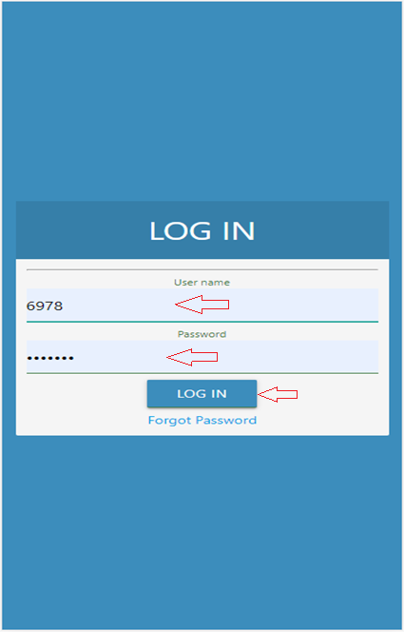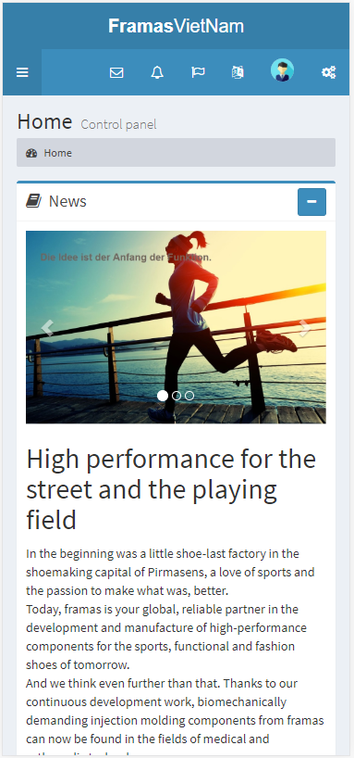After login success, the system will go to Home page

**Step 2: Update email:**

* 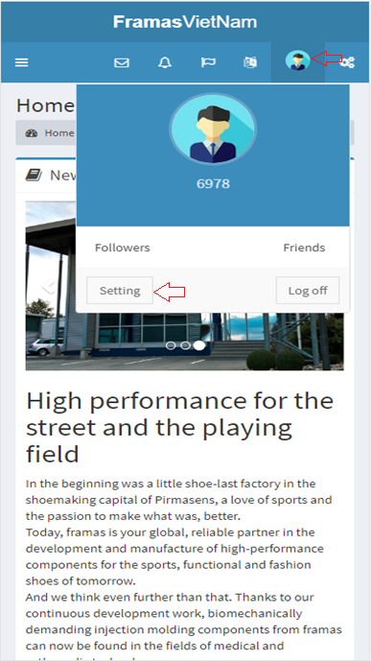Click Setting

**Step 3: Update email:**

* 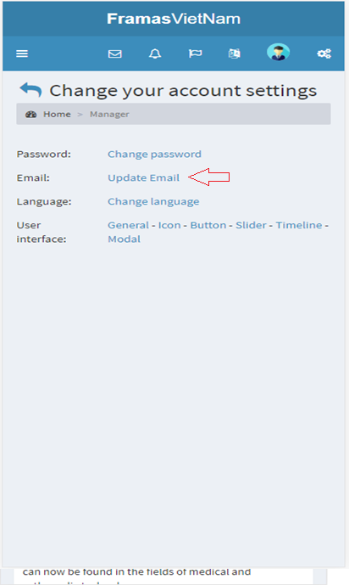Click update email

**Step 4: Update email:**

* 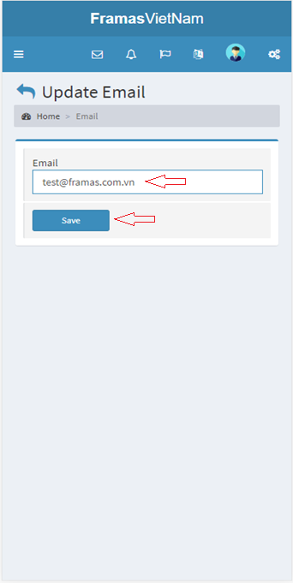Input your email and click Save

**Step 5: Visio Booking:**

* 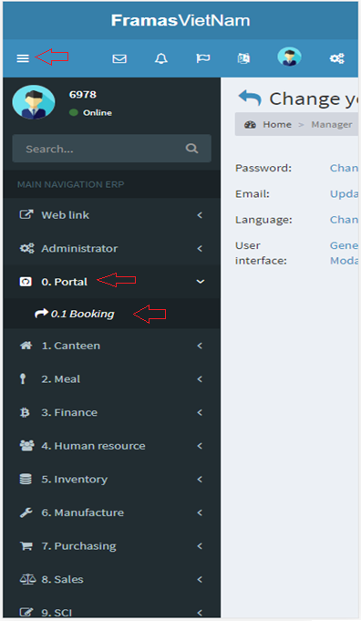Click Booking

**Step 6: Visio Booking:**

* 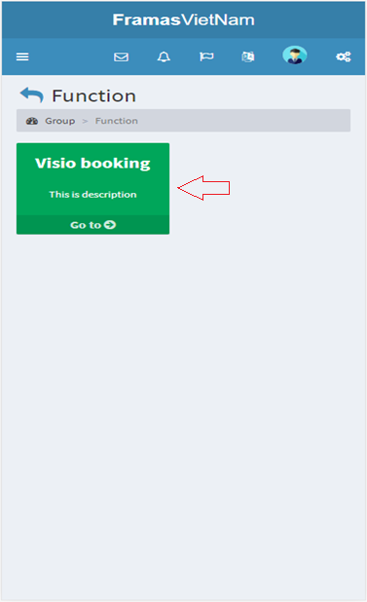Click Visio Booking

**Step 7: Add new:**

* After click Visio booking, the system will go to booking function
* Click Add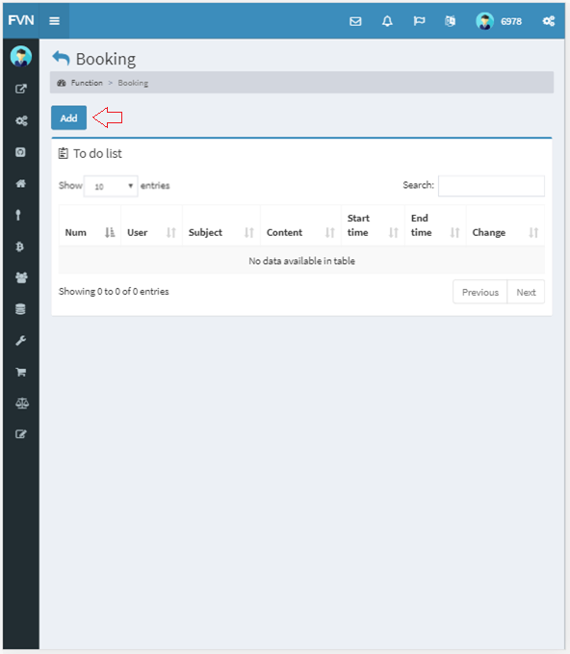

**Step 8: Add new:**

* Input start time, end time, subject, content
* Click Save
* Note:
* End time greater than Start time
* Start time greater than current day
* 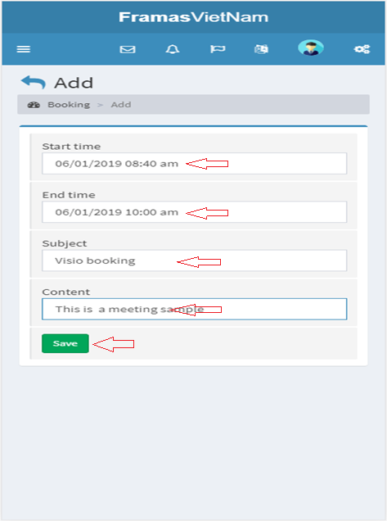Subject and content is not null

**Step 9: Edit:**

* 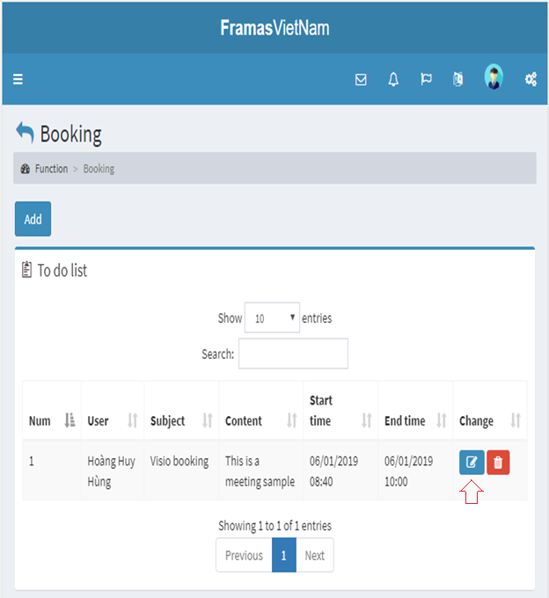Click edit icon

**Step 10: Edit:**

* After click edit, the system will go to edit page
* Change info booking
* Click save

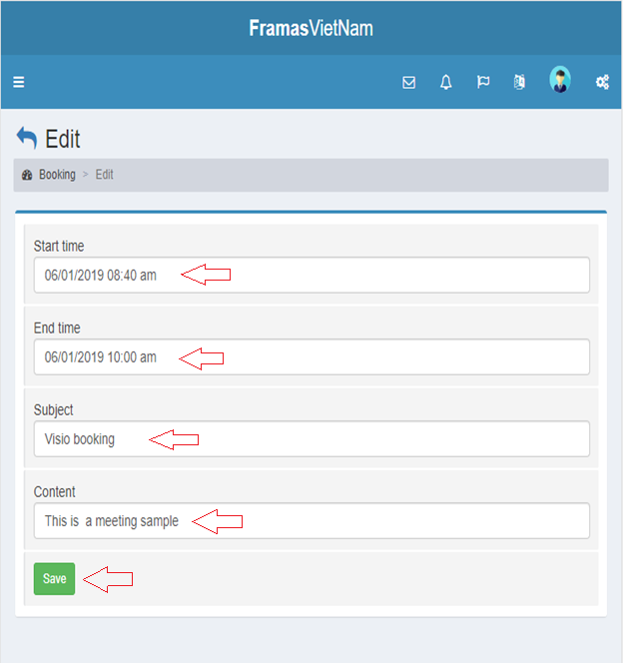

**Step 11: Delete:**

* 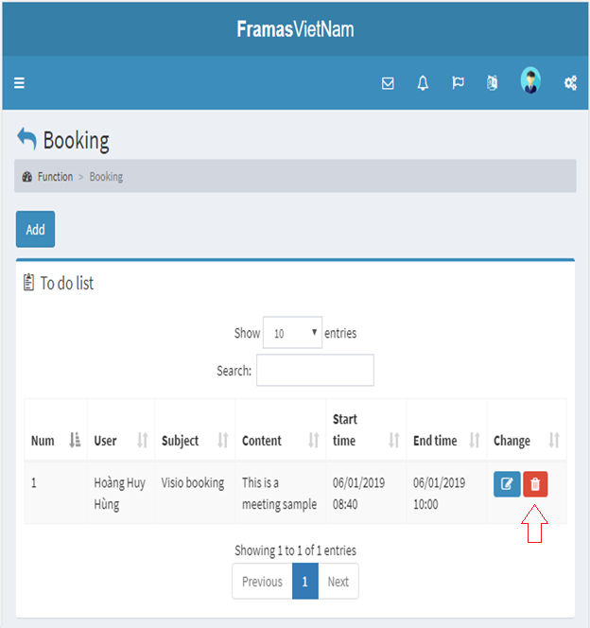Click delete icon on row you want to delete
* 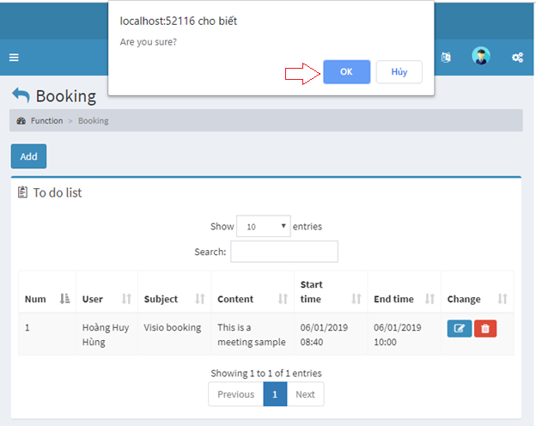Click OK to delete, No to cancle