Document Design Software

Meal Control in Framas

# Getting Started

## Introduction about meal system in framas

* 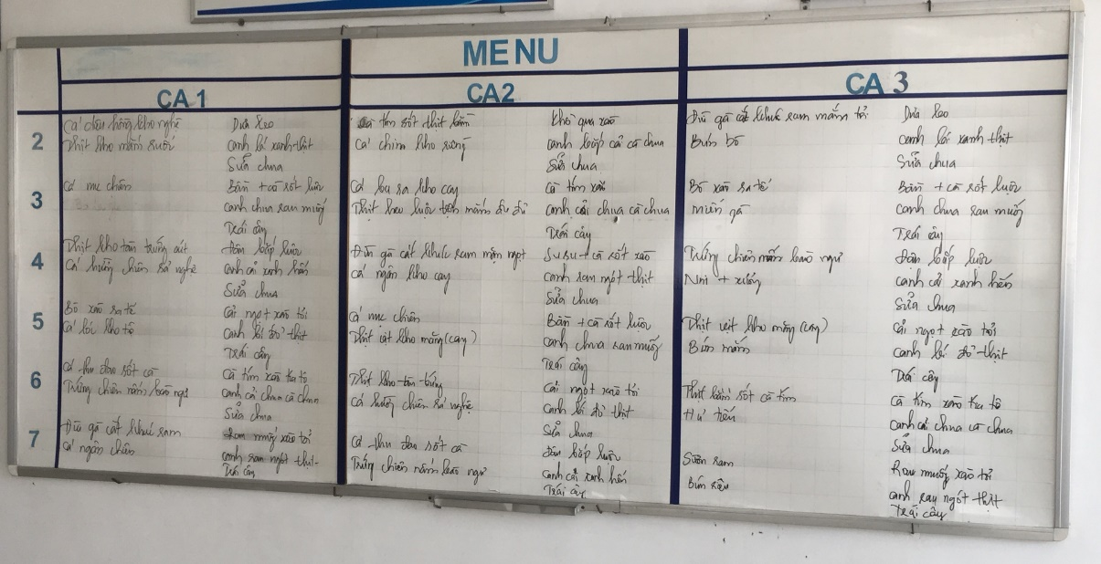Setup by week
* This is setup info meal schedule for employee and worker at Framas.
* Meal schedule will setup by week, from monday to saturday, canteen will delivery meal to employee three times a day

## Solution

### Employee

* Working 8 hours and do not OT:
  + Order meal: when the employee get in company, they have to use a fingerprint scanner to login to order meal, choose meal for office hours. The system will lock order function after 9h30 am.
  + Take meal: the canteen will delivery meal at 12 pm and employee have to finger scan before take meal.
* Working 8 hours and OT:
  + Order meal: when the employee get in company, they have to use a fingerprint scanner to login to order meal, choose meal for office hours shift and meal for OT. The system will lock order function after 9h30 am.
  + Take meal: the canteen will delivery meall at 12 pm, OT at 6 pm.The employee have to finger scan before take meal.

### Worker

* Shift work:
  + Order meal: when the worker get in company, they have to use a fingerprint scanner to login to order meal. Choose shift work (1, 2, 3) and choose meal.

Shift 1: after 9.30 am, the system will lock order function and worker don’t change meal.

Shift 2: after 3 pm, the system will lock order function

Shift 3: after 22.30 pm, the system will lock order function

* + Take meal:

Shift 1: the canteen will delivery meall at 10h and employee have to finger scan before take meal.

Shift 2: the canteen will delivery meall at 5h and employee have to finger scan before take meal.

Shift 3: the canteen will delivery meall at 23h and employee have to finger scan before take meal.

### Other

* New employee, customer:

Leader, manager will have to statical list, quantity and pass report to receptionist. The receptionist will order and print meal coupon.

Take meal: new employee, customer will use meal coupon to take meal from canteen

### Statical report

* Statical list quantity meal order by day, week, month.
* Statical feedback from employee, worker about quality of meal and so on

# Design

## Note

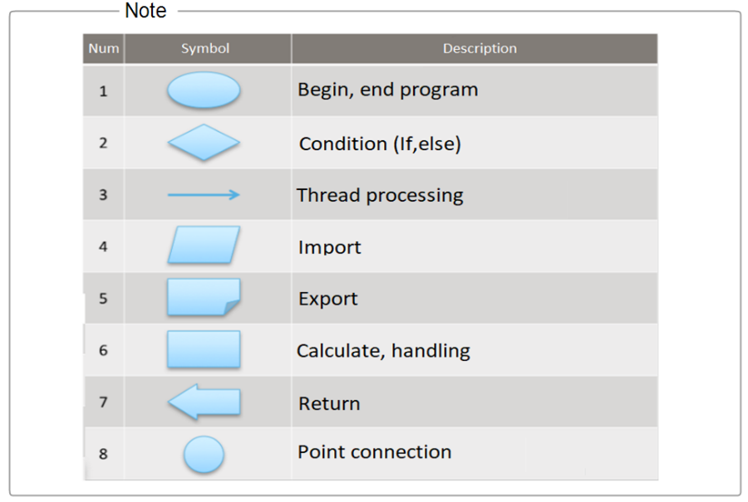

## Function diagram

* Manager meal menu: the canteen will setup meal list by day once a week in application.
* Meal order: user will order user’s meal on the screen (the screen show meal list by day, shift)
* 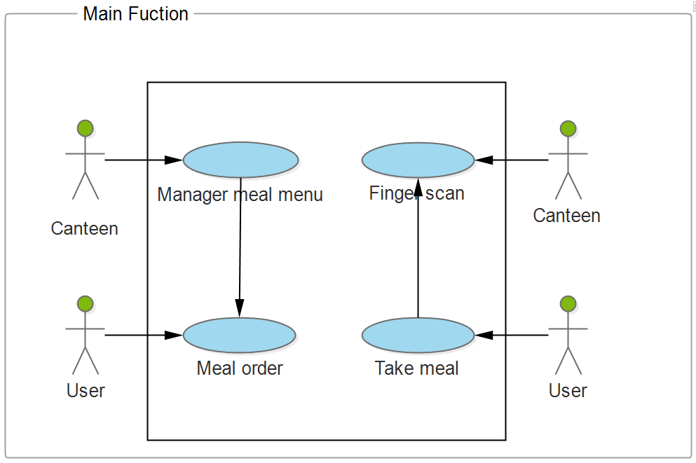Take meal: when take meal, user have to finger scan, if success the canteen will delivery meal to user.

## User function diagram

* Order meal: login to system, choose Order meal function, the screen will show meal list by day, office hours, shift and so on.
* Feedback: user can comment quality of meal and post user’s feedback to canteen.
* Take meal: user have to finger scan for take meal, if finger scan is success, the canteen will delivery meal to user.

### Order meal

* + 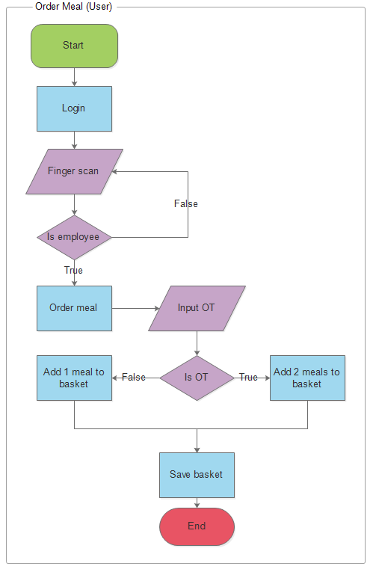User finger scan for login to system, if finger scan success, the system will go to home page.
  + In there, choose Order meal for order, the screen will show meal list by day, shift. Add meal to basket and click save.
  + If user do overtime, click checkbox OT and choose meal for OT.
  + Click save basket for save meal data.

### Feedback

* + The user have to finger scan for login to system.
  + After login success, the system will go to home page.
  + Click chọn Feedback để phản hồi thông tin liên quan đến chất lượng bữa ăn tới nhà hàng.
  + Click feedback function for comment something about meal quality.
  + After input feedback data, click post for send feedback data to canteen

### Take meal

* + When employee take meal, they have to finger scan and the system will check data info and output to screen.
  + If this info is correct, canteen will delivery meal to employee

## Canteen function diagram

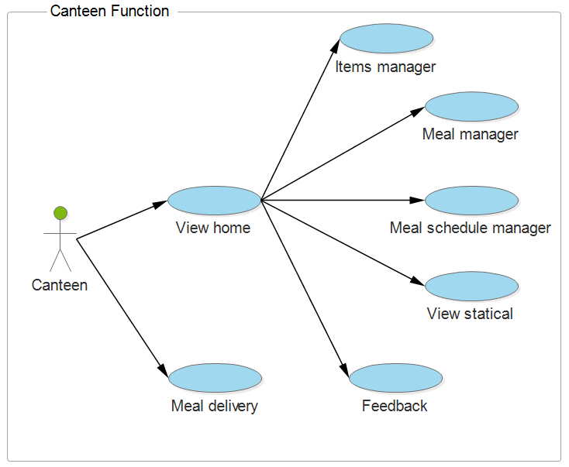

* After login success, the system will go to home page. In there, canteen can setup food, meal, menu schedule, statical list meal order, meal delivery to employee by day, week, month and so on.
* Meal delivery: this function will check user ‘s info and output data to screen. If data is correct, canteen will delivery meal to employee.

### Login

* + Input user name and password in login page.
  + Click login

### Items manager

* + In Home page, click Item manager function for manager food.
  + Choose Add new item for add new a food, input code, name, description and click save for save data.
  + Click Edit for change meal info. Change name, description and click save for save data.
  + Click Delete for remove food.

### Meal manager

* + Click Meal manager (manager all list meal)
  + Click Add new meal for add new meal, input code, name, description and list food. Click save data.
  + Click Edit for change meal information, change name, description, list food and click save data.
  + Click Delete for remove meal information.

### Meal schedule manager

* + Click Meal schedule manager function for setup meal schedule.
  + Click Add new schedule function, choose day, input code, name description, list meal and click save data.
  + Click Edit for change meal information, change name, description, list meal and click save data.
  + Click Delete for remove meal schedule

### View statical

* + Click Meal statical, in there canteen can view list report about meal order, meal delivery, meal schedule and so on.
  + Choose report in list reports and click print for show data.

### Meal delivery

* + Click Meal delivery function.
  + Before take meal, user have to finger scan.
  + If finger scan success, canteen will delivery meal to employee.