Bike sharing course

Nannet Fabri

5-11-2020

## Abstract

I looked for any associations between different parameters and the number of bikes taken per hour. I found an association with the season, the weathertype, the temperature, the ‘feels like’ temperature, the humidity and the windspeed.

## Material and methods

I looked if there were associations between the number of bikes taken per hour and 8 other parameters during that hour. These were the season, whether or not it was a holiday, whether or not it was a workingday, the weathertype, the temperature, the ‘feels like’ temperature, the humidity and the windspeed. For the factor variables (season, holiday, workingday and weathertype) I performed a Kruskal Wallis test with a dunn test as post hoc. For the numerical variables (temperature, ‘feels like’ temperature, humidity and windspeed) I performed a Spearman rank test.

For the above-mentioned tests I first made an R-package, so it was easier to perform them for each pair of variables I wanted to test. I called this R-package ‘Bikecourse’.

The package ‘Bikecourse’, the data and the R-code can be found at my GitHub: <https://github.com/NDFabri/Bike_sharing_course>

## Results

I found an association between the number of bikes taken per hour and the season, the type of weather, the temperature, the ‘feels like’ temperature, the humidity and the windspeed (Figure 1). I did not find any association between the number of bikes taken per hour and whether or not it is a holiday an whether or not it is a workingday.

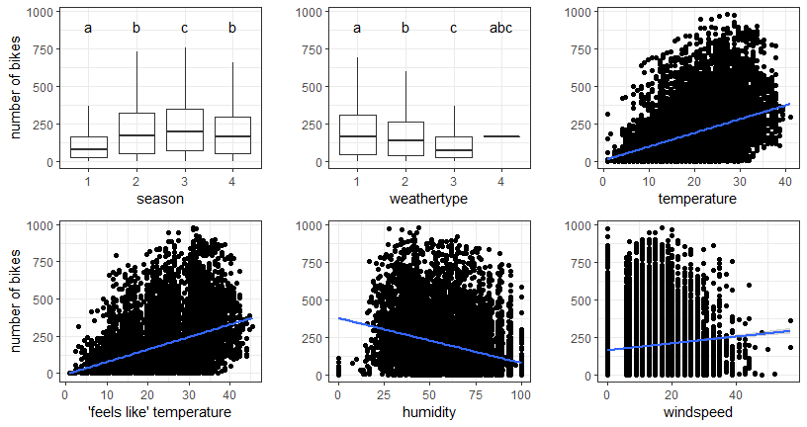

Figure 1: associations between the number of bikes taken per hour (count) and the parameters where I found an association

## Literature

Rstudio version 3.6.0 Database: Fanaee-T, Hadi, and Gama, Joao, Event labeling combining ensemble detectors and background knowledge, Progress in Artificial Intelligence (2013): pp. 1-15, Springer Berlin Heidelberg.