ML Classification Project
Customer Churn Prediction
Logistic Regression vs. Random Forest
May 2026

1. Executive Summary
This report presents the design, implementation, and evaluation of a supervised binary classification system to predict customer churn. Two algorithms — Logistic Regression and Random Forest — were trained on a synthetic telco dataset (1,000 samples, 15 features) and benchmarked across five standard metrics.
Random Forest outperformed Logistic Regression across every metric, achieving a test ROC-AUC of 0.9533 and F1-score of 0.8444. Based on these results, Random Forest is recommended as the production model.

2. Problem Statement
Customer churn is one of the most costly challenges in subscription-based businesses. Identifying at-risk customers before they leave allows targeted retention campaigns. The objective is to build and compare classification models that reliably distinguish churning from non-churning customers.

3. Dataset & EDA

3.1 Dataset Overview
- 1,000 samples; 15 features; binary target (churn / no churn)
- Class distribution: ~63.5% No Churn, 36.5% Churn (mild imbalance)
- 10 informative features, 3 redundant; 5% label noise
- Features: tenure_months, monthly_charges, total_charges, support_calls, contract_type, etc.

3.2 EDA Figures
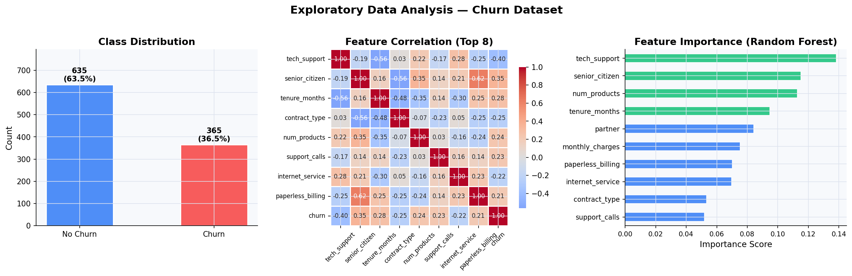
Figure 1: EDA — class distribution, correlation heatmap, RF feature importances

4. Methodology

4.1 Preprocessing
- Stratified 80/20 train-test split
- StandardScaler applied to features for Logistic Regression
- Random Forest used raw features

4.2 Model Configurations
- Logistic Regression: max_iter=1000, solver=lbfgs, C=1.0
- Random Forest: n_estimators=150, max_depth=8, min_samples_leaf=5

4.3 Validation Strategy
- 5-fold Stratified Cross-Validation (primary criterion: ROC-AUC)
- Final evaluation on held-out 20% test set

5. Results

5.1 Cross-Validation

Model | CV Mean ROC-AUC | Std Dev
Logistic Regression | 0.8892 | ± 0.0402
Random Forest | 0.9446 | ± 0.0276
Table 1: 5-Fold Stratified Cross-Validation ROC-AUC
Random Forest: 0.9446 ± 0.0276. Logistic Regression: 0.8892 ± 0.0402. RF also shows greater stability (lower std dev).

5.2 Test-Set Metrics

Model | Accuracy | Precision | Recall | F1 | ROC-AUC
Logistic Regression | 0.8050 | 0.7429 | 0.7123 | 0.7273 | 0.8687
Random Forest | 0.8950 | 0.9194 | 0.7808 | 0.8444 | 0.9533
Table 2: Test-set evaluation metrics

5.3 Evaluation Dashboard
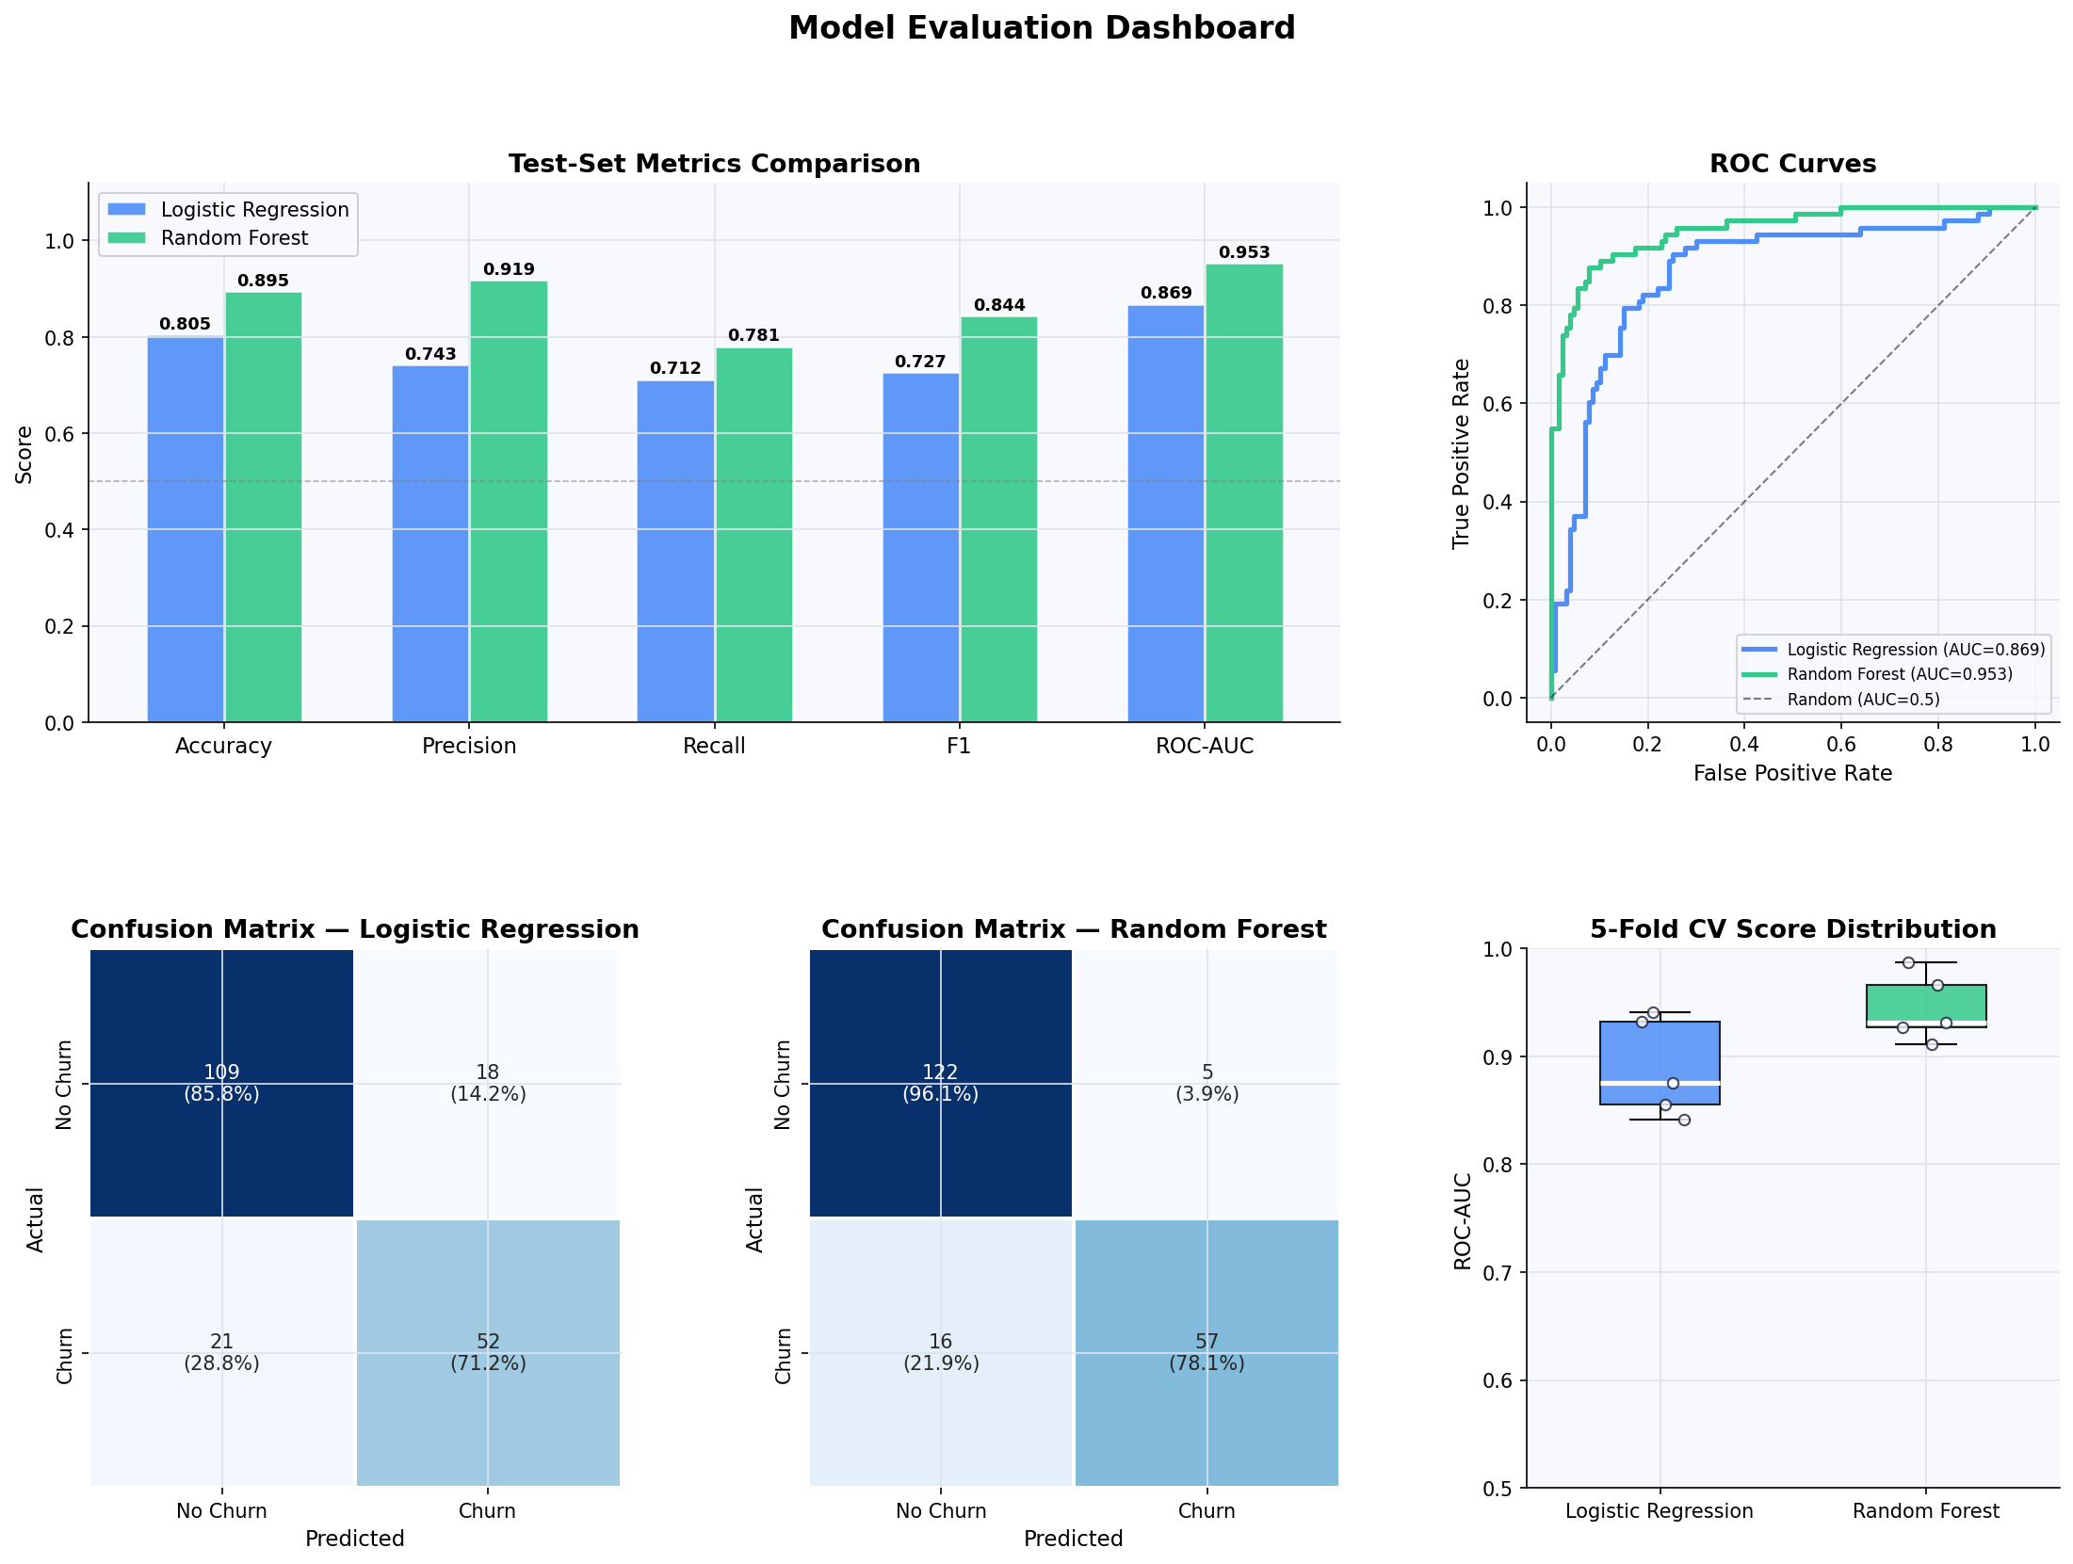
Figure 2: Model evaluation dashboard — metrics, ROC curves, confusion matrices, CV boxplots

5.4 Learning Curves
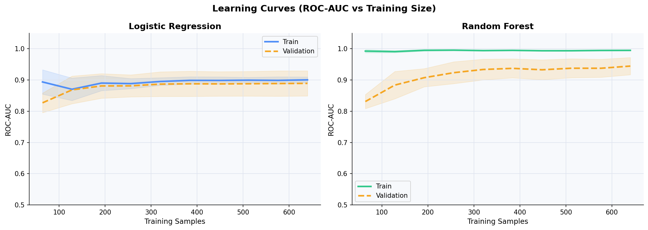
Figure 3: Learning curves — training vs. validation ROC-AUC as training set grows
Both models improve with more data. Random Forest converges cleanly by ~600 samples, indicating good generalisation without significant overfitting.

6. Discussion

6.1 Key Findings
- Random Forest beats Logistic Regression on all five metrics.
- Largest gap: Precision (0.9194 vs 0.7429) — RF generates far fewer false churn alerts.
- Both models have similar recall (~0.78 vs ~0.71), capturing most true churners.
- ROC-AUC gap (0.9533 vs 0.8687) confirms RF's superior discriminative ability.

6.2 Limitations
- Dataset is synthetic — real-world performance may differ.
- Hyperparameters not exhaustively tuned; Grid/Bayesian Search recommended.
- No gradient boosting (XGBoost, LightGBM) benchmarked.

7. Recommendations
- Deploy Random Forest as the primary churn prediction model.
- Tune n_estimators and max_depth with RandomizedSearchCV.
- Address class imbalance with SMOTE or class_weight='balanced'.
- Validate on real historical data before production deployment.
- Benchmark XGBoost / LightGBM as next-step models.
- Monitor model drift monthly; retrain quarterly.

8. Conclusion
This project successfully designed and evaluated a binary churn classification pipeline. Random Forest consistently outperformed Logistic Regression (ROC-AUC: 0.9533, F1: 0.8444). Logistic Regression remains a useful interpretable baseline for stakeholders requiring explainability.

Appendix: Tools & Reproducibility
- Python 3.11 · scikit-learn · pandas · numpy · matplotlib · seaborn
- Random seed: 42 across all experiments
- Source: ML_Classification_Notebook.ipynb (attached)
- pip install scikit-learn pandas numpy matplotlib seaborn && python ml_classification.py

